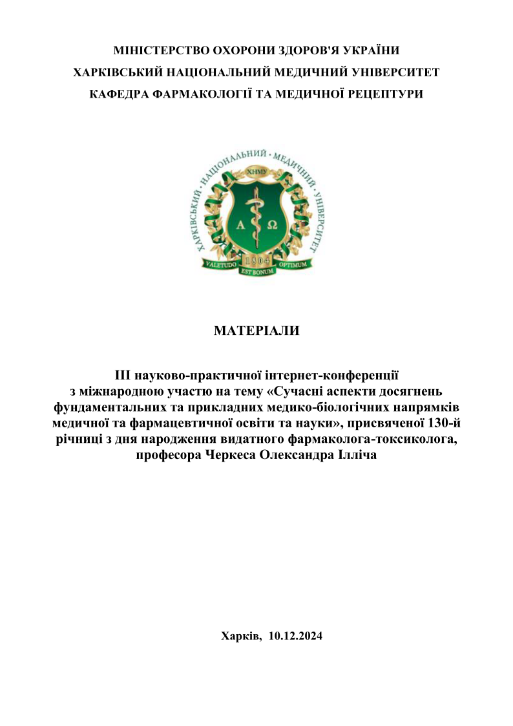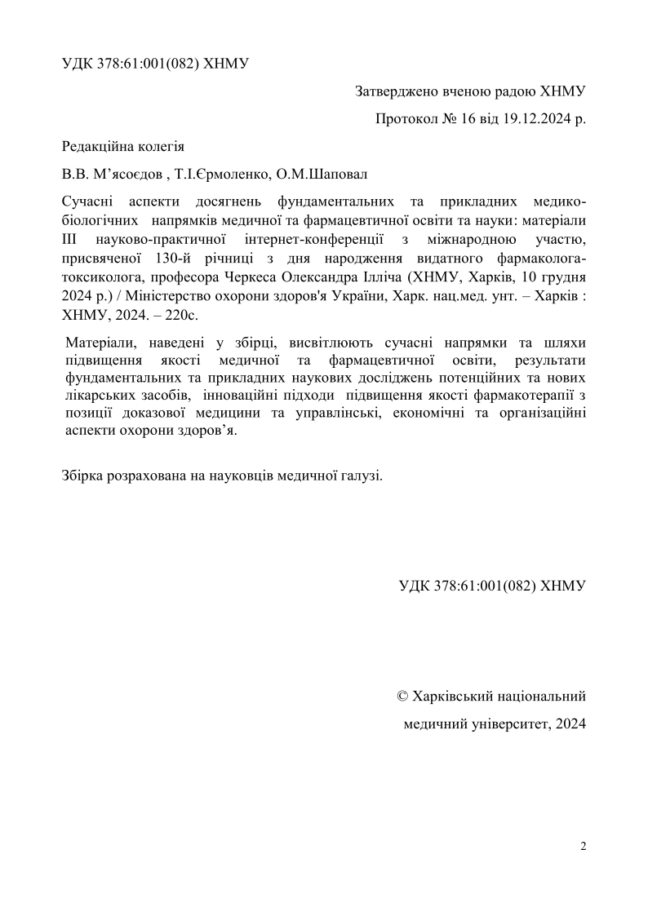
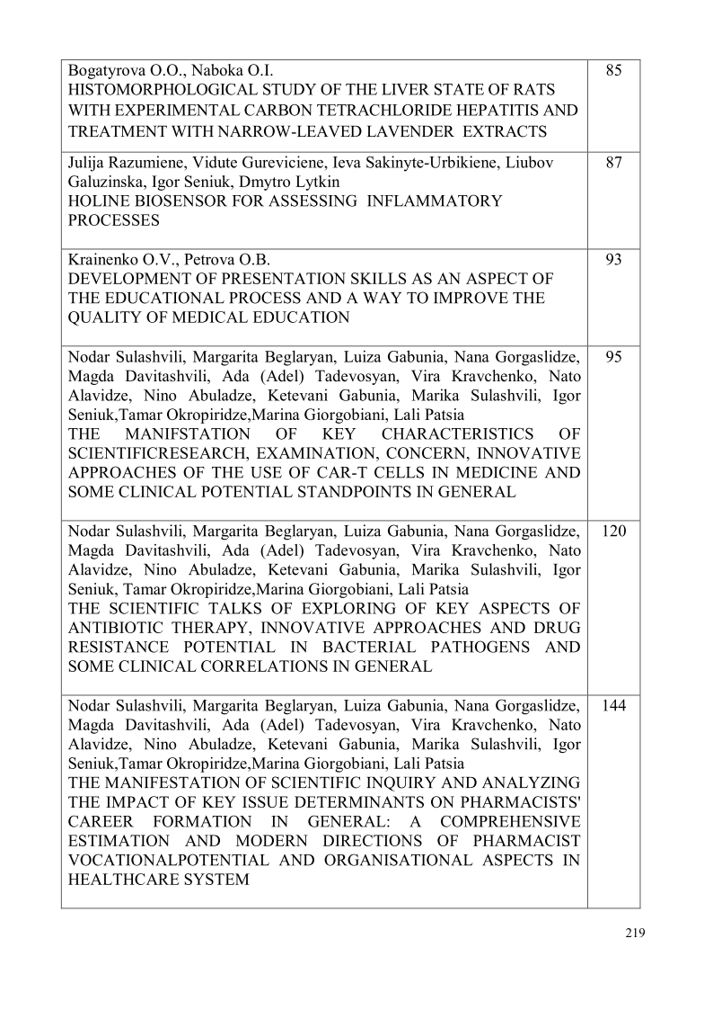
DEVELOPMENT OF PRESENTATION SKILLS AS AN ASPECT OF THE EDUCATIONAL PROCESS AND A WAY TO IMPROVE THE QUALITY OF MEDICAL EDUCATION
Krainenko O.V., Petrova O.B.
Kharkiv National Medical University, Kharkiv, Ukraine, ov.krainenko@knmu.edu.ua, ob.petrova@knmu.edu.ua
Statement of the problem. Acquiring professional competencies and acquiring appropriate knowledge and skills have become interwoven with the need to foster a system of extra competencies that meet contemporary standards in the subject area. This also concerns the development of professionally oriented communicative competencies of a future specialist. Exquisite conditions should be created in the framework of the educational process at higher education medical institutions. Practical activity requires the introduction of some learning technologies in the learning process that may attract the students’ attention, and help them develop the following skills: critical thinking, emotional intelligence, ability to socialize, and management skills.
In the time of worldwide online education and the broad use of digital technologies, involving students during distance learning in various online educational projects, training, webinars, and seminars has become an indispensable part of the educational process.
The objective of the work is to highlight the relevance of the development of medical students’ skills to make captivating and appealing presentations.
Material and Methods. The work uses the method of a systematic approach to the study of the reflection of the issues that arise while developing presentation skills in the educational process in medical universities elucidated in the articles published recently in the scientific literature on the topic.
Results and discussion. To present information quickly, clearly, and in a smart way, to be able to design its structure has become extremely important. Therefore, medical students have to master different techniques and be ready to use them in class, during the defense of projects, discussion of case histories, etc.
The general survey of the rules as to how to make your presentation fruitful, encouraging, and attractive, proposed by James A. Baker, Philip Bourne, and Mark Fowler, has shown that when presenting a material some tips should be taken into consideration. They all agree that the speaker (presenter) must have a deep understanding of the material he has to present, be concentrated on the idea he has to deliver to the audience, be aware of the technologies, use appropriate visual material, and effectively structuralize the content. The knowledge and the messages of the speaker are to be converted in a clear and concise manner.
All the above-mentioned presentation tips should be exercised by the students when making presentations during online classes. Furthermore, that could be a good idea for the formative assessment of a student’s knowledge of some piece of material. These are sure to help the medical students grasp the material they learn much better than just drilling numerous pages trying to memorize the whole bulk. Logical structuralizing of the necessary content for the presentation slides would benefit the students more advantageously.
Of late the brisk five-minute presentations have become even more popular. Concise content improves readability and helps the audience quickly understand the key points of the material presented. This makes students to be selective about the content they choose for the slides. Besides, it is important not only what the student tells, but the way and the style in which the material is presented. The appropriate wording is rather beneficial. Slides with less text make more space, making them more visually appealing. They are concise though no less informative.
Presentations are a great way to teach students to practice all the aspects of the language they speak (vocabulary, grammar, phonetics). They become more self-confident. Presentation skills are helpful when socializing, and teach the student to be patient and tolerant which is crucial for effective communication between a doctor and a patient and will contribute to the development of “soft skills”.
Conclusions. Finally, we may conclude that formation and development of presentation skills, which are an integral part of “soft skills” are highly relevant and prove the effectiveness of training medical students. The introduction of such educational technologies into the educational process determines the effectiveness of the training of medical students, on which the success of the future doctors largely depends, as well as the quality of medical education.

