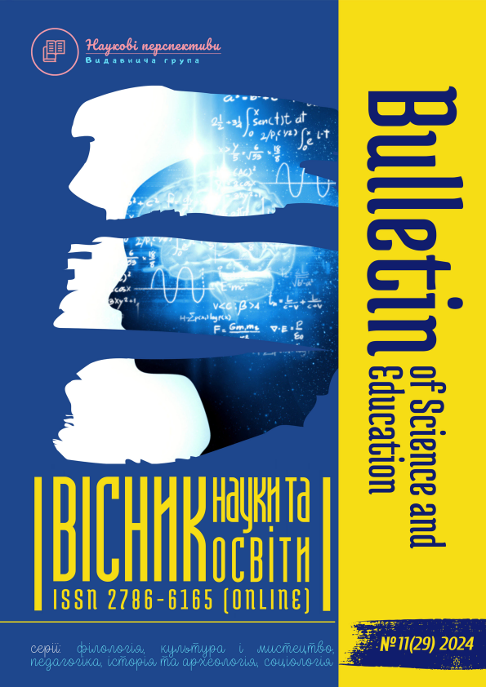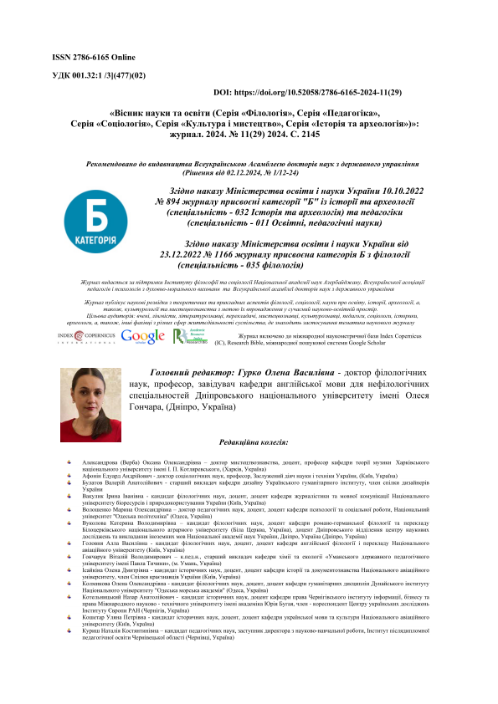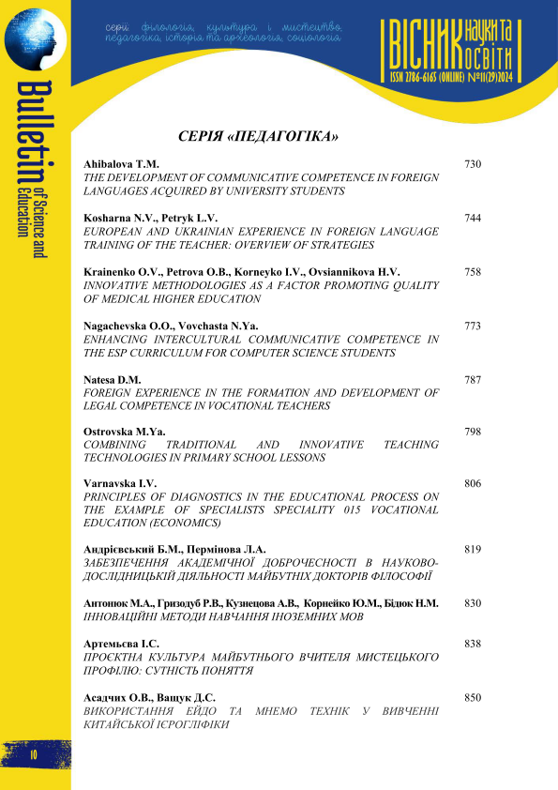

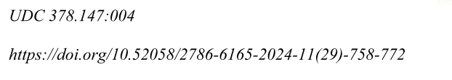
Krainenko Olena Volodymyrivna Senior Lecturer at the Foreign Languages Department at Kharkiv National Medical University, Kharkiv, tel.: +380 980373161
e-mail: ov.krainenko@knmu.edu.ua , https://orcid.org/0009-0000-3436-0379

Petrova Olha Borysivna Candidate of Science in Philology, Associate Professor of the Foreign Languages Department at Kharkiv National Medical University, Kharkiv, tel.: +380 671559895, e-mail: ob.petrova@knmu.edu.ua , https://orcid.org/0000-0002-4876-7759
Korneyko Iryna Vasylivna Candidate of Science in Philology, Associate Professor, Chief of Foreign Languages Department at Kharkiv National Medical University, Kharkiv, tel.: (050) 1957777, e-mail: iv.korneiko@knmu.edu.ua , https://orcid.org/0000-0003-3581-4138
Ovsiannikova Hanna Valeriivna Senior Lecturer at the Foreign Languages
Department at Kharkiv National Medical University, Kharkiv, tel.: +380
675704094 e-mail: hv.ovsiannikova@knmu.edu.ua , https://orcid.org/0000-0001-8426-6313

INNOVATIVE METHODOLOGIES AS A FACTOR PROMOTING QUALITY OF MEDICAL HIGHER EDUCATION

Abstract. The article concerns analyzing the innovative technologies being implemented in the teaching practice of medical higher education institutions. It is noted that the idea of e-learning competence has become crucial in teaching medical students; hence, the ongoing information and digital transformation call for e-didactics. Innovative technologies are given attention to and regarded as a factor that may be essential in improving the quality of training in medical higher education institutions. Concept-based approaches, inquiry strategies methodology, concept mining techniques, "mind mapping" technology, adaptive learning technology, and edutainment technology have been discussed in the article. The mind-mapping technology facilitates the process of grasping and memorizing a large number of medical terms and factual material. It has been pointed out that mind mapping helps to highlight the main ideas and emphasize the notions and words describing them, which facilitates grasping the material. It has been stated that the profession of a doctor requires high levels of empathy, which lets the doctor be aware of the patient’s emotions to convince the patient that the doctor understands the patient’s problems and worries.
It is noted that various learning systems are undergoing the integrative process, which makes the learning process even more attractive for medical students as contemporary medical science requires deep insight and skills in diverse fields of knowledge. STEM education has been mentioned as a way to integrate medical science, technology, engineering, and mathematics. The leading principle of STEM education – integration – makes it possible to modernize the methodology, content, and volume of the educational material, making medical education high-tech. The article states that adaptive learning technology makes it possible to adapt the syllabus and curriculum to the needs of medical students and goes together with smart learning, which is provided by innovative digital technologies, Learning Management Systems (LMS), and artificial intelligence (AI). The application of digital tools is meant to methodize and adapt the training to satisfy the academic needs of every student.
Keywords: e-learning competence, mind mapping technology, inquiry strategies methodology, e-didactics, teaching medical students

Крайненко Олена Володимирівна старший викладач кафедри іноземних мов Харківського національного медичного університету, м. Харків, тел.: +380 98 0373161e-mail: ov.krainenko@knmu.edu.ua , https://orcid.org/0009-0000-3436-0379

Петрова Ольга Борисівна кандидат філологічних наук, доцент кафедри іноземних мов Харківського національного медичного університету, м. Харків, тел.: +380 671559895, e-mail: ob.petrova@knmu.edu.ua , https://orcid.org/0000-0002-4876-7759
Корнейко Ірина Василівна кандидат філологічних наук, доцент, завідувачка кафедри іноземних мов Харківського національного медичного університету, м. Харків, тел.: (050) 1957777, e-mail: iv.korneiko@knmu.edu.ua , https://orcid.org/0000-0003-3581-4138
Овсяннікова Ганна Валеріївна старший викладач кафедри іноземних мов Харківського національного медичного університету, м. Харків, тел.: +380
675704094 e-mail: hv.ovsiannikova@knmu.edu.ua , https://orcid.org/0000-0001-8426-6313

ІННОВАЦІЙНІ МЕТОДИКИ ЯК ЧИННИК ПІДВИЩЕННЯ ЯКОСТІ ВИЩОЇ МЕДИЧНОЇ ОСВІТИ
Анотація. Стаття присвячена аналізу інноваційних технологій, які впроваджуються у педагогічну практику вищих медичних закладів. Зазначається, що ідея компетентності електронного навчання стала вирішальною під час навчання студентів-медиків; отже, інформаційна та цифрова трансформація, що триває, потребує е-дидактики. Інноваційні технології розглядаються як фактор, що може мати істотне значення для підвищення якості підготовки кадрів у вищих медичних навчальних закладах. У статті обговорюються концептуальні підходи, методологія дослідницьких стратегій, методи інтелектуального аналізу, технологія "mind maps", технологія адаптивного навчання, а також технологія "edutainment". Відзначено, що технологія "mind maps" полегшує процес розуміння та запам’ятовування великої кількості медичних термінів та фактичного матеріалу, та допомагає виділити основні ідеї і підкреслити поняття і слова, які описують їх, що полегшує засвоєння матеріалу.
Стверджується, що професія лікаря вимагає високого рівня емпатії, дозволяючи лікарю усвідомлювати емоції пацієнта для переконання пацієнта, що лікар розуміє його проблеми і переживання. Відзначається, що різні системи навчання зазнають інтегративного процесу, що робить процес навчання ще більш привабливим для студентів-медиків, оскільки сучасна медична наука вимагає глибокого розуміння та навичок у різних галузях знань. STEM-освіта згадується як спосіб інтеграції медичної науки, технологій, інженерії та математики. Інтеграція як провідний принцип STEM-освіти дозволяє модернізувати методологію, зміст та обсяг навчального матеріалу, роблячи медичну освіту високотехнологічною. У статті стверджується, що технологія адаптивного навчання дозволяє адаптувати навчальну програму та навчальний план до потреб студентів-медиків, та поєднується з інтелектуальним навчанням, яке забезпечується застосуванням цифрових інноваційних технологій, LMS (систем управління навчанням) та штучного інтелекту (ШІ). Застосування цифрових інструментів пов'язане зі створенням доцільної методики та адаптацією навчального процесу для задоволення академічних потреб кожного студента.
Ключові слова: компетенція е-навчання, технологія "mind maps", методологія дослідницьких стратегій, е-дидактика, навчання студентів-медиків.

Problem statement. The need for competence in e-learning and the application of new technologies for teaching students in medical institutions of higher education has recently arisen worldwide. In Ukraine, the need for mastering such technologies has increased even more. Improving quality in medical universities has become crucial in determining the education level. The quality of teaching the disciplines of the educational professional programs in specialties trained in medical universities is becoming essential for developing the educational system. The implementation of technologies in the daily practice of a higher medical education institution has many different elements in the ongoing information and digital transformation of the educational system, and innovative methods and the quality of academic services are among the leading ones. The advanced training of educators and their readiness to develop didactic materials, improve professional competencies using web resources, and update the programs in a student-centered medium with new learning tools are of great topicality. The connection of the academic process with the implementation of information technologies is being updated, given the transition to distance and blended education, and considered in modern e-didactics. Thus, innovative technologies are emphasized and regarded as a factor that may be essential in improving the quality of higher education institutions' activity. They present the subject for current work.
Analysis of recent research and publications. The publishing activity has been observed recently in the academic community to meet the need for analysis and identification of competencies required for e-learning and the use of new technologies in higher education institutions (A. Sánchez-Caballé, M. G. Cervera, M. O. Al-Momani, E. M. Rababa, S. Yu, Y. Lu, M. A. Uppal, M. J. Sá, A. I. Santos, L. Zhao, J. S. Moreira-Choez, K. E. G. Barzola, T. M. L. de Rodriguez, A. R. Sabando-Garcia, J. C. C. Mendoza, L. A. C. Barcia, P. Patrick, E. Care D. Nanto, D. M. Rahiem, T. K. Maryati, C. Hasse, G. Falloon, M. Claro, et al.). In higher education institutions in Ukraine, the necessity to acquire such technologies has become even more urgent (J. P. Mund, V. Khrutba, E. Wallor, A. Holovko, Y. Nikitchenko, Y. Khrutba, M. Dekhtiar, O. Gerasymenko, O. Sovirda, V. Tiupa, and others).
Currently, educational technologies, including e-books, digital textbooks, online homework systems, video lectures, digital maps, and many other tools, are beginning to be widely used in education by university students and teachers worldwide (M. Chikwaka, D. Ahmad, L. Mohebi; F. Kamalov, D. S. Calonge, I. Gurrib, A. Kushwaha, R. K. Kushwaha, S. Ahmad, B. Hollister, P. Nair, S. Hill-Lindsay, L. Chukoskie, and others). In particular, in medical higher education institutions, these options have found their practical use of late that has been reported in recent publications (A. W. K. Yeung, E. D. Parvanov, Y. Lysanets, O. Bieliaieva, H. Morokhovets, I. Znamenska, S. Efendiieva, Y. S. Iliasova, L. S. Shevchenko). Hence, digital technologies require innovative solutions to balance theory and practice to make the teaching process more effective. Furthermore, there is a need for methodologies that require structuring, organizing, and reducing the information that education seekers need to.
Along with the above tools, artificial intelligence (AI) technologies are gaining increasing popularity in all spheres of human life and activity, including higher education and namely teaching English for Specific Purposes in university settings, and are beginning to be used in education (R. Pahuja, R. Kushwaha; R. Luckin, M. Cukurova; F. Kamalov, D. S. Calonge, I. Gurrib; J. Hutson, T. Jeevanjee, V. V. Graaf, et al.). Integration of these advances into the educational context contributes to ensuring the quality of education by engaging students in the learning process and achieving results, demonstrating "reshaping teaching and learning processes in English language education" as "AI can enhance English language instruction by providing tailored feedback, facilitating immersive learning environments, and supporting diverse learning needs" [1, p. 383]. The authors (J. Hutson, T. Jeevanjee, V. V. Graaf [2]) show how AI allows effective combination and integration among the educational program components while "offering personalized, adaptive, and interactive learning experiences" [1, p. 383].
Some recent reports of educators involved in the research with a concept-based approach, substantiated by D. A. Frayer, W. C. Frederick, and H. J. Klausmeier [3; 4], demonstrated its efficiency in teaching medical students the educational professional program components in specialties trained in medical universities, and English for specific purposes (ESP) as well (E. Al-Omari, R. Dorri, M. Blanco, M. Al-Hassan; T. Barrett, S. R. Jacob, W. Likes [5]; C. J. Gómez-Carrasco, J. Monteagudo-Fernández, J. R. Moreno-Vera, M. Sainz-Gómez and others).
The usage of the concept-based inquiry methodology (H. J. Klausmeier, D. A. Frayer), and its application for language learning (C. Marschall, R. French) [3; 4; 6] helps medical students to understand, memorize, and use adequately numerous medical words, terms, and collocations that occur in texts dealing with medicine. The usage of concept maps in medical education has become a useful pedagogical strategy for teaching medical subjects as well (concept mapping is being reported by the authors as a method to teach evidence-based educated medical topics: B. J. Daley, D. M. Torre; F. Saeidifard, K. Heidari, M. Foroughi, A. Soltani; S. R. Sorte, S. Sande, S. B. Rathod, V. A. Vij, J. Gumashta, G. Muthiyan, A. Patil, K. M. Surapaneni, A. Tekian). The mind mapping technique is associated with the formation of ideas and the construction of predictable aspects related to the concept being studied, helping in students' cognitive processes, building logical connections, activating different senses, and thus processing and acquiring the concept (A. Erdem; A. Kruk, R. Kulbanska, R. Monastyrska) [7].
The purpose of the article is to analyze the innovative technologies being implemented in the teaching practice with concept-based inquiry methodology, particularly for the components of educational professional programs in specialties trained in medical universities.
Presentation of the main material. According to the concept-based inquiry methodology [3; 4], inquiry strategies assist in grasping ideas and getting deeper knowledge. The concept-based approach considers the word in terms of inclusion, exclusion, subordination, and superordination, which is guided by a graphic organizer used for word analyses and vocabulary building. "Four levels in the attainment of the same concept at successively higher levels of inclusiveness and abstractness are outlined" … that are "concrete, identity, rudimentary classificatory, and formal" [4, p. 5-9], and they are used in the proposed model. The four-square model designed by these Wisconsin University researchers describes the meaning of a word by defining the term, describing its essential characteristics, providing examples of the idea. As well, the opposite, probable misinterpreting of concept examples is given. These ideas are productively used to help learners build connections between different ideas and make sense of the presented information.
Some fruitful ideas can be helpful when teaching university students; hence, the students have to be involved in learning emotionally and intellectually as the career of a doctor deals with rapport with patients. First of all, this is the work related to communication, doctors, teachers, and psychotherapists being on the frontline. In communicating with a patient, a doctor should show empathy, which means being aware of the patient’s emotions transferred via words and gestures to convince the patient that the doctor understands his problems and worries. Developing emotional intelligence in students contributes to the growth of problem-solving abilities and critical and creative thinking skills. The students should feel a research interest and strive to learn more.
We may suppose that concept-based inquiry is interwoven with the idea of concept mining, which is a technique that may be effectively used in teaching English medical terminology and ESP to the medical students.
We can adhere to the opinion that practicing the mind mapping technology, which was introduced by Tony Buzan [8], is a useful memorization method and way of information processing using graphical representations of ideas or topics in a radial, non-linear manner. Mind mapping, applied when teaching medical students ESP, facilitates the process of grasping and memorizing a large number of medical words and factual material presented in the English language; eventually, this helps develop the four basic language skills: reading, writing, listening, and speaking.
The psychological basis of the mind map technology is associative thinking that allows the medical student to see an object (a concept) not detached and isolated from the whole but in connection with other objects (concepts) of that whole, which would help to grasp the idea and get a deeper understanding of complicated texts and a great bulk of information that deals with medical science. The problems and prospects of using mind maps in the educational process have been considered in the works of many scientists.
The popularizer of this methodology, Tony Buzan [8], claims that this method is both an application program and a kind of graphic expression of a person’s radiant thinking based on the way the human brain works, which has been used by many great philosophers and thinkers. He points out that during the evolutionary development of thought processes, people used only individual radiant rays instead of the entire powerful multidimensional mechanism. Mind maps allow you to shorten the process of mastering educational material because both hemispheres of the brain take part in the cognitive process, hence involving both channels of perception.
Considering the empirical findings, we can agree that mind mapping is an effective way to systematize and structure information to ease the process of memorizing a logical presentation. This also promotes the medical students' creative thinking and problem-solving abilities in acquiring the professional educational program. Presentation of a mind map helps to highlight the main ideas and emphasize the notions and words describing them, which facilitates grasping the material.
It is important to emphasize that mind mapping is a technique based on the general principle of visualization, such as traditional diagrams, graphs, structural and logical diagrams, etc. The rapid growth in the use of digital tools for transferring visual information has a significant impact on the principles and methods of perceiving educational information.
Relying on the understanding of the learning styles mostly presented by the following ways of perception: image perception (visualization), aural perception, and kinetic memory, we may suppose that distance learning, which has become so common today, has limited the perception ways to image perception (visualization) and aural perception. Today, students use the perception of images. Even the idea of adding or substituting paper-based mind maps with digital mind maps was examined recently in education [9]. A modern option is realized by the software for mind mapping (Coggle, MindMeister, Xmind, Freemind, etc.). Therefore, mind mapping can significantly improve the quality of education at higher medical institutions. The principle of interactivity and integration in education best suits the challenges of online learning to enhance engagement in the process of training medical students, as well as modern trends in the development of computer and digital technologies.
The idea of ​​integration in learning is a significant achievement of pedagogy since the goal of quality education is realized with its effective implementation. Therefore, the integration of knowledge and skills gained while studying different subjects as a whole is a necessary means through which it is possible for medical students to create a holistic idea of ​​an object of study and to develop interdisciplinary competence. Today, the educational system in Ukraine strives to overcome the isolated study of subjects and create new curricula that turn the educational process towards an integrative approach. Various learning systems are undergoing the integrative process as well which makes the learning process even more attractive for medical students as contemporary medical science requires deep insight and skills in a diversity of fields of knowledge. Among the benefits of integrated learning are the development of soft skills, learning theory, the opportunity to get a better job, and a better understanding of the global context and challenges in a particular branch of activity.
There is a general tendency to apply adaptive learning systems and data-based systems, which make the educational process in higher education institutions more transparent and measurable. Adaptive learning presupposes the application of digital tools to methodize and adapt the training process to satisfy the academic needs of every student. Adaptive learning systems can provide information about the learning outcomes of the student, the student’s engagement in the training process, and other information. Adaptive learning technology makes it possible to adapt the syllabus and curriculum to the needs of medical students and make upgrades by comparing data across semesters. Adaptive learning technology goes together with smart learning, which is provided by innovative digital technologies and techniques. This reflects how these technologies give a chance to the students to acquire knowledge and develop skills more efficiently and attractively.
Digital innovative technologies and techniques are not only technical tools, they presuppose methodology changes, which are no less important for ensuring a successful educational process. Digital educational tools can help promote international academic mobility, cooperation, and collaboration being an important component of higher education and giving students freedom and flexibility.
Online learning technologies allow for the integration of science, technology, engineering, and mathematics offered by a didactical approach called STEM education (Science, Technology, Engineering, and Mathematics), originating from the educational initiative, created at the beginning of this century by the US National Science Foundation, and "was intended to provide all students with critical thinking skills that would make them creative problem solvers and, ultimately, more in demand in the workforce" [10, p. 2]. According to this approach, the basis for acquiring knowledge is simple and accessible visualization of scientific phenomena.
Starting in the mid-second decade, the development of STEM education in Ukraine has constantly evolved. STEM centers and STEM laboratories ensure the implementation of research activities. They provide science-centered education, medical sciences being among them, based on the modernization of natural and humanities profiles which contributes to the popularization of medical specialties.
Implementing the leading principle of STEM education – integration – makes it possible to modernize the methodology, content, and volume of the educational material, make medical education high-tech, and help the educational competencies acquire a qualitatively new level. Mastering the skills at a higher level will let young doctors get better employment and proceed with further education, which requires diverse and technically challenging skills.
Educational websites, virtual laboratories, and training with simulators make the process of study and research at medical higher education establishments modern and attractive and complement the study of medicine. STEM education is being implemented taking into account the principles of a personal approach, and constant updating of education content under new scientific achievements and labor market requirements. We agree that there is a need to integrate the adapted STEM didactic approach into teaching educational program components to provide medical students with more technological competencies supporting the quality of education.
The advocates of STEM education look forward to forms of entertainment and practical strategies for incorporating some fun in science-centered education, all presented in an enjoyable format with engaging activities. The technological advancements have created a whole new category of edutainment tools and programming to enhance teaching and learning. The principles of gamification have become closely related to STEM education.
The medical students are expected not to passively participate, but to be involved, respond, and actively interact to boost awareness of medical knowledge and student engagement. The popular edutainment technology makes it possible to combine theory and reality. Discussion clubs, experiment laboratory, and interactive roleplay activities would facilitate practicing in serious discussions of case histories, laboratory test results, and Doctor-Patient communication and foster critical thinking and collaboration. These activities can help to acquire invaluable skills, especially in professional contexts. For example, the ability to spontaneously operate with different data appropriately can often be helpful for future doctors.
However, some educators do not support edutainment technology principles so enthusiastically as they think this may distract the students’ attention from learning and that entertainment is designed mostly to amuse, not to educate.
Edutainment is the name for "the process of entertaining people at the same time as you are teaching them something, and the products, such as television programs or software, that do this" [11]. It is one of the modern pedagogical innovations that meets the needs of the modern educational environment with blended learning at higher education medical institutions. The relevance of edutainment technology is explained by the fact that this technology helps satisfy the interests of students and improves the quality of the educational process in general. The appropriate, to our mind, definition of the word 'edutainment' comprises "application compounded with educational aims and measurements and providing learners with regarding the value of life, using resource and methods and having a good time with the way of creating and having experience"[12, p.1232].
Particularly popular in the field of education have become different blended learning models, namely, Station Rotation, Lab Rotation, Flipped Classroom, and Individual Rotation. These models have ample opportunities to apply various forms of training and effective teaching technologies, including edutainment.
The usage of game-based learning (serious games and gamification) is also an element of edutainment technology and is effective, as proven in the numerous reports of educators researched in medical education (M. Xu et al., Thesen T. et al., Walker J, et al. A. E. J. van Gaalen et al.). "Negative outcomes for using gamification were not reported" [13, p. 683], as was done in the study, and this is a common outcome of using educational entertainment. The educators give evidence that "both ESP teachers and students had positive attitudes toward the use of games in the learning process" [14, p.74]. The reasons can be found in the game's motivation, pleasant and active nature, creating an atmosphere of exploration, turning learning into an exciting process.
E-teaching, digital competence, and the application of digital tools make learning attractive and efficient; the interaction of art and science helps medical students improve their PC and AI skills which are essential today, and help develop important general competencies of a future specialist. Various programs, platforms, and tools are aimed at facilitating the learning process and are meant to improve the quality of education. They are used for different purposes, but the overall goal of using digital technologies in education is to improve the study process and the educational process's effectiveness. Digital tools provide a student-centered approach to teaching, enabling teachers to create programs based on student’s needs and adapt the material to their knowledge level and interests.
The use of multimedia resources, and interactive tasks helps to engage students in learning and encourage them to study the subject. The use of information multimedia technologies makes the learning process more technologically advanced and effective. The main advantage is the interest of students, their readiness for creativity, the need to gain new knowledge, and a sense of independence. The feeling of novelty helps medical students be involved in the process of gaining knowledge constantly. The use of multimedia in the classroom through interactivity, capable of structuring and visualizing information, enhances students' motivation and activates their cognitive ability both at the level of consciousness and subconsciousness.
From the perspective of time, the use of multimedia technologies in distance learning has several positive aspects: both synchronous and asynchronous distance cooperation with students in and outside the class proves to be successful. Online learning technologies and educational platforms (e.g., Google Classroom, Microsoft Teams, Zoom, Moodle, etc.) make it possible for teachers and students to work anytime and from anywhere, making the educational process more flexible and convenient.
Particularly productive is the work of students with online dictionaries, the use of thesauruses, and platforms for editing and checking texts when studying material in ESP classes. Every year, the latest technologies are increasingly changing the world, and artificial intelligence is increasingly influencing everyday life. Gaining knowledge and developing skills is no longer limited solely to books and Internet sites.
LMS (Learning Management System) a software, often a cloud-based tool, needs to be given special attention. LMS allows you to create educational products in digital and printed content in case there is a need to organize online training. The most often used are Google Classroom or Moodle educational platforms. These systems allow teachers to download educational materials, tasks, tests, etc. Some other popular tools such as ChatGPT, Gemini, Microsoft Copilot, LearningApps, Dropbox, Quizlet, and Kahoot help to make education effective and classes more attractive for medical students.
The most popular program with built-in artificial intelligence currently available is ChatGPT (Generative Pre-trained Transformer), which is a chatbot with generative AI. It is quickly becoming the most influential learning tool, even though it was introduced to the general public by OpenAI only 2 years ago. Students more often use ChatGPT, because it is a very powerful virtual assistant in any subject: it can better explain a topic, provide clear examples, or help prepare for an exam.
Today, distance learning demands that students be well-organized and disciplined, so the program may help you with time management or organizing a workspace. The advantages of ChatGPT include its work in many languages ​​around the world; if a student is learning a foreign language, the program can explain the rules and the meaning of words, give relevant examples, or work as a good translator for texts.
ChatGPT can be helpful in explaining complex concepts or formulating answers to questions. Also, it may be used to prepare educational materials such as tests and presentations, etc. Users can request recommendations on certain topics or get ideas for creating interesting and meaningful material. It may be very helpful when writing a research paper or an essay, it can draw up a plan, find the arguments, or suggest ideas for this work.
ChatGPT platforms like LitMaps or Research Rabbit may help with citations, reviews, and comparisons of the research results done in the same field of research.
Having so many benefits, this virtual assistant has some disadvantages as the students may over-rely on ChatGPT when doing the task at the last moment without analytical thinking and not properly performing the assignment.
Unfair learning assessment can also be one of the disadvantages of ChatGPT. Hence, we may note that ethical considerations such as ensuring accessibility, transparency, and fairness in AI-based education systems also need to be taken into account [15, p.260]. Despite these challenges, the potential of AI in education is immense, it can provide better data analysis, enabling educators to make data-driven decisions, can also improve student engagement by providing interactive and engaging learning experiences. Thus, we can agree that "with the help of AI, education can be made more accessible and inclusive, enabling learners of all backgrounds to access high-quality education" [15, p. 261].
Conclusions. In conclusion, it should be stated that innovative learning strategies and technologies are an indispensable part of the new educational environment that keeps students interested and engaged. Digital technologies help educators reach out to learners to provide them with better access to knowledge and information. The principles of interactivity and integration in medical education are the milestones in stimulating students' creativity, developing critical thinking skills, enabling students to manage their time, prioritize tasks, communicate, and much more. The Learning Management System, as well as other e-learning tools, aims to develop and use the results of scientific research and development in the field of medical higher education. Educator's awareness of the fundamentals of pedagogical technologies and e-learning competence ensures the effective use of modern teaching and learning technologies in the educational process. One of the promising technologies effectively used in teaching medical students is the "concept-based approach", which enables medical students to develop problem-solving abilities and creative thinking skills. Developing the student's emotional intelligence and applying the edutainment technology let the students be involved in learning emotionally and intellectually. The use of didactic, technical, and computer teaching, as well as skills assessment tools, have to be integrated to guarantee a sufficiently high level of quality training for future doctors and to corroborate a human-centered approach in medical education.

References:

- Kushwaha R., Pahuja R. Harnessing Artificial Intelligence for Advancing English Language Pedagogy: Innovations and Applications. / Pedagogical progression in teaching from classical to AI era. Twenty-First Century Publications, 2024. P.383-396. https://www.researchgate.net/publication/384247025_Harnessing_Artificial_Intelligence_for_Advancing_English_Language_Pedagogy_Innovations_and_Applications Retrieved 28.11.2024
- Hutson J., Jeevanjee T., Graaf V. V. Artificial Intelligence in Higher Education: Strategies for Integrations across Disciplines. Creative Education. 2022. 13(12). P.3953-3980. URL:https://www.researchgate.net/publication/366660390_Artificial_Intelligence_and_the_Disruption_of_Higher_Education_Strategies_for_Integrations_across_Disciplines Retrieved 28.11.2024
- Frayer D. A., Frederick W. C., Klausmeier H. J. A schema for testing the level of concept mastery. Working paper from the Wisconsin Research and Development Center for Cognitive Learning. The University of Wisconsin, 1969. 32 p. URL:https://books.google.com.ua/books/about/A_Schema_for_Testing_the_Level_of_Concep.html?id=pSRFGwAACAAJ&redir_esc=y Retrieved 28.11.2024
- Klausmeier Herbert J. Cognitive Operations in Concept Learning. (Paper presented at the American Psychological Association Annual Convention, Washington, D.C., September 1971). 1971. 29 p. URL:https://files.eric.ed.gov/fulltext/ED056151.pdf Retrieved 28.11.2024
- Barrett N., Jacob S. R., Likes W. Development of a concept-based curriculum Teaching and Learning in Nursing. 2022. 18 (2). P. 330-334. URL:https://www.sciencedirect.com/science/article/abs/pii/S1557308722000695?via%3Dihub Retrieved 28.11.2024
- Marschall C., French R., Kampa K. Language learning through Concept-based Inquiry. Oxford University Press, 2024. URL:www.oup.com/elt/expert Retrieved 28.11.2024
- Kruk A., Kulbanska R., Monastyrska R. Mind mapping technique in teaching professionally-oriented foreign languages.Humanities science current issues. 2023. 2(61). P.227-231. URL:https://www.researchgate.net/publication/370997256_MIND_MAPPING_TECHNIQUE_IN_TEACHING_PROFESSIONALLY-ORIENTED_FOREIGN_LANGUAGES Retrieved 28.11.2024
- Buzan T., Buzan B. The mind map book. How to use radiant thinking to maximize your brain’s untapped potential. N.Y.: Penguin Group DUTTON, 1994. 320 p. URL:https://www.academia.edu/42863502/The_Mind_Map_Book_Tony_Buzan Retrieved 28.11.2024
- Debbag M., Cukurbasi B., Fidan M. Use of Digital Mind Maps in Technology Education: A Pilot Study with Pre-Service Science Teachers. Informatics in Education, Vilnius University, ETH Zürich. 2021, Vol. 20, No. 1, P. 47–68. URL:https://files.eric.ed.gov/fulltext/EJ1289388.pdf Retrieved 28.11.2024
- White D. What is STEM education and why is it important? Florida Association of Teacher Educators Journal. 2014. Vol. 14. Р. 1-8. https://www.researchgate.net/publication/264457053_What_is_STEM_education_and_why_is_it_important Retrieved 28.11.2024
- Cambridge Dictionary. Edutainment. https://dictionary.cambridge.org/dictionary/english/edutainment Retrieved 28.11.2024
- Aksakal N. Theoretical View to The Approach of The Edutainment. Procedia - Social and Behavioral Sciences.2015. 186. 1232-1239. URL:https://www.researchgate.net/publication/277964389_Theoretical_View_to_The_Approach_of_The_Edutainment Retrieved 28.11.2024
- Van Gaalen A. E. J., Brouwer J., Schönrock-Adema J., Bouwkamp-Timmer T., Jaarsma A. D. C., Georgiadis J. R. Gamification of health professions education: a systematic review. 2020. Vol. 26, Р. 683–711 URL: https://link.springer.com/article/10.1007/s10459-020-10000-3 Retrieved 28.11.2024
- Synekop O., Lavrysh Y., Lytovchenko I., Chugai O., Lukianenko V. Use of Games in ESP Classes: Perceptions from Students and Teachers. International Journal of Emerging Technologies in Learning. 2023. Vol. 18. P. 74-86. https://www.researchgate.net/publication/373529613_Use_of_Games_in_ESP_Classes_Perceptions_from_Students_and_Teachers Retrieved 28.11.2024
- Harry A., Sayudin S. Role of AI in Education. Interdisciplinary Journal and Humanity. 2023. №2. Р.260-268. https://www.researchgate.net/publication/369545925_Role_of_AI_in_Education Retrieved 28.11.2024

Література:

- Kushwaha R., Pahuja R. Harnessing Artificial Intelligence for Advancing English Language Pedagogy: Innovations and Applications. / Pedagogical progression in teaching from classical to AI era. Twenty-First Century Publications, 2024. P.383-396. https://www.researchgate.net/publication/384247025_Harnessing_Artificial_Intelligence_for_Advancing_English_Language_Pedagogy_Innovations_and_Applications (звернення 28.11.2024)
2. Hutson J., Jeevanjee T., Graaf V. V. Artificial Intelligence in Higher Education: Strategies for Integrations across Disciplines. Creative Education. 2022. 13(12). P.3953-3980. URL:https://www.researchgate.net/publication/366660390_Artificial_Intelligence_and_the_Disruption_of_Higher_Education_Strategies_for_Integrations_across_Disciplines (звернення 28.11.2024)
3. Frayer D. A., Frederick W. C., Klausmeier H. J. A schema for testing the level of concept mastery. Working paper from the Wisconsin Research and Development Center for Cognitive Learning. The University of Wisconsin, 1969. 32 p. URL:https://books.google.com.ua/books/about/A_Schema_for_Testing_the_Level_of_Concep.html?id=pSRFGwAACAAJ&redir_esc=y (звернення 28.11.2024)
4. Klausmeier Herbert J. Cognitive Operations in Concept Learning. (Paper presented at the American Psychological Association Annual Convention, Washington, D.C., September 1971). 1971. 29 p. URL:https://files.eric.ed.gov/fulltext/ED056151.pdf (звернення 28.11.2024)
5. Barrett N., Jacob S. R., Likes W. Development of a concept-based curriculum Teaching and Learning in Nursing. 2022. 18 (2). P. 330-334. URL:https://www.sciencedirect.com/science/article/abs/pii/S1557308722000695?via%3Dihub (звернення 28.11.2024)
6. Marschall C., French R., Kampa K. Language learning through Concept-based Inquiry. Oxford University Press, 2024. URL:www.oup.com/elt/expert (звернення 28.11.2024)
- Kruk A., Kulbanska R., Monastyrska R. Mind mapping technique in teaching professionally-oriented foreign languages.Humanities science current issues. 2023. 2(61). P.227-231. URL:https://www.researchgate.net/publication/370997256_MIND_MAPPING_TECHNIQUE_IN_TEACHING_PROFESSIONALLY-ORIENTED_FOREIGN_LANGUAGES (звернення 28.11.2024)
- Buzan T., Buzan B. The mind map book. How to use radiant thinking to maximize your brain’s untapped potential. N.Y.: Penguin Group DUTTON, 1994. 320 p. URL:https://www.academia.edu/42863502/The_Mind_Map_Book_Tony_Buzan (звернення 28.11.2024)
- Debbag M., Cukurbasi B., Fidan M. Use of Digital Mind Maps in Technology Education: A Pilot Study with Pre-Service Science Teachers. Informatics in Education, Vilnius University, ETH Zürich. 2021, Vol. 20, No. 1, P. 47–68. URL:https://files.eric.ed.gov/fulltext/EJ1289388.pdf (звернення 28.11.2024)
10. White D. What is STEM education and why is it important? Florida Association of Teacher Educators Journal. 2014. Vol. 14. Р. 1-8. https://www.researchgate.net/publication/264457053_What_is_STEM_education_and_why_is_it_important (звернення 28.11.2024)
- Cambridge Dictionary. Edutainment. https://dictionary.cambridge.org/dictionary/english/edutainment (звернення 28.11.2024)
- Aksakal N. Theoretical View to The Approach of The Edutainment. Procedia - Social and Behavioral Sciences.2015. 186. 1232-1239. URL:https://www.researchgate.net/publication/277964389_Theoretical_View_to_The_Approach_of_The_Edutainment (звернення 28.11.2024)
- van Gaalen A. E. J., Brouwer J., Schönrock-Adema J., Bouwkamp-Timmer T., Jaarsma A. D. C., Georgiadis J. R. Gamification of health professions education: a systematic review. 2020. Vol. 26, Р. 683–711 URL: https://link.springer.com/article/10.1007/s10459-020-10000-3 (звернення 28.11.2024)
- Synekop O., Lavrysh Y., Lytovchenko I., Chugai O., Lukianenko V. Use of Games in ESP Classes: Perceptions from Students and Teachers. International Journal of Emerging Technologies in Learning. 2023. Vol. 18. P. 74-86. https://www.researchgate.net/publication/373529613_Use_of_Games_in_ESP_Classes_Perceptions_from_Students_and_Teachers (звернення 28.11.2024)
- Harry A., Sayudin S. Role of AI in Education. Interdisciplinary Journal and Humanity. 2023. №2. Р.260-268. https://www.researchgate.net/publication/369545925_Role_of_AI_in_Education (звернення 28.11.2024)

