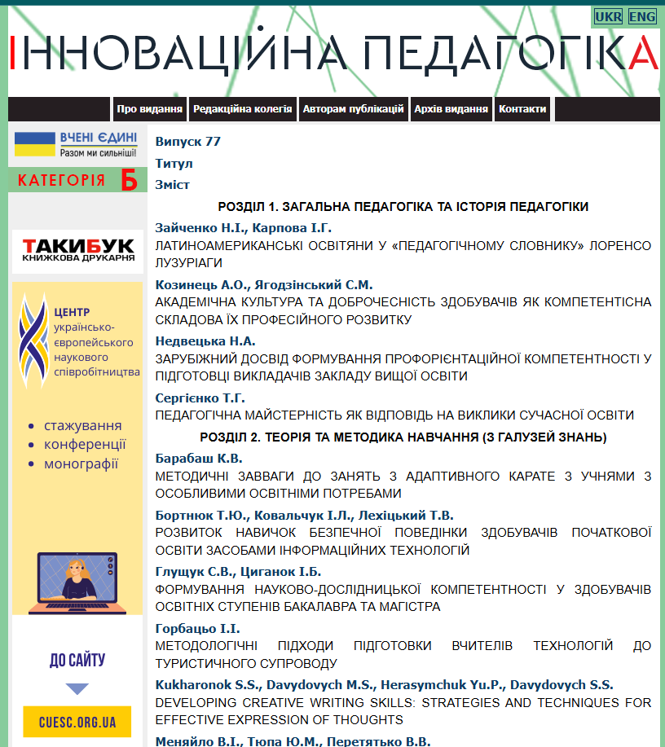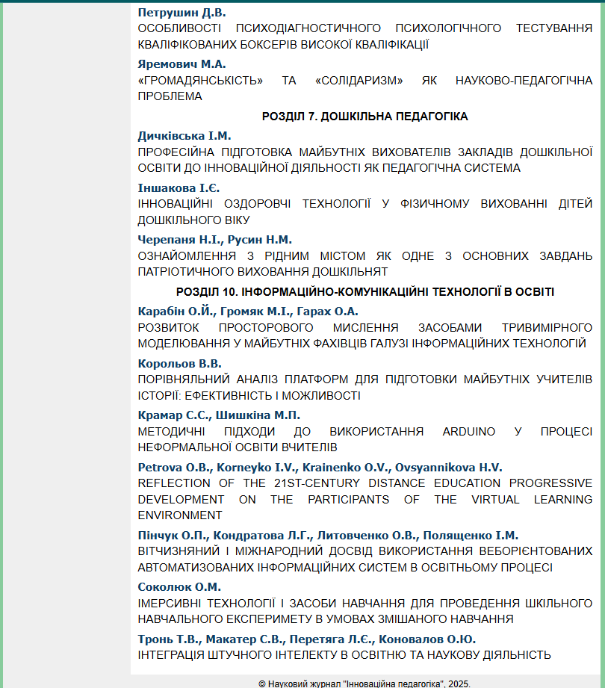

Journal Section: Information and communication technologies in education
UDC 378.81:004
REFLECTION OF THE 21ST-CENTURY DISTANCE EDUCATION PROGRESSIVE DEVELOPMENT ON THE PARTICIPANTS OF THE VIRTUAL LEARNING ENVIRONMENT
ВПЛИВ ПОСТУПАЛЬНОГО РОЗВИТКУ ДИСТАНЦІЙНОЇ ОСВІТИ ХХІ СТОЛІТТЯ НА УЧАСНИКІВ ВІРТУАЛЬНОГО НАВЧАЛЬНОГО СЕРЕДОВИЩА
Petrova O. B.,
Candidate of Philological Sciences,
Associate Professor,
Associate Professor
at the Foreign Languages
Department
Kharkiv National Medical University

Korneyko I. V.,
Candidate of Philological Sciences,
Associate Professor,
Head of the Foreign Languages
Department
Kharkiv National Medical University

Krainenko O. V.,
Senior Lecturer
at the Foreign Languages
Department
Kharkiv National Medical University

Ovsyannikova H. V.,
Senior Lecturer
at the Foreign Languages
Department
Kharkiv National Medical University

Стаття присвячена огляду концептуально нового рівня та форми дистанційної освіти, які пропонується впроваджувати у віртуальне освітнє середовище, оскільки цифровізація різноманітних сфер людської діяльності вимагає таких змін. Акцентовано, що для сучаснго педагогічного мислення властива глибока гуманізація педагогічного процесу, особливо у вищій школі. Основна тенденція в освіті представлена ​​зміною взаємин між учасниками віртуального навчально-виховного процесу. Розглянуто співвідношення між емоційним інтелектом студентів, соціальними зв'язками та взаємодіями під час онлайн-навчання на підставі огляду сучасних публікацій. Зазначається, що створення віртуальних спільнот відбувається за рахунок впровадження інноваційних педагогічних технологій та відповідає сучасним цифровим трансформаціям в освіті у вищих навчальних закладах. Наголошується, що віртуальне освітнє середовище (VLE) дозволяє створення персонального освітнього середовища (PLE), яке є не тільки технологічним навчанням, орієнтованим на здобувачів, а і певним відривом від інституційної традиційної концепції знань. Сучасний дистанційний обмін інформацією пов'язує студента та викладача з віртуальним освітнім середовищем, яке інтегроване з цифровими ресурсами, завданнями та дискусіями та підтримує саморозвиток студента, сприяючи природній активності навчання. Таким чином, створюються навчальні дослідницькі спільноти, що відповідають намірам викладачів дати студентам відчути себе залученими до процесу та сприймати себе частиною університетської спільноти. У статті зазначено, що особливістю сучасної дистанційної освіти є тип навчання, який надається у VLE через моделі інтерактивності: викладач/студент, студентська група/студент, студентська група/викладач, студент/студент, студент/навчальний заклад, викладач /навчальний заклад. Зазначається, що розгляд можливого середовища навчання з погляду викладача чи інструктора доповнюється точкою зору студента. Інноваційна педагогіка спрямована та орієнтована на вирішення завдань розробки змісту, методів та організаційних форм навчального курсу відповідно до конкретної мети студентів. Викладач має вміти демонструвати відповідний рівень цифрової та технологічної грамотності, щоб не сприяти розриву між поколіннями викладачів та студентів.
Ключові слова: інноваційні педагогічні технології, віртуальне освітнє середовище, цифрова та технологічна грамотність, персональне освітнє середовище, педагогічний процес

The article is devoted to the overview of a conceptually new level and form of distance education to be implemented in the virtual educational environment, as digitization of diverse areas of human activity calls for such changes. It is agreed that modern pedagogical thinking corresponds to the thorough humanization of the teaching-learning process, particularly in higher education. The principal trend in education is presented by the change in relationships between the participants of the virtual teaching-learning process. The correlation between students’ emotional intelligence, social connections, and interactions in online learning presented in the analyzed publications has been examined. It has been stated that creating virtual communities occurs due to the implementation of innovative pedagogical technologies and is relevant to modern digital transformations in education in higher educational institutions. It is noted that a virtual learning environment (VLE) suggests a personal learning environment (PLE), which is not only technology-enabled student-centered learning but is a challenging disruption to the institutional, traditional conception of knowledge. Modern remote information exchange connects the student and teacher with a virtual educational environment that is integrated with digital resources, assignments, and discussions and supports the student's self-development promoting the natural activity of students’ learning. Thus, the formation of communities of inquiry and intentions made by trainers to make trainees feel involved and experience belonging to the university are being created. The article states that a specific feature of modern distance education is a type of education provided in the VLE via interactivity models like teacher/student, student group/student, student group/teacher, student/student, student/educational institution, and teacher/educational institution. It is noted that consideration of the possible learning environment from the perspective of the teacher or instructor is complemented by the student's perspective. Innovative pedagogy is aimed and tailored to solve the tasks of developing content, methods, and organizational forms of the learning course according to the specific purpose of the trainees. A teacher is to be able to demonstrate no less a level of digital and technological literacy and not to contribute to the generation gap between teachers and students.
Key words: innovative pedagogical technologies, virtual learning environment, digital and technological literacy, the teaching-learning process, personal learning environment

Introduction. Problem statement. Technological processes are clearly reflected in education. Therefore, the field of distance education is actively developing according to the level reached, for example, from correspondence to online and web-based forms of education (M. Moore, M. Simonson, A. W. Bates, A. G. Picciano, M. Bílek, L. Caprara, S. Nicolaou, I. Petrou, and others). The rapid progress of digital technologies and the expansion of the global Internet at the beginning of the 21st century created the prerequisites for the digitization of diverse areas of human activity, and, undoubtedly, among them, education. Along with advanced technologies, modern pedagogical thinking prevails in the academic community, the basic idea of which is the thorough humanization of distance education and reassessment of all components of the human-creating process in teaching-learning (priority value of developing creative personality and individuality; satisfied educational needs and abilities; targeted positive attitude to the chosen profession that is being mastered, awareness and inquiry in it; active attitude to work; motivation in improving the efficiency of training). In addition, the principal trend in education combines methodological, professional, social, and psychological features and digital literacy. The novel level and form of distance education entail changes in the virtual educational environment participants' relationships in the teaching-learning process, particularly in higher education.
Analysis of recent research and publications. Researchers have shown that "distance education has begun to enter the mainstream" as a "more available, easier to use, and less costly", with "broad coverage of various technologies that can be used for the delivery of distance education from correspondence study to online, internet-based learning" [9, p. 4]. The publications in this area subjected such vital issues of distance education as technological systems in an innovative educational environment, interactive technological components, and requirements for interactive technologies (M. Skouradaki, Y. Molodovska, M. Weller, Z. Turan); basic pedagogical ideas for transition to distance education in higher educational institutions (S. Nicolaou, I. Petrou, N. Bitar, M. Simonson, et al.); virtual learning environment (VLE) (M. Chakraborty, F. M. Nafukho); design and adaptability of VLEs (M. Weller, R. Maaliw III); managing individual differences, like creativity in technology-enhanced learning (M. Rosar, C. Richardson, P. Mishra).
It should also be mentioned that the issues appearing in creating virtual communities due to the implementation of innovative pedagogical technologies and the functioning of VLEs in higher educational institutions are relevant to the modern digital transformations in education (T. Anderson, A. M. McCarthy, D. Maor, A. McConney, C. Cavanaugh, H. Kharkevych, et al.). The concerns regarding teaching presence and immediacy, including the correlation between students' emotional intelligence, social connections, and interactions in online learning, were examined in the publications by G. Siemens, G. Dragan, D. Shane, R. McKerlich, T. Anderson, H. Lu, H. Han, S. D. Johnson, M. Chakraborty, F. M. Nafukho. Various aspects of a virtual learning environment were described in some works published in recent decades, particularly in relation to "effective teaching in universities, as it sets out a model for effective use and seeks to provide a bridge between pedagogical approaches and the tools educators have at their disposal … to create engaging learning experiences" (M. Weller) [11, p. 1]. Meanwhile, the scholars argue that a simple and popular label of VLE does not guarantee pedagogical effects: as emphasized by the authors (P. Dillenbourg, D. K. Schneider, P. Synteta), "turning potential effects into actual outcomes is the challenge of designers" [3, p. 3].
Some researchers (G. Attwell, O. Liber, L. Castañeda, N. Dabbagh, R. Torres-Kompen), analyzing the continuing involvement of technology in education, suggest a Personal Learning Environment (PLE) that is "comprised of all the different tools we use in our everyday life for learning" [1, p. 4], "is not just one of the most innovative dimensions of technology-enabled student-centered learning, but also one of the most challenging disruptions to the institutional traditional conception of knowledge" [2, p. 1], and preferably is established on social software connected by a computer network. The term of a PLE supposes combination of different digital services; "a number of institutions are looking at the potential of PLE type applications for Continuing Professional Development" [1, p. 6].
A virtual learning environment is mostly elucidated by authors describing web-based learning platforms, learning management systems (LMS), or some related components (learning/course/content management systems) and facilitating the teaching-learning process. The researchers identify VLE as a system that integrates digital resources and assignments, discussions, and assessments in a single environment that students and instructors can access from any location with an internet connection (C. McAvinia, P. Dillenbourg, et al.).
Psychological problems of VLE participants are defined as an aspect actualized for the analyzed topic (S. Datta, M. L. Smulson, A. Bhutoria, S. R. Cellini, X. Wang, et al.). The scholars state that "virtual educational space should be interpreted as an integral psychological and pedagogical meta-technology that systemically organizes the activity of all subjects of the educational process" [10, p. 3]. Virtual Learning Environments (VLEs) are defined as web-based learning systems where students can virtually interact with their groupmates and teachers, access learning materials with no time limits, and make use of the most advanced information and Communication Technologies (ICTs) (S. Datta, M. Weller, P. Dillenbourg, D. Schneider, P. Synteta, M. L. Smulson, D. S. Meshcheriakov, M. M. Nazar, P. P. Ditiuk). One of the lessons from the history of the development of distance education is that recognizing that every student is different, teachers must use "instructional design and communication technologies to address this diversity while continuing to explore the social dynamics of learning, additional research is needed on the personal dynamics of learning, that is, what happens within each learner" [7, p. 39].
Emphasizing previously unresolved parts of the common problem. 21st-century distance education has been transformed into a special educational technology based on open learning using modern remote information exchange (telecommunications) to connect the student and teacher with a virtual educational environment. According to the student-centered concept, the main point in distance learning is the student. Distance education demands changes in the virtual educational environment participants' relationships in the teaching-learning process, especially in higher education. "A virtual learning environment is a designed information space" and "is a social space: educational interactions occur in the environment, turning spaces into places" [3, p. 3]. Thus, the aim of the VLE is to support the student's self-development and attain the natural activity of students (learning) under the distance conditions of studies: they "are not only active but also actors: they co-construct the virtual space" [3, p. 3].
Searching for ways to improve learning, some researchers (A. W. Bates, T. Anderson, P. Dillenbourg, et al.) see an option as exploring the possibility of creating a model of the learning environment from the student's perspective. However, the issue of optimizing distance learning has not been resolved and is the subject of scientific debate. Some issues arise that need clarification regarding the virtual educational environment, such as attitude toward the new form of distance education, the idea of belonging to the university community, the formation of communities of inquiry, and intentions made by trainers to make trainees feel involved, etc. These have not been sufficiently elaborated, especially in higher education settings (L. Thomas).
The generation gap between students and teachers (A. Singh, M. Nasir, D. Purmayanti, Hilmi M.) needs further exploration, specifically in distance education. The researchers emphasize that the teacher's competence and use of digital technologies can support learning with suitable activities and, in the opposite case, affect the adequate learning process. Thus, the main issues are "lack of supportive access and digital tools, lack of digital literacy skill from teachers and also students’ lack of digital literacy skills" [8, p.101]. The methodologists showed that due to the shift to online teaching, "teachers' professional identity underwent some phases of instability as tensions arose between how they viewed themselves, their beliefs, and their practices in the online environment" [4, p. 1]. These changes relate to the teaching practice, organizing, and social roles in the academic process and need more advances.
The purpose of the work is to overview the aspects of the novel level of distance education that appeared for the participants of the virtual learning environments formed by modern distance education implementation in universities.
The statement of the main material. Currently, the educational space is in the process of digital transformation, when the issue of ensuring a high-quality digital level of the process of adapting education to modern needs or skills is on the agenda, which is carried out by updating education and its environment and implementing new educational resources into educational practice. Therefore, along with the priority of creating a modern, innovative information platform for the learning environment is the harmonious organization of the university VLE participants' interaction.
We can state a unique feature of modern distance education as a type of education provided in the VLE during interactivity teacher/student, student group/student, student group/teacher, student/student, student/educational institution, teacher/educational institution. This form of education is called a distance one to reflect the main difference between it and the historically previous type of traditional face-to-face education: remoteness, the distance between teacher and student, as well as students and their groupmates, and all of them and an educational institution. The style of communication and interaction between these participants of VLE reflect the open type of education, which allows flexible access to the participants' time and place of stay, making it possible to implement a distance education system in modern higher educational institutions.
Educators who are charged with the design and support of filling the platform with methodically developed structured educational materials, realize that the general set of didactic tools needs to be revised because of the transfer of the educational process to the online mode. We hold the opinion that didactically developed material is developed and adapted specifically for a certain group of students involved in distance learning, for their developmental needs (A. W. Bates, T. Anderson).
Designing a VLE in a corporate university network may be associated with some problems in realizing its didactic potential and determining ways of practical implementation in the educational process (distance or blended), in particular, to support the student's personality development.
While adopting the virtual educational environment according to the specific features of the university academic services, the strategy of distance education and the psychological component necessary for ensuring the student's personality development during the learning activity in program disciplines should be considered.
We can share our observations regarding the maintenance of collaboration, interactivity, and mutual participation of all participants in the virtual educational environment. The corporate network organizes students, teaching them to purposefully use it in the university space they belong to. The involvement in the university community is facilitated by the targeted use of exclusively corporate communication tools for educational interactions, which include corporate e-mail, a calendar, a distance learning platform (LMS) used in the university network and filled with appropriate training courses in each discipline specifically for each contingent of learners and learning goals, a scheduling system and invitations to online meetings, video conferences using certain tools adopted at the university, etc.).
We can argue that the rules announced at the beginning of the course regarding the use of the corporate network and the university's distance learning platform, etc., facilitate the delivery of synchronous and asynchronous online classes, determining the boundaries and scope of activity of each of the subjects of the virtual learning environment.
The virtual learning environment is characterized as an integrated, immersive meta-technology, which is developed as a platform for learning and development and purposeful achievement of academic goals [10, p. 5]; it functions actively due to the interaction of all involved participants. Such educational interactions stimulate the development of personal qualities and contribute to the growth of intelligence. The formation of creative thinking for the development of knowledge and the improvement of the ethical and aesthetic education of students, the use of problem-based and creative learning leads to the student's independence and activation of students' creative search through their independent work.
We advocate a policy of active participation of all VLE community members in the educational process. To provide additional opportunities and promote the active participation of students in online synchronous learning while trying to achieve a positive psychological climate in academic communities, we consider it an obligatory requirement for everyone to participate in the online synchronous sessions with the microphone and camera turned on. The practice of dividing (or vice versa, voluntarily combining) learners into small groups for educational purposes to perform individual tasks is also productive, which to some extent contributes to socialization in a virtual learning environment and better involvement of the entire group in communication. This is very important and can be considered as one of the means of psychological and social joining the participants in the VLE, and is also perfectly suited for creating conditions for cooperation in the implementation of the student's project or other independent, individual, and additional work offered within distance courses.
VLE influences student learning, including their engagement in the subject and motivation to acquire the offered material and use it according to the proposed aims, which are partly connected with the sense of belonging to the community. Developing a virtual learning environment for students in a particular course or program is probably the most creative part of teaching, the VLE is wider and includes the learners' features, the goals for teaching and learning, the choice of the best activities, the assessment policy and strategies, etc.
Distance education is based on the achievements of pedagogical science and theoretical and practical knowledge in the field, and the information and communication component has become an essential, integral part of teaching and learning (H. Han, S. D. Johnson) and the essentials of forming the student's personality. In this sense, the new level of distance education is no exception. We can state that the role of an educational setting that provides distance education and is based on a virtual educational environment, such as a higher educational institution, is vital for improving general personality qualities.
Pedagogical practice proves that a student may experience various psychological problems during his studies. In distance learning, the teacher's role is to identify such a problematic state and take it into account when communicating with the student and the group to find methods and strategies to solve such problems, achieve understanding, and facilitate the creation of a comfortable environment, as intended to be a component of the teacher's role in face-to-face classes. On the other hand, distance learning students should accept the rules and code of conduct for online courses, be well-informed about duties and responsibilities, and be aware of their VLE participant status, thus "promoting enhancement of overall personality traits and standards of living, i. e. forming positive viewpoints regarding various factors and individuals" [6, p. 386].
To achieve effective communication in the VLE, ​​the teacher can give a kind of introduction to the distance course and mention in the syllabus in the section "Policy of the educational component" the information about the passed/failed online classes (students must attend all practical online classes, completing all synchronous and asynchronous tasks, if they missed the class, it must be worked off, completed according to the schedule in the electronic register and corporate LMS). If students have questions, they can contact the teacher by e-mail or in the department's chat, using the links the teacher provides in the first practical session. Students should be informed in advance, at the beginning of the course, that online practical classes require their active participation, questions, expression of their own opinions, discussion with respect for colleagues, and tolerance for classmates and the teacher.
As we have already noted, in order to be a worthy participant in the educational process of distance education, the role of a teacher must include many general didactic requirements that traditionally make up the structure of the professional activity of a teacher-educator or group supervisor. A distance education instructor who organizes a distance course, developing the structure and specific content of activities, tasks, and materials for an electronic distance course, must take into account the importance of determining the specific characteristics of a group of students for adaptation to the academic discipline included in the distance learning form. Analyzing individual students and the student group as a whole when conducting online classes and organizing the communication process is also the activity of a distance teacher. Based on the specifics of the educational component of the professional program being taught, teachers must demonstrate certain special competencies that are determined by their narrow specialty.
Thus, for our experience of teaching distance subjects related to a foreign language for specific purposes (Medicine, Dentistry, Technology of Medical Laboratory Diagnosis, Pediatrics, Physiotherapy, Medical Psychology, Social Work, and others), the part of the teacher's activity during online classes is to diagnose the level of foreign language proficiency, the degree of general development, the presence of communicative skills in general, communication skills, as well as communication skills in a virtual learning environment. Given the main role of the teacher in transferring methods of obtaining knowledge and forming skills for searching for it, the teacher must teach students to observe, compare, analyze, and express their opinions (for example, if a university discipline is related to the acquisition of foreign language competencies in a future profession, then all this is ensured by the formation of foreign language professional competencies, i.e. communicative competencies in a foreign language for specific purposes).
Important for the activities of a university teacher in conditions of distance or blended learning are the competencies to manage activities in VLE and interact with a group, with individual students, to manage the work of a group, and to encourage students' curiosity while processing educational material. For developed professional and pedagogical communication, a teacher must not only be able to use information resources of computer technologies, taking into account the forms of interaction between the teacher and students but also to see aspects of the application and formation of communicative skills and abilities, critical thinking, ability to work in a team, self-organization. The psychological component of structuring educational material in accordance with the interactive methods used may be, for example, the use of group discussion, case method, gamification of some topics studied, usage of simulation game, etc. So, for example, such a game may be undertaken while preparing for the Young Scientists Conference. It may, particularly, include acting out all stages of participation in a scientific and practical conference from the idea to finding a suitable conference on the chosen topic, correspondence with the organizing committee, preparation of a report, writing the draft, editing (it is appropriate to involve the Chat GPT assistance that may be called for the search of sources and editing, compiling abstract, etc.). These interactive, cooperative methods provide an opportunity to show openness, empathy, and the chance to express oneself in front of everyone, which generally helps to prevent the emergence of conflict situations.
Interactivity in the VLE promotes helpfulness and collaboration, improves analytical, critical thinking, and problem-solving skills, as well as effective psychological problem-solving, demonstrating honesty, truthfulness, and academic integrity. A creative approach is encouraged, both in career search and research (for example, participation in extracurricular projects, activities, scientific communities, conferences of young scientists, etc.) in the distance online or blended modes. Students need to know and follow the rules of appropriate behavior at the university. The VLE Assessment Policy and Rules are accessible and familiar to all.
"Electronic pedagogy" ("e-pedagogy", "electronic learning", "computer system of learning", "distance learning") is a virtual pedagogy. It comprises a set of specified methods, approaches, and procedures for teaching subject matter in an internet-based (or hybrid) environment, where students are situated remotely from the educator and/or other students. This is a relatively new field of pedagogy related to distance educational technologies and fundamentally new possibilities for using educational resources and managing them, aimed at solving the tasks of developing content, methods, and organizational forms of learning in various information environments.
So, currently, the task for educators is to add modern technologies to the LMS because life has been changing, and now it is not about computer literacy but about implementing an effective virtual learning environment, which is only possible with modern technologies.
An aspect is transforming the medium of academic resources from hardcover books to electronic books or didactically prepared electronic resources. Equipping the university system with digital technologies while designing VLE "should conceptually correspond to the designed system of relevant psychological and pedagogical technologies" [10, p. 3]. It is about the self-development of educators, which is connected with the high-quality performance of methodical tasks in an educational institution. The activities of the teaching staff include the development of distance courses, the ongoing implementation of a virtual learning environment, and research on this process in higher education institutions. It can be seen that the methods, approaches, and techniques partly overlap with those used in a face-to-face learning environment; but undoubtedly, online pedagogy presents the unique prospects and restrictions of VLE. As the researchers note (C. McAvinia), distance education reviews the impact of learning technologies in higher education.
A problem of the teachers' insufficient level of technological and digital awareness and literacy, causing a 'generational gap', is connected with different trainers' and trainees' value systems, worldviews, lifestyles, teaching, and learning methods (A. Singh).
It is a crucial statement that educators must be aware of the necessary level to ensure the distance learning process and feel full participants in the university's virtual learning environment, as such an incompetent situation may be further intensified by the fundamental characteristics of distance learning and, indeed, all its activities held in a virtual educational environment are inherently high-tech and collaborative. Some factors, such as the senior age of the trainers, cognitive factors, not satisfactory level of digital literacy may also aggravate the condition, and thus the quality of academic services requires definite effort from the teaching staff (B. W. Pratolo, D. Purmayanti, N. O. Argawati, L. M. Castaneda, M. R. Lea, E. I. Feola).
The challenges that involve either teachers' and policymakers' faults may be added with students' incompetence or "the lack of internet access and digital devices and the limited digital literacy skill of both students and teachers" [8, p. 107]. As was noted by the researchers involved in distance education, the its influence on the so-called "Generation Z" students evidences "that technology has also greatly enhanced the two-way learning process, such as through class blogs, social media, online reading, and recording presentations in short video format" [5], and the conclusion which we may do from this issue is that the good learning opportunities must be provided well enough and supported with the adequate competence level of the teaching-learning process participants.
Such issue may be adequately solved by the continuing professional development of educators in various aspects and related areas that are required to increase the level of knowledge and skills, as well as acquire the competencies necessary for use in everyday practice and LMS management, developing and completing a framework created for distance courses within the VLE.
It is an exciting view that some methodologists consider that Personal Learning Environments (PLEs) may apply new technologies for learning in a perspective approach, especially lifelong learning (C. McAvinia, G. Attwell, L. Castañeda, N. Dabbagh, R. Torres-Kompen, A. Bhutoria).
Compared to historically conventional education, we have witnessed fundamental changes in the learning process, the emergence of distance technological education, and certain redefinitions of the role of the teacher and the learner. The teacher is entrusted with such functions as designing the course of study, adapting the course of study in accordance with the specific goals of students, coordinating the cognitive process, consulting participants in the learning process, analyzing feedback, etc. The student's activity changes from simply acquiring and accumulating knowledge to searching for it, on teachers' advice and through interaction in the virtual learning environment.
Conclusions and prospects for further research. Universities realize that changes are not only about implementing modern innovative tools to supplement conventional teaching methods in a new reality for students and teachers who create them. Each involved VLE participant feels the need to change themselves through the successful use of technology in education. There is a process of redistribution of the educational environment; it is important to pay attention to the formation of the competencies necessary in the digital world on the part of the student to actively participate in learning in a virtual educational environment, and the teacher to be able to demonstrate no less a level of digital and technological literacy and not to contribute to the generation gap between teachers and students. All VLE participants should consider the importance of feeling a sense of belonging to the university community in a virtual educational environment, develop mutual understanding with community members, and manage psychological issues. We should take into account the developmental nature of the innovative virtual educational environment in a higher educational institution, its influence and support of the personal development opportunities of students and teachers who can competently apply the scientific and technical results of progress in professional activity and education (web and cloud technologies and services, digital educational platforms, artificial intelligence, electronic learning resources, and other modern devices and achievements). A virtual learning environment is a good choice for creating a more productive, engaging learning experience for participants pursuing higher education.
REFERENCES:
1. Attwell G. Personal Learning Environments - the future of eLearning? eLearning Papers. 2007. Vol. 2. № 1. P. 1-7.
2. Bates A. W. Technology, E-Learning and Distance Education. 2nd edition. London: Routledge, 2005. 260 p.
3. Dillenbourg P., Schneider D. K., Synteta P. Virtual Learning Environments. /Proceedings of the 3rd Hellenic Conference "Information and Communication Technologies in Education". Rhodes: Kastaniotis Editions, 2002. P. 3-18. URL:https://telearn.hal.science/hal-00190701/document
4. El-Soussi A. The shift from face-to-face to online teaching due to COVID-19: Its impact on higher education faculty's professional identity. International Journal of Educational Research. 2022. Vol. 3, P. 1-8. URL:https://www.sciencedirect.com/science/article/pii/S2666374022000188
5. Hilmi, Martin. Re: Generation between students and teachers. 2023. Retrieved from: https://www.researchgate.net/post/ Generation_gap_between_students_and_teachers/64969dcb9c5ec53e7c01ab18/citation/download.
6. Kapur R. Personality Development: Essential in Leading to Progression of Individuals. Delhi, 2024. 467 p. URL:https://www.researchgate.net /publication/377336954_Personality_Development_Essential_in_Leading_to_Progression_of_Individuals
7. Moore M. G. From Correspondence Education to Online Distance Education. / O. Zawacki-Richter, I. Jung. Handbook of Open, Distance and Digital Education. Springer, 2023. P. 27-42. URL:https://doi.org/10.1007/978-981-19-2080-6_2
8. Purmayanti D. The Challenges of Implementing Digital Literacy in Teaching and Learning Activities for EFL Learners in Indonesia. 2022. BATARA DIDI: English Language Journal. № 1. P. 101-110. URL:10.56209/badi.v1i2.38
9. Simonson M., Smaldino S., Albright M., Zvacek S. Teaching and learning at a distance. Foundations of distance education. Fourth ed. Pearson. 374 p. URL:www.pearsonhighered.com
10. Smulson M. L., Meshcheriakov D. S., Nazar M. M., Ditiuk P. P. Concept of designing a virtual educational space with the potential for the adult's subjectness development. Technologies of intellect development. 2023. Vol. 7, No 1 (33). P. 1-29. URL: https://psytir.org.ua/index.php/technology_intellect_develop/article/view/619
11. Weller M. Virtual Learning Environments: Using, Choosing and Developing Your VLE. London: Routledge, 2007. 190 p.

