Biomechanical justification for external fixation of the pelvis using rods with different thread hands

Istomin A.G.¹, Kovaliov S.I.², Zhuravliov V.B.¹, Istomin D.A.¹, Karpinskiy М.Yu.³

1 Kharkiv National Medical University
2 Municipal Noncommercial Enterprise “City Clinical Hospital No. 17 of Kharkiv City Council”
3 State Institution "Sytenko Institute of Spine and Joint Pathology of the National Academy of Medical Sciences of Ukraine

Information about the authors
Istomin Andriі Heorhiyovych - Dr. Med. Sciences, Professor, Acting Head of the Department of Sports, Physical and Rehabilitation Medicine, Physical Therapy and Occupational Therapy, Kharkiv National Medical University, 61022, Kharkiv, 4 Nauki Ave., tel. 050-984-56-96, E-mail: ah.istomin @ knmu.edu.ua, ORCID: 0000-0002-1510-6516

Sergiy Ivanovych Kovalyov - Candidate of Medical Sciences Sciences, traumatologist-orthopedist KNP "City Clinical Hospital № 17 Kharkiv City Council", Kharkiv, Moscow Ave., 195, tel. 0503003575 Email: kovalev0503003575@gmail.com
ORCID 0000-0001-7956-9053

Zhuravlyov Valentyn Borysovych, Senior Laboratory Assistant, Department of Sports, Physical and Rehabilitation Medicine, Physical Therapy and Occupational Therapy, Kharkiv National Medical University 61022, Kharkiv, 4 Nauki Ave., tel. 067-706-75-12, E-mail: albusreal5@com.ua
ORCID 0000-0001-5456-3253
Istomin Dmytro Andriiovych Assistant of the Department of Traumatology and Orthopedics, Kharkiv National Medical University 61022, Kharkiv, 4 Nauki Ave., tel. 050-910-03-86 Email: dai_7@outlook.com
ORCID 0000-0002-8754-1103

Karpinsky Mykhailo Yuriiovych - researcher of the laboratory of biomechanics of the State Institution "Institute of Spine and Joint Pathology named after Prof. MI Sytenko of the National Academy of Medical Sciences of Ukraine", Kharkiv, 80 Pushkinskaya Street, tel. 057-704-14-71, E-mail:
korab.karpinsky9@gmail.com
ORCID: 0000-0002-3004-2610

Corresponding Author: Andrii Istomin, MD, Professor, Head of Department of sports, physical and rehabilitational medicine, physical therapy, ergotherapy
Kharkiv National Medical University, Nauky Avenue 4, Kharkiv, 61002, Ukraine
tel. 050-984-56-96, E-mail: ah.istomin@ knmu.edu.ua

ABSTRACT
Biomechanical justification for external fixation of the pelvis using rods with different thread hands
Istomin A.G.¹, Kovaliov S.I.², Zhuravliov V.B.¹, Istomin D.A.¹, Karpinskiy М.Yu.³

1 Kharkiv National Medical University, Ukraine
2 Municipal Noncommercial Enterprise “City Clinical Hospital No. 17 of Kharkiv City Council”, Ukraine
3 State Institution "Sytenko Institute of Spine and Joint Pathology of the National Academy of Medical Sciences of Ukraine

Background. External fixation devices (EFD) have found wide application in pelvic fractures treating, but it is not always that strength characteristics of these devices make it possible to realize early rehabilitation. Objective: the biomechanical justification for external pelvic osteosynthesis with use of rods having different thread hands on the basis of analysis of the stress-strain state (SSS) of the “EFD – pelvis” system and an experimental study of the strength of threaded connections of different rods and the pelvic bone under the effect of alternate cyclic loads. Materials and Methods. Was analyzed the SSS of the “EFD – pelvis” system verified in an experimental study of the strength of threaded connections of different rods and the pelvic bone under the effect of alternate cyclic loads. Results: standing on a single basis in the AVF rods with the same thread, there are torques directed in different directions: on the right - clockwise (screwing in), on the left - counterclockwise (screwing out).A change in the thread direction does not lead to change in the moment values, but directions of the action of the moments of force for the left rod will correspond to the direction of its screwing both in the left- and right-sided one-support position. Conclusions: Bar-connected rods with a differently directed thread create a reciprocally interlocking structure, which counteracts self-unscrewing. Such a structure significantly increases the strength of connection of an EFD with the pelvic bone and creates conditions for an effective use of the early rehabilitation of patients with pelvic fractures.
Key words: pelvis, stress-strain state, external fixation, experimental study.

РЕЗЮМЕ
Біомеханічне обгрунтування зовнішньої фіксації таза із застосуванням стрижнів з різним напрямком різьби.

Істомін А.Г.¹, Ковальов С.І.², Журавльов В.Б.¹, Істомін Д.А.¹,
Карпинський М.Ю.³
1 Харківський національний медичний університет
2 КНП «Міська клінічна лікарня № 17 Харківського міської ради»
3ДУ "Інститут патології хребта та суглобів ім. проф. М.І.Ситенка НАМН України

Актуальність. Апарати зовнішньої фіксації (АЗФ) знайшли широке застосування при лікуванні переломів таза, але не завжди міцність з’єднання стрижнів і кістки дозволяє здійснити ранню реабілітацію пацієнтів. Мета: Біомеханічне обгрунтування зовнішнього остеосинтезу таза АЗФ зі стрижнями з разноспрямованою різьбою на грунті аналізу напружено-деформованого стану (НДС) системи «АЗФ - таз» і експериментального дослідження міцності різьбових з'єднань різних видів стрижнів і тазової кістки під дією знакозмінних циклічних навантажень. Матеріали та методи. Проведено аналіз НДС системи «АЗФ - таз» на скінченноелементній математичній моделі, результати математичного моделювання веріфіковані експериментальними дослідженнями міцності різьбових з'єднань різних видів стрижнів і тазової кістки при впливі знакозмінних циклічних навантажень. Використовувалися АВФ зі стрижнями з циліндричною односпрямованою різьбою і стрижні, один з яких мав правобічну різьбу, а інший - лівобічну. Результати: При одноопорному стоянні в стрижнях АЗФ з однаковою різьбою виникають крутні моменти, спрямовані в різні боки: праворуч-спрямований за годинниковою стрілкою (вкручування), ліворуч - проти годинникової стрілки (викручування). Зміна напрямку різьби на стрижні АЗФ не призводить до перерозподілу НДС системи «АВФ - таз» і зміни значень моментів, але напрямки дії моментів сил для лівого стрижня будуть відповідати вкручуванню як при лівобічному, так і правобічному одноопорному стоянні. Висновки: З’єднані в АЗФ балкою стрижні з різноспрямованою різьбою створюють взаємноблокуючу структуру, яка перешкоджає самовикручіванню стрижнів. Така конструкція значно збільшує міцність з'єднання АЗФ з тазовою кісткою і створює умови для ефективного застосування ранньої реабілітації хворих з переломами кісток тазу.
Ключові слова:Таз, напружено-деформований стан, зовнішня фіксація, експериментальне дослідження.

РЕЗЮМЕ
Биомеханическое обоснование внешней фиксации таза с применением стержней с различным направлением резьбы.

Истомин А.Г.¹, Ковалев С.И.², Журавлев В.Б.¹, Истомин Д.А.¹,
Карпинский М.Ю.³
1 Харьковский национальный медицинский университет
2 КНП «Городская клиническая больница № 17 Харьковского городского совета»
3 ГУ "Институт патологии позвоночника и суставов им. проф.М.И. Ситенко НАМН Украины
.
Актуальность Аппараты внешней фиксации (АВФ) нашли широкое применение при лечении переломов костей таза, но далеко не всегда прочностные характеристики этих устройств позволяют осуществить раннюю реабилитацию пациентов. Цель: биомеханическое обоснование наружного остеосинтеза таза АВФ со стержнями с разнонаправленнойй резьбой на основе анализа напряженно-деформированного состояния (НДС) системы «АВФ - таз» и экспериментального исследования прочности резьбовых соединений различных видов стержней и тазовой кости под действием знакопеременных циклических нагрузок. Материалы и методы. Проведен анализ НДС системы «АВФ - таз» на конечноэлементной математической модели. Результаты математического моделирования подтверждены экспериментальным исследованием прочности резьбовых соединений различных видов стержней и тазовой кости при воздействии знакопеременных циклических нагрузок. Использовались АВФ со стержнями с цилиндрической однонаправленной резьбой и стержнями, один из которых имел правую резьбу, а другой - левую. Результаты: При одноопорном стоянии в стержнях АВФ с одинаковой резьбой возникают крутящие моменты, направленные в разные стороны: справа- направленный по часовой стрелке (вкручивание), слева - против часовой стрелки ( выкручивание). изменение направления резьбы на стержне АВФ не приводит к перераспределению НДС системы «АВФ - таз» и изменению значений моментов, но направления действия моментов сил для левого стержня будут соответствовать вкручиванию как при левостороннем, так и правостороннем одноопорном стоянии. Выводы: Соединенные в АВФ балкой стержни с разнонаправленной резьбой создают взаимноблокирующую структуру, которая препятствует самовыкручиванию стержней. Такая конструкция значительно увеличивает прочность соединения АВФ с тазовой костью и создает условия для эффективного примененния ранней реабилитации больных с переломами костей таза.
Ключевые слова: Таз, напряженно-деформированное состояние, внешняя фиксация, экспериментальное исследование.

Introduction. Results of medical rehabilitation of patients with consequences of unstable pelvic fractures (UPF) depend upon many factors, among which the strength of fixation of fragments that makes possible early recovery of the staticodynamic function of the lower girdle is particularly important,
External fixation rod devices have found wide application in treating fresh UPF and their consequences, but it is not always that strength characteristics of these devices make it possible to realize modern tendencies in medical rehabilitation, which call for early verticalization of patients and use of constant passive movement and application of electromechanical splints. This is explained by the fact that in patients with UPF, who have underwent external osteosynthesis with a rod device, both axial load and repeated cycles of hip flexion and extension reduce the strength of rod fixation in the iliac bone.
In order to improve strength characteristics of the “external fixation device – pelvis” system, experimental studies and mathematical modeling with use of the finite element method (FEM) have been conducted [1-4]. Recently, assessment of the stress-strain state (SSS) of biomechanical systems with FEM has become widely used [5-8]; herewith good prospects of this method in modelling both internal and external pelvic fixation are indicated [9, 10, 11].
The purpose of the present study consists in biomechanical justification for external pelvic osteosynthesis with use of rods having different thread hands on the basis of analysis of the stress-strain state of the “external fixation device – pelvis” system and an experimental study of the strength of threaded connections of different rods and the pelvic bone under the effect of alternate cyclic loads.
Materials and methods. At the first stage of this study we analysed the stress-strain state of the “external fixation device – pelvis” system on a finite element mathematical model, which was built on the basis of tomographic sections of the pelvic bones, drawn through 0.5-1 cm for irregular zones. Two variants of the calculation model were built (Fig. 1). The first one was intact. The second one was the model had a rotationally unstable pelvic fracture of B1 type (AO) (rupture of the pubic symphysis and left ventral sacroiliac ligament), fixed with a rod device. The model consisted of 59,713 finite elements (10-noded isoparametric tetrahedrons) and had 111,420 nodes. All contact pairs of model elements, apart from external fixation device (EFD) rods and pelvic bone, were performed by the “bonded” type. The contact pair between the threaded portion of fixing screws and the iliac bone was performed by the “frictional” type with the metal-bone friction coefficient equal to 0.3. The geometric model was built using the SolidWorks program. The calculations were carried out in the ANSYS program.
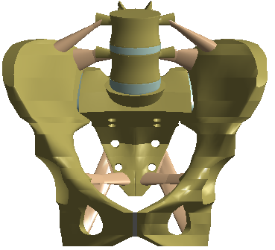 | 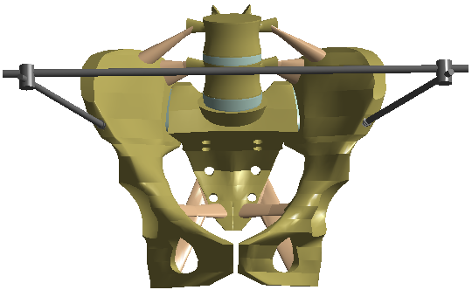
а | b
Fig. 1. Calculation models: а) intact model; b) model with a fracture of B1 type fixed with EFD.

Previous studies took into consideration different kinds of biological tissues: cortical and cancellous bones, cartilaginous tissue, ligaments. In our study the material was regarded to be homogeneous and isotropic. We used the data, which are most commonly found in literature [12-14]. The mechanical characteristics of biological tissues are summarized in Table 1.
Table 1. Mechanical characteristics of biological tissues.
Tissue | E (МPа) | ν | Source
Cortical bone | 12240 | 0.3 | [12]
Cancellous bone | 380 | 0.3 | [12]
Cartilage | 5.58 | 0.45 | [13]
Ligaments | 330 | 0.4 | [14]

The values of resultant muscle forces and angles of their power for the pelvis were taken in compliance with the data from the study L. Modenese, A. T. M. Phillips, A. M. J. Bull (2011) [15]. The pattern of loading and fixation of the model is shown in Fig. 2. The body mass, equal to 700 N, was the major load. In one-support standing the applied force value was 540 N (without including the weight of the weight-bearing extremity).
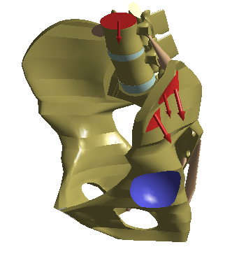
Fig. 1. The pattern of loading and fixation of the model: in red colour – applied load and muscle forces, in blue colour – the area of fixation.
Results and discussion.
Analysis of the performed calculation of SSS (Fig. 3) has shown that the region of the sacroiliac joint on the weight-bearing side is the most stressed element of the model. The stressed state level in this region reaches to 11.5 MPa. In the study by Ding S. et al (2020) [4] its authors received on an intact model in one-support standing the maximum values in the same region equal to 28 MPa. It should be emphasized that higher values of the stressed state in the above study resulted from modelling with a higher load, 600 N, as well as from using higher values for the elastic modulus of materials. In the anterior pelvic ring, the most stressed regions are as follows: the superior pubic ramus from the weight-bearing side – 4.7 MPa, and the anterior acetabular rim from the non-weight-bearing side – 3.7 MPa.
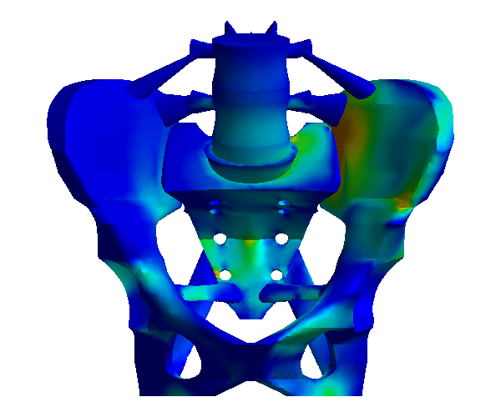 | 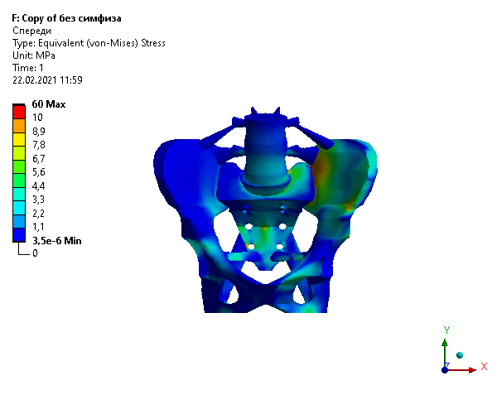
Fig. 3. Von Mises stresses in the intact model.

Fig. 4 shows a displacement of the model. With a support from the left leg, displacements of the iliac bone and sacroiliac joint from the non-weight-bearing side do not exceed 0.4 mm.

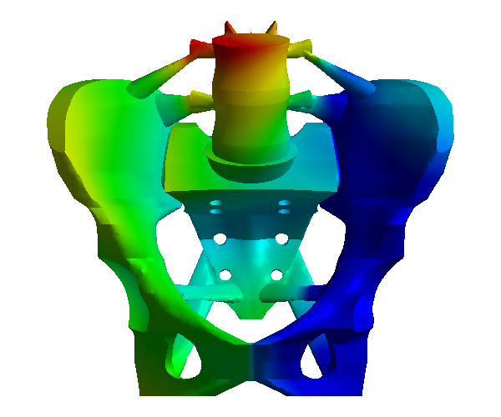 | 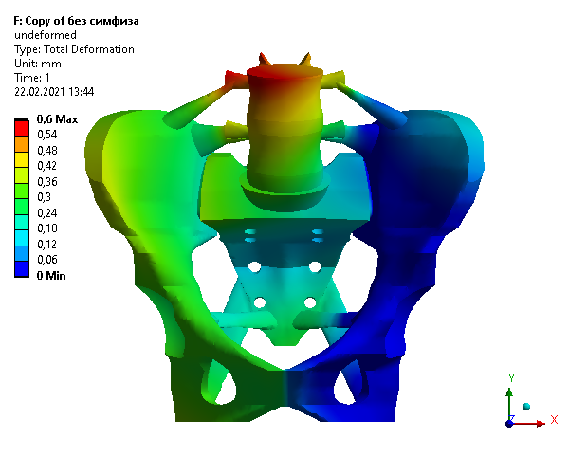
Fig. 4. Displacements of the intact model.

Analysis of SSS of the intact pelvis revealed the following facts:
- The sacroiliac joint from the weight-bearing side, the pubic rami from the weight-bearing side and the anterior acetabular rim from the non-weight-bearing side are the most stressed regions of the model with the stressed state level not exceeding 11.5 MPa.
- The right (non-weight-bearing) pelvic side slightly moves down (not more than by 0.4 mm.
- The stressed state level in the bone structure is not critical from the viewpoint of strength.

The next stage of our study consisted in examination of SSS of the pelvic model with a rotationally unstable pelvic fracture of B1 type and fixation with a rod device in one-support standing. Analysis of the performed calculation (Fig. 5) has shown that EFD rods are the most stressed elements of the model. The stressed state level in them does not exceed 60 MPa. For bone structures, the most stressed regions are as follows: the sacroiliac joint from the weight-bearing side – 14.1 MPa (11.5 MPa for the intact model) and the entrance of rods into the bone, where the maximum value of von Mises stresses is 11.9 MPa for the weight-bearing side (5 MPa for the intact model) and 8.9 MPa for the non-weight-bearing one (0.2 MPa for the intact model).
 | 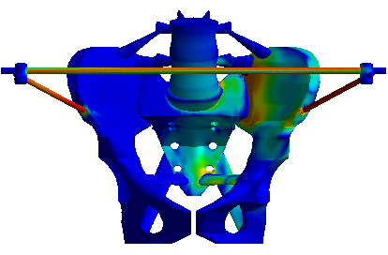
а | б
Fig. 5. Von Mises stresses: a) in the intact model; b) in the model with a fracture of B1 type fixed with EFD.
Fig. 6 demonstrates the distribution of SSS along the passage of EFD rods in the bone in more detail. Our analysis has revealed that on the weight-bearing side the stressed state level in the rod is higher and its distribution is more homogeneous along the whole length of the threaded portion. As for the weight-bearing side (Fig. 6a), the stressed state level on the rod-bone border changes within 9.5-11.9 MPa. On the non-weight-bearing side, the stressed state distribution is not homogeneous, a higher level is observed approximately on one-fourth of the threaded portion length of the rod and changes (Fig. 6b) within 3.5-8.9 MPa.
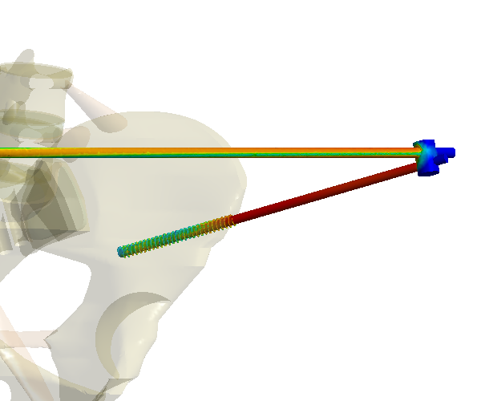
а
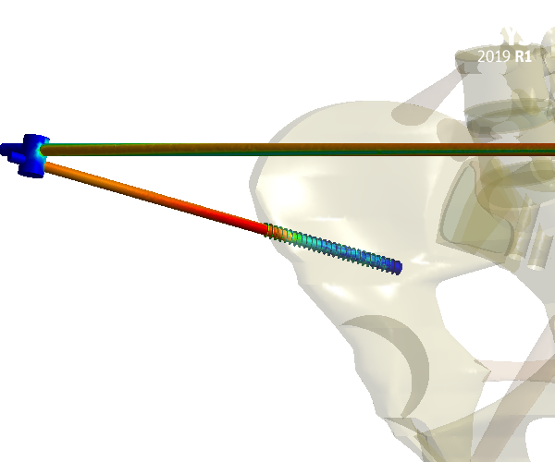
b
Fig. 6. Von Mises stresses in section: а) the left rod; b) the right rod.
Fig. 7 shows comparison of the deformed and undeformed model (the gray colour). With a support from the left leg, the largest displacement is performed by the right node of rod fixation – 4.7 mm.
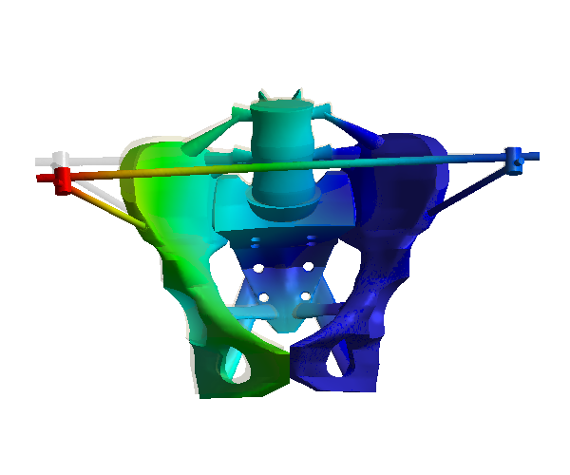 | 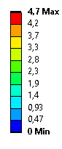
Fig. 7. Displacements of the model (the scale of deformity is multiplied by 2.5 times for illustration purposes).

The above displacement creates a rotary moment of force around EFD rod axes, which acts on the left rod in the counterclockwise direction from a front view (Fig. 8). The performed calculation results in the value of the moment in the node of fixing of the transverse bar and the left rod equal to 4.1 Nm. The value of the moment in the right rod in the section of the node of intersection with the transverse bar is less and equals to 0.02 Nm. The direction of the moment action corresponds to a clockwise turn from a front view. When the support is changed for the right leg we receive a symmetrical pattern of SSS distribution, and the direction of moments in the nodes of rod fixing is preserved (clockwise for the right screw and counterclockwise for the left one).
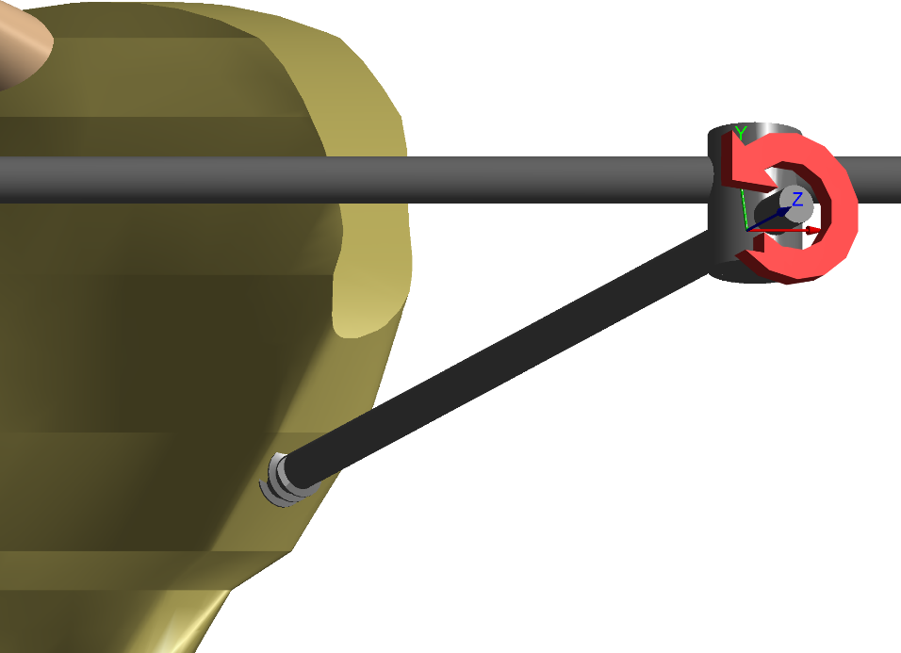
Fig. 8. The direction of the moment in the section of the left EFD rod.

Analysis of SSS of the pelvic model with a fracture of B1 type fixed with EFD revealed the following facts:
- EFD rods are the most stressed elements of the model, the rod from the weight-bearing side of the pelvis being more stressed.
- The right (non-weight-bearing) pelvic side slightly moves down thereby creating a moment of force, which acts on the left rod counterclockwise and facilitates unscrewing of the left rod (in case of a right-handed thread)
- The stressed state level in the bone structure is not critical from the viewpoint of strength.
The comparative analysis of calculations of SSS has demonstrated that one-support standing develops rotary moments with different directions in EFD rods. For the right fixing screw, both in left and right one-support standing, a moment of force is created, which is clockwise and facilitates screwing (strengthening of fixation) of the rod. For the left fixing rod, a moment of force is created, which is counterclockwise and facilitates unscrewing of the rod (destabilization of EFD) both in left and right one-support standing.
Results of the mathematical modelling were verified in an experimental study of the strength of threaded connections of different rods and the pelvic bone under the effect of alternate cyclic loads.
The experimental studies were conducted on preparations of the pelvic bones of a pig. We used external fixation devices having rods with a cylindrical unidirectional thread and rods, where one had a right-handed thread and the other was with a left-handed thread (Fig. 9).
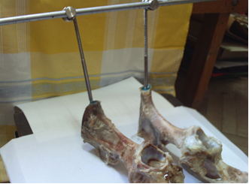
Fig. 9. The experimental model on the testing device.

For each type of rods, three preparations were used. Cyclic alternate loads were performed with help of a shaker device (Fig. 10) with vibration frequency of 25 Hz and amplitude of 2.5 mm [16].
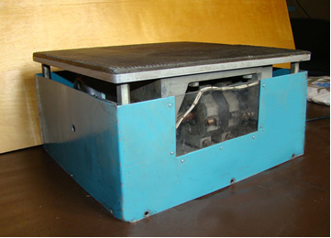
Fig. 10. The shaker device.

The vibration effect was performed during 30 minutes, this duration corresponding to 45,000 gait cycles. Contact places of the rods with the bone were treated with such an aniline dye as brilliant green.
In the end of the experiment the value of self-unscrewing of the screws from the bone was determined with help of an optical micrometer (Fig. 11).
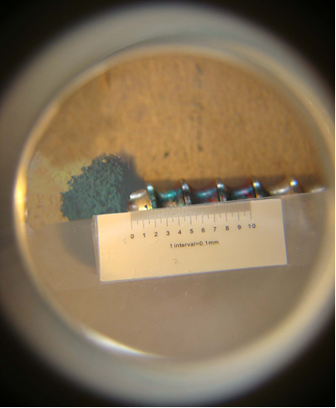
Fig. 11. The view of the preparation under an optic micrometer.
Besides, the value of the unscrewing moment during screwing of the rod into the bone tissue was experimentally studied. For this purpose we used a rigidly fixed preparation of the hip bone of a pig. With help of a tommy bar the rod was screwed into the mid-diaphysis across its entire width. The scheme of the experiment is shown in Fig. 12.
a
b
Fig. 12. The scheme of the experiment with unscrewing of a rod:
а – view in the sagittal plane; b – top view ( D – dynamometer; Funscr – force of unscrewing; l – length of the lever of action of the unscrewing force.

The length of the lever of action of the unscrewing force in our experiment was:
l = 100 mm.
A photograph of the experiment procedure is presented in Fig. 13
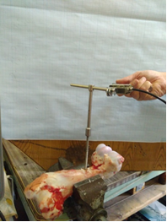
Fig. 13. An experimental study of the unscrewing moment value,
when a rod is screwed into the bone tissue.

The unscrewing force was applied to the tommy bar, and its value was measured with help of a tensometric sensor SBA-100L and a CAS registration device of CI-2001 type (Fig. 14).
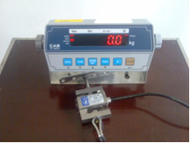
Fig. 14. The device for registering the value of loading
with a tensometric sensor.

The unscrewing moment value was calculated by the formula [16]:
Мunscr = Fl, (1)
where F – value of the unscrewing force;
l – length of the lever of action of the unscrewing force.
By results of the experiment we calculated the value of the screwing moment [17] and critical values of the amplitude and frequency of vibration, with which a rod can unscrew [18].
The experimental data were subjected to statistical processing. We calculated the mean value (M) and its standard deviation (SD) as well as the minimum and maximum values. Analysis of the findings was performed in a pack for statistical analysis IBM Statistic SPSS 20.0 [19].
In order to understand the alternate cyclic loads on the strength of threaded connections let us use the method of calculations presented in [16]. The geometrical characteristics of thread and forces in the threaded connection are given in Fig. 15.
Fig. 15. Interacting forces in a threaded connection:
where Ft – circumferential driving force;
F – axial force on a screw;
ψ – lead angle;
φ – friction angle;
d2 – pitch diameter;
P – thread pitch.

According to [17], the moments, which are necessary for unscrewing a threaded connection, can be presented in the form of:

$M_{вгв}=M_{вигв}\frac{\left[\tan\left(ϕ+ψ\right)+f_{T}\frac{d_{cp}}{d_{2}}\right]}{\left[\tan\left(ϕ-ψ\right)+f_{T}\frac{d_{cp}}{d_{2}}\right]}$ (2)
where Мunscr, Мscr – the moments, required for unscrewing/screwing a threaded connection;
fR – friction ratio on the thread edge;
dm – mean diameter of a contact ring;
d2 – pitch diameter.
Results of our experimental study of the unscrewing moment value for a rod, screwed into the diaphyseal portion of the hip bone of a pig, are shown in Table 2.

Table 2. Values of the unscrewing moment for a rod, which is screwed into the diaphyseal portion of the hip bone of a pig.
No. of test | Unscrewing moment М_{unscr}, Nm
No. of test | М_{unscr} | М±SD | min÷max
1. | 2.80 | 3.3±0.32 | 2.80÷3.60
2. | 3.50 | 3.3±0.32 | 2.80÷3.60
3. | 3.40 | 3.3±0.32 | 2.80÷3.60
4. | 3.20 | 3.3±0.32 | 2.80÷3.60
5. | 3.60 | 3.3±0.32 | 2.80÷3.60

According to the results of our experimental study the mean value of the unscrewing moment was 3.3±0.32 Nm. Therefore for calculating we take the mean value:
Мunscr = 3,3 Нм.
In compliance with additional data [16] we chose the value of the friction ratio for the metal-bone pair:
fT = 0.3.
We chose the last parameters according to the design of the rod, engaged in the experiment:
Dm = 5 mm;
d2 = 6 mm;
ψ = 10°;
φ = 30°;
P = 3 mm.
If the above values are inserted into the equation (2), the value of the screwing moment of our rod is received:
М_{unscr} = 4.9 Nm
According to the results of our experimental study the mean value of the unscrewing moment was 3.3±0.32 Nm. Therefore for calculating we take the mean value: As it can be seen, the main factors that produce their effect on the forces, required for unscrewing a threaded connection, are as follows: the moment of the previous tightening and the friction force on turns and edges of the thread. Consequently, lowering of the unscrewing moment is directly caused by a change of the friction force in turns and edges of the thread. One study [2] has examined the effect of vibration on the friction ratio and demonstrated that longitudinal vibration is its major cause. The conditions for absence of slipping are as follows/
$\frac{2M_{вгв}\left[\tan\left(ϕ-ψ\right)+f_{T}\frac{d_{cp}}{d_{2}}\right]}{d_{2}\left[\tan\left(ϕ+ψ\right)+f_{T}\frac{d_{cp}}{d_{2}}\right]}>mAω^{2}$ (3)

where m – rod weight, in our case m = 20 g;
А – vibration amplitude;
ω – vibration frequency.
Having transformed the inequation (3), we can receive an equation for determining critical values of vibration frequency depending upon its amplitude:
$ω<\sqrt{\frac{2M_{вгв}\left[\tan\left(ϕ-ψ\right)+f_{T}\frac{d_{cp}}{d_{2}}\right]}{{mAd}_{2}\left[\tan\left(ϕ+ψ\right)+f_{T}\frac{d_{cp}}{d_{2}}\right]}}$ (4)
Let us insert necessary values into the inequation (4) and calculate critical values of vibration frequency for its amplitude in the range from 1.0 mm to 5.0 mm with the pitch of 0.5 mm.
Results of the calculations are presented in Table 3.

Table 3. Critical values of vibration frequency from its amplitude for unscrewing a rod from the bone.
Amplitude, mm | Frequency, Hz
0 | 681
0.5 | 305
1.0 | 215
1.5 | 176
2.0 | 152
2.5 | 136
3.0 | 124
3.5 | 115
4.0 | 108
4.5 | 102
5.0 | 96

A better visualization of critical values of vibration frequency from its amplitude, for rod unscrewing from the bone is possible with help of a graph given in Fig. 16.
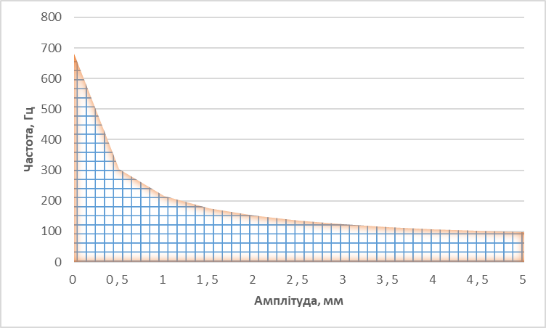
Fig. 16. Diagram of vibration frequency dependence upon its amplitude, which is critical for unscrewing a rod from the bone tissue.

The above graph vividly demonstrates that the region above the shaded area is especially dangerous from the viewpoint of possible self-unscrewing of rods.
Table 3 contains results of testing of the pelvic bones of a pig for vibrational effect; the above bones were connected with an external fixation device in variants with rods having unidirectional and differently directed threads.

Table 3. Values of unscrewing of rods under vibrational effect.
Sl. No. | Values of unscrewing of rods, µm
Sl. No. | Unidirectional threads | Differently directed threads
1 | 713 | 0
2 | 823 | 0
3 | 936 | 0
M±SD | 824±112 | 0
min÷max | 713÷936 | 0

As a result of the conducted studies it has been revealed that screws with a unidirectional thread are less resistant to cyclic alternate loads. The mean value of screw unscrewing was 824±112 µm. In the device that had rods with a differently directed thread they did not unscrew at all (0 µm). We explain it by the fact that the presence of bar-connected screws with a differently directed thread creates a reciprocally interlocking structure, which counteracts self-unscrewing.
The stability of threaded connections is based on the presence of the friction force in the thread plane that in its turn depends upon the pressing force of the centralizer. Vibration is one of unfavourable factors for stability of threaded connections. Vibration causes microdisplacements of the centrator with a resultant reduction of the friction force in some cases down to zero. Studies of the unscrewing moment value have shown that the rod used for fixing the pelvic bones creates a sufficient pressing force, but with regard for the structure mass tends to its reduction under the effect of low-frequency mechanical vibrations. This fact was confirmed by results of tests on a shaker device. One of the methods for counteracting a negative effect of vibration waves on threaded connections consists in creating an additional pressing force by using spring washers, plastic or silicone sealants, etc. Another method involves blocking of a threaded connection, for example with help of a check nut. In our case the blocking was achieved by using rods with differently directed threads, which provide self-locking of the rods. Experimental studies on a shaker device completely confirmed the effectiveness of such an approach.
Conclusions. We believe that in order to increase the stability and reliability of pelvic fixation with EFD it is necessary to use a left-handed thread for the left rod, thereby making it possible to avoid loosening of its fixation in the bone, since the “behaviour” of the left rod will be similar to that of the right one.
A change in the thread direction does not lead to redistribution of SSS and change in the moment values, but directions of the action of the moments of force for the left rod will correspond to the direction of its screwing both in the left- and right-sided one-support position, i.e. both in standing and walking.
Bar-connected rods with a differently directed thread create a reciprocally interlocking structure, which counteracts self-unscrewing. Such a structure significantly increases the strength of connection of an external fixation device with the pelvic bone and creates conditions for an effective use of the technique of СРМ in rehabilitation of patients with unstable pelvic fractures.

Acknowledgments. The authors would like to express their gratitude to laboratory scientists of the State Institution "Sytenko Institute of Spine and Joint Pathology of the National Academy of Medical Sciences of Ukraine” Yaresko A.V. and Karpinska Ye.D. for their consulting and technical assistance in conducting these researches.
References:
1. Osterhoff, G., Tiziani, S., Ferguson, S. J., Spreiter, G., Scheyerer, M. J., Spinas, G. L., … Werner, C. M. (2014). Mechanical testing of a device for subcutaneous internal anterior pelvic ring fixation versus external pelvic ring fixation. BMC Musculoskeletal Disorders, 15, 111. doi:10.1186/1471-2474-15-111
2. Lei, J., Dong, P., Li, Z., Zhu, F., Wang, Z., & Cai, X. (2017). Biomechanical analysis of the fixation systems for anterior column and posterior hemi-transverse acetabular fractures. Acta Orthopaedica et Traumatologica Turcica, 51(3), 248–253. doi:10.1016/j.aott.2017.02.003
3 Zienkiewicz, O. C., & Taylo, R. L. (2005). The Finite Element Method for Solid and Structural Mechanics. Butterworth-Heinemann.
4. Lee, C. H., Hsu, C. C., & Huang, P. Y. (2017). Biomechanical study of different fixation techniques for the treatment of sacroiliac joint injuries using finite element analyses and biomechanical tests. Computers in Biology and Medicine, 87, 250–257. doi:10.1016/j.compbiomed.2017.06.007
5. Ding, S., Chen, F., Huang, J., Zhang, G., Wang, F., … Ruan, Z. (2020). Modified pedicle screw-rod versus anterior subcutaneous internal pelvic fixation for unstable pelvic anterior ring fracture: A retrospective study and finite element analysis. Orthopedic Clinical Research. doi: 10.21203/rs.3.rs-16488/v1.
6. Jhou, S. Y., Shih, K. S., Huang, P. S., Lin, F. Y., & Hsu, C. C. (2019). Biomechanical analysis of different surgical strategies for the treatment of rotationally unstable pelvic fracture using finite element method. Journal of Mechanics in Medicine and Biology, 19(1), 1940015. doi:10.1142/S0219519419400153
7. Li, L., Lu, J., Yang, L., Zhang, K., Jin, J., Sun, G., Wang, X., & Jiang, Q. (2019). Stability evaluation of anterior external fixation in patient with unstable pelvic ring fracture: a finite element analysis. Annals of Translational Medicine, 7(14), 303. doi:10.21037/atm.2019.05.65
8. Chen, H., Wu, L., Zheng, R., Liu, Y., Li, Y., & Ding, Z. (2013). Parallel analysis of finite element model controlled trial and retrospective case control study on percutaneous internal fixation for vertical sacral fractures. BMC Musculoskeletal Disorders, 14, 217. doi:10.1186/1471-2474-14-217.
9. Liu, L., Fan, S., Chen, Y., Peng, Y., Wen, X., Zeng, D., Song, H., & Jin, D. (2020). Biomechanics of Anterior Ring Internal Fixation Combined with Sacroiliac Screw Fixation for Tile C3 Pelvic Fractures. Medical Science Monitor : International Medical Journal of Experimental and Clinical Research, 26, e915886. doi:10.12659/MSM.915886
10. Shan, T., Anlin, L., Mingming, Y., Haitao, Y., Anwei, Z., & Shichang, G. (2020). Anterior supra-acetabular external fixation for tile C1 pelvic fractures: a digital anatomical study and a finite element analysis. European Journal of Trauma and Emergency Surgery, 10.1007/s00068-020-01517-8.
11. Shim, V., Gather, A., Höch, A., Schreiber, D., Grunert, R., Peldschus, S., Josten, C., & Böhme, J. (2017). Development of a Patient-Specific Finite Element Model for Predicting Implant Failure in Pelvic Ring Fracture Fixation. Computational and mathematical methods in medicine, 2017, 9403821. doi:10.1155/2017/9403821
12. Bone mechanics handbook (2001). S. C. Cowin (Ed.). CRC Press Reference.
13. Vidal-Lesso, A., Ledesma-Orozco, E., Daza-Benítez, L., |& Lesso-Arroyo, R. (2014). Mechanical Characterization of Femoral Cartilage Under Unicompartimental Osteoarthritis. Ingeniería Mecánica Tecnología Y Desarrollo, 4(6), 239–246.
14. Savio, L. Y., & Woo, S. D. (2006). Abramowitch, Robert Kilger, Rui Liang. Biomechanics of knee ligaments: injury, healing, and repair. Journal of Biomechanics, 39, 1–20. doi:10.1016/j.jbiomech.2004.10.025
15. Modenese, L., Phillips, A. T., & Bull, A. M. (2011). An open source lower limb model: Hip joint validation. Journal of Biomechanics, 44(12), 2185–2193. doi: 10.1016/j.jbiomech.2011.06.019
16. Karpinskiy, M. Iu., Zubatii, S. S., Lavinskii, D. V., & Fomin, G. G. (2000). Matematicheskoye issledovaniye mekhanicheskikh kolebatel'nykh svoystv dlinnykh kostey [Mathematical study of mechanical vibrational properties of long bones]. Medicina i и ..., (1), 47–50.
17. Serdiuk, A. I., Miteleva, Z. M., Kas'yanov, A. I., Mon'ko, O. N., & Karpinskiy, M. Iu. (1994). Razrabotka, sozdaniye i issledovaniye upravlyayemogo vibromassazhnogo ustroystva [Development, creation and research of a controlled vibration massage device]. Proceedings 45th Conference of Polava ISI, Poltava, 214.
18. Aleksandrov, A. V., Potapov, V. D., & Derzhavin, B. P. (2000). Soprotivleniye materialov [Strength of materials]. Moscow: Vysshaya shkola.
19. Birger, I. A., & Iosilevich, G. B. (1990). Rez'bovyye i flantsevyye soyedineniya [Threaded and flange connections.]. Moscow: Mashinostroyeniye.
20. Blekhman, I. I., Blekhman, L. I., Vasil'kov, V. B., Ivanov, K. S., & Yakimova, K. S. (2012). Ob iznose oborudovaniya v usloviyakh vibratsii i udarnykh nagruzok [Wear and tear of machine parts affected by vibration and
percussive impacts]. Vestnik nauchno-tekhnicheskogo razvitiya, (11), 3–14. Retnrived from http://www.vntr.ru/ftpgetfile.php?id=643
21. Nasledov, A. (2011). SPSS 19: professional'nyy statisticheskiy analiz dannykh [SPSS 19: Professional Statistical Analysis of Data]. Saint Petersburg: Peter.

