PEDAGOGICAL POTENTIAL OF THE ANATOMICAL EDUCATIONAL MUSEUM OF THE HIGHER MEDICAL ESTABLISHMENT
L. Zelenska, O. Vovk, M Lyutenko, O. Avilova
ПЕДАГОГІЧНИЙ ПОТЕНЦІАЛ АНАТОМІЧНОГО МУЗЕЮ
ЗАКЛАДУ ВИЩОЇ ОСВІТИ
Л. Зеленська, О. Вовк, М. Лютенко, О. Авілова

Abstract.
Background. Human Anatomy discipline is th basis for all medicine, thus, requires huge attention of educators in order to improve and optimize the educational process. Nowadays anatomical museum is not just a scientific, but also a cultural institution. In addition to the traditional and demonstrational functions of the exhibition, the museum becomes a learning environment, research and development center, center of education and leisure. The museum must play the role of an educational tool and emphasize the importance of science in a modern society, also it should create favorable conditions for the development of creative abilities of the students. Purpose. To raise awareness of the development of scientific, pedagogical and cultural competence of Human Anatomy eduational museums all over the World. Methodology. Overview of the history of the human anatomy department of Kharkiv Ntional Medical University (KhNMU), introduction of the importance of educational museums digitalisation, analysis and systematization of the educational museum sections. Results. Proposition of number of measures that could contribute to the realization of the pedagogical potential of the educational museums and Human Anatomy Department of KhNMU in particular. Conclusion. The study leads to the conclusion that the pedagogical potential of the educational museum of human anatomy is to ensure the unity of theoretical and practical training of students, the formation of analytical thinking, observation, research skills, education of values ​​in the subject and profession in general.
Keywords: anatomy, education, educational museum, pedagogical potential, preparation of doctors

Абстракт.
Актуальність. Навчальна дисципліна «Анатомія людини» є основоположною у фаховій підготовці майбутніх лікарів. Це вимагає від професорсько-викладацького складу закладів вищої медичної освіти оптимального використання в освітньому процесі не лише традиційних й інноваційних методів і технологій навчання, але й педагогічного потенціалу засобів навчання, зокрема експонатів анатомічного музею. Сьогодні анатомічний музей закладу вищої медичної освіти – це не лише освітній, науковий, але й культурний центр. Крім демонстраційних функцій експонатів, музей виконує функції навчального середовища, науково-дослідного центру, центру освіти та дозвілля. Музей відіграє роль навчального засобу, популяризує значення анатомії як науки в суспільстві, а також створює сприятливі умови для розвитку дослідницьких і творчих здібностей здобувачів освіти. Мета. Схарактеризувати педагогічний потенціал Анатомічного музею Харківського національного медичного університету й підвищити обізнаність науковців, здобувачів медичної освіти, широкого загалу щодо дослідницьких, освітніх та просвітницьких функцій навчальних музеїв анатомії людини у всьому світі. Методологія. У процесі дослідження використано комплекс загальнонаукових методів, як-от: аналіз, синтез, абстрагування, узагальнення, систематизація, класифікація. Результати. Схарактеризовано досвід реалізації Анатомічним музеєм Харківського національного медичного університету таких функцій: навчальної, дослідницької, культурно-просвітницької. Висновки. Дослідження дозволяє зробити висновок, що педагогічний потенціал навчального музею анатомії людини полягає перш за все у забезпеченні єдності теоретичної та практичної підготовки майбутніх лікарів, формуванні в них аналітичного мислення, спостережливості, дослідницьких умінь, виховання цінностей у професійній діяльності. Окрім того, музей слугує осередком популяризації анатомічних знань у суспільстві.
Ключові слова: анатомія, освіта, анатомічний музей, педагогічний потенціал, підготовка лікарів.
INTRODUCTION. During past years, teaching of human anatomy discipline requires more and more attention in order to improve and optimize the educational process. Syllabus of human anatomy for medical and biological faculties of higher educational institutions contains a huge amount of information material. Modern higher educational establishments are in need of educators who are the leaders with developed general cultural competence and ability to master new methods and strategies of constructive professional activity in the conditions of modern technologies and directions of interactive and simulation learning. Teachers of higher medical and biological educational institutions attach great importance in the development of modern competence to anatomical museums for different profiles of educators, and pay attention to the potential use of these museums in the organization of the educational process.
PURPOSE. To help teachers in usage of the elements of museum pedagogy in the educational process (including various types of excursions). To raise awareness of the development of scientific, pedagogical and cultural competence, to emphasize necessaty to hold various events in higher education institutions, such as panel discussions, conferences, trainings, workshops on the museum pedagogy topics.
METHODOLOGY. Nowadays anatomical museum is not just a scientific, but also a cultural institution. In addition to the traditional and demonstrational functions of the exhibition, the museum becomes a learning environment, research and development center, center of education and leisure. Many countries already experienced the use of different technologies and methods of organizing the training for students in museums of different directions. It is not associated with usual use of the museum premises for conducting classes, but with such trainings which could be integrated into educational curriculum. A modern museum exposition should nurture visitors' personal emotional attitude to its exhibits. The museum must play the role of an educational tool and emphasize the importance of science in a modern society, also it should create favorable conditions for the development of creative abilities of students.
MATERIAL AND METHODS.
- overview of the history of the human anatomy department of KhNMU from the museum perspectives;
- introduction of the importance of X-ray anatomy, anatomy of individual development, tomography, 3D anatomical models of rare variants of human ontogenesis in norm and in pathology into syllabus of human anatomy discipline;
- analysis and systematization of the educational museum sections.
THEORETICAL FRAMEWORK. Turning to the history, it is important to note that in Ukraine great attention has always been paid to the museum development. Among the oldest museums are anatomical museums in Kharkiv (1804), Kyiv (1842), Lviv (1894) medical universities. Currently, such museums are present in almost all departments of human anatomy in our country. What is their condition? Analysis of the state of museum сollections shows that museums at different departments of anatomy are extremely diverse. Thus, in some departments the museum occupies a large area, more than 500 m² in Kyiv, in Kharkiv – 1500 m². If in some universities special, well-equipped premises are allocated for the museum, in others, its area does not exceed 50-70 m². Museums, which are given a lot of attention and where they are regularly replenished, the number of specimens is measured in thousands. In others - only dozens of preparations, but not of the best quality.
A number of museums have special, usually well-selected collections from different sections of anatomy, for example in Kyiv museum there is good collection of osteology material, in Kharkiv – nervous system specimens, in Ivano-Frankivsk, Ternopil and Lviv complex preparations of vessels and nerves. At some departments X-ray anatomy sections are created, and the Department of Human Anatomy of KhNMU there are 3D models and plastic models are present.
Some relatively young departments managed to get good museums in a short time. For example, the Department of Human Anatomy and Physiology by prof. Y. R Sinelnikov H. S. Skovoroda Kharkiv National Pedagogical University; Department of Human Anatomy of Medical Faculty V. N. Karazin Kharkiv National University.
A positive trend observed in the organization of museum work is the desire to increase natural specimens. This is facilitated by the development of the student scientific society, faculties of advanced training of teachers, where the issue of preparing museum specimens is given special attention. Thus, during the last 5 years’ participants of student scientific society of human anatomy of KhNMU prepared or restored more than 50 museum preparations.
It is worth paying attention to the existing shortcomings in the usage of the anatomical museum in the pedagogical process of higher educational establishment. First of all, it is the lack of necessary premises, as a result of which it compels to exhibit specimens in the hallways or near the walls of classrooms. In such museums, students do not have the opportunity to study anatomy in a proper way, as a result of which these museums turn into simple exhibitions and contribute little to self-directed work. The lack of special furniture forces to place specimens on educational tables, operating tables, in tool cabinets, etc., which makes the museum inconvenient. Difficulties in obtaining standard museum jars forces to use jars of different shapes, sizes and colors, which makes the educational museum appearance and structure disorganised. There are disproportions of specimen’s collections in different departments which does not provide a sufficient level of visual information in the study of anatomy. Often the specimens are exhibited without any order and systematization by departments, which is contrary to the goals of the educational museum and turns into a chaotic set of exhibits.
Taking these points into account, arise such questions: “What type the anatomical museum should be for a comprehensive study of human anatomy? What modern requirements of the pedagogical process it should comply with? ˮ
After deliberating over these questions and thorough dscussions was highlighed the following:
- The basis of the anatomical museum should be natural preparations of organs of all systems of the human body or animals body in sufficient quantities.
2) Given that modern anatomy is not a separate science, and the study of anatomy is based on the solution of various clinical and scientific problems of future professionals - the museum should have, albeit not very large, but quite demonstrative sections of comparative anatomy, age anatomy, radiological anatomy. Specimens showing developmental abnormalities and individual variability of organs and systems are also needed.
3) Considering that the future doctor will provide care to the patient taking into account his individual characteristics, age, sex, profession and lifestyle, the museum should have a special section that reflects these aspects of the anatomy of a living person. Of particular importance are X-rays, 3D models of organs in the norm and with individual features and pathological changes. If it is a museum of anatomy of biological or zooveterinary profile, there should also be similar visual aids on the peculiarities of the structure of an animal.
4) The museum should pay due attention to the stands on the history of anatomy, history of the department and its achievements during the entire period since its foundation. In addition, of a great importance are the methods and techniques of manufacture, storage and exhibition of museum anatomical preparations. The greater the variety of methods used in the preparation of the specimen, the better the details of the structure of the human or animal body will be displayed.
In the museum of the Department of Anatomy of KhNMU there are more than 3000 natural preparations made according to different methods. Some exhibits are more than 200 years old. Most of the collection is represented by the specimens related to the central and peripheral nervous system, preparations on comparative anatomy, and specimens made by the faculty members and students.
Among the applied methods of specimens' preparation can be distinguished such as: injection method, tissue lightening, corrosion, mummification, macromicroscopic method according to Academician V. P. Vorobiyov technique, a method of preserving specimen without fluid and many others.
Placement of specimens is best to provide in special cabinets-showcases equipped with boards-tables for textbooks, atlases and notebooks. Near such showcases the student can observe the specimen and at the same time use the educational literature and make notes. Wet preparations are good to place in square jars of clear transparent glass. Such jars better to install in special cabinets and place next to the jar annotation of the specimen in accordance with modern anatomical terminology (or to attach QR code on the jar with the describtion of specimen). This is modern approach to help the students and all museum visitors to grasp information. Detailed acquaintance with the methods of manufacturing anatomical preparations, methods of conservation, storage and display is essential for improving the pedagogical skills of anatomy teachers.
Also, the educational museum serves to improve the knowledge of senior students who come to the museum to restore knowledge gap from some certain anatomy sections, plays a role in improving the skills of doctors. Anatomical museums should be scientific-methodical and educational centers. Museums are used to promote widely knowledge about the structure of the human body or animal anatomy among health professionals, biologists, non-medical students, schoolchildren, as well as the interested population of the city.
The rules and recommendations of the museum exposition were developed at the Department of Human Anatomy of KhNMU. The number of units of exhibits in each museum is determined by the head of the department and the responsible employee of the museum at the meeting of the department. Wax models can be used only for exploration certain topics (embryogenesis, sensory organs, etc.). For convenient use of the exposition of the anatomical museum in the pedagogical process, departments were created that correspond to the thematic plans for the study of human anatomy at the medical university.
Each museum section must adhere to a single principle of exposure of specimens and a single nature of their design as follows:
1. Osteology. Collection of skulls of different ages. Individual bones (in different projections and sections). For the dental faculty - the upper and lower jaws of different age groups. Anomalies of skull development. Vertebrae, ribs, sternum. Bones of the extremities. Developmental anomalies (photographs, radiographs, drawings).
2. Syndesmology and arthrology. It is preferable to present each joint by two or three specimens (in different projections, sections). Types of continuous and interrupted connections (on the stand). It is recommended to have a set of models that demonstrate different joint shapes. Joints of the trunk. Joints of the bones of extremities. Temporomandibular joint. Anomalies of joint development.
3. Myology. Dissected muscles of the whole corpse (shown either in a sarcophagus with a glass lid, or in a vertical position in a special window). Muscles of the head and neck. Chest and abdomen muscles. Back muscles. Muscles and fascia of the extremities. Bones with designated places of muscles attachments. Elements of biomechanics (a series of drawings or photographs). Transversal cross sections of the human trunk at different levels according to Professor MI Pirogov «icy anatomy» technique.

4. Splanchnology (science about organs)
Digestive System. Oral cavity and its derivatives. Anomalies in the development of the oral cavity (teeth, jaws – for the dental faculty). Pharynx, esophagus, stomach, small and large intestine. Liver. Pancreas. Topography of abdominal organs on cross-sections. Individual variability of organs. Reverse arrangement of the viscera (specimen, model or photograph).
Respiratory system. Nasal cavity. Larynx (cartilages, muscles, ligaments, model of the larynx musculature). The larynx of an adult and a child. Trachea, bronchi, "bronchial tree" (corrosion specimen). Lungs. Pleura. Topography of the lungs (wet specimen, model). Model of segments of the right and left lung.
Genitourinary system. Urinary organs. Kidney, kidney capsules. Adrenal glands. Ureter. Anomalies of kidney development. Sagittal dissection of the pelvis (bladder). Male and female urethra (opened). Male genitals. Female genitals. Developmental anomalies. Muscles and fascia of the perineum.
Endocrine glands. Preparations of individual endocrine gland. Development of endocrine glands (scheme). (Fig.1).

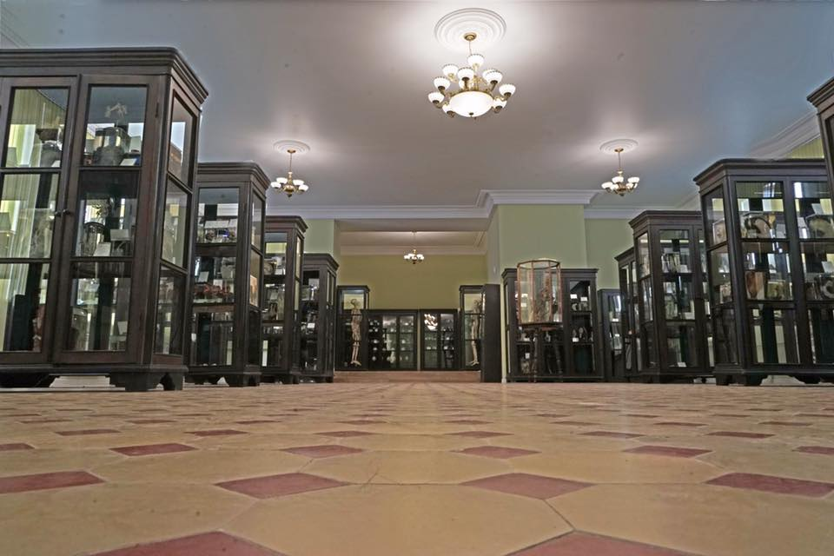Fig.1. Educational museum of Kharkiv National Medical University,
Splanchnology section, 2021

5. Angiology. Vascular system development and overview (scheme). Heart. General view. Chambers of the heart. The structure of the walls. Arteries and veins of the heart. Pericardium. Topography of the heart. Heart development (set of models).
Vessels of the pulmonary blood circulation. Vessels of the greater blood circulation. Aorta. Branches of the aortic arch. Arteries of the head andn eck. Blood vessels of the brain. Arteries of the upper extremity (specimens, schemes). Branches of the abdominal and thoracic aorta. Pelvic arteries. Arteries of the lower extremity. Blood vessels of the thoracic, abdominal and pelvic cavities. The system of the inferior vena cava. Portacaval and cavocaval anastomoses (specimen or schemes). Fetal circulation (specimen or schemes). (Fig.2).

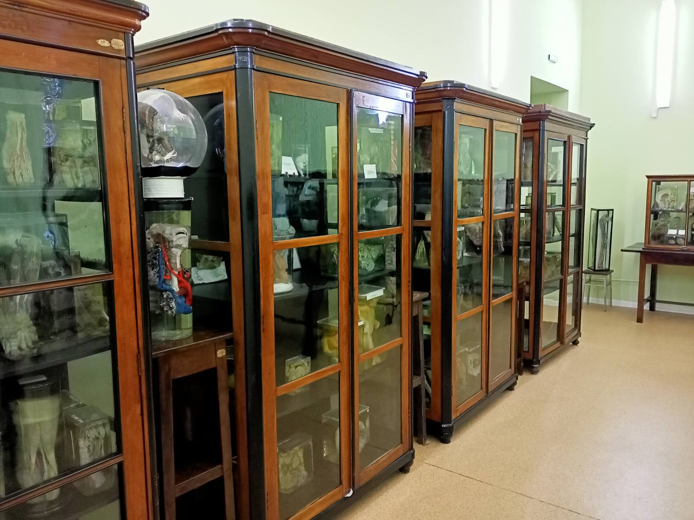Fig.2. Educational museum of Kharkiv National Medical University, Angiology section, 2021

6. Lymphatic system. Lymphatic duct preparations. Lymph node scheme. Lymphatic vessels of certain areas and organs of the human body (specimens). Spleen. Thymus.
7. Nervous system
Central nervous system. Development of the spinal cord and brain (wax models, drawings, specimens). Spinal cord. Meninges of the spinal cord. Skeletotopy of the spinal cord (scheme). Brain (specimens). Sections (frontal, horizontal, sagittal) of the cerebrum. Localization of analyzers in the cortex (painted by different colors). Meninges. Conducting pathways (brain cross-sections with the different threads passing through and representing conducting pathways of CNS). Anomalies in the development of the central nervous system. (Fig.3).

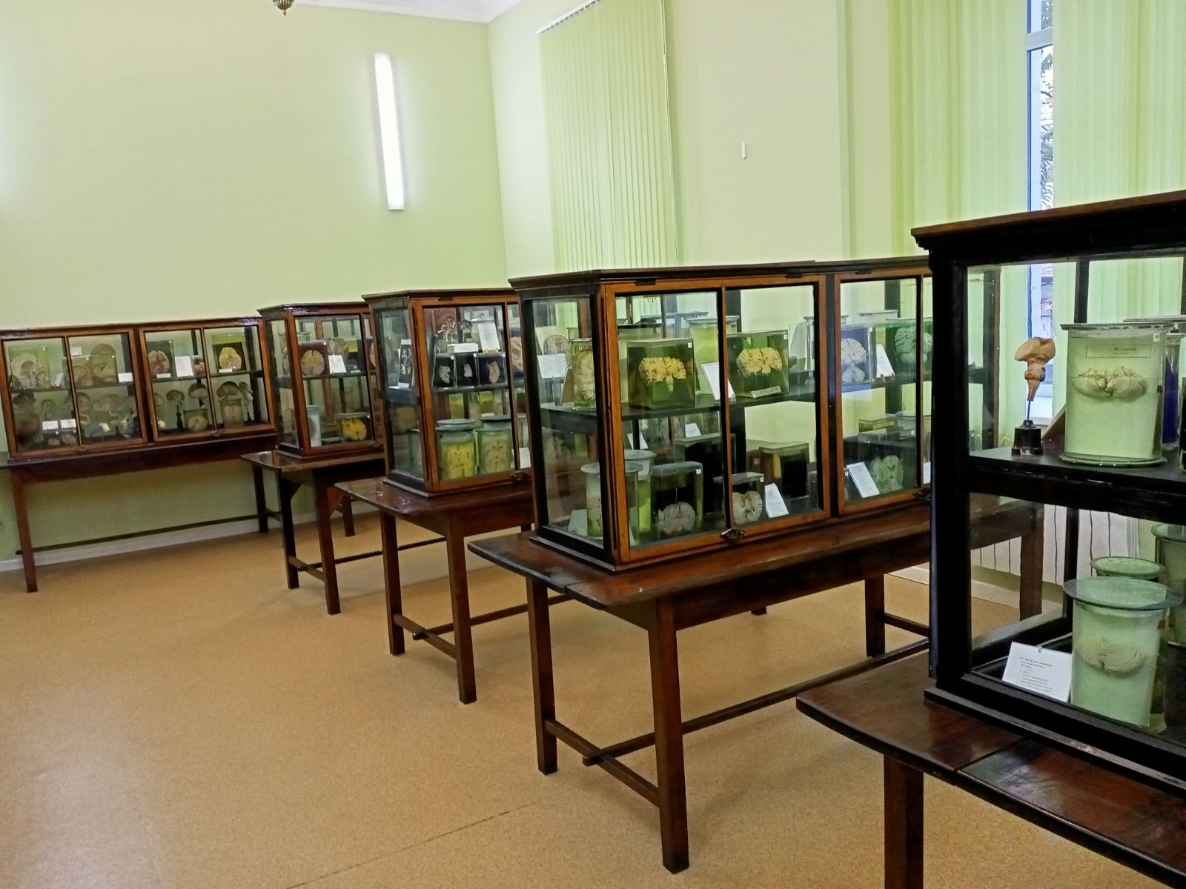Fig.3. Educational museum of Kharkiv National Medical University,
Central nervous system section, 2021
Peripheral nervous system. Cranial nerves (specimens, makets, electrified stands). For the dental faculty it is recommended to make specific specimens for innervation of the upper and lower jaws (tables, diagrams). Spinal nerves. Cervical plexus. Brachial plexus. Zones of skin innervation of the upper extremity (specimens, schemes). Thoracic nerves. Lumbosacral plexus. Skin innervation zones of the lower extremity (specimens, schemes).
Autonomic nervous system. Central compartments. Vegetative plexuses of the thoracic, abdominal and pelvic cavities. Vegetative nerves of separate organs (preparations made according to a method of Academician VP Vorobyov).
8. Sensory organs. Development of the sensory organs (schemes, wax models). Organ of vision (specimens, wax models). Organ of hearing and balance (schemes, wax models, specimens). Olfactory organ (preparation of the nasal cavity). Organ of taste (schemes, photos, macromicroscopic preparations of the papillae of the tongue). Skin (photos with 5-10 times magnification).
Special sections of the museum. In each museum, in addition to general sections, should be allocated special one, the size of which is determined by the volume of the museum funds, the scientific orientation of the department, and the historical traditions of the department. At the Department of Human Anatomy of Kharkiv National Medical University there is a separate "Museum of Comparative Anatomy", created by VP Vorobyov in 1931. (Fig.4).

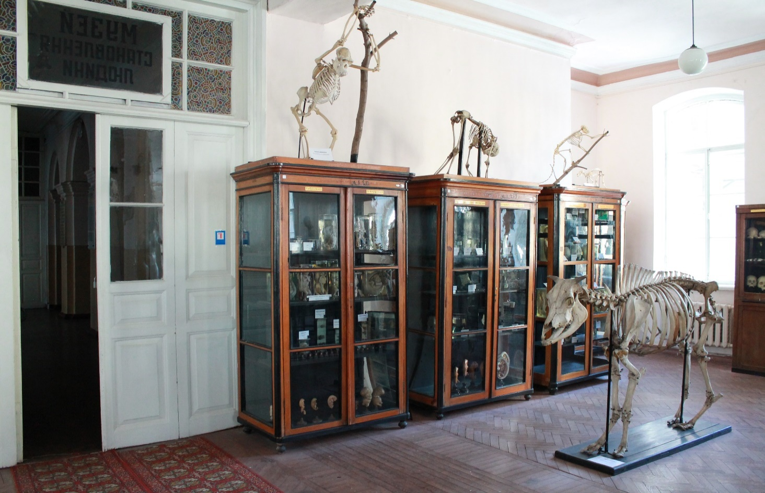Fig. 4. Museum of comparative anatomy, of Kharkiv National
Medical University, 2021
Section of Human and Some Animal Development in Phylogeny
Skeletons, skulls and stuffed animals (horse, cow, wild boar, tiger, goat, chimpanzee, green monkey, kangaroo, dog, cat, rabbit, etc.), preparations of the structure of the inner ear of human and some animals, phylogeny of human extremities and some animals, wet preparations of various systems of animals and humans.
Section of Human Development in Ontogenesis. Prenatal ontogenesis (a series of specimens prepared by diaphanization method) of human embryos and fetuses. Postnatal ontogenesis (skeletons, skulls).
Section of Anomalies of development of organs and systems. Pathologies of the development of extremities, central nervous, cardiovascular and urinary systems, conjoined twins and others.
Section of of Mummified drugs and wax models of the XIX and XX centuries. Artificial mummification, lyophilisation or freeze-drying, embalming by academician VP Vorobyov method, wax models and papier-mâché models of organs and body parts with the image of nerve projection.
Memorial Museum in memory of Academician VP Vorobyov. A memorial museum of Academician VP Vorobyov was established at the Department of Human Anatomy of KhNMU in 1937. There are placed professor’s Vorobyov personal belongings, scientific and methodical manuals and other historical documents of prominent professors of the department in different years. In 2000, an exposition of the office of a famous scientist - anatomist VP Vorobyov was created and his wax sculpture was made.

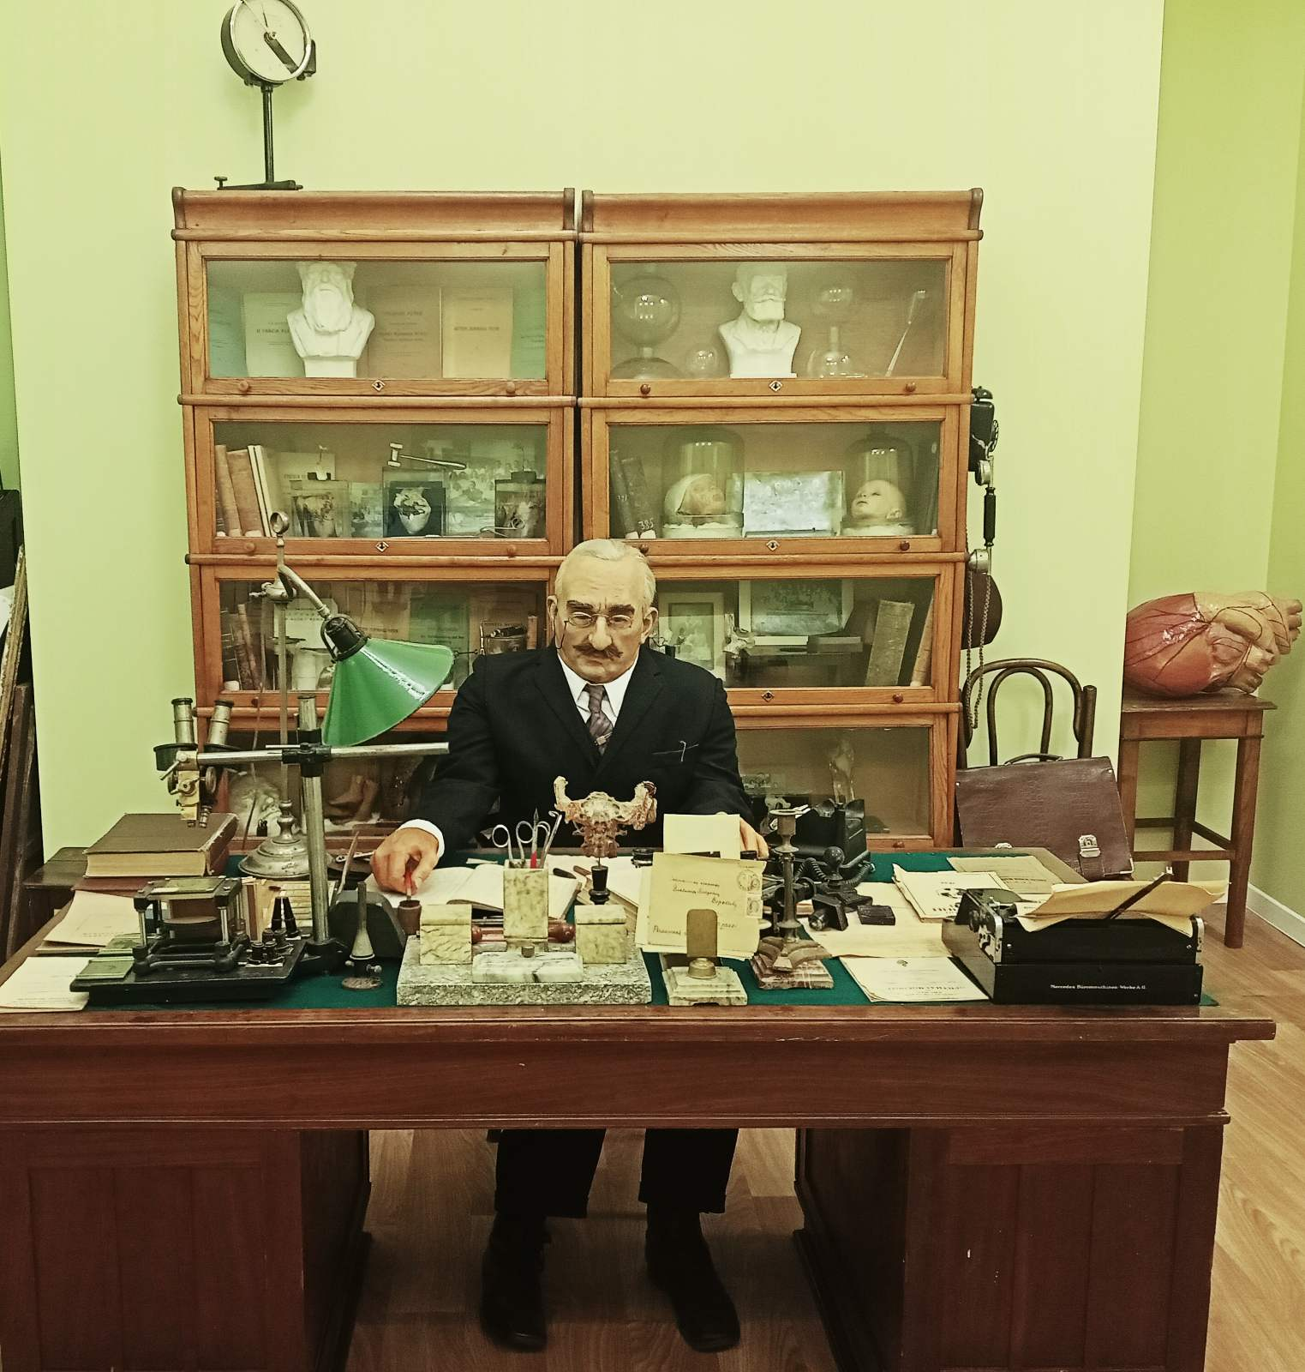
Fig. 5. Memorial museum in memory of Academician V. P. Vorobiov of Kharkiv National Medical University, 2021

DISCUSSION.
A number of measures contribute to the realization of the pedagogical potential of the educational museum of the Department of Anatomy of KhNMU, such as:
- To determine the scope of work in the museum before the beginning of the educational year, the department discusses the plans to supplement the museum fund, as well as to restore the old but valuable specimens and the removal of outdated ones. According to the plan, the head of the department gives the task to the museum manager and each teacher to prepare the museum fund for the new educational year, as the anatomical museum must be replenished with specimens using modern technology, based on modern museum methods that meet all scientific and technological progress in higher education;
- To install a showcase or a stand showing new specimens and copies of patents for inventions and utility models in the field of providing visual aids and new research methods in anatomy for the educational and scientific process;
- To equip the museum with new natural anatomical preparations or 3D models made according to these specimens. These manuals allow to increase the level of mastering the material provided by the syllabus of higher educational establishment, give a variety of deep knowledge about the structure of the human body in the norm and taking into account its individual variability. All this is a fundamental knowledge base for further practical activities and professionalism of the future specialist, both as a doctor and as a scientist in the field of medicine and biology.
CONCLUSIONS AND PROSPECTS FOR FURTHER RESEARCH
The study leads to the conclusion that the pedagogical potential of the educational museum of human anatomy is to ensure the unity of theoretical and practical training of students, the formation of analytical thinking, observation, research skills, education of values in the subject and profession in general. And most importantly seeing by your own eyes the exhibits made by scientists and students during many decades, gives a desire to leave the mark in the history of the department, university and even country by creating something new and valuable in the use of museums in education and pedagogy teaching anatomy.
Further research is needed on issues related historical overview of the museums funds of the Department of the Human anatomy of Kharkiv National Medical University, as well as creation and organizing the specimens’ cataloque with QR codes and electronic quide around museum.

CONTRIBUTIONS.
Lyutenko M., Avilova O. – work concept and design, writing the article.
Zelenska L., Vovk O. – critical review, final approval of the article.
CONFLICT OF INTERESTS.
The authors declare that there are no conflicts of interest regarding the publication
of this paper.
FUNDING.
The authors declare that this study received no specific financial support.

REFERENCES

Cardenas, V. J. L. (2018). The anatomy museum of the University of Chile: a national monument. Revista Medica De Chile, 146(12), 1459-1465.
Cooke, R. A. (2010). A moulage museum is not just a museum Wax models as teaching instruments. Virchows Archiv, 457(5), 513-520. https://doi.org/10.1007/s00428-010-0983-8
Dimitrova-Burlayenko, S. D. (2017). Geneza poniattia "kreatyvna kompetentnist" u konteksti psykholoho-pedahohichnykh doslidzhen [The genesis of the concept of "creative competence" in context of psychological and pedagogical research]. Educational Challenges, (58), 3-14. https://doi.org/10.5281/zenodo.1116968 (in Ukrainian).
Dua, A., Coppola, K. M., Mulheron, G. W., Troupe, D., & Lebeau, R. (2021). Development of a Novel Peer-sharing Application to Supplement Learning from Cadaveric Dissection. Anatomical Sciences Education, 14(4), 491-504. https://doi.org/10.1002/ase.2032
Jedrzejewski, Z., Loranger, B., & Clancy, J. A. (2020). Virtual Anatomy Museum: Facilitating Public Engagement Through an Interactive Application. Biomedical Visualisation, 7(1262), 1-18. https://doi.org/10.1007/978-3-030-43961-3_1
Kabatska, O. V. (2020). Vyvchennia pidkhodiv do roboty vykladachiv zakladu vyshchoi osvity v napriamu zdoroviazberezhennia studentiv [Study of Approaches to Teachers’ Work in Higher Education Institutions in the Direction of Students’ Health Protection]. Educational Challenges, (63), 60-68. https://doi.org/10.34142/2312-2471.2020.63.07 (in Ukrainian).
Kiourexidou, M., Antonopoulos, N., Kiourexidou, E., Piagkou, M., Kotsakis, R., & Natsis, K. (2019). Websites with Multimedia Content: A Heuristic Evaluation of the Medical/Anatomical Museums. Multimodal Technologies and Interaction, 3(2). https://doi.org/10.3390/mti3020042
Ortug, G., Midi, A., Elbizim, D. S., Karaot, H., Yilik, E., & Uluisik, I. E. (2021). Introducing Children to Anatomy: "Getting to Know Our Bodies: The First Step Toward Becoming a Scientist". Anatomical Sciences Education, 14(2), 232-240. https://doi.org/10.1002/ase.2019
Osis, F. (2021). "Inform the Head, Give Dexterity to the Hand, Familiarise the Heart": Seeing and Using Digitised Eighteenth-Century Specimens in a Modern Medical Curriculum. Biomedical Visualisation, 9(1317), 163-179. https://doi.org/10.1007/978-3-030-61125-5_9
Ryazantsevа, A. V. (2016). Osnovni uminnia vykladacha dystantsiinoi systemy osvity, shcho spryiaiut uspishnii orhanyzatsii navchalnoho protsesu [Basic skills teacher distance education system, contribute to the successful organization of the educational process]. Educational Challenges, (55), 64-73. https://doi.org/10.5281/zenodo.194586 (in Ukrainian).
Sobchenko, T. M. (2020). Pidhotovka maibutnikh pedahohiv do innovatsiinoi profesiinoi diialnosti [Future Teachers’ Preparation for Innovative Professional Activity]. Educational Challenges, (63), 159-167. https://doi.org/10.34142/2312-2471.2020.63.17 (in Ukrainian)
Tkachova, N. O., & Tkachov A. S. (2019). The System of Value Indicators for the Quality of Higher Education Improvemen. Educational Challenges, (61), 180-192. https://doi.org/10.34142/2312-2471.2019.61.19 (in Ukrainian)
Trelease, R. B. (2016). From Chalkboard, Slides, and Paper to e-Learning: How Computing Technologies Have Transformed Anatomical Sciences Education. Anatomical Sciences Education, 9(6). 583-602. https://doi.org/10.1002/ase.1620
Xu, W., Dai, T.-T., Shen, Z.-Y., & Yao, Y.-J. (2021). Effects of technology application on museum learning: a meta-analysis of 42 studies published between 2011 and 2021. Interactive Learning Environments. https://doi.org/10.1080/10494820
Zhernovnykova, O. A., Nalyvaiko, O. O., Chornous, N. A. (2017). Intellectual competence: essence, components, levels of formation. Educational Challenges, (58), 32-41. https://doi.org/10.5281/zenodo.1116977

Людмила Зеленська  Доктор педагогічних наук, професор, професор кафедри освітології та інноваційної педагогіки Харківського національного педагогічного університету імені Г. С. Сковороди  zelenskaya_ludmila@ukr.net  ORCID https://orcid.org/0000-0002-3324-5173 | Lyudmila Zelenska  Ph.D., Professor at the Educology and Innovative Pedagogy Department, H. S. Skovoroda Kharkiv National Pedagogical University, Kharkiv  zelenskaya_ludmila@ukr.net  ORCID https://orcid.org/0000-0002-3324-5173
Олег Вовк  Доктор медичних наук, професор, завідувач кафедри анатомії людини Харківського національного медичного університету  oy.vovk@knmu.edu.ua  ORCID https://orcid.org/0000-0002-9788-3000 | Oleg Vovk  Ph.D., Professor, Head of the Human Anatomy Department, Kharkiv National Medical University  oy.vovk@knmu.edu.ua  ORCID https://orcid.org/0000-0002-9788-3000
Михайло Лютенко  Старший викладач кафедри анатомії людини Харківського національного медичного університету  ma.liutenko@knmu.edu.ua  ORCID https://orcid.org/0000-0002-8161-1756 | Mikhailo Lyutenko  Assistant Professor at the Human Anatomy Department of Kharkiv National Medical University  ma.liutenko@knmu.edu.ua  ORCID https://orcid.org/0000-0002-8161-1756
Ольга Авілова  Кандидат медичних наук, доцент кафедри анатомії людини Харківського національного медичного університету  ov.avilova@knmu.edu.ua  ORCID https://orcid.org/0000-0003-4508-8336 | Olga Avilova  Ph.D., Assistant Professor at the Human Anatomy Department of Kharkiv National Medical University,  ov.avilova@knmu.edu.ua  ORCID https://orcid.org/0000-0003-4508-8336

© Zelenska L., Vovk O., Lyutenko M., Avilova O., 2022 DOI:

