УДК 617:355(091)«19»

**“MILITARY-SURGICAL NOTES FROM THE SERBIAN-TURKISH WAR OF 1876” AS A REFLECTION OF APOLLINARIUS PODREZ’S EARLY PROFESSIONAL DEVELOPMENT**

I. Yu. Robak,

V. A. Alkov

To honor memory of outstanding Ukrainian surgeon-innovator A. G. Podrez in the connection with his 170th anniversary, authors analysed his “Military-Surgical notes from the Serbian-Turkish war of 1876”. The conclusion has been done that the medic gained significant experience not only in field surgery, but also in all the spheres of medical institution functioning in extremal conditions, and it gave a powerful impetus for professional development.

**Keywords**: surgeons, volunteers, biography, Ukraine, A. G. Podrez, military surgery, Serbia, the Russian Empire, historical sources.

**«ВІЙСЬКОВО-ХІРУРГІЧНІ ЗАМІТКИ З СЕРБСЬКО-ТУРЕЦЬКОЇ ВІЙНИ 1876 РОКУ» ЯК ВІДДЗЕРКАЛЕННЯ ПОЧАТКІВ ПРОФЕСІЙНОГО РОЗВИТКУ АПОЛІНАРІЯ ПОДРЄЗА**

І. Ю. Робак,

В. А. Альков

На пошану видатного українського хірурга-новатора А. Г. Подрєза у зв’язку з його 170-річним ювілеєм автори звернулись до аналізу його «Військово-хірургічних заміток із Сербсько-турецької війни 1876 року». Зроблено висновок, що медик отримав величезний досвід не тільки в польовій хірургії, а й у всіх сферах екстремального функціонування медичного закладу, що забезпечило йому потужний імпульс для професійного розвитку.

Ключові слова: хірурги, добровольці, біографія, Україна, А. Г. Подрєз, військова хірургія, Сербія, Російська імперія, історичні джерела.

**Introduction.** November 30, 2022 marks the 170th anniversary of the birth of outstanding physician and surgeon-innovator Apollinarius Grigorievich Podrez. **The purpose** of this paper is to honor his memory by analysing the role of the experience reflected in his “Military-Surgical notes from the Serbian-Turkish war of 1876” for initial professional development of the medic. This experience is particularly topical in the conditions of continuing war in Ukraine and for understanding how will it influence professional development of modern young medics of that country, which problems and opportunities can create.



**Prof. Dr. A. G. Podrez** (**1852–1900**)

**Literature review.** We cannot say that the topic has been completely ignored in historiography, but there were only general biographical studies without any problematization. Researchers of A. G. Podrez’s life path and work collected a wide range of materials and created some descriptive works, as usual, devoted to anniversaries and aimed at promotion of the educational institution where he studied and worked. Works are mostly biographical by their nature [1–11, etc.], and there was no great attention for the role of the pointed “Notes” for formation of the professional.

**Results.** We will start our story from 1875, when A. G. Podrez graduated from the Imperial Kharkiv university and started his career as a prospective 25-year-old young medic. Guided by his patron and mentor prof. W. F. Grube, he was sent to Serbia firstly, and after a return he was appointed to General Geiman’s unit in Asia Minor [12]. “Military-Surgical Notes from the Serbian-Turkish War of 1876” give us a colorful picture of this period of surgeon’s life [13]. In the paper, A. G. Podrez reflected medical care organization for the wounded; material supply of medic’s activities; specific characteristics of medical staff; historical information about Serbia; the enemy; patients of the hospital of the 1st Kharkiv Sanitary Detachment, and treatment. It was the result of observations made in Serbia, where the medic was in charge of the surgical unit for two and a half months. As Professor O. I. Dudukalov noted, “these notes can serve as a certificate of the author’s personal abilities for independent surgical activity”, and his work in the army gave the surgeon wide practical experience, which he later repeatedly referred to [14]. However, the author of the source is skeptical about the statistical significance of his data, taking into account generally small number of cases and “other various circumstances.” Among those circumstances, he points out the extreme nature of the work, when observations were made hastily, without sufficient scientific equipment, in a bad hygienic environment [13].

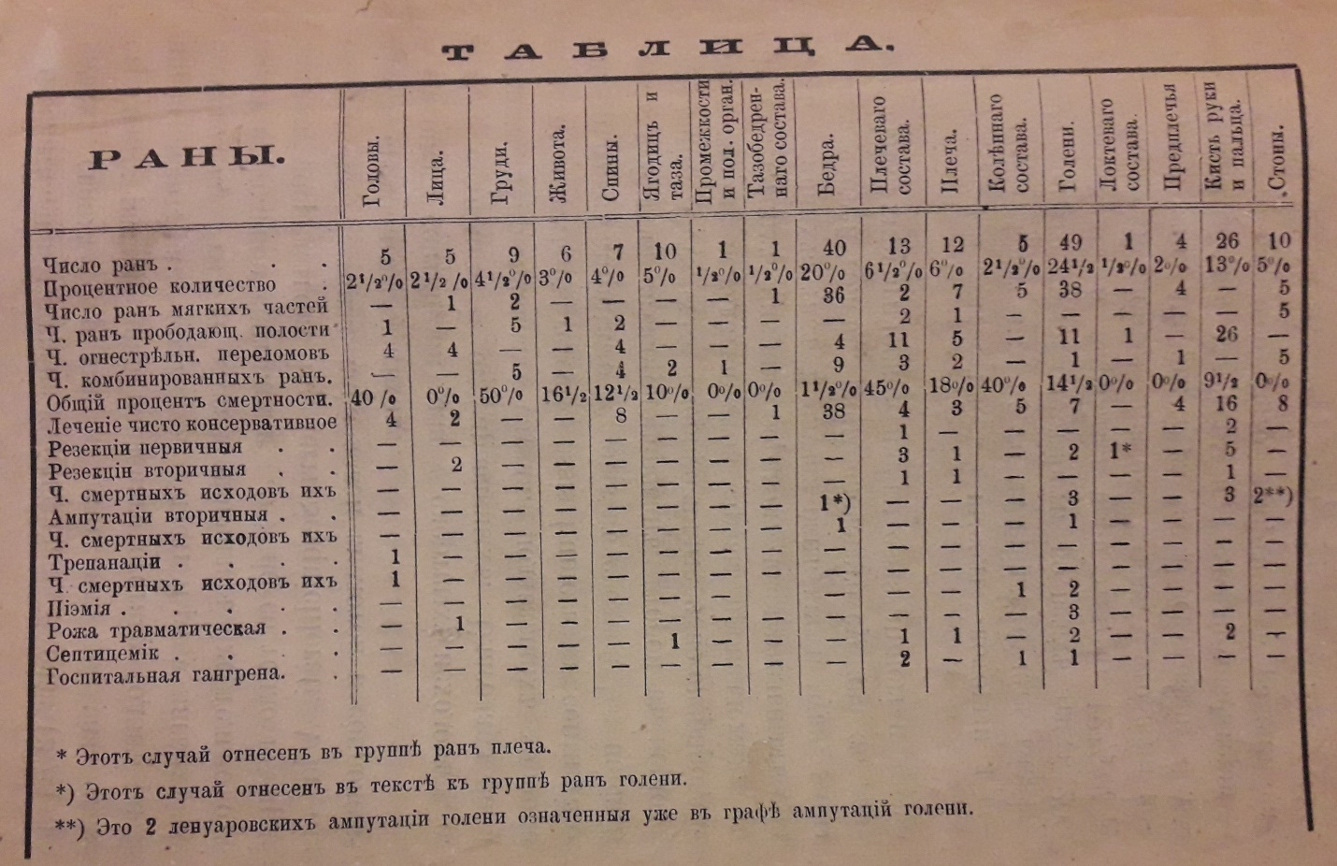

**Spreadsheet of the distribution of wounds from the materials of A. G. Podrez**

First of all, the author of the “Notes” points out that in his work he was guided by the principles of his mentor, respected professor W. F. Grube, and this made it possible to postpone the “unpleasant end” that befell his Hospital in Jagodina [13].

In the source, he points major problems medics faced. For example, the fate of typhoid and dysentery patients, who made up almost the majority, was difficult. All attention was paid to the wounded, and the sick were neglected, they were not admitted to hospitals, and had to spend the night in the open air on carts or even on the ground. For this attitude, Serbian authorities issued something like a reprimand to the doctors. In Jagodina, near four hospitals, there was a small Serbian hospital, which was supposed to accommodate more ill patients than the wounded in those four hospitals. So, it was necessary to put them in hospitals, where intra-hospital infections developed, in particular, dysentery. Because of the lack of normal ventilation and sanitary measures, there were more problems from one dysentery patient than from 5 wounded, as a result of which the infection spread rapidly.

The surgeon pointed out that a characteristic feature of the Serbian wounded was steadfast enduring of all the suffering associated with their condition. A. G. Podrez describes his patients in detail in the second chapter, paying attention to the nature and circumstances of their injuries and wounds, the course of treatment. For example, the case of young Serbian Matia Brdarich, who had enormous physical strength and a severe head injury, is described. Two paramedics barely managed to hold him down. Unfortunately, strong health did not save him. Or the case of captain of Bulgarian origin from Macedonia Ilia Markovich, wounded in the back by Serbian soldiers themselves due to the demands of strict discipline. The latter, despite receiving several bullets and not being young (55 years old) recovered, but with a decrease in the strength of the most injured shoulder. From the other newly arrived patient 5 pounds of pus were removed, and, despite consecutive treatment, he died of gangrene and septicemia. The “lucky man” with 6 holes from one bullet (in two hips and a penis) quickly recovered. It was a unique curious thing that ended well, but the descriptions of the wounds paint a realistic, unromantic, horrible truth of war. Also, from these materials it becomes known that local civilians used medical care in the hospital, as well as even a captured notorious bashi-bazouk who died of dysentery. Types of wounds were grouped into the wounds of skull, abdomen, back, etc. The most dangerous were injuries of a chest, with a 50 % mortality rate. At the same time, many patients, even with minor injuries, were affected by septicemia. Most of the injuries were caused by bullets and grenades. Speaking about injuries of hands and left hands’ fingers, A. G. Podrez indicates where this problem comes from. There were more than 400 such wounds. Powerful guns of the Peabody system caused terrible wounds, especially after shot from a close range. Hands were practically destroyed. The facts of self-mutilation were confirmed by numerous avowals, but Dr. Podrez did not reveal a nary patient in his text. For the first time in his practice, the doctor recorded a “mysterious phenomenon”, a contusion, calling it a “concussion of the nervous system”, after analyzing the inconsistency of the minor wounding of the young private Yovan Stanishych with fatal consequences. Also, we could find information about A. G. Podrez’s demonstration of his successful operation to Prof. N. V. Sklifosovsky and other outstanding doctors in the September of 1876. In general, statistically, out of 200 cases of injuries described by A. G. Podrez, 25 ended by death, i.e. 12.5%, of which 4.5% were directly from wounds. The rest were septicemia, hospital gangrene, pyemia, and dysentery. It should be noted that the statistical data is very incomplete, we are talking about the described cases only, and the surgeon himself points it out.

A. G. Podrez indicates that the activities of the majority of doctors in Serbia encountered incredible organizational difficulties. Unpreparedness of Serbia for the war and the lack of everything necessary for sanitary work except energy and the desire to work became obvious immediately. The biggest problem, according to A. G. Podrez’s vivid expression, “the most terrible evil”, was the servants, junior medical personnel, an analogue of modern paramedics [13]. There is nothing special here, because the same problem with the quality of junior medical personnel was also common in Kharkiv [15], and such an experience helped the medic in further work. The quality of training and the lack of motivation of local junior medical staff, who did not want to perform their duties, turned a simple dressing into a torture. A. G. Podrez pays attention to low-quality bandages, when it would be more useful not to do them at all. However, it was not possible to hire better staff financially. In addition, the author emphasizes the extreme unprofessionalism of the hospital management, which was not familiar with either Serbia or work. According to A. G. Podrez, his hospital was rightly accused of lack good administration, and, therefore, of poor hygienic conditions and disorder [13]. Later, by his fruitful administrative work in Kharkiv, he will show that a medical institution could be organized in a much better way.

One of the most difficult problems of hospitals at that time was overcrowding. This was not something extraordinary for Kharkiv doctors, they saw it at home as well [16], but the hospitals had an obvious specificity. After every significant battle, there was a large influx of wounded, and, writes A. G. Podrez, that all the places were occupied, and patients, if the weather permitted, were literally dumped in the yard or even on the street, even during rainy and cold nights. Here we should point that the main obstacle for A. G. Podrez was the need to send every wounded person as quickly as possible to more distant facilities. Analysing the style of speech in the text, we can see that the surgeon was at least not happy about such a situation at all, because it had not given him full and proper experience of treatment. Only after the end of his practical activity in the country, A. G. Podrez visited some hospitals on his way back, met “his” wounded there, who were interesting from a scientific point of view, but he could not always gather additional information about them. Apparently, this is a manifestation of a specific for the time medical subculture, when the wounded were not only people, but also study and scientific material.

**Conclusion.** We can see that during the war reflected in the “Notes” A. G. Podrez gained significant experience not only in field surgery, but also in all the spheres of medical institution functioning in extremal conditions. Participation in the Serbian-Turkish war during his early years influenced professional development of the young medic greatly; it was a real impetus for practical and theoretical growth. Basing on experience of that time, we can predict growth of contemporary Ukrainian young medics’ professionalism.

**Literature list**

1. Робак І.  Подрєз Аполлінарій Григорович // Енциклопедичний словник Харківщини. Харків : Золоті сторінки, 2014. С. 285.
2. Лесовой В. Н. Страницы истории урологии: профессор А. Г. Подрез // Урология. 2003. № 4. С. 71–72.
3. Зайцев Е. И., Лазарев С. М., Озеров В. Ф. Аполлинарий Григорьевич Подрез // Вестник хирургии. 2003. Т.162. № 5. С. 9–11.
4. Циганенко А. Я., Лісовий В. М. Професор А. Г. Подрєз: до 150-річчя з дня народження // Харківська хірургічна школа. 2002. № 4. С. 120–122.
5. Сипливий В. О., Гузь А. Г. А. Г. Подрєз – визначний хірург, науковець, викладач: до 150-річчя з дня народження // Харківська хірургічна школа. 2002. № 4. С. 123–125.
6. Теличкин И. А. Профессор хирургии Харьковского университета Аполлинарий Григорьевич Подрез: (к 150-летию со дня рождения) // Лікарська справа. 2002. № 7. С. 135–138.
7. Аполлинарий Григорьевич Подрез // Вестник хирургии им. И. И. Грекова. 1989. Т. 142, № 5. С. 2.
8. Шаповал В. И., Арнольди Э. К. Жизнь и деятельность профессора А. Г. Подреза: к 125-летию со дня рождения // Урология и нефрология. 1977. №6. С. 71–74.
9. Гозный А. Д. Профессор Аполлинарий Григорьевич Подрез (1852–1900) // Клиническая хирургия. 1975. № 2. С. 78–79.
10. Лесовой В. Н., Перцева Ж. Н. А. Г. Подрез – один из основоположников отечественной урологии (к 160-летию со дня рождения) // Медична газета. 2012. № 21. С. 7.
11. Попов М. А. Профессор Аполлинарий Григорьевич Подрез, его служебная и литературная деятельность. Харьков: паровая тип. и литогр. М. Зильберберг и сыновья, 1902. 158 с.
12. Подрез А. Профессор Вильгельм Федорович Грубе // Записки Императорского харьковского университета. 1894. Кн. 4. Харьков : Типо и литография М. Зильберберг, 1894. С. 22–28.
13. Подрез А. Военно-хирургические заметки из Сербско-турецкой войны 1876 года. Харьков : Типография К. П. Счасни, 1877. 82 с.
14. Вірні клятві Гіппократа: розповіді про тих, хто є взірцем для прийдешніх поколінь лікарів / В. М. Лісовий, В. А. Капустник, Ж. М. Перцева. Харків : ХНМУ, 2020. 624 с. С. 185.
15. Al’kov V. A. The issue of moral level among the junior personnel of Kharkiv provincial municipal hospital psychiatric units in the late 19-th – early 20-th century // Медицина третього тисячоліття. Харків : ХНМУ, 2014. С. 340–341.
16. Альков В. А. Харківська Олександрівська лікарня в імперську добу: проблема доступності // Історична спадщина та сучасні аспекти забезпечення громадського здоров’я в Україні. Харків : ХНМУ, 2017. С. 17–18.

**References**

1. Robak I. Podriez Apollinarii Hryhorovych [Podrez Apollinarius G.]. In: Encyclopedic dictionary of Kharkiv region. Kharkiv : Zoloti storinky; 2014:285 (In Ukrainian).
2. Lesovoj VN. Stranicy istorii urologii: professor A. G. Podrez [Pages of history of Urology: Professor A. G. Podrez]. Urologiya – Urology. 2003;4:71–72 (In Russian).
3. Zajcev EI, Lazarev SM, Ozerov VF. Apollinarij Grigor'evich Podrez [Apollinarius G. Podrez]. Vestnik hirurgii – Bulletin of Surgery. 2003;5:9–11 (In Russian).
4. Tsyhanenko AY, Lisovyi VM. Profesor A. H. Podriez: do 150-richchia z dnia narodzhennia [Professor A. G. Podrez: on the 150th anniversary of his birth]. Kharkivska khirurhichna shkola – Kharkiv surgical school. 2002;4:120–122 (In Ukrainian).
5. Syplyvyi VO, Huz AH. A. H. Podriez – vyznachnyi khirurh, naukovets, vykladach: do 150-richchia z dnia narodzhennia [A. H. Podrez. Prominent surgeon, scientist, teacher: on the 150th anniversary of his birth]. Kharkivska khirurhichna shkola – Kharkiv surgical school. 2002;4:123–125 (In Ukrainian).
6. Telichkin IA. Professor hirurgii Har'kovskogo universiteta Apollinarij Grigor'evich Podrez: (k 150-letiyu so dnya rozhdeniya) [Professor of Surgery of Kharkiv University Apollinarius G. Podrez: (on the 150th anniversary of his birth)]. Likars'ka sprava – Medical Affair. 2002;7:135–138 (In Russian).
7. Apollinarij Grigor'evich Podrez [Apollinarius G. Podrez]. Vestnik hirurgii im. I. I. Grekova – I. I. Grekov bulletin of Surgery. 1989;5:2 (In Russian).
8. Shapoval VI, Arnoldi EK. Zhizn' i deyatel'nost' professora A. G. Podreza: k 125-letiyu so dnya rozhdeniya [Life and work of Professor A. G. Podrez: on the 125th anniversary of his birth]. Urologiya i nefrologiya – Urology and Nephrology. 1977;6:71–74 (In Russian).
9. Goznyj AD. Professor Apollinarij Grigor'evich Podrez (1852–1900) [Professor Apollinarius G. Podrez (1852–1900)]. Klinicheskaya hirurgiya – Clinical Surgery. 1975;2:78–79 (In Russian).
10. Lesovoj VN, Pertseva ZN. A. G. Podrez – odin iz osnovopolozhnikov otechestvennoj urologii (k 160-letiyu so dnya rozhdeniya) [A. G. Podrez as one of Domestic Urology Founders (celebrating the 160th anniversary of the birth)]. Medychna gazeta – Medical Newspaper. 2012;21:7 (In Russian).
11. Popov MA. Professor Apollinarij Grigor'evich Podrez, ego sluzhebnaya i literaturnaya deyatel'nost' [Professor, his official and literary activities]. Kharkiv : M. Zil'berberg i synov'ya; 1902. 158 p. (In Russian).
12. Podrez A. Professor Vil'gel'm Fedorovich Grube [Professor Wilhelm F. Grube]. In: Notes of the Imperial Kharkiv University. Vol. 4. Kharkiv : M. Zil'berberg; 1894: 22–28. (In Russian).
13. Podrez A. Voenno-hirurgicheskie zametki iz Serbsko-tureckoj vojny 1876 goda [Military-Surgical notes from the Serbian-Turkish war of 1876]. Kharkiv : Tipografiya K. P. Schasni; 1877. 82 p. (In Russian).
14. Virni kliatvi Hippokrata: rozpovidi pro tykh, khto ye vzirtsem dlia pryideshnikh pokolin likariv [Faithful to the oath of Hippocrates: story about those, who are examples for upcoming generations of physicians]. Kharkiv : KhNMU; 2020:185 (In Ukrainian).
15. Al’kov VA. The issue of moral level among the junior personnel of Kharkiv provincial municipal hospital psychiatric units in the late 19th – early 20th century. In: Medicine of the third millennium. Kharkiv : KhNMU; 2014:340–341.
16. Alkov VA. Kharkivska Oleksandrivska likarnia v impersku dobu: problema dostupnosti [Kharkiv Alexander’s Hospital during the imperial era: the problem of accessibility]. In: Historical heritage and modern aspects of public health in Ukraine, Kharkiv : KhNMU; 2017:17–18 (In Ukrainian).

Робак Ігор Юрійович, доктор історичних наук, професор, завідувач кафедри суспільних наук Харківського національного медичного університету, м. Харків, 61022, пр. Науки, 4, 0679300444, [robak@ukr.net](mailto:robak@ukr.net)

Альков Володимир Андрійович, кандидат історичних наук, доцент, кафедра суспільних наук Харківського національного медичного університету, м. Харків, 61022, пр. Науки, 4, 0935690444, [va.alkov@knmu.edu.ua](mailto:va.alkov@knmu.edu.ua)

Ihor Robak, Dr. Hab. in History, Professor, Head of the Department of Social Sciences, Kharkiv National Medical University, Kharkiv, 61022, Nayky Ave, 4, 0679300444, [robak@ukr.net](mailto:robak@ukr.net)

Volodymyr Alkov, Ph.D. in History, Associate Professor of the Department of Social Sciences, Kharkiv National Medical University, Department of Social Sciences, Kharkiv, 61022, Nayky Ave, 4, 0935690444, [va.alkov@knmu.edu.ua](mailto:va.alkov@knmu.edu.ua)