COMPARATIVE ANALYSIS OF THE DYNAMICS OF MODIFIED RISK FACTORS OF NON-COMMUNICABLE DISEASES AMONG THE POPULATION OF CHINA AND UKRAINE
Vyacheslav M. Zhsan¹, Irina A. Holovanova¹, Maksim V. Khorosh¹, Maria M. Tovstiak¹, Andriy .M. Zinchuk²
¹ Ukrainian Medical Stomatological Academy, Poltava, Ukraine
² Kharkiv National Medical University, Kharkov, Ukraine

ABSTRACT
Introduction. In the modern world, the problem of non-communicable diseases, which nowadays constitute the main cause of social and economic losses, is extremely topical: the main causes of disability and mortality of the working population are caused by non-communicable diseases.
The aim is a comparative analysis of the prevalence and dynamics of the risk factors of the NCDs, and the overall mortality rate between the economically developed country - China and the developing country - Ukraine.
Materials and methods: To achieve the set goal, the method of data analysis was used - the alignment of dynamic rows with the definition of increasing rates, the determination of reliability between two unrelated aggregates, triangulation. Material: annual reports of the State Statistics Service of Ukraine and the National Bureau of Statistics of China.
Results and discussion. As a result of the study, it was found that with the tendency to reduce the mortality rate, the mortality rate in Ukraine exceeds the rate in China, especially among men (2.5-3 times); the percentage of smoking is 6 times higher among Ukrainian women; an increase in malnutrition is observed in Ukraine, while in China it is constantly decreasing; in both countries there is an increase in the frequency of obesity in both sexes, but in Ukraine the prevalence is 4-6 times higher.
Conclusions. Thus, using the obtained data, one can conclude that, despite the difference in the level of economic development between countries, behavioral risk factors remain an extremely important problem.
Key words: non-communicable diseases, risk factors, triangulation, dynamic rows, China, Ukraine

Introduction. In the modern world, the problem of non-communicable diseases, which nowadays constitute the main cause of social and economic losses, is extremely topical: the main causes of disability and mortality of the working population are caused by non-communicable diseases (cardiovascular diseases, various neoplasms, chronic obstructive pulmonary diseases and diabetes mellitus).
The importance of this problem was noted during the Third High-level Meeting of the UN General Assembly on Non-communicable Diseases (NCDs) (New York, September 27, 2018) [1]. According to published data, about 71% (40.5 million cases) of all deaths in the world are due to NCDs. The rejuvenation of this problem was noted separately - 4% of deaths were noted at the age of up to 30 years and 38% at the age of 30 to 70 years. The data on increasing the probability of death before reaching of 70 years old age, as a result of NCDs among 165 countries (89% of countries) [2, 3].
Specialized missions in more than 25 countries are being organized by a specialized United Nations task force on the prevention and control of non-communicable diseases. The goals of these missions is to promote and support measures to strengthen the political support for the fight against NCDs at the level of governmental and non-governmental organizations, as well as the private sector and scientific communities [3].
When assessing the prevalence of NCDs, there is a situation where more economically developed countries (USA, Western Europe, China) have the capacity to organize adequate prevention and treatment of this group of pathologies, combat against the main risk factors contributing to its development, but still have a high prevalence of non-communicable diseases and their risk factors. For patients with non-communicable diseases from countries of low economic well-being and countries that are developing, another pattern is observed: on the one hand, the cost of treating a cardiovascular disease or tumor process is 5-7 or more times higher than the patient’s income, which makes it difficult or rejects his treatment, on the other hand, in economically underdeveloped countries, there is an excessive spread of risk factors for these diseases [4, 5].
In China, chronic non-communicable diseases account for about 80% of deaths and 70% of lost years of life. The main non-communicable diseases that are characteristic of China are cardiovascular diseases and cancer, which are the main causes of death and exacerbate the burden of disease. One of the main NCDs behavioral risk factors - smoking is widely spread among China's population: more than 300 million men smoke cigarettes. The high level of concern induced by is the prevalence of obesity, since more than 20% of children and adolescents are overweight or have obesity. Great attention is paid in China to organizing of preventive measures in relation to the NCD group. [6].
Nowadays, the state of health of Ukraine's population is estimated at unsatisfactory level, what is associated with a high level of overall mortality, morbidity and disability, which are steadily increasing [7, 8]. Non-communicable diseases in Ukraine account for about 86% of the global burden of disease and have a negative tendency to increase. The first place in the structure of mortality (67.3%) and primary disability of the adult population (23%) are cardiovascular diseases (CVD): during the year 2015, mortality from CVD increased by 4.7%, from malignant neoplasms - by 4.4%, from diabetes - by 8.8%. In the WHO European countries ranking, Ukraine ranks fourth in terms of standardized mortality rates due to CVD, mortality of the working-age population as a result of oncological diseases, prevalence of smoking among men, and the fifth place - per capita consumption of alcohol [9].
The aim of our research is to conduct a comparative analysis of the prevalence and dynamics of the risk factors of the NCDs (smoking, obesity and malnutrition), and the overall mortality rate between the economically developed country - China (2nd place per GDP per capita) and the developing country - Ukraine (61 place by level of GDP per capita) [10, 11].
Materials and methods: To achieve the set goal, the method of data analysis was used - the alignment of dynamic rows with the definition of increasing rates, the determination of reliability between two unrelated aggregates, triangulation. Material: annual reports of the State Statistics Service of Ukraine and the National Bureau of Statistics of China.
Results and discussion. The first step of the study was to trace the dynamics of the indicators of total mortality between China and Ukraine. It was found that in China throughout the entire study period, there has been a steady decline in the overall mortality rate for both men - from 108.4 per 1000 population in 2005 to 92.1 per 1000 population in 2016, and among women - from 81.3 up to 67.1 per 1000 population respectively (Fig. 1а). For the population of Ukraine, the picture is somewhat different: the trend towards a decline in the overall mortality rate has been observed since 2008, and before that there has been a gradual rise in the indicator (Fig. 1b). Thus, among the male population, the overall mortality rate changed from 382.8 per 1000 population in 2005, reaching a maximum of 403.5 per 1000 population in 2008 and gradually decreasing to 292.1 in 2016. A similar pattern is observed for the total mortality rate among the female population - from 140.5 per 1000 population in 2005 to 111.3 per 1000 population in 2016 with a peak of 150.2 per 1000 population in 2008.
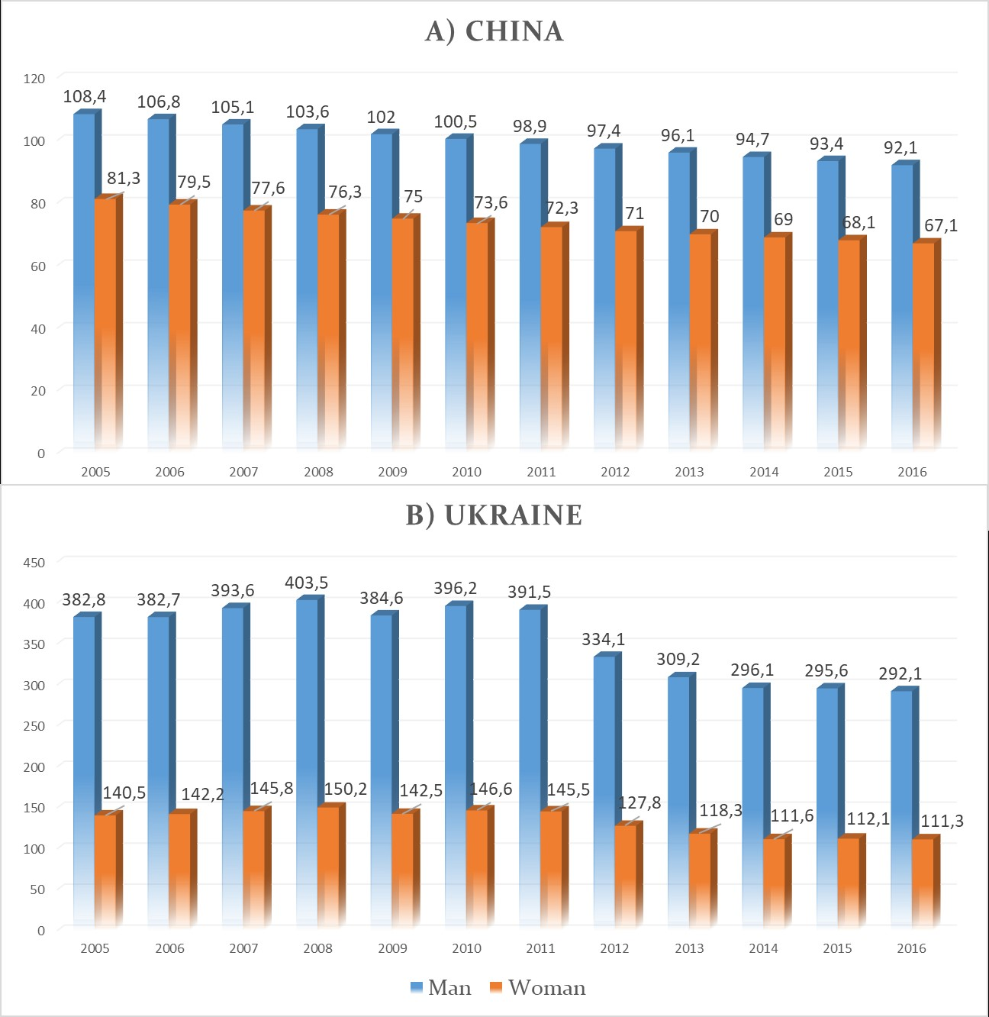
Figure 1. The total mortality rate of the adult population in China (A) and Ukraine (B) for the years 2005-2016.
As a result of the comparative analysis of the mortality rate, depending on gender, it has been established that there is a tendency towards a decrease in the mortality rate in both countries in the adult male population (p <0.05) (Fig.2а). The mortality rate of the male population in Ukraine is 2,5-3 times higher than in China. A similar picture is observed for indicators of mortality among adult female population (p<0,05) (Fig. 2b), the difference between mortality rates is 1.3-1.8 times.
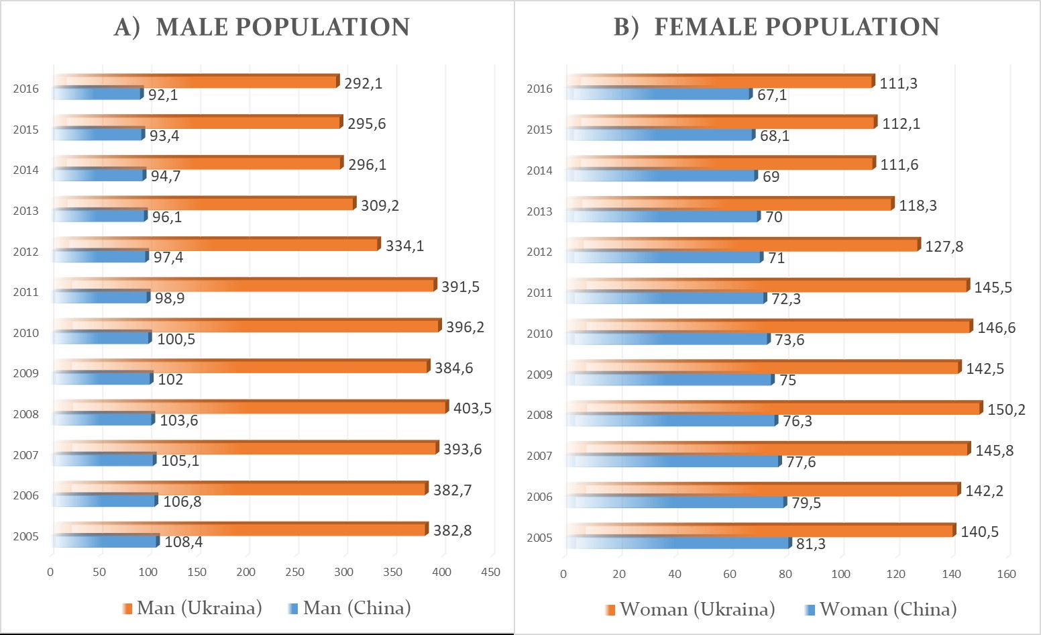
Figure 2. Comparison of mortality rates in China and Ukraine, depending on gender: a - men, b - women.
Analyzing the growth rate (decline) of the total mortality rate it was established that for the population of China this indicator is stable and amounts to -1.3% - -1.6% among men and -1.3% - -1.8% among women. At the same time, Ukraine is characterized by a constant fluctuation of this indicator from -14.7% to + 3.0% among men and from -12.2% to + 3.0% among women (Fig. 3a,b).
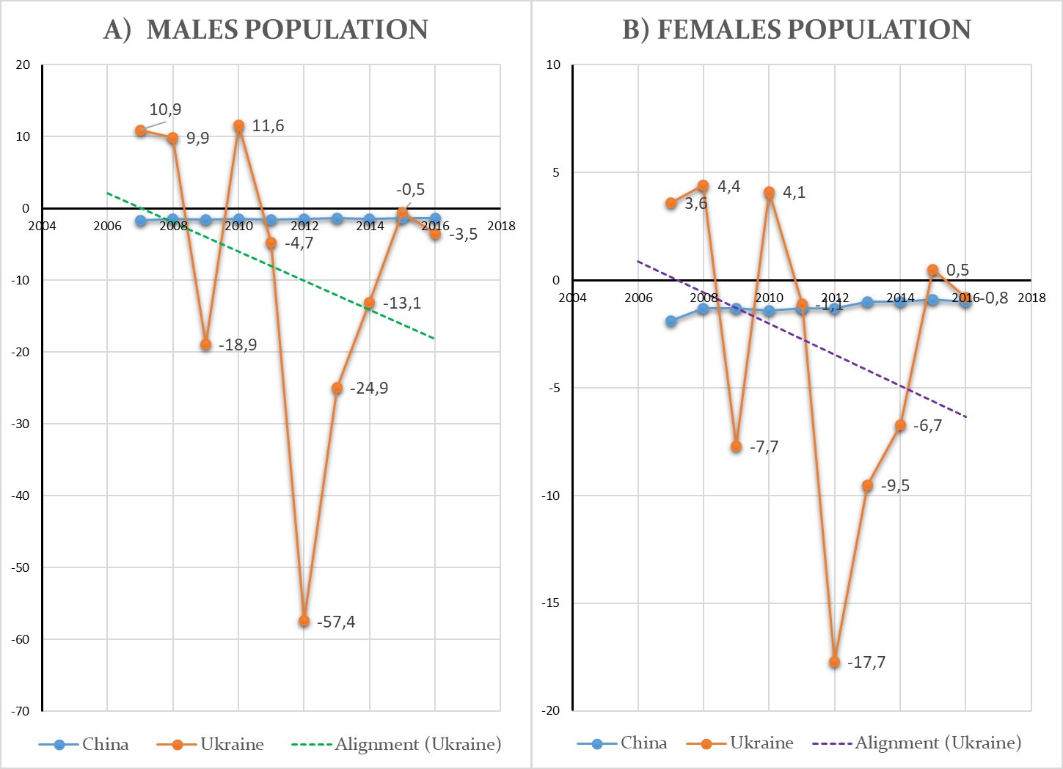
Figure 3. Comparison of the dynamics of the increasing (decreasing) rate of the total mortality rate in China and Ukraine: a - men, b - women.
Smoking is one of the major risk factors for non-communicable diseases. Studying the prevalence of smoking among the population of China and Ukraine depending on gender, it was found that the prevalence of smoking among the male population of both countries is consistently high - 48.4% for Ukraine and 47.4% for China (Fig. 4а). As for the prevalence of smoking among women, there is a significant predominance of smoking among the female population of Ukraine - 13.5% against 1.9% among Chinese residents. (Fig. 4б). It should be noted that in both countries there is a tendency to reduce the prevalence of smoking for both man and woman.
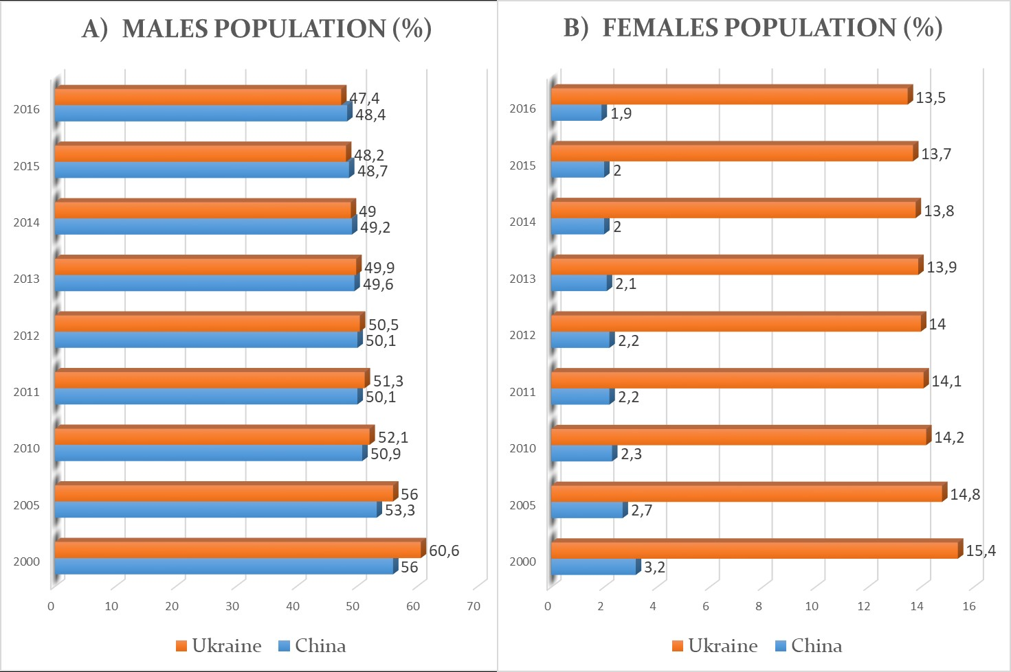
Figure 4. The prevalence of smoking among the population of China and Ukraine: a - men, b - women.
Analyzing the increasing (decreasing) rate in the prevalence of smoking, it was established that throughout the entire study period there was a decrease in this indicator among both men and women in both countries. It should be noted that if the decreasing rate for the male population is stable over the whole period of time: -0.8% – -1% in China and -1.1% – -1.5% in Ukraine (Fig. 5a), then among women there is a variation of this indicator in the population of China from -4.35% to 0.0%, while in Ukraine this indicator is stable and amounts to -0.7% – -1.4% (Fig. 5b).
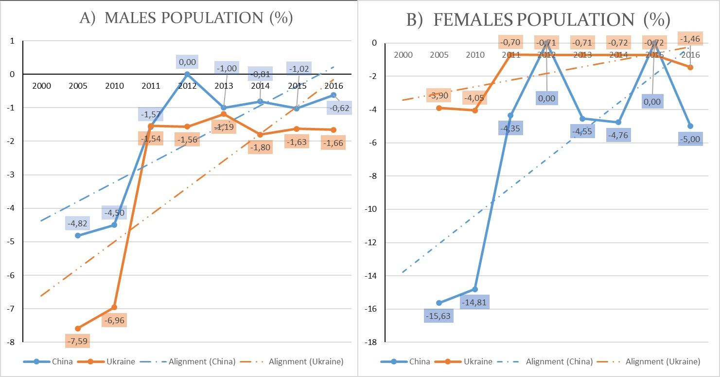
Figure 5. Comparison of the dynamics of the increasing (decreasing) rate of the smoking among population of China and Ukraine: a - men, b - women.
Separate interest for the development of non-communicable diseases are nutritional disorders, both in the direction of excessive consumption of certain foods and the development of alimentary obesity, as well as due to insufficient unbalanced nutrition. We have analyzed the prevalence of malnutrition rates in Ukraine and China. As a result of the analysis, it was established that the malnutrition rate in China has a constant downward trend throughout the entire covered period: from 15.2% in 2005 to 8.7% in 2016, which points towards a gradual improvement in the quality of life. In the same period, the opposite situation is observed in Ukraine - the malnutrition rate for a long period was consistently 2.5%, and only from 2015 it began to change upwards – 2.9% in 2015 and 3.3% in 2016 year (Fig. 6).
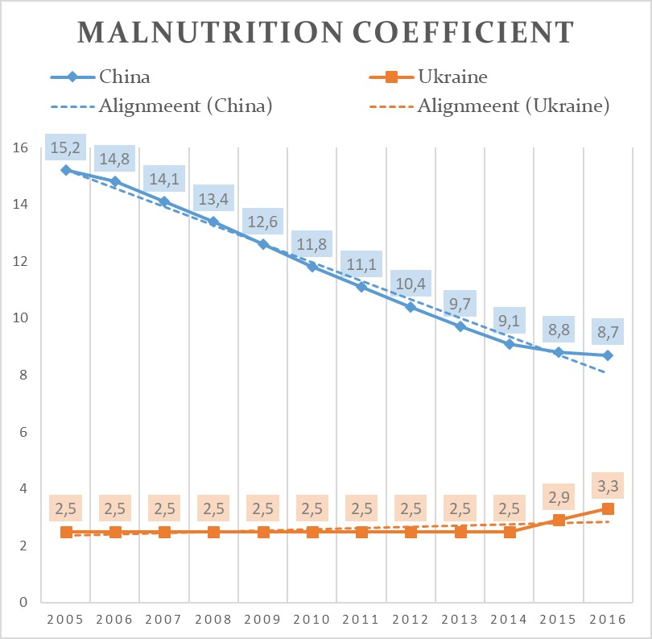
Figure 6. Dynamics of malnutrition rate among the population of China and Ukraine.
Studying the increasing (decreasing) rate of the malnutrition coefficient, it was established that for the population of China there is a change in the rate of decline in the range of -3.3% – -6.7% with a tendency to slow down. In Ukraine, the increasing (decreasing) rate tends to increase and varies between + 13.7% – + 16.0% (Fig. 7).
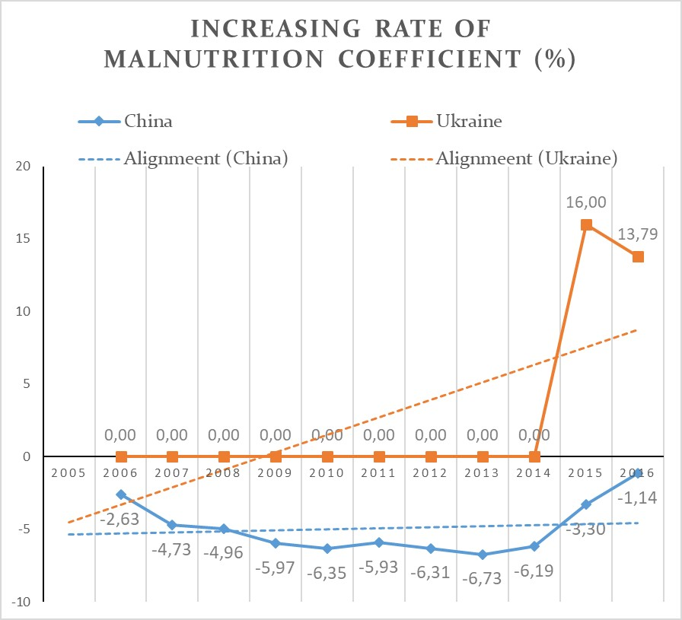
Figure 7. The increasing (decreasing) rate of the malnutrition coefficient among the population of Ukraine and China.
Studying the prevalence of obesity among the population of China and Ukraine, it was established a gradual increase in the prevalence of obesity among the population of both China and Ukraine. At the same time, in Ukraine, both among men and women, the obesity rate among the population is 3.5–4 times higher than in China (Fig. 8).
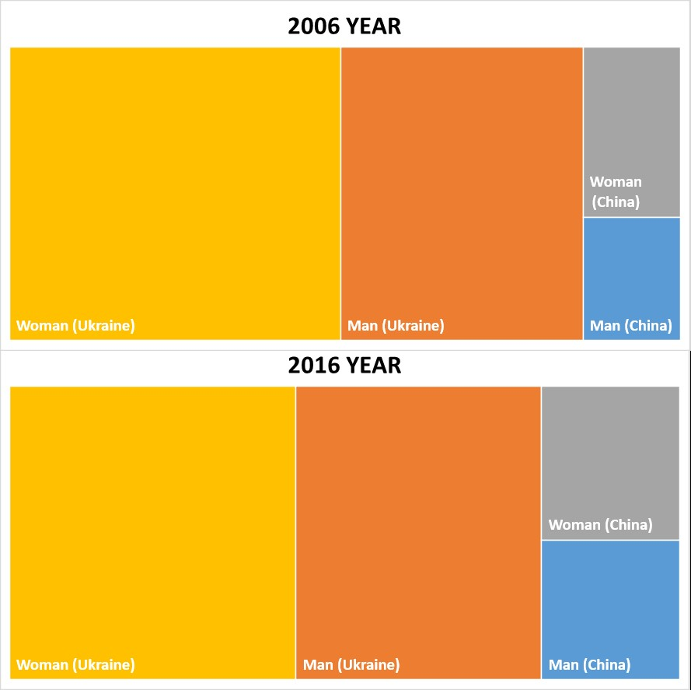
Figure 8. The ratio of the prevalence of obesity among the population of China and Ukraine.
During the study period, the obesity rate among men in Ukraine increased from 17.2% in 2006 to 22% in 2016 (in China from 2.9% to 5.9% respectively) (Fig. 9a); among women in Ukraine there is an increase in the prevalence of obesity from 23.5% in 2006 to 25.7% in 2016 (in China, respectively, from 4% to 6.5%) (Fig. 9b).
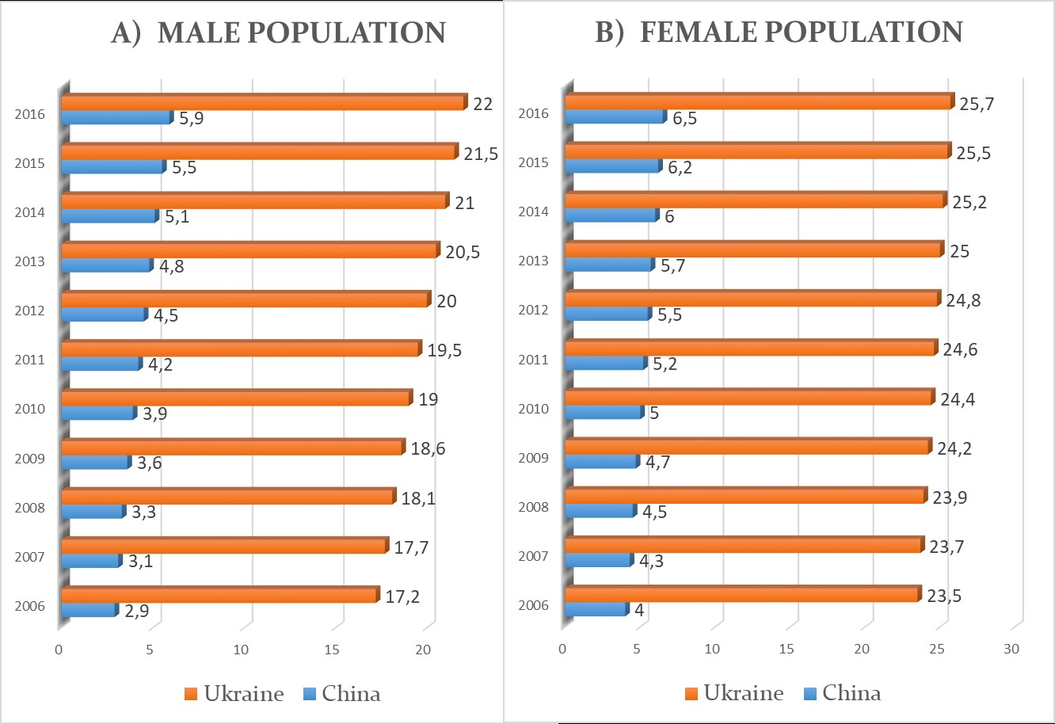
Figure 9. The prevalence of obesity among the population of China and Ukraine: a - men, b - women.

Investigating the dynamics of the increasing (decreasing) rate in the prevalence of obesity, there is a trend to increase the rate as among the male population of China with an annual fluctuation of the growth rate within the range of 6.5-7.5%, as well as among Ukrainian men with a fluctuation of growth rate within 2, 2% -2.8%. A similar situation is observed among women: in China, the indicator varies between 1.5%-2.5%, and in Ukraine, within the range of 0.8%-1.4% (Fig. 10).
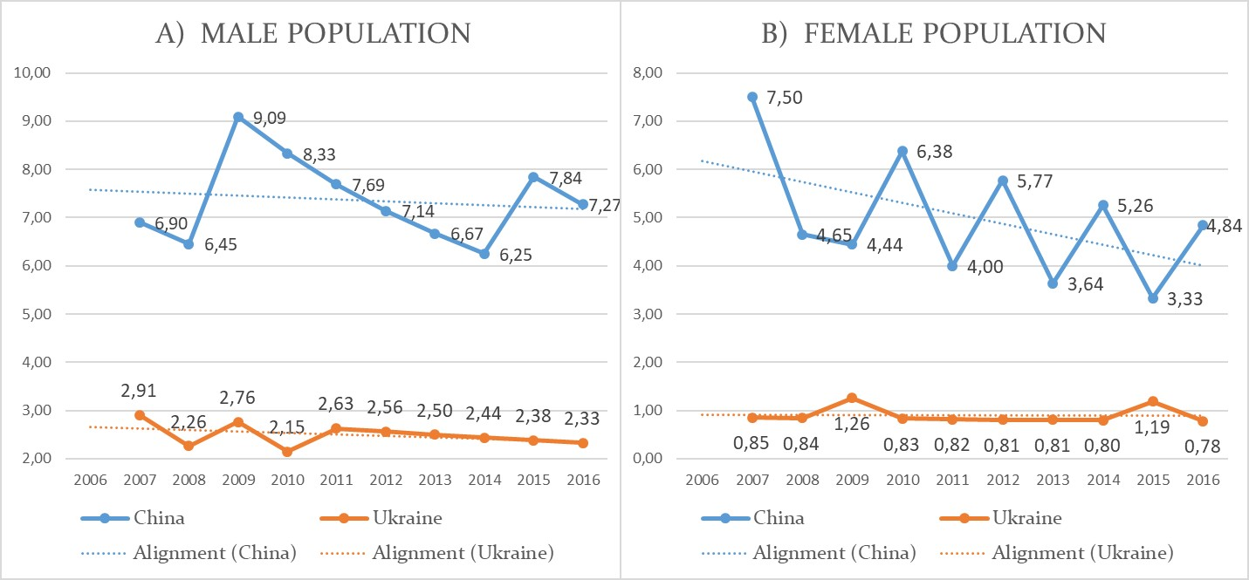
Figure 10. Comparison of the increasing (decreasing) rate in the prevalence of obesity among the population of China and Ukraine: a - men, b - women.
Conclusions. As a result of the study, it was found that with the tendency to reduce the mortality rate, the mortality rate in Ukraine exceeds the rate in China, especially among men (2.5-3 times); the percentage of smoking is 6 times higher among Ukrainian women; an increase in malnutrition is observed in Ukraine, while in China it is constantly decreasing; in both countries there is an increase in the frequency of obesity in both sexes, but in Ukraine the prevalence is 4-6 times higher.
Thus, using the obtained data, one can conclude that, despite the difference in the level of economic development between countries, behavioral risk factors remain an extremely important problem.

REFERENCES
1. Time to deliver. Third UN High-Level Meeting on Non-communicable Diseases. New York. September 27, 2018. – https://www.who.int/ncds/governance/third-un-meeting/brochure.pdf?ua=1 [Electronic access].

2. James E Bennett, Gretchen A Stevens, Colin D Mathers. NCD Countdown 2030: worldwide trends in non-communicable disease mortality and progress towards Sustainable Development Goal target 3.4./James E Bennett, Gretchen A Stevens, Colin D Mathers et all// Lancet. – Vol. 392. – Issue 10152. – 22–28 September 2018. – P. 1072-1088. – https://www.sciencedirect.com/science/article/pii/S0140673618319925 [Electronic access].

3. Nicholas Banatvala, Svetlana Akselrod, Douglas Webb. Actions needed to prevent noncommunicable diseases and improve mental health. //Bull World Health Organ. – 2019 Feb 1; 97(2): 75–75A. – https://www.ncbi.nlm.nih.gov/pmc/articles/PMC6357564/ [Electronic access].

4. Stephen Jan, Tracey-Lea Laba, Beverley M Essue. Action to address the household economic burden of non-communicable diseases. // Lancet. – Vol. 391. – Issue 10134. – 19–25 May 2018. – P. 2047-2058. – https://www.sciencedirect.com/science/article/pii/S0140673618303234 [Electronic access].

5. Zhdan V. M. Medical evaluation of efficiency of optimized models for early detection and primary prevention of cardiovascular diseases /V. M. Zhdan, I. A. Holovanova, M. V. Khorosh et all// WiadomosciLwkarskie. – 2017. – T. LXX. - №3. – cz. I. – P. 433–438.
6. Longde Wang, Lingzhi Kong, Fan Wu. Preventing chronic diseases in China. //Lancet. – Vol. 366. – Issue 9499. – 19–25 November 2005. – P. 1821-1824. – https://www.sciencedirect.com/science/article/pii/S0140673605673448 [Electronic access].

7. Strashko S.V. Infekcijni ta neinfekcijni xvoroby`, shho nabuly` social`nogo znachennya. (Ukr) [Infectious and non-infectious diseases that have acquired social significance] / S.V. Strashko, І.P. Krivich, G.M. Guseva, V.G. Bilyk // Appendix to the textbook on the basics of medical knowledge for students of pedagogical specialties of institutions of higher education. - Kyiv: Publishing House "Alaton", 2018. - Edition. 2.- 74 p.

8. Romanjuk N., Romanjuk L., Riabokon M. Rol likariv pervynnoi medyko-sanitarnoi dopomohy v borotbi z epidemiieiu neinfektsiinykh zakhvoriuvan.(Ukr) [The role of primary health care physicians in the fight against the epidemic of non-communicable diseases]. - Achievements of clinical and experimental medicine. – 2018. – №2. – P.249-251.

9. Gruzeva T. S., Galienko L.I. Protydiia ta kontrol za neinfektsiinymy zakhvoriuvanniamy: novi perspektyvy v umovakh formuvannia systemy hromadskoho zdorovia v Ukraini. [Counteraction and control of non-infectious diseases: new perspectives in the context of public health system formation in Ukraine]./ Ukraine. The health of the nation. – 2017. - №3(44). – P. 315-316.

10. The World Bank: Gross Domestic Product 2018. - http://www.worldbank.org/ [Electronic access]
11. Belikova I.V., Rudenko LA. K voprosu usovershenstvovaniya informatsionno-analiticheskoy sostavlyayuschey v usloviyah reformirovaniya sistemyi zdravoohraneniya Ukrainy (Rus) [On the issue of improving the information-analytical component in the context of reforming the health care system in Ukraine].// Wiadomosci Lekarskie. – 2016. – LXIX. – 2(II) – P. 249-251.

ADDRESS FOR CORRESPONDENCE
Maksim V. Khorosh
Shevchenka, 23, Poltava, Ukraine
e-mail: indarion0@gmail.com

