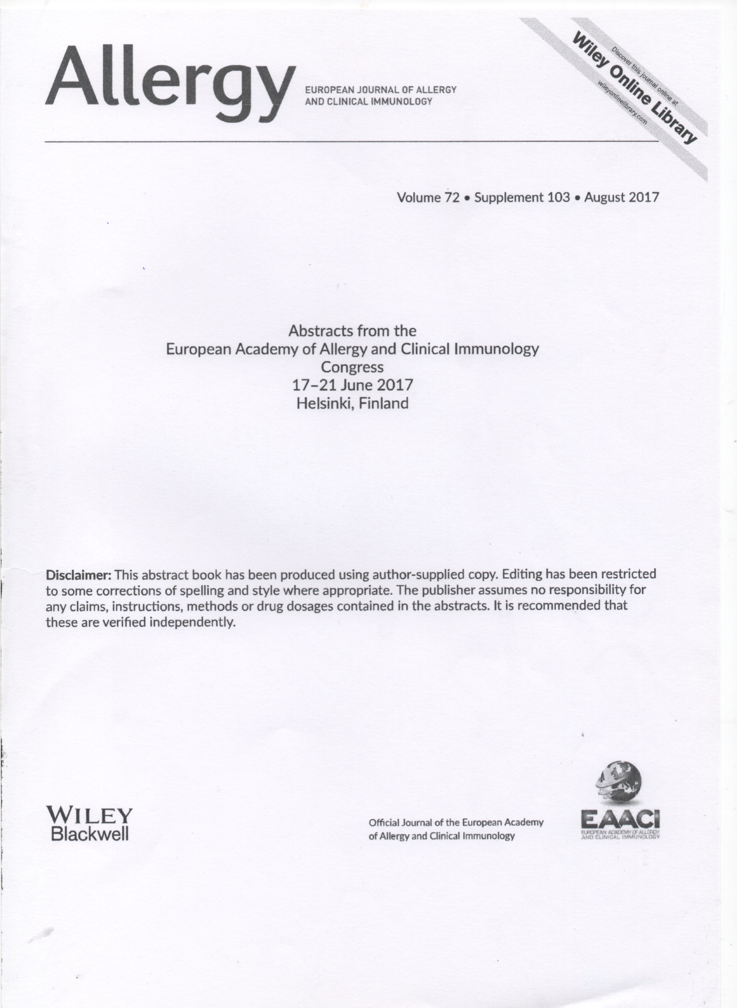

№ 1663.The role of allergens in the progression of obesity and hyperglycemia in asthma patients.

Bezditko T.,Yeremenko G.
Aim: Set the influence of obesity and hyperglycemia on the threshold of allergic sensitization in patients with asthma
Materials and Methods A total of 23 patients asthma uncontrolled flow in combination with diabetes mellitus type 2 (SD2T). Evaluated the clinical and laboratory data, FVC, FEV1, the level of total (IgE) and specific (sIgE to Ara h9, Gly m 4, Tri a 19, Pru p 1, Bet v 1, nAmb, nArt v3, nArt v1) by technique ImmunoCap (Fadia)
Discussion of the results. The high sensitization to food allergens in 16 patients, in 5 - pollen in patients, 3 patients, sensitization to allergens studied is not revealed. Revealed sensitization to an allergen and polisensibilizatsiya. These indicators are distributed as follows: from 9 -Ara h9 averaged 14,3 ± 1,12 kUA / L, at 6 Gly m 4 - 16,4 ± 0,85 kUA / L; 1 patient Tri a 19 - 8,3 kUA / L. Polisensibilizatsiya detected in 15 patients, 8 - Ara h9 and Bet v 1, Bet v 1 and 7 - Gly m 5 and Tri a 19.
Positive correlations among the entire group of patients examined between the level of hyperglycemia and the level of sensitization to food allergens r = 0,72 (p <0,001), and pollen allergens r = 0,55 (p <0,05) IMB = 0,32 (p <0.05), and negative correlation with FEV1 r = -0,42 (p <0.05).

Conclusions: The problem of glucose homeostasis disorder demand further study to pathogenesis clarification, diagnostic optimization and treatment. The solution to the problem of food and pollen allergyinfluence on disease progression is evident, however, for making detailed conclusions it is important to research this group of patients.

