TOPIC: «**Orthopedic dentistry as the medical science. Organs of masticatory system and their function**»

Teacher : Dudina I. L.

Plan of the lecture:

1. Orthopedic dentistry as medical science;
2. Dental and technician apartments

3. Organs of maxilla-facial system

"Orthopedics"

prevention and correction of musculoskeletal

system disorders

Dentistry

prevention, diagnosis, and treatment of diseases and disorders of oral cavity, maxillofacial region, and associated structures

orthopedic dentistry

recognition, prophylaxis and treatment of hereditary and gained diseases or deformations of dental-maxilla-facial system by using of orthopedic methods (devices and prostheses)

The goals of orthopedic dentistry:

1. To improve methods of diagnostics, prophylaxis, treatment of dental-maxilla-facial system’s diseases;

2. To provide qualified dental aid to the patients;

3. To widen knowledge concerning physiological and pathological processes before and after treatment.

The tasks of orthopedic dentistry:

1. To provide prophylaxis, early diagnosis, treatment of dental-maxilla-facial system diseases by using of orthopedic methods;

2. To provide rehabilitation procedures after treatment;

3. To provide regular medical check-up of the patients.

ORTHOPEDIC DENTISTRY

Propedeutic course

* anatomical-physiological features of masticatory apparatus;
* methods of patient’s examination;
* signs of illness;
* material science;
* laboratory technique.

The main course

* prosthodontics;
* maxilla-facial orthopedics;
* orthodontics

Scheme of a dental room (14m2 for 1 dental unit and + 7m2 to each added dental unit)

Square for 1 dental unit is 14m2 + 7m2  for additional one

1. Dental unit;
2. Dental arm-chair;
3. assistant‘s table;
4. assistant‘s chair;
5. dentist‘s chair;
6. Table for instruments;
7. Cabinet for medicines;
8. Draught;
9. Couch
10. sink;
11. Gypsum table.

Scheme of a dental laboratory apartment

In dental policlinic or separated

Accident prevention

* To work wearing a working clothes (surgeon’s coat, cap);
* To work with protective gloves, plastic cover, glasses;
* To work with saliva ejector, dust separator;
* To wash hands with special disinfectants;
* Impressions, prostheses and other materials must be disinfected properly;
* Disposable instruments must be destroyed immediately after using, others - sterilized;
* to start working with patient from taking his history;
* To be careful using sharp instruments
* To use earth connection to electrical devises, don’t use apparatus' out of order or you don’t know their mode of operation;
* To be careful using harmful liquids (sulfuric acid, hydrogen peroxide).

Maxillofacial system composed of:

- Skeleton;

- Teeth;

- Masticatory and mimic muscules;

- Organs which take part in forming of food bolus;

- Salivary glands;

- Temporo-mandibular joint (TMJ).

Functions of the musular-facial system include:

* Feeding (mastication)
* Phonation and Vocalization
* Breathing

Permanent teeth

The simple formula of permanent teeth

8 7 6 5 4 3 2 1 1 2 3 4 5 6 7 8

8 7 6 5 4 3 2 1 1 2 3 4 5 6 7 8

Formula of permanent teeth   
by WHO

I II

18 17 16 15 14 13 12 11 21 22 23 24 25 26 27 28

48 47 46 45 44 43 42 41 31 32 33 34 35 36 37 38

IV III

Tooth formation

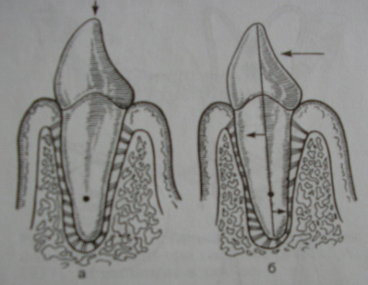Anatomical neck of the tooth is the border between crown and root (the thinnest part of the tooth)

Clinical neck of the tooth is the thinnest part of the crown which is located above the gum

Surfaces of teeth

Incisors and canines:

1. Vestibular
2. Palatal or lingual (oral)
3. Medial and distal contact
4. Scalprum

Premolars and molars:

1. Vestibular
2. Palatal or lingual (oral)
3. Medial and distal contact
4. Chewing or occlusive

Dental archs (dentitions)

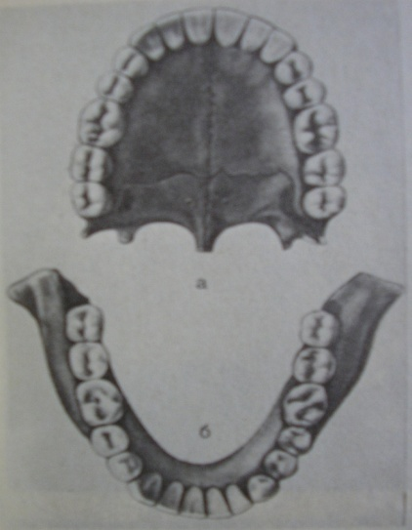

semi-elliptical shape

Parabolic shape

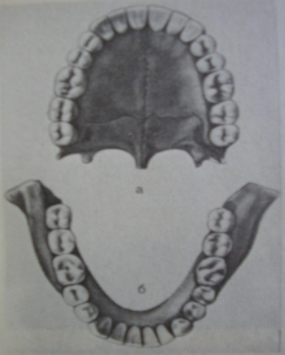Occlusal curve – the line which connects   
1. sculprums and vestibular cusps in saggital plane  
2. vestibular and oral cusps in transversal plane

occlusal surface – the plane of chewing surface of teeth

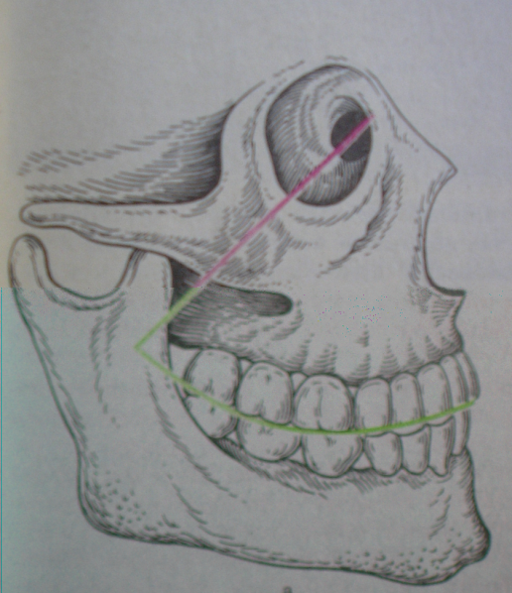Saggital occlusal curve

first described by E. Spee (1890).

and forms concave curve from premolars to the last molar. The deepest place - is the occlusal surface of the first lower molar. Upper dental arch in the area of premolars and molars has sagital protuberant curve that congruous to the lower curve.

Transversal occlusal curve   
(Wilson’s curve)

Cheek cusps of upper premolars and molars are at more high level, than lingual. Transversal line united the cusps is a concave transversal curve.

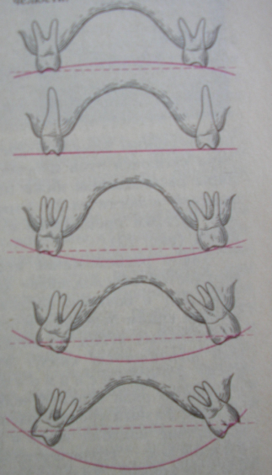

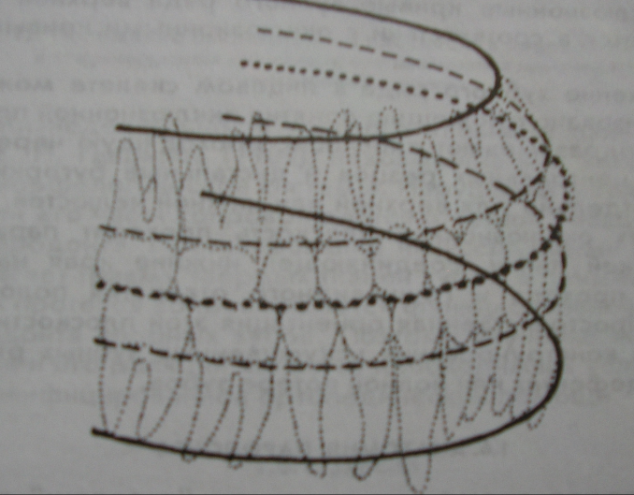

basal arches ( )of upper and lower jaws (line through the apexes)

dental arches ( ) of upper and lower jaws (line through the crowns of teeth)

alveolar arches ( ) of upper and lower jaws (line through the roots of teeth)

On the lower jaw basal arch is the biggest; dental – is the smallest.

On the upper jaw basal arch is the smallest; dental – the biggest.

Periodontium (periodontal ligament) - dense connective tissue located in space between wall of alveolus and root surface

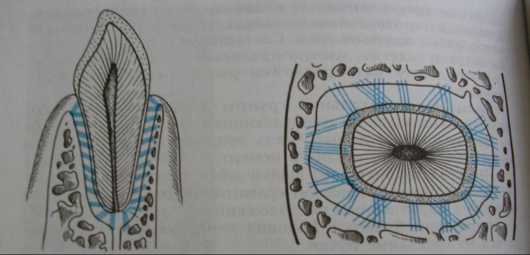Main functions:

* supporting (as a ligament);
* amortizing (lowing the pressure);
* pressure distributive, sensitive (has baroreceptors);
* protective (has lymphatic cells);
* trophic (has blood vessels, nerves).

Reserved strength of periodontium is the ability to adjust to masticatory perssure (goes down with ageing and in case of periodontium diseases).

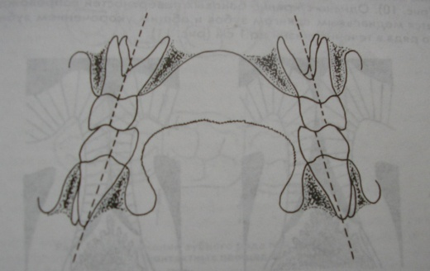Dentitions have supporting mechanism to protect of dental arches from deformations:

1. Presence of tooth-antagonists (opposing teeth);
2. Presence of tooth-synergists (adjacent teeth);
3. three dimensional orientation of teeth (trapezium shape of vertical axes of teeth-antogonists);

Hard palate

concave upward

Palate is divided into 3 regions:

1. Plicae transversae area;
2. Middle area;
3. Back one-third area.

Innocents have plane palate with most evident cross folds.

With ageing and permanent teeth eruption there is a process of making it concave upward shape with less prominent transversal fold.

With teeth loss the shape of hard palate becomes flat again.

Soft palate – is formed by muscles and glandular tissue covering the muscles

1. 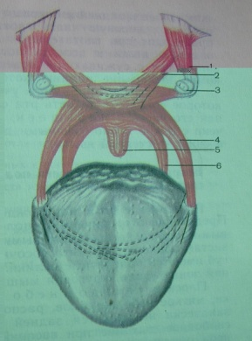- m. Tensor veli palatini;
2. - m. levator veli palatini;
3. - hamulus pterygoideus;
4. - m. palatoglossus;
5. - m. uvulae;
6. - m. palatopharyngeus.

The functions of soft palate:

1. To separate the respiratory tract from digestive system;

2. To provide the sound making.

Mucous membrane of the oral cavity

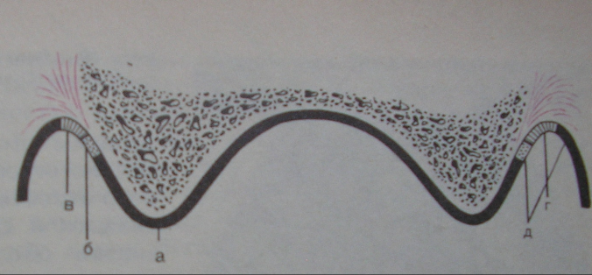Transitional plicae are formed in area of alveolar process mucous membrane ends and cheek and lip mucous membrane begins.

There are two kinds of mucous membrane: mobile and immobile.

Mobile mucosa has strongly pronounced submucosal layer.

Immobile mucosa is connected to the periosteum and does not have strongly pronounced submucosal layer.

Masticatory muscles

* Elevators: m. masseter, m. temporalis, m. pterygoideus med. (provide saggital movements of the mandible);
* Muscles pulling the mandible forward and sideways: m. pterygoideus lat. (provide protrusive and transversal movements);
* Depressors: m. geniohyoideus, m. mylohyoideus, m. digastricus (provide saggital movements of the mandible).

Synergism of masticatory muscles – the group of muscles which perform the same function

Antagonism of masticatory muscles - the group of muscles which perform inverse function

Relative rest of masticatory muscles - is the state of minimum muscular tension or physiological equilibrium of muscles lifting and downing the mandible.

Mimic muscles

Masticatory muscle strength and pressure

* Absolute strength – the maximum muscle’s force in its constraction;
* Relative strength (masticatory pressure) – force of muscles which do on the certain surface in process of mastication.

Reflexes of masticatory apparatus

1. gingiva-muscular reflex (gingiva has receptors to stop muscular contraction in case of over strength);

2. periodontium-muscular reflex (periodontium has reseptors to stop muscular contraction in case of over strength which might be destructive);

3. muscular-muscular reflex (muscles have proprioreceptors to stop muscles’s contraction if the force might tear the muscular fibres).

The ways to transmit of masticatory pressure from occlusal surface to scull base – thickening of cancellous tissue (counterforts)

Trajectories of the mandible

Temporomandibular joint

Difference between TMJ structure in human and animals

Articulation - all the positions of the mandible during its movements

Central occlusion;

Frontal occlusion;

Right lateral occlusion;

Left lateral occlusion.

Distal occlusion

Signs of centric occlusion

Contacts between tooth-antogonists in central occlusion

Gyzi: scheme of mastication

Saggital angles

* Saggital incisor angle - formed by crossing the line laying on extension of saggital incisor track and occlusal plane
* Saggital articular angle - formed by crossing the line laying on extension of saggital condylar track and occlusal plane

Transversal angles

Transversal angles

* Transversal incisor angle - formed on crossing the incisor lines in sideway mandible’s movements
* Transversal articular angle - angle between frontal and lateral condylar movements on nonworking side

Bite - is the name of relations between dental sets of upper and lower jaws in central occlusion (The alignment of the teeth of the upper and lower jaws when brought together.).

Compensated bite – the bite in which protrusive movements give all the tooth-antogonists to be in contact

Subcompensated bite – if in frontal occlusion there are two areas of contacts: between central incisors and between last molars

Decompensated bite has only one area of contact of teeth – frontal area