MahdI Al Kharsa, Pytetska N.

PLETHYSMOGRAPH OR PULMONARY FUNCTION TEST (PFT S)
Kharkiv National Medical University

A plethysmograph is an instrument for measuring changes in volume within an organ or whole body (usually resulting from fluctuations in the amount of blood or air it contains).
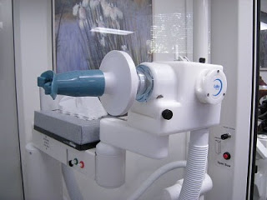
Respiratory function tests to better understand the respiratory functions and how breathing put be affected by certain diseases. In the presence of respiratory disease already known, PFT will quantify the degree of achievement in order to assess the importance and ask the indication of a change in treatment. With PFT, the pulmonologist can appreciate the evolution of respiratory failure and have elements to better monitor the effects of treatment. PFT are also useful for preoperative assessments in case of respiratory diseases. Finally, PFT can be performed to detect before any clinical manifestation of alterations in lung function in smoking or under exposed occupations. PFTs are a battery of breathing tests commonly ordered to characterize asthma, chronic obstructive pulmonary disease, and other lung abnormalities. At its most complex form, the set-up is the one shown above. There is a "body box" which can be completely sealed so the machine can precisely measure changes in volume and pressure.
You put your mouth on the device shown above which can deliver various combinations of gases and measure pressures, flow, and volume of breathing. We went through basic spirometry as it is taught in medical school; I breathed normally, then inhaled to my maximum and exhaled as quickly and completely as I could. I then did a handful of other maneuvers from inhaling and exhaling as hard as I could against a closed valve (calculating maximum inspiratory and expiratory pressures) to breathing in large volumes as rapidly as I could (to test for diaphragm weakness). I also breathed in a whole bunch of different gases: carbon monoxide to calculate diffusing capacity, methane, and 100% oxygen as two separate methods of calculating total lung capacity. The data generated included graphs like this:
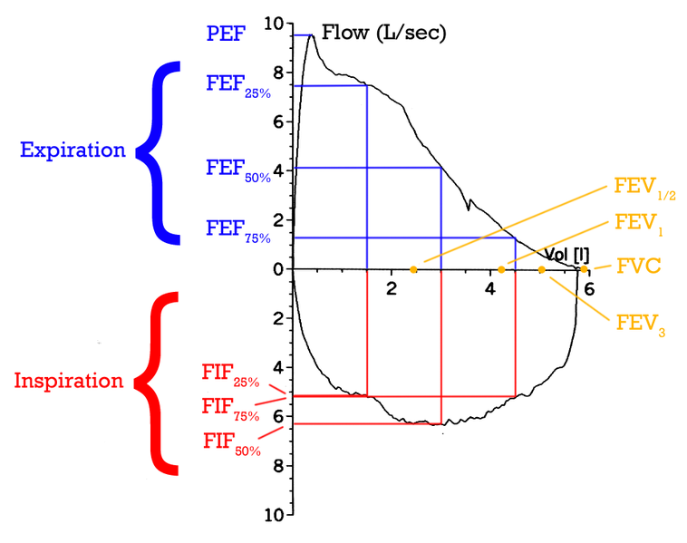
Overall, it was a great way to spend the afternoon. It was highly educational, both in reviewing basic lung physiology, formulas, and relationships, but also in interpreting data. Seeing my own graphs and numbers was far more fascinating and relevant than reading a textbook chapter. But moreover, I found it really important to learn what a patient experiences when we ask him to do pulmonary function tests. It wasn't as easy as I thought it would be, and I'm a healthy person. I can't imagine how hard it must be for someone with lung problems. I think it's educational, fun, and important for providers to undergo some of the tests their patients have to take, and this was a great experience for me to do so.

