DISTANT APOPTOSIS BIOMARKERS IN HUMAN HYPERTENSION
Ashcheulova T, Kovalyova O.

Apoptosis, or programmed cell death, is a normal component of the development and health of multicellular organisms. Cells die in response to a variety of stimuli and during apoptosis they do so in a controlled, regulated fashion [1,2]. This makes apoptosis distinct from another form of cell death called necrosis in which uncontrolled cell death leads to lysis of cells, inflammatory responses and, potentially, to serious health problems. Apoptosis, by contrast, is a process in which cells play an active role in their own death (which is why apoptosis is often referred to as cell suicide) [3,4].
The term programmed cell death was first introduced in 1964, proposing that cell death during development is not of accidential nature but follows a sequence of controlled steps leading to locally and temporally defined self-destruction [5].
Eventually, the term apoptosis had been coined in order to describe the morphological processes leading to controlled cellular self-destruction and was first introduced in a publication by Kerr, Wyllie and Currie [6]. Apoptosis is of greek origin, having the meaning "falling off or dropping off", in analogy to leaves falling off trees or petals dropping off flowers. This analogy emphasizes that the death of living matter is an integral and necessary part of the life cycle of organisms. The apoptotic mode of cell death is an active and defined process which plays an important role in the development of multicellular organisms and in the regulation and maintenance of the cell populations in tissues upon physiological and pathological conditions. It should be stressed that apoptosis is a well-defined and possibly the most frequent form of programmed cell death, but that other, non-apoptotic types of cell death also might be of biological significance [3,5].
There are a number of mechanisms through which apoptosis can be induced in cells. The sensitivity of cells to any of these stimuli can vary depending on a number of factors such as the expression of pro- and anti-apoptotic proteins (eg. the Bcl-2 proteins or the Inhibitor of Apoptosis Proteins), the severity of the stimulus and the stage of the cell cycle.
There are 3 different mechanisms by which a cell commits suicide by apoptosis.
- Generated by signals arising within the cell;
- Triggered by death activators binding to receptors at the cell surface:
  - Tumor necrosis factor-α (TNF-α)
  - Lymphotoxin
  - Fas ligand (FasL)
- May be triggered by dangerous reactive oxygen species [7,8].

Apoptosis is an energy-dependent process by which a specific genetic program leads to the activation of molecular cascades that cause cell death. Apoptosis is marked by the involution of the cell, eventuating in phagocytosis by neighboring cells. By deleting cells, apoptosis plays a physiological role in controlling cell mass and architecture in many tissues, including the myocardium [9-11].
Under a pathophysiological point of view, hypertension affects the myocardium at two different stages. In both humans and animal models, pressure overload is characterized by a period of compensation in which left ventricular concentric hypertrophy normalizes systolic wall stress and contractile function is preserved. The period of adaptation, which may last for weeks in rodents and months to years in humans, is inexorably followed by a transition to cardiac failure. This transition is characterized by impaired survival, the onset of chamber dilatation with the failure of further concentric hypertrophic growth to normalize load, and progressive contractile dysfunction. A number of observations suggest that the transition to failure relates mainly to cardiomyocyte loss due to both apoptosis and necrosis, changes in the composition of motor unit and cytoskeleton of cardiomyocytes, and alterations in the metabolism of the extracellular matrix [12-16].
Apoptosis is recognized, increasingly, as a contributing cause of cardiomyocyte loss with important pathophysiological consequences. Recent evidence demonstrates that cardiomyocyte apoptosis is abnormally stimulated in the heart of animals and humans with arterial hypertension [17,18].
Cardiomyocyte apoptosis has been proposed to occur as a result of an imbalance among the factors that induce or block apoptosis. Alternatively, it is possible that apoptosis reflects some intrinsic abnormalities in those factors that act within the cardiomyocyte determining the resistance or the susceptibility of the cell to apoptosis [19].
In conclusion, much work is being carried out regarding the mechanisms and the extent of cardiomyocyte apoptosis in hypertensive heart disease, but many methodological and conceptual issues still remain unsolved. Clarification of these unresolved issues will then allow an estimation of the role of apoptosis in the pathogenesis of heart failure associated with hypertensive heart disease.
Therefore, the aim of our clinical investigation was to study plasma apoptosis markers (TNF-α, sTNF-R1, sFasL) levels in patients with arterial hypertension depend on degree of blood pressure elevation.

Design and methods. We examined 78 patients with arterial hypertension, duration of the diseases in which was from one month to 40 years (10.09±48 years). Duration of blood pressure (BP) elevation not more than 5 year was evaluated in 30.28%, from 5 to 10 years – 34.51%, and more than 10 years – in 35.21% of patients. Control group include 20 healthy persons.

BP levels vary: systolic BP (SBP) – from 134.70 mm Hg to 250.00 mm Hg (in average 170.96±1.33 mm Hg); diastolic BP (DBP) – from 80.70 mm Hg to 160.00 mm Hg (in average 103.14±0.63 mm Hg). Average mean of heart rate (HR) 80.32±0.69 beats per minute were determined (from 50 to 120 b/min).
AH 1 degree were diagnosed in 35.01% patients (SBP – 149.39±0.56 mm Hg, DBP – 95.96±0.46 mm Hg); 2 degree – in 32.39 % patients (SBP – 166.33±0.67 mm Hg, DBP – 102.53±0.72 mm Hg); 3 degree AH was detected in 32.39 % patients (SBP – 196.54±1.72 mm Hg, DBP – 111.46±1.29 mm Hg) (Figure 1).

Figure 1. Patients division depend on arterial hypertension degree
Depend on degree of target-organs affection, I stage AH was determined in 8.45% patients, II stage AH in 81.69%, III stage – in 9.86% patients (Figure 2). In 3.17% examined persons, cerebral stroke was in anamnesis, in 6.69% patients – myocardial infarction.

Figure 2. Patients division depend on arterial hypertension stage

In most patients (93.66%) hypertension was complicated by heart failure (HF): in 26.06% cases I degree HF, in 59.15% - IIA degree HF, and in 8.45% - IIB degree HF. 6.34% patients had no HF signs (Figure 3).

Figure 3. Patients division depend on heart failure degree

Division of the patients according to functional class (FC) New York Heart Association (NYHA) showed I NYHA functional class in 3.17% patients, II NYHA FC – in 45.452%, III NYHA FC – in 44.37%, and IV NYHA FC – in 7.04% (Figure 4).

Figure 4. Patients division depend on functional class (NYHA)

Concomitant coronary heart disease (CHD) took place in 72.89% patients: among them in 1 degree AH presence of CHD was diagnosed in 57% patients, whereas in 2 degree AH – in 77.17% and in 3 degree – in 85.86% patients.

Exclusion criteria: secondary arterial hypertension, concomitant oncological pathology, acute and chronic inflammatory diseases, diabetes mellitus, significant alterations of heart rhythm and conductivity.
Tumor necrosis factor-α plasma levels were determined by ELISA method (“ProCon TNFα “Protein contour”, Saint Petersburg, Russia), which is used to quantitative determination of Human TNF-α in plasma, serum, and cultural fluids in concentrations intervals 20-2000 pg/ml. According to this method normal serum blood TNF-α levels usually don’t exceed 50 pg/ml.
Determination of tumor necrosis factor-α soluble receptors type 1 (sTNF-R1) was done by ELISA (sTNF-RI EASIA, BioSource Europe S.A., Belgium). Reagents kit is used to human sTNF-R1 quantitative analysis in serum, plasma, cellular cultures and others biological fluids. According to this method normal sTNF-R1 level that was assessed in 129 healthy persons vary from 0.3 ng/ml to 2.9 ng/ml, 1.2±0.6 ng/ml in average.
Plasma sFasL levels were measured by test-system “human sFas Ligand ELISA” (Bender MedSystems, Vienna, Austria). Assay kit is used to human sFasL quantitative analysis in such solutions as supernatants or fluids of human organisms by Enzyme-Linked Immunosorbent Assay – ELISA.
Statistical analysis was conducted according to rules of medico-biological information assessment after creation of data base in program Microsoft® Excel. Parametric and nonparametric statistical methods were used. Continuous variables are presented as average mean (M) and standard error (SE) and were tested using Student’s t-test. To analyze relationships between examined parameters correlation analysis was conducted. All tests were two-sided and considered statistically significant at p<0.05. Odds ratios are reported with 95% confidence intervals. Data analyses were performed using computer program „STATISTICA 7.0” for Windows (Stat Soft Inc., USA).
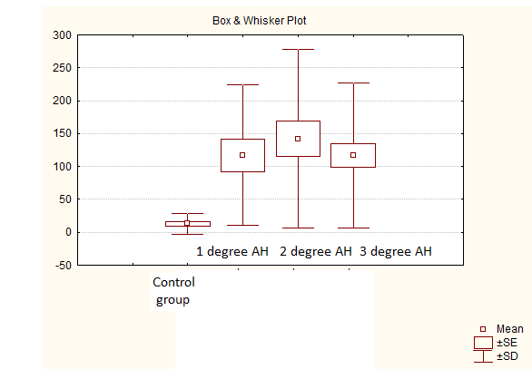
Hemodynamic overload causes hyperactivity of proinflammatory cytokines that can initiate apoptosis cascade. In order to confirm this hypothesis, patients were divided into 3 groups depend on AH degree: 1 group (n=18) – 1 degree AH, 2 group (n=25) – 2 degree AH, 3 group (n=35) – 3 degree AH (Figure 5).

Figure 5. Plasma TNF-a levels in healthy persons and patients depend on AH degree

It was found that plasma TNF-α levels in all groups patients were statistically higher than healthy normotensive persons levels (control vs 1 degree AH p=0.00006; vs 2 degree AH p=0.00006; vs 3 degree AH p=0.00005). Maximum mean of this apoptosis marker was detected in 2 degree AH patients (p=0.010 vs 1 degree AH). In patients with 3 degree AH TNF-α levels were decreased compared with 2 degree AH group (p=0.054) and was close to level of patients with 1 degree AH group (p=0.163).
Circulating sTNF-R1 levels of all groups hypertensive patients were elevated vs normal means (p<0.001 in all cases) (Figure 6).
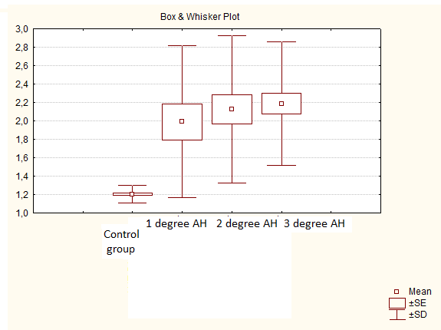

Figure 6. Plasma sTNF-R1 levels in healthy persons and patients depend on AH degree

Analysis of plasma sTNF-R1 content dynamic showed tendency of its increasing parallel to BP level elevation (1 group vs 2 group p=0.59; 1group vs 3 group p=0.36; 2group vs 3 group p=0.75).
Mean of TNF-α/sTNF-R1 ratio that reflect relation ligand/receptor complex, of normotensive control group was 11.03±2.84. Study of this parameters changes shows its increasing in hypertensive patients with different degree of BP elevation as compared with normotensive persons (control vs 1 group p=0.0004; vs 2 group p=0.0001; vs 3 group p=0.0006). Maximum mean was revealed in patients with 2 degree AH, that reflect more significant elevation of TNF-α vs its natural antagonists – sTNF-R1 (p=0.34 vs 1 degree AH; p=0.61 vs 3 degree AH). In patients with 3 degree AH it was evaluated insignificant lowering TNF-α/sTNF-R1 compared with 2 degree AH patients, but it was higher than in 1 degree AH (p=0.59) and normotensive subjects of control group.
Correlation analysis revealed positive relationships between SBP and sTNF-R1 (r_{s}=0.41; p=0.040) in patients with 2 degree AH; between DBP and TNF-α (r_{s}=0.51; p=0.002), TNF-α/sTNF-R1 (r_{s}=0.49; p=0.003).
Thus, in spite of detected increasing sTNF-R1 concentration, natural TNF-α inhibitor, and insignificant decreasing of TNF-α/sTNF-R1, cytokine level remained high, that confirm possibility of TNF-mediated apoptosis pathway in hypertensive patients.
Alternative mechanism of apoptotic cellular death realization is binding of Fas receptor with corresponding ligand – Fas ligand (FasL). Apoptosis inductor rate in blood of hypertensive patients was 73±5%, in average level 0.38±0.03 ng/ml (concentration interval from 0 to 0.91 ng/ml).
We found significant sFasL detection rate in hypertensive patients depend on degree of BP elevation (Table 1).
Table 1
sFasL depend on level of blood pressure elevation
Parameters | 1 degree АH  (n=18) | 2 degree АH  (n=25) | 3 degree АH  (n=35)
Age (years) | 52.83±1.46 | 53.40±2.35 | 55.94±1.56
AH duration (years) | 5.51±1.20 | 7.52±1.36 | 13.20±1.56
SBP (mm Hg) | 149.08±1.51 | 164.97±1.13 | 196.40±2.83
DBP (mm Hg) | 96.04±1.21 | 102.03±1.53 | 113.52±2.06
sFasL (ng/ml)  Detection rate (%)  Absolute patients amount (n) | 0.28±0.07  56±12  10 | 0.40±0.06  76±9  19 | 0.41±0.04  80±7  28
In 1 degree AH sFasL presence was found approximately in one-half of patients; in 2 degree AH sFasL detection rate was higher (p=0.082 according χ²); in 3 degree AH tendency of sFasL detection rate increasing was shown (p=0.75 vs 2 degree AH; p=0.040 vs 1 degree AH according χ²).
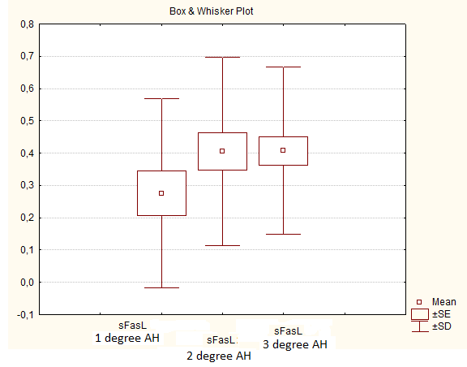
Assessment of average sFasL levels dynamics evaluated same tendency of its elevation (Figure 7).

Figure 7. Plasma sFasL levels in hypertensive patients depend on blood pressure level elevation
There were no significant difference between average sFasL means in blood plasma of patients with 2 and 3 degree AH (p=0.97) and sFasL levels were some higher compared with 1 degree AH (p=0.16; p=0.10 correspondingly).
Positive correlation was found between age of hypertensives and plasma sFasL levels (r=0.40; p=0.048); negative – between sFasL and TNF-α (r=-0.55; p=0.005), TNF-α/sTNF-R1 (r=-0.45; p=0.023) in patients of 2 degree AH, between sFasL and TNF-α (r_{s}=-0.54; p=0.0008), TNF-α/sTNF-R1 (r_{s}=-0.55; p=0.0006) in 3 degree AH patients. Obtained results indicate possibility of Fas-related apoptosis in patients with arterial hypertension.
Conclusion. Result of our clinical study showed increased immune-inflammatory and proapoptotic activity depend on presence and degree of arterial hypertension.
REFERENCES
- Ameisen JC. On the origin, evolution, and nature of programmed cell death: a timeline of four billion years // Cell Death Differ. – 2002. – Vol.9(4). – P.367-393.
- Lawen A. Apoptosis-an introduction // Bioassays. – 2003. – Vol.25(9). – P.888-896.
- Elmore S. Apoptosis: a review of programmed cell death //
Toxicol Pathol . – 2007. – Vol.35(4). – P.495-516.
- Rathmell JC, Thompson CB. Pathways of apoptosis in lymphocyte development, homeostasis, and disease // Cell. – 2002. – Vol.109(Suppl). – P.S97-107.
- Lockshin RA, Zakeri Z. Programmed cell death and apoptosis: origins of the theory // Nat Rev Mol Cell Biol. – 2001. – Vol.2(7). – P.545-550.
- Kerr JF, Wyllie AH, Currie AR. Apoptosis: a basic biological phenomenon with wide-ranging implications in tissue kinetics // Br J Cancer. – 1972. – Vol.26(4). – P.239-257.
- Kroemer G, Reed JC. Mitochondrial control of cell death // Nat Med. – 2001. – Vol.6(5). – P.513-519.
- Ashkenazi. Death receptors: signaling and modulation / A Ashkenazi, V Dixit // Science. – 2008. – Vol.281. – P.1305-1308.
- Skulachev VP. Programmed death in yeast as adaptation? // FEBS Lett. – 2003. – Vol.528(1-3). – P.23-26.
- Zuzarte-Luis V, Hurle JM. Programmed cell death in the developing limb // Int J Dev Biol. – 2002. – Vol.46(7). – P.871-876.
- Vermeulen K, Berneman ZN, Van Bockstaele DR. Cell cycle and apoptosis // Cell Prolif. – 2003/ - Vol.36(3). – P.165-175.
- Opferman JT, Korsmeyer SJ. Apoptosis in the development and maintenance of the immune system // Nat Immunol. – 2003. – Vol.4(5). – P.410-415.
- Matute-Bello G, Martin TR. Apoptosis: the complex scenario for a silent cell death // Mol Imaging Biol. – 2003. – Vol.5(1). – Vol.2-14.
- Doseff AI. Apoptosis: The Sculptor of Development // Stem Cells and Development. – 2004. – Vol.13(5). – P.473-483.
- Kitahori K., He H., Kawata M. et al. Development of Left Ventricular Diastolic Dysfunction With Preservation of Ejection Fraction During Progression of Infant Right Ventricular Hypertrophy //
Circ Heart Fail . – 2009. – Vol.2(6). – P.599-607.
- Sharma A.K., Dhingra S., Khaper N., Singal P.K.
Activation of apoptotic processes during transition from hypertrophy to heart failure in guinea pigs // Am J Physiol Heart Circ Physiol. – 2007. – Vol.293(3). – P.H1384-H1390.
- Gonzalez A., Fortuno M.A, Querejeta R. et al. Cardiomyocyte apoptosis in hypertensive cardiomyopathy // Cardiovasc Res. – 2003. – Vol.59(3). – P.549-562.
- Korshunov VA. Smooth muscle apoptosis and vascular remodeling / VA Korshunov, BC Berk // Curr Opin Hematol. – 2008. – Vol.15(3). – P.250-254.
- Kockx MM. The role of apoptosis in vascular disease / MM Kockx, MWM Knaapen // J Pathol. – 2007. – Vol.190. – P.267-280.
DISTANT APOPTOSIS BIOMARKERS IN HUMAN HYPERTENSION
Ashcheulova T, Kovalyova O.
The aim was to study plasma apoptosis markers (TNF-α, sTNF-R1, sFasL) levels in patients with arterial hypertension (AH) depend on degree of blood pressure elevation.
We examined 78 patients with AH, which were divided into 3 groups depend on AH degree: 1 group (n=18) – 1 degree AH, 2 group (n=25) – 2 degree AH, 3 group (n=35) – 3 degree AH. Plasma tumor necrosis factor-α (TNF-α), soluble TNF receptors type 1 (sTNF-R1), and soluble Fas ligand (sFasL) levels by ELISA were detected.
It was found that plasma TNF-α levels in all groups patients were higher than in healthy normotensives (p<0.05). Maximum mean was detected in 2 degree AH patients. Circulating sTNF-R1 levels of all groups patients were elevated vs normal means (p<0.05). In spite of detected increasing sTNF-R1 concentration, natural TNF-α inhibitor, and insignificant decreasing of TNF-α/sTNF-R1, cytokine level remained high, that confirm possibility of TNF-mediated apoptosis pathway in hypertensive patients. Obtained results indicate possibility of Fas-related apoptosis in patients with arterial hypertension.
Conclusion. Result of our clinical study showed increased immuno-inflammatory and proapoptotic activity depends on presence and degree of arterial hypertension.
Keywords: apoptosis, circulating apoptosis biomarkers, arterial hypertension.
ДИСТАНТНЫЕ БИОМАРКЕРЫ АПОПТОЗА ПРИ АРТЕРИАЛЬНОЙ ГИПЕРТЕНЗИИ У ЧЕЛОВЕКА
Ащеулова Т.В., Ковалева О.Н.
Целью было изучение уровня плазматических маркеров апоптоза (ФНО-α, рФНО-Р1, sFasL) у больных с артериальной гипертензией (АГ) в зависимости от степени повышения уровня артериального давления.
Обследовано 78 пациентов с АГ, которые были разделены на 3 группы в зависимости от степени АГ: 1 группа (n=18) - 1 степень АГ, 2 группа (n= 25) - 2 степень АГ, 3 группа (n=35) - 3 степень АГ. Уровень фактора некроза опухолей-α (ФНО-α), растворимых рецепторов ФНО 1 типа (рФНО-Р1), и растворимого Fas лиганда (sFasL) определялись иммуноферментным методом.
Было обнаружено, что уровень в плазме ФНО-α у всех групп пациентов был выше, чем у здоровых лиц (р<0,05). Максимальное среднее значение определено у больных с 2 степенью АГ. Циркулирующие уровни рФНО-Р1 во группах пациентов были повышены против контрольной группы (р<0,05). Несмотря на обнаруженное увеличение концентрации рФНО-Р1, естественного ингибитора ФНО-α, и незначительное снижение соотношения ФНО-α/рФНО-Р1, уровень цитокинов оставался высоким, что подтверждает возможность ФНО-опосредованного пути апоптоза у больных АГ. Полученные результаты указывают на возможность Fas-зависимого апоптоза у больных с АГ.
Выводы. Результаты нашей клинического исследования показали повышенную иммуно- воспалительную и проапоптотическую активность в зависимости от наличия и степени артериальной гипертензии.
Ключевые слова: апоптоз, циркулирующие биомаркеры апоптоза, артериальная гипертензия.

ДИСТАНТНІ БІОМАРКЕРИ АПОПТОЗУ ПРИ АРТЕРІАЛЬНІЙ ГІПЕРТЕНЗІЇ У ЛЮДИНИ
Ащеулова Т.В., Ковальова О.М.
Метою було вивчення рівня плазматичних маркерів апоптозу (ФНП-α, рФНП-Р1, sFasL) у хворих на артеріальну гіпертензію (АГ) залежать від ступеня підвищення артеріального тиску.
Ми обстежили 78 пацієнтів з АГ, які були розділені на 3 групи залежно від ступеня АГ: 1 група (n=18) - 1 ступінь AГ, 2 група (n=25) - 2 ступінь АГ, 3 група (n=35) - 3 ступінь АГ. Рівень фактора некрозу пухлин-α (ФНП-α), розчинні рецептори ФНП 1 типу (рФНП-Р1) та розчинні Fas ліганд и (sFasL) визначали імуноферментним методом.
Було виявлено, що рівні в плазмі ФНП-α у всіх груп пацієнтів були вище, ніж у здорових осіб (р<0,05). Максимальне значення було виявлено у хворих з 2 ступенем АГ. Циркулюючий рівень рФНП-Р1 у всіх групах пацієнтів був підвищений проти контрольної групи (р<0,05) . Незважаючи на виявлене збільшення концентрації рФНП-Р1, природного інгібітора ФНП-α, і незначне зниження ФНП-α/рФНП-Р1, рівень цитокінів залишався високим, що підтверджує можливість ФНП-опосередкованого шляху апоптозу у хворих на гіпертонічну хворобу. Отримані результати свідчать про можливість Fas-залежного апоптозу у хворих на АГ.
Висновки. Результати нашого клінічного дослідження показали підвищену імуно-запальну і проапоптотичну активність залежно від наявності та ступеня артеріальної гіпертензії.
Ключові слова: апоптоз, циркулюючі біомаркери апоптозу, артеріальна гіпертензія .

