THE EVOLUTION OF MRI IN CARDIOLOGY
Igboanugo Stephanie .E., A. Demydenko
Magnetic Resonance Imaging (MRI) has long been useful for diagnosing problems of the brain, spine and joints. Over the past decade, MRI has proven useful in diagnosing certain uncommon cardiovascular problems such as aortic dissection, cardiac tumors, and congenital heart disease. And MRI has proven a valuable research tool for studying more common cardiac disorders such as ischemia and cardiomyopathy Until recently, however, it has been impractical to use MRI where it would be the most useful – in the routine evaluation and management of patients with coronary artery disease. In December, 2001, researchers at Harvard reported in the New England Journal of Medicine that they were able to use MRI scanning of the coronary arteries to detect (or rule out) disease in the major branches of the coronary arteries. They reported an overall accuracy of 72% with the MRI technique, and a much higher accuracy for disease of the left main coronary artery (which, while relatively uncommon, is the most dangerous place for a person to have coronary artery disease.)
What is MRI?
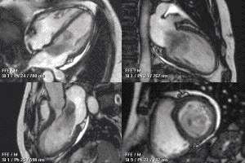
MRI is an imaging technique that takes advantage of the property of certain atomic nuclei (in this case, the single proton that forms the nucleus of a hydrogen atom) to vibrate – or “resonate” – when exposed to bursts of magnetic energy. When the hydrogen nuclei resonate in response to changes in a magnetic field, they emit radio-frequency energy. The MRI machine detects this emitted energy, and converts it to an image.Hydrogen nuclei are used because hydrogen atoms are present in water molecules (H2O), therefore are present in every tissue in the body. The images obtained by MRI scanning are remarkably precise and detailed. With current MRI machines, these images are generated as 3-D projections. And once a 3-D MRI image is obtained it can be “sliced” and examined in detail, and in any plane – almost like being able to do exploratory surgery on a computer screen.
Also, subtle differences in the hydrogen atoms between various parts of a tissue – differences caused, for instance, by differences in blood flow or in the viability of the tissue – emit different amounts of energy. These energy differences show up as different shades of gray on the MRI image. Thus, the MRI offers a potential means of detecting areas of cardiac tissue that have poor blood flow (as in coronary artery disease) or that has been damaged (as in a heart attack). However, there are many technical problems in imaging moving structures like the heart with MRI. Movement of the heart during scanning significantly distorts the image (just as taking a photo of a moving object causes a blurring of the picture), and when the structures you are trying to see are small (such as the coronary arteries) the movement problem becomes extremely difficult to overcome.
POTENTIAL USES OF MRI
MRI has the potential (and has been used in the research setting) to diagnose heart attacks in patients presenting with chest pain. Not infrequently, a patient coming to the emergency room with chest pain will not have the typical ECG changes have been seen with myocardial infarction and the doctors end up waiting for an hour or two for the results of cardiac enzyme tests. If a heart attack is actually occurring, critical time is thus lost before therapy can begin. MRI can detect myocardial infarction immediately, and can reduce the time it takes to begin definitive treatment.
A new MRI processing technique called “black-blood” MRI (so called because it produces an image of an artery in which the blood appears black, and the wall of the artery appears white) to be able to distinguish atherosclerotic coronary arteries
MRI can help distinguish between “stable”and “vulnerable” atherosclerotic plaques. Vulnerable plaques are those that are prone to rupture, thus suddenly occluding a coronary artery and causing a myocardial infarction. If vulnerable plaques can be identified (and this is something the cardiac catheterization has no hope of ever doing), those particular plaques can be targeted for intervention (angioplasty, bypass), while leaving the stable plaques alone. Also it can be used to identify re-stenosis after angioplasty. MRI might thus prove an accurate, noninvasive means of following patients after angioplasty.
History and Evolution
Cardiac MRI is an evolving and challenging area.The phenomenon of Nuclear Magnetic Resonance (NMR) was first described in molecular beams (1938) and bulk matter (1946), work later acknowledged by the award of a joint Noble Price in 1952. Further investigation laid out the principles of relaxation times leading to nuclear spectroscopy. In 1973, the first simple NMR image was published and the first medical imaging in 1977, entering the clinical arena in the early 1980s.
In 1984, NMR medical imaging was renamed MRI. Initial attempts to image the heart were confounded by respiratory and cardiac motion, solved by using cardiac ECG gating, faster scan techniques and breath hold imaging. Increasingly sophisticated techniques were developed including cine imaging and techniques to characterise heart muscle as normal or abnormal (fat infiltration, oedematous, iron loaded, acutely infarcted or fibrosed).
As MRI became more complex and application to cardiovascular imaging became more sophisticated, the Society for Cardiovascular Magnetic Resonance, SCMR was set up (1996) with an academic journal, (JCMR) in 1999, which is going open source in 2008. In a move analogous to the development of echocardiography from cardiac ultrasound, the term ‘Cardiovascular Magnetic Resonance’ was proposed and has gained acceptance as the name for the field.
Felix Bloch and Edward Purcell were both awarded the Nobel Prize in 1952. Both of these individuals independently discovered the MR phenomenon in 1946. In the subsequent 2 decades, NMR was developed and used for chemical and physical molecular analysis.
The Road to Clinical Application
Raymond Damadian discovered in 1971 that the nuclear magnetic relaxation times of tissues and tumors differed, which motivated scientists and physicians to consider MR for the detection of disease. Subsequently, in 1973, Paul Lauterbur demonstrated the MRI phenomenon on small test tube samples using a gradient approach to scanning. In 1975, Richard Ernst proposed MRI using phase and frequency encoding, and the Fourier Transform. This technique is the basis of current MRI techniques for 2D and 3D image/slice reconstruction.
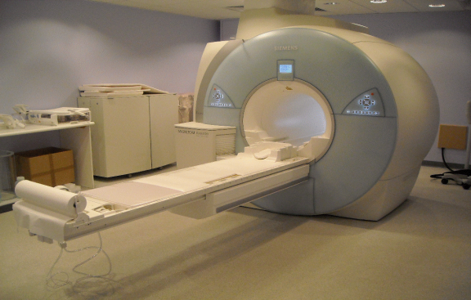
Meanwhile, Raymond Damadian founded the FONAR (Field Focused Nuclear Magnetic Resonance) Corporation to produce commercial MRI scanners in 1978. His prototype whole-body scanner, named Indomitable, produced the first whole-body patient images in 1977. Although the Indomitable prototype did not immediately result in a commercially viable product, the FONAR Corporation began producing commercial scanners in 1980.Current MRI Systems in Clinical Practice The MRI technology first became available in clinical practice in the 1970s, most of which operated at a strength of .6T. During the following decade, stronger 1.5T MRI systems were introduced. Imaging systems with a strength of 1.5T are now considered the clinical gold standard for current MRI modalities. In 1998, the US Food and Drug Administration (FDA) gave marketing clearance for scanners operating at strengths of up to 4T, and in 2002, the agency approved some 3T scanners for the brain and the whole body. Four years ago, more than 100 of these machines had been installed.
What are the major advantages of cardiac MRI?
Note: these advantages are largely potential advantages, and won’t be realized until technology currently being tested becomes more refined and widespread:
- MRI has the potential of replacing at least 4 other cardiac tests: the echocardiogram, the MUGA scan, the thallium scan and diagnostic cardiac catheterization
- MRI does not involve exposing the patient to ionizing (potentially harmful) radiation, as do most non-invasive cardiac imaging tests (the exception being the echocardiogram)
- The images generated by MRI are remarkably complete, detailed and precise – far more so than other cardiac imaging tests.
What are the disadvantages of cardiac MRI?
Being placed in the MRI scanner can induce significant claustrophobia in about 5% of patients
It is difficult to monitor patients while they are in the MRI scanner – for one thing, the ECG is significantly distorted – so this technique is not suitable for patients who are critically ill.
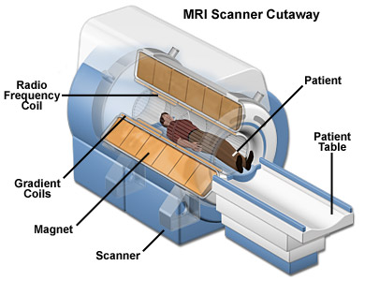
Patients with certain kinds of medical devices – pacemakers and implantable defibrillators and some artificial heart valves – cannot receive MRI.

The MRI image becomes distorted by metal – so the image is distorted in patients with surgical clips or stents for instance.
- MRI technology extremely complex and expensive. For MRI to come under widespread usage, funds will have to be developed to purchase equipment, and many more individuals will need to be trained to use this technology.
MRI technology holds tremendous promise in the evaluation and treatment of cardiac disease. It is clearly technically feasible for MRI to replace – and significantly improve on – many of the sophisticated imaging techniques that are now routinely performed in cardiology. The potential for MRI to accurately diagnose and direct the treatment of coronary artery disease before it becomes clinically apparent is probably the most exciting prospect. Before this can happen, however, the amazing technology now being developed needs to be made accurate enough and inexpensive enough to achieve broad usage.

