Rhinosinusitis in patients in post-COVID-19 period: etiology, clinical and morphological characteristics
Mykhailo S. Myroshnychenko ¹, Yuliia M. Kalashnyk-Vakulenko ¹, Nataliia V. Kapustnyk ², Oleksandra O. Babycheva ¹, Nadiia O. Yurevych ¹, Olha V. Bondarenko ¹, Mykhailo V. Kalashnyk ³, Inna I. Torianyk ⁴, Anton S. Shapkin ¹, Andrii V. Lupyr ¹
¹ Kharkiv National Medical University, Kharkiv, Ukraine
² Municipal Nonprofit Organization of the Kharkiv District Council
«Regional Clinical Perinatal Centre», Kharkiv, Ukraine
³ Municipal Nonprofit Organization of the Kharkiv District Council
«Regional Clinical Hospital», Kharkiv, Ukraine
⁴ State Institution «Institute of Microbiology and Immunology named by I.I. Меchnikov National Academy of Medical Sciences of Ukraine», Kharkiv, Ukraine
Introduction. Rhinosinusitis is one of the otorhinolaryngological manifestations of the post-COVID-19 syndrome. The etiopathogenesis of such pathology is not well studied. The effectiveness of rhinosinusitis treatment in patients is determined by timely diagnosis and early implementation of etiopathogenetic therapy. Morphological examination of biopsy or surgical material is of great importance in the diagnosis of this pathology.
The purpose is to identify the etiology, clinical and morphological features of rhinosinusitis in patients in post-COVID-19 period.
Materials and methods. In the present study, it was carried out the analysis of 11 cases of rhinosinusitis, which developed after COVID-19 infection. The diagnosis of rhinosinusitis was established on the basis of anamnesis, clinical and laboratory examination, specialized instrumental examination (rhinoendoscopy, X-ray, magnetic resonance imaging, spiral and 3D computed tomography). All patients underwent endoscopic sanitation of the nasal cavity, expansion of the maxillary anastomosis, maxillary sinusotomy, sanitation of the maxillary sinuses and removal of pathologically altered tissues. Microbiological examination of the swab from the nasal cavity was carried out in all patients. Histological and morphometric research methods were used during the morphological study of surgical material. The nonparametric Mann-Whitney U test was used to compare the means in the groups.
Results. The conducted comprehensive study made it possible to identify chronic atrophic rhinosinusitis at the stage of exacerbation caused by associations of bacteria and fungi in patients in post-COVID-19 period. Among bacteria, the authors most often noted Staphylococcus aureus, Staphylococcus epidermidis, Klebsiella pneumonia, Streptococcus pneumonia and Enterococcus faecalis. Among fungi, there were Aspergillus, Candida, Mucor and Coccidioides. Fungal infection was characterized by invasion into the mucous membrane of the nose and paranasal sinuses. In patients in post-COVID-19 period the invasive bacterial-fungal chronic atrophic rhinosinusitis at the stage of exacerbation was predominantly bilateral, characterized by the involvement of several or all paranasal sinuses in the process. Patients with such pathology complained of periodic fever, headaches and malaise; nasal congestion and constant difficulty in nasal breathing; yellowish-greenish-reddish discharge from the nasal cavity, sometimes with a fetid odor; discomfort and pain in the area of paranasal sinuses; immobility of the eyeball, hyposmia or anosmia; reduction or complete loss of vision. Frequent risk factors for the development of invasive bacterial-fungal chronic atrophic rhinosinusitis at the stage of exacerbation in patients in post-COVID-19 period were the information about moderate or severe course of this infection in anamnesis; comorbidities (predominantly diabetes mellitus, hypertensive disease and ischemic heart disease).
Conclusions. The study conducted by the authors made it possible to identify the etiological, clinical and morphological features, as well as risk factors of rhinosinusitis in patients in post-COVID-19 period. This information will contribute to a better understanding of such pathology by the doctors and improve the diagnostic and treatment process.
Key words: etiology, clinical and morphological features, rhinosinusitis, post-COVID-19 period.
Introduction. The pandemic of coronavirus disease 2019 (COVID-19) caused by the severe acute respiratory syndrome coronavirus 2 (SARS-CoV-2) is one of the global health concerns all over the world in the 21st century [1].
The clinical spectrum of COVID-19 ranges from asymptomatic infection to severe respiratory illness and multiorgan failure. Moreover, extrapulmonary manifestations may also occur [2, 3]. Patients who recovered from SARS-CoV-2 can be diagnosed with post-COVID-19 syndrome lasting for weeks or months [4]. The latter is one of those challenges which became increasingly common as the pandemic evolved, including pulmonary, cardiovascular, hematologic, renal, central nervous system, gastrointestinal, psychosocial, otorhinolaryngological manifestations [2, 5].
One of the otorhinolaryngological manifestations of the post-COVID-19 syndrome is rhinosinusitis [6]. The latter is known to be caused by various factors of exogenous and endogenous origin [7], but in patients in post-COVID-19 period, based on literature data, it is caused by fungi [8, 9]. The incidence of fungal rhinosinusitis is markedly more prominent in post-COVID19 patients than in non-COVID-19 [9]. Also, fungal rhinosinusitis was found in patients during COVID-19 infection (COVID-19 associated fungal rhinosinusitis) [10, 11]. The most common fungal infections of the nose and paranasal sinuses in patients in post-COVID-19 period are aspergillosis, mucormycosis and candidiasis [12]. In this category of patients, coccidioidomycosis is very rarely diagnosed [13, 14].
In literature today, we still lack published statistical data about rhinosinusitis in patients in post-COVID-19 period [15]. The etiopathogenesis of such pathology is not well studied. The effectiveness of rhinosinusitis treatment in patients is determined by timely diagnosis and early implementation of etiopathogenetic therapy. Morphological examination of biopsy or surgical material is of great importance in the diagnosis of this pathology.
The purpose is to identify the etiology, clinical and morphological features of rhinosinusitis in patients in post-COVID-19 period.
Materials and methods. The present study analyzed 11 cases of rhinosinusitis, developed after COVID-19 infection. Among all cases, there were 7 men and 4 women. The patients with COVID-19 infection were treated in the intensive care unit, those with rhinosinusitis in post-COVID-19 period – in the otorhinolaryngology department of hospitals in Kharkiv region (Ukraine) from 2019 to 2022.
The authors conducted the study in accordance with the guidelines of the Declaration of Helsinki. The Ethics and Bioethics Commission of Kharkiv National Medical University approved the study.
The diagnosis of rhinosinusitis was established on the basis of anamnesis, clinical and laboratory examination, specialized instrumental examination (rhinoendoscopy, X-ray, magnetic resonance imaging, spiral and 3D computed tomography). All patients underwent endoscopic sanitation of the nasal cavity, expansion of the maxillary anastomosis, maxillary sinusotomy, sanitation of the maxillary sinuses and removal of pathologically altered tissues.
The swab from the nasal cavity was microbiologically examined in all patients. Special and elective culture environment was used for bacteria and fungi growing.
Morphological examination was carried out in Pathology Department of Municipal Nonprofit Organization of the Kharkiv District Council «Regional Clinical Hospital» (Ukraine), Alpern Department of General and Clinical Pathological Physiology of Kharkiv National Medical University (Ukraine). Two groups were formed. Group 1 (comparison group) included fragments of a visually unchanged mucous membrane of the nose and maxillary sinuses, taken during autopsies of 10 deceased. The cause of death of the latter was chronic heart failure. Group 2 included surgical material from the above 11 patients. The average age of the deceased (group 1) was 55.6±4.8 years and did not differ (p>0.05) from the average age of the patients of group 2 (54.9±5.1 years).
Biological material was fixed in 10% solution of neutral buffered formalin, carried out according to the generally accepted method and embedded in paraffin. Serial sections of 3-4 μm thick were made from paraffin blocks. Microspecimens stained with hematoxylin and eosin were studied, using an Olympus BX-41 microscope (Japan) with subsequent processing with the Olympus DP-soft version 3.1 software, which was used to conduct a morphometric study. By morphometry, in the mucous membrane of the nose and sinuses the specific volumes (%) of parenchyma (glandular structures) and stroma (connective tissue fibers, blood vessels and nerve fibers) were determined; the absolute number of lymphocytes, macrophages, plasma cells, mast cells, eosinophilic leukocytes, neutrophilic leukocytes was counted at × 100 magnification.
The nonparametric Mann-Whitney U test was used to compare the means in the groups. Differences were considered significant at p<0.05. We used Microsoft Excel in all calculations. Statistical analysis was performed using IBM SPSS software Statistics 28 (license No. Z125-3301-14).
Results. In patients with rhinosinusitis it was detected in anamnesis in 5 cases (45.5%) a moderate course of COVID-19 infection and in 6 cases (54.5%) – severe course. The mean number of days during which rhinosinusitis developed after COVID-19 infection was 41.2±4.63.
In all analyzed cases, patients had comorbidities (Table 1). Diabetes mellitus, hypertensive disease and ischemic heart disease were the most frequently identified comorbidities.

Table 1. – Characteristics of comorbidities
Comorbidities name | Cases number  absolute / relative (%)
Diabetes mellitus | 8/72.7%
Hypertensive disease | 6/54.5%
Ischemic heart disease | 6/54.5%
Obesity | 4/36.4%
Bronchial asthma | 3/27.3%
Chronic glomerulonephritis/pyelonephritis | 2/18.2%
Autoimmune thyroiditis | 2/18.2%
Chronic hepatitis | 1/9.1%

At the time of admission to the hospital, patients with rhinosinusitis complained of periodic fever, headaches and malaise (11 cases, 100%); nasal congestion and persistent obstructed nasal breathing (11 cases, 100%); yellowish-greenish-reddish discharge from the nose (11 cases, 100%), sometimes with a fetid odor (5 cases, 45.5%); discomfort and pain in the projection area of the paranasal sinuses (11 cases, 100%); immobility of the eyeball, hyposmia (8 cases, 72.7%) or anosmia (3 cases, 27.3%); decreased vision (9 cases, 81.8%) or complete vision loss (2 cases, 18.2%).
In 9 cases (81.8%) rhinosinusitis was bilateral, and in 2 cases (18.2%) – unilateral. In 7 cases (63.6%), the inflammatory process spread to all paranasal sinuses, and in 4 cases (36.4%) we identified maxillary and ethmoid sinuses inflammation.
Table 2 shows the results of the microbiological examination of the swab from the nasal cavity. The most common bacteria and their associations were Staphylococcus aureus, Staphylococcus еpidermidis, Klebsiella pneumonia, Streptococcus pneumonia and Enterococcus faecalis. Among the fungi, only yeast-like fungi of the genus Candida were identified.
Morphological examination of surgical material in all cases of group 2 revealed necrotically changed tissues of unknown histogenesis with or without focal mild cell infiltration (Fig. 1). The latter was characterized by the presence of lymphocytes, macrophages, plasma cells, mast cells, neutrophilic and eosinophilic leukocytes.
Microscopic examination in group 2 revealed particles of mucous membrane of the nose and paranasal sinuses, covered by mainly atrophied stratified ciliated epithelium in certain fields of view. Areas of metaplastic transitional epithelium were also determined in the epithelial layer in single fields of view (Fig. 2).
Group 2 revealed moderate or pronounced necrotic and hemodynamic changes, as well as diffuse polymorphic cellular infiltration in thickness of the mucous membrane of the nose and paranasal sinuses (Fig. 2). In this infiltration, we determined an increase (p<0.05) in the absolute number of lymphocytes, macrophages, plasma cells, mast cells and the appearance of neutrophilic and eosinophilic leukocytes, as compared with group 1 (Table 3).

Table 2. – Results of microbiological and morphological examination
Infectious  agent | Case number |  |  |  |  |  |  |  |  |  |  | Total cases number  absolute/relative (%)
 | 1 | 2 | 3 | 4 | 5 | 6 | 7 | 8 | 9 | 10 | 11
Microbiological examination
Staphylococcus aureus | + | + | + | + | + | + | + | + | + | + | + | 11/100%
Staphylococcus еpidermidis | + | + | + | + | + | + | + | + | + | + | + | 11/100%
Klebsiella pneumoniae | + |  | + | + | + | + | + | + | + | + | + | 10/90.9%
Streptococcus pneumonia | + | + | + | + | + |  | + | + |  | + | + | 9/81.8%
Enterococcus faecalis | + |  | + |  | + |  | + |  | + |  | + | 6/54.5%
Proteus vulgаris |  | + |  |  |  | + |  | + |  | + |  | 4/36.4%
Pseudomonas aerugenosa | + |  |  |  | + |  |  |  | + |  |  | 3/27.3%
Fungi of the genus Candida | + |  |  | + | + | + | + |  | + | + | + | 8/72.7%
Morphological examination
Fungi of the genus Candida | + |  |  | + | + | + | + |  | + | + | + | 8/72.7%
Fungi of the genus Aspergillus | + | + |  | + |  | + |  | + | + | + | + | 8/72.7%
Fungi of the genus Coccidioides |  |  | + |  | + |  | + | + |  |  | + | 5/45.5%
Fungi of the genus Mucor | + | + |  | + |  | + |  |  | + |  |  | 5/45.5%

Morphometric study of the mucous membrane of the nose and paranasal sinuses showed a decrease (p<0.05) in the specific volume of parenchyma due to glandular atrophy and an increase (p<0.05) in the specific volume of stroma due to sclerosis in group 2 compared with group 1 (Table 3). Thus, in all studied cases, morphological examination revealed chronic atrophic rhinosinusitis at the stage of exacerbation.

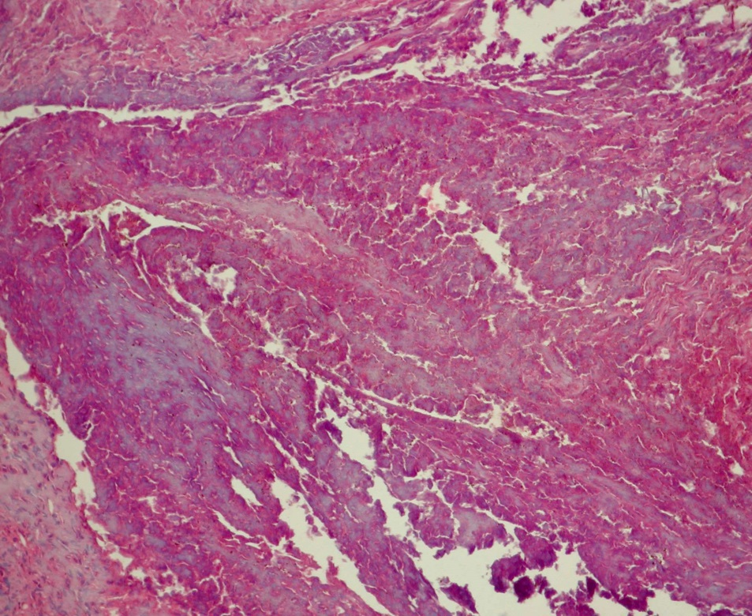
Fig. 1. Necrotically changed tissues with focal cell infiltration. Stained with hematoxylin and eosin, × 200.

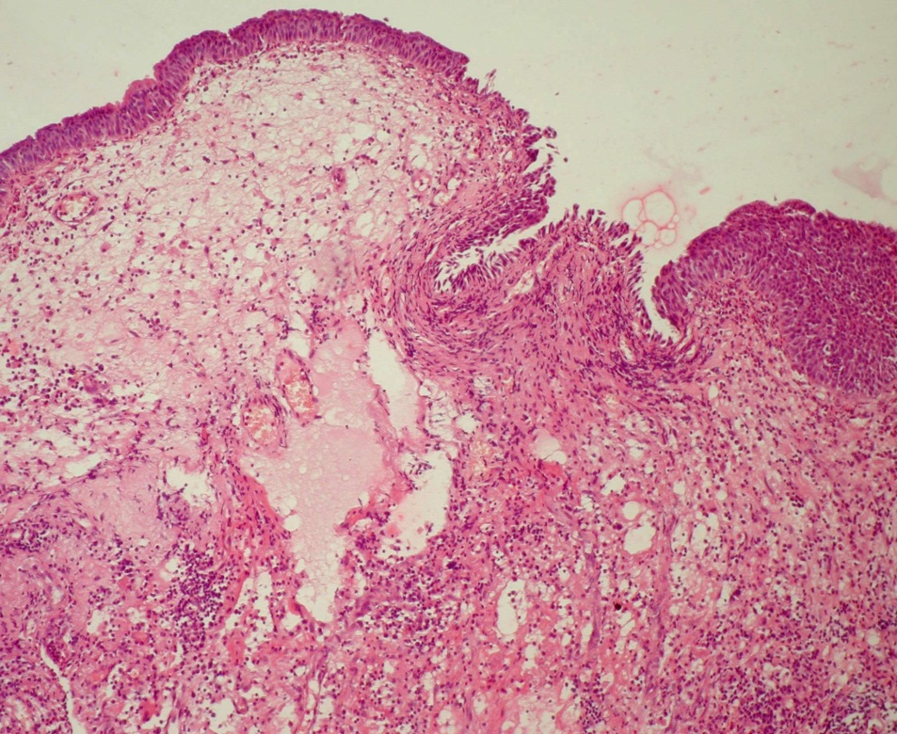
Fig. 2. Atrophied stratified ciliated epithelium or metaplastic transitional epithelium covers the surface of the nasal mucosa. Pronounced necrotic and hemodynamic changes, diffuse polymorphic cell infiltration in the mucous membrane thickness. Stained with hematoxylin and eosin, × 100.
Table 3. – Morphometric study results
Indicator name | Group 1 | Group 2
Absolute number of lymphocytes | 50.9±3.7 | 767.4±43.5 *
Absolute number of macrophages | 34.1±2.1 | 841.5±24.5 *
Absolute number of plasma cells | 56.1±3,1 | 873.2±28,9 *
Absolute number of mast cells | 20.2±1.9 | 686.5±41,2 *
Absolute number of eosinophilic leukocytes | ˗ | 107.3±5.2
Absolute number of neutrophilic leukocytes | ˗ | 168.9±12.9
Specific volume of parenchyma (%) | 39.8±2.5 | 15.6±1.2 *
Specific volume of stroma (%) | 60.2±2.5 | 84.4±1.2 *
* - statistically significant differences (p<0.05) between group 1 and group 2.

In 5 cases, microscopic examination revealed small fragments of bone tissue with pronounced necrotic changes and the presence of cellular infiltration. The latter was characterized by lymphocytes, macrophages, plasma cells, mast cells, neutrophilic and eosinophilic leukocytes. These changes indicated the development of chronic osteomyelitis at the stage of exacerbation.
In all cases, microscopy of surgical material clarified the genesis of rhinosinusitis, as various fungi (Fig. 3-5) were identified among structureless necrotic tissues (Table 3). Among the fungi and their associations, we found fungi of the genus Candida, Aspergillus, Mucor and Coccidioides. In all 11 cases various fungi were found not only among necrotic tissues, but also in thickness of the mucous membrane of the nose and paranasal sinuses, which indicated the fungal invasion (Fig. 6).
Thus, the conducted microbiological and morphological studies determined that rhinosinusitis in patients in post-COVID-19 period was of bacterial-fungal origin. In these patients, microbiological examination of the swab from the nasal cavity revealed only fungi of the genus Candida, while morphological examination of the surgical material identified fungi of the genus Aspergillus, Candida, Mucor and Coccidioides. This fact indicates that morphological study, compared with a microbiological study, is the most reliable method for detecting fungal infection.

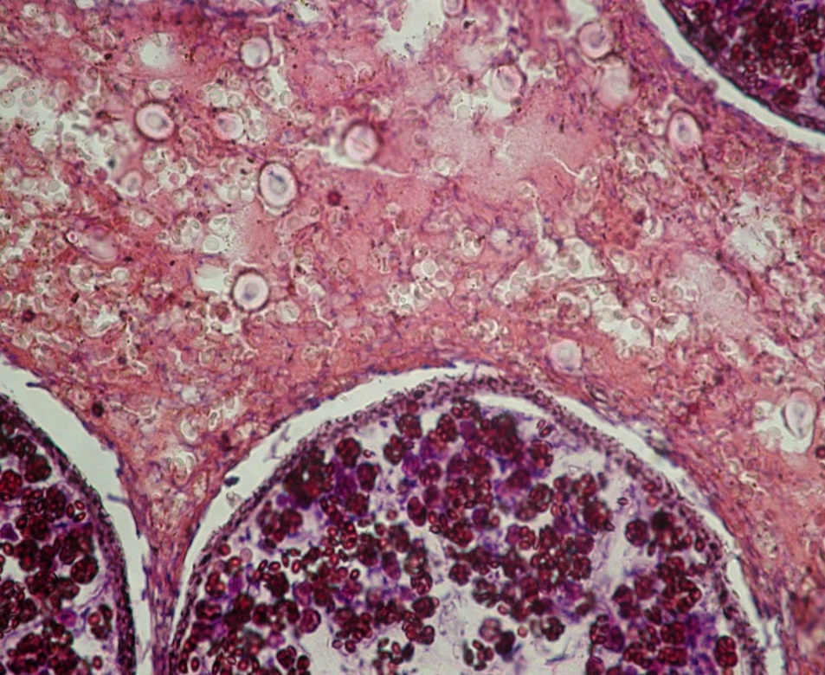
Fig. 3. Elements (spherules and endospores) of fungi of the genus Coccidioides. Stained with hematoxylin and eosin, × 400.

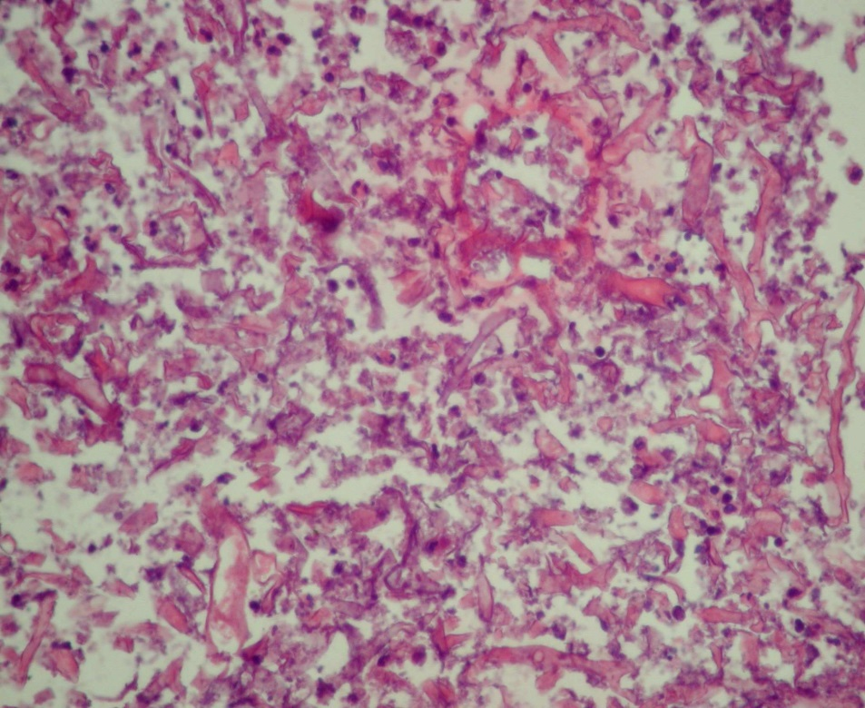
Fig. 4. Necrotically changed tissues with cell infiltration and chaotically arranged threads of the fungi of the genus Mucor. Stained with hematoxylin and eosin, × 400.

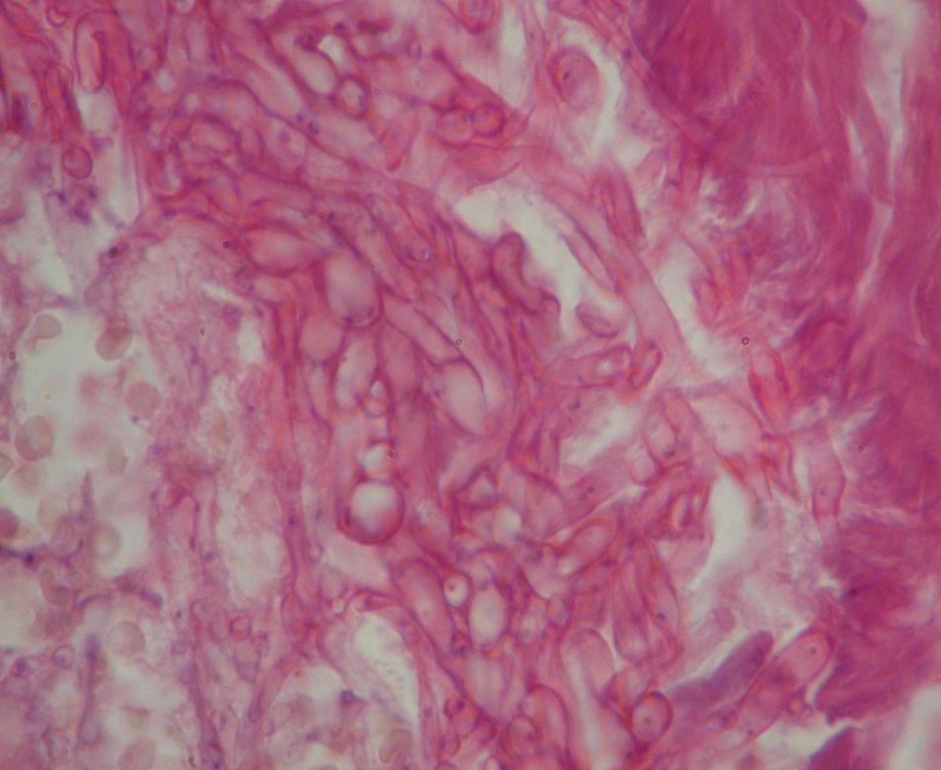
Fig. 5. Mycelium of the fungi of the genus Aspergillus. Stained with hematoxylin and eosin, × 1000.

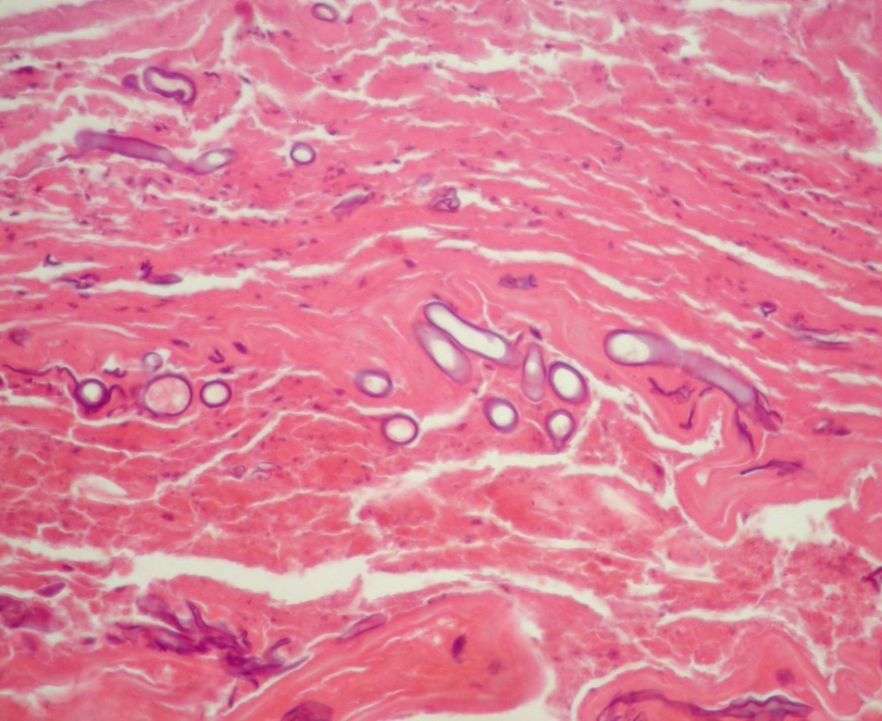
Fig. 6. Invasion of fungi threads of the genus Mucor into the thickness of the mucous membrane of the nose. Stained with hematoxylin and eosin, × 400.

The complex treatment in 7 cases (63.6%) was effective and led to recovery of the patients. In 4 cases (36.4%), there was an unfavorable outcome – death, caused by intoxication or multiple organ failure.
Discussion. The nasal cavity and paranasal sinuses form a single system of air cavities, which provides conditioning of inhaled air (its purification, neutralization, thermoregulation and humidification). The mucous membrane of the nose and paranasal sinuses plays a key role in these functions [16]. The nasal mucous membrane passes into the sinus lumen in a continuous manner without a distinctive border, that’s why paranasal sinuses are often involved in the inflammatory process in rhinitis with the rhinosinusitis development [17].
Normal microflora of the nasal cavity and paranasal sinuses are characterized by the presence of lactobacilli, coagulase-negative staphylococci, actinobacteria and anaerobes (Staphylococcus aureus). Literature data on a viral and fungal component of the normal microbiome are extremely contradictory. This microflora is a stimulating factor of the immune system, which leads to its prolonged antigenic irritation and antibodies production in low titers [18].
Microbiological study of the swab from the nasal cavity, as well as a morphological study of the surgical material, made it possible to identify the associations of bacteria and fungi in all 11 cases, which were the cause of the rhinosinusitis in patients in post-COVID-19 period. The most common bacteria were Staphylococcus aureus, Staphylococcus epidermidis, Klebsiella pneumonia, Streptococcus pneumonia and Enterococcus faecalis. Among fungi, Aspergillus, Candida, Mucor and Coccidioides were observed. Thus, rhinosinusitis in patients in post-COVID-19 period was of mixed bacterial-fungal origin.
In the literature data, there are mostly articles describing COVID-19 associated rhinosinusitis, caused, as a rule, by one of the fungi of the genus Aspergillus, Candida or Mucor [19]. Rhinosinusitis, which is caused by two or three fungal co-infections, (Aspergillus and Candida, or Aspergillus and Mucor, or Candida and Mucor etc.) in patients during COVID-19 infection or especially in post-COVID-19 period have been reported in a limited number of studies [20, 21]. Moreover, the description of rhinosinusitis in patients in post-COVID-19 period is still scarce in recent literature [22].
Microscopic and morphometric study of the surgical material made it possible to identify chronic atrophic rhinosinusitis in all cases at the stage of exacerbation in patients in post-COVID-19 period. Atrophic changes in mucous membrane of the nose and paranasal sinuses were characterized by a decrease in the epithelial layer thickness, number and size of the glands which led to the dysfunction of this layer. Functional disorders of the mucous membrane, as is known, correlate with the severity of atrophic processes in it [23].
The development mechanism of atrophic changes in mucous membrane of the nose and paranasal sinuses in patients with rhinosinusitis in post-COVID-19 period, from our point of view, is complex.
Firstly, prolonged exposure of the biological factors (bacteria and fungi) on the mucous membrane caused the development of chronic inflammation in it in post-COVID-19 period, which was characterized by the periods of exacerbation and remission. Atrophic changes were the outcome of this inflammation.
Secondly, atrophy developed because of the trophism disorder of the mucous membrane, since SARS-CoV-2 caused vascular damage and hemodynamic disorders. A number of scientists have identified endothelial dysfunction in vessels of the nasal mucosa, increased permeability of the vessel wall, predominance of the vasospasm over the vasodilatation, sludge phenomenon, thrombus formation etc. [24, 25]. Blood supply disorders and trophic changes in the mucous membrane of the nose and paranasal sinuses could also be caused by the presence of comorbidities (predominantly diabetes mellitus, hypertensive disease, coronary heart disease) in these patients.
Fungal rhinosinusitis can be divided into invasive and non-invasive types [8], depending on the potential of the fungal hyphae to invade the tissues through the epithelium (invasive) in comparison with the infection confined to the superficial epithelium (non-invasive) [26]. Invasive fungal rhinosinusitis is a more aggressive form compared with a non-invasive one, which can lead to serious morbidity and mortality. In our study, we identified the invasive form in all cases.
Chronic atrophic rhinosinusitis at the stage of exacerbation in patients in post-COVID-19 period was predominantly bilateral and characterized by the involvement in the process of all paranasal sinuses. This fact indicated the aggressive character of the course of such pathology.
Our study and literature data made it possible to identify the risk factors of the development of bacterial-fungal chronic atrophic rhinosinusitis in patients in post-COVID-19 period (Fig. 7).
SARS-CoV-2 damaging effects
Comorbidities

Endocrinopathy
Negative effects of COVID-19 infection treatment
Cardiovascular and respiratory systems diseases

Environmental factors
Primary and secondary immunodeficiency states

Liver and renal diseases, multiple organ dysfunction syndrome

Bacterial-fungal chronic atrophic rhinosinusitis in
post-COVID-19 period

Fig. 7. Risk factors of the development of bacterial-fungal chronic atrophic rhinosinusitis in patients in post-COVID-19 period.

The main risk factors of the development of bacterial-fungal chronic atrophic rhinosinusitis in patients in post-COVID-19 period are the damaging effects of SARS-CoV-2 and negative effects of COVID-19 infection treatment.
SARS-CoV-2 affects the immune system, leading to immunosuppression and increasing the susceptibility to bacterial and fungal infections. Thus, in patients with COVID-19 infection, the scientists revealed a marked reduction in CD4⁺ T cells, CD8⁺ T cells, B cells, NK cells along with lymphocytes, monocytes, eosinophils and increase in neutrophil count, pro-inflammatory markers, such as interleukin (IL)-1, IL-6 and tumor necrosis factor alpha (TNF-α) [27]. In the mucous membrane of the nose and paranasal sinuses this virus also leads to hemodynamic, trophic and alterative changes, which disrupts the known mucosa functions, contributes to the microbiome changes and development of secondary infections of various origins.
The widespread use of hormones as part of the armamentarium against COVID-19 for stopping cytokine storm syndrome may lead to the immune dysregulation with the immunosuppressive state formation [9]. Thus, hormone therapy leads to cytopaenias, inhibition of cell signalling as well as inhibition of function of T cells, B cells, and/or phagocytes, development of fungal and bacterial infection [3].
Hormone therapy may be the cause of primary or reactivate latent fungal infection development. In the latter fact we should consider the latent fungal infection before treatment with glucocorticoids. It is also noted that glucocorticoids enhance the growth rate of fungi independent of host immunosuppression [28].
In our study, patients had moderate or severe course of COVID-19 infection. They were treated according to generally accepted standards in the intensive care unit. During their treatment, we used a long-term oxygen therapy (nasal, through a face mask, high-flow), which could lead to dryness and trauma of the nasal mucosa. The latter, against the background of immunosuppressive status, could contribute to the development of fungal-bacterial infections in the nasal cavity and paranasal sinuses.
Environmental pollution, radiation against the background of immunosuppressive status can also be the risk factor of bacterial-fungal rhinosinusitis development in patients in post-COVID-19 period [29-31].
Comorbidities also play an important role in the development of bacterial-fungal chronic atrophic rhinosinusitis in patients in post-COVID-19 period. In our study, combined comorbidities were identified in all cases. Among the latter, we determined diabetes mellitus (8 cases, 72.7%) most often, which coincides with the literature data [32]. Diabetes mellitus, especially uncontrolled with ketoacidosis, can alter the normal immunologic response of patients to infections [33].
Diabetes mellitus also leads to generalized micro- and macroangiopathy, which in the mucous membrane of the nose and paranasal sinuses can lead to the development of trophic and alterative changes. These changes cause the impaired protective function of the mucous membrane and secondary fungal-bacterial infections development. This category of patients experienced dryness and atrophy of the nasal mucosa, dysregulation of the nasal-associated lymphoid tissue, glucose-rich acidic environment in tissues, which are also the conditions for the development of a secondary infection [34]. In diabetes mellitus patients the binding of iron to transferrin is inhibited and results in elevated iron levels, which promotes the growth of fungal infection [27].
Among endocrinopathies, our study also revealed obesity (4 cases, 36.4%) and autoimmune thyroiditis (2 cases, 18.2%). Several studies have reported that obesity can be a risk factor for development of different otorhinolaryngologic diseases, including rhinosinusitis as well. It happens because obesity is a potential chronic inflammatory condition, leading to chronic systemic inflammation and immune system dysfunction [35]. The study has proved an increase in the incidence of rhinosinusitis with an increase of the patient’s body mass index [36].
Recent findings demonstrate that thyroid pathology may be a risk factor of rhinosinusitis development [37]. Experimental studies on rats with rhinitis and hypothyroidism have shown activation of thyroid hormone receptors in the nasal mucosa, overproduction of acid mucopolysaccharide in the nasal and paranasal sinus regions [38].
Diseases of cardiovascular and respiratory systems can often act as a risk factor for the development of bacterial-fungal chronic atrophic rhinosinusitis in patients in post-COVID-19 period. In our study, bronchial asthma was found in 3 cases (27.3%), hypertensive disease in 6 cases (54.5%) and ischemic heart disease in 6 cases (54.5%).
Studies have shown that bronchial asthma is one of the most common risk factor for the rhinosinusitis development. Chronic rhinosinusitis and bronchial asthma are considered in the context of the unified airway theory, which describes the upper and lower airways as a single functional unit [39]. It has been estimated, that approximately 90% of asthmatics suffer from rhinosinusitis, and around 50% of rhinosinusitis patients suffer from asthma [40]. Scientists have proven that inflammatory changes in the nose and paranasal sinuses are associated with bronchoconstriction. There are similar mechanisms for the development of chronic rhinosinusitis and bronchial asthma: activation of Th2 type cells and hyperproduction of pro-inflammatory cytokines (IL-4, IL-5, IL-13); hyperreactivity of the airways, as a result of which the allergen enters the mucous membrane of the upper or lower respiratory tract, leading to the development of inflammation in various parts of the respiratory tract [41].
Other chronic diseases of the respiratory system can also be a risk factor for developing rhinosinusitis [40].
Modern literature describes the relationship between the incidence of rhinosinusitis and that of cardiovascular pathology [42]. Cardiovascular comorbid pathology (hypertensive disease and ischemic heart disease), which we have identified in a significant number of cases, can lead to hemodynamic, trophic and alterative changes in the sinonasal mucosa. This, in turn, can lead to the normal microbiome disturbances and development of a secondary fungal-bacterial infection.
Human immunodeficiency virus infection and acquired immunodeficiency syndrome, iatrogenic immunodeficiency states in massive antibiotic therapy in chronic infection treatment, long-term use of hormones and immunosuppressive drugs in cases of malignant tumors or autoimmune diseases, bone marrow and organ transplantation increase the risk of bacterial-fungal chronic rhinosinusitis development [10, 11, 13].
Chronic kidneys and liver diseases, multiple organ dysfunction syndrome are also significant risk factors for bacterial-fungal chronic rhinosinusitis development [43]. In our study, chronic hepatitis was detected in 1 case (9.1%), chronic glomerulonephritis – in 1 case (9.1%), chronic pyelonephritis – in 1 case (9.1%). Dysfunction of these organs is accompanied by intoxication, immune disorders, which can cause the development of bacterial-fungal chronic rhinosinusitis [44].
Conclusions.
1. The conducted comprehensive study made it possible to identify chronic atrophic rhinosinusitis at the stage of exacerbation caused by associations of bacteria and fungi in patients in post-COVID-19 period. Among bacteria, the authors most often noted Staphylococcus aureus, Staphylococcus epidermidis, Klebsiella pneumonia, Streptococcus pneumonia and Enterococcus faecalis. Among fungi, there were Aspergillus, Candida, Mucor and Coccidioides. Fungal infection was characterized by invasion into the mucous membrane of the nose and paranasal sinuses.
2. In patients in post-COVID-19 period the invasive bacterial-fungal chronic atrophic rhinosinusitis at the stage of exacerbation was predominantly bilateral, characterized by the involvement of several or all paranasal sinuses in the process. Patients with such pathology complained of periodic fever, headaches and malaise; nasal congestion and constant difficulty in nasal breathing; yellowish-greenish-reddish discharge from the nasal cavity, sometimes with a fetid odor; discomfort and pain in the area of paranasal sinuses; immobility of the eyeball, hyposmia or anosmia; reduction or complete loss of vision.
3. Frequent risk factors for the development of invasive bacterial-fungal chronic atrophic rhinosinusitis at the stage of exacerbation in patients in post-COVID-19 period were the information about moderate or severe course of this infection in anamnesis; comorbidities (predominantly diabetes mellitus, hypertensive disease and ischemic heart disease).
References
1. Majumder J, Minko T. Recent developments on therapeutic and diagnostic approaches for COVID-19. AAPS J. 2021;23(1):14. doi: 10.1208/s12248-020-00532-2.
2. Higgins V, Sohaei D, Diamandis EP, Prassas I. COVID-19: from an acute to chronic disease? Potential long-term health consequences. Crit Rev Clin Lab Sci. 2021;58(5):297-310. doi: 10.1080/10408363.2020.1860895.
3. Basile K, Halliday C, Kok J, Chen SC. Fungal infections other than invasive Aspergillosis in COVID-19 patients. J Fungi (Basel). 2022;8(1):58. doi: 10.3390/jof8010058.
4. Scordo KA, Richmond MM, Munro N. Post-COVID-19 syndrome: theoretical basis, identification, and management. AACN Adv Crit Care. 2021;32(2):188-194. doi: 10.4037/aacnacc2021492. PMID: 33942071.
5. Jimeno-Almazán A, Pallarés JG, Buendía-Romero Á, Martínez-Cava A, Franco-López F, Sánchez-Alcaraz Martínez BJ, Bernal-Morel E, Courel-Ibáñez J. Post-COVID-19 syndrome and the potential benefits of exercise. Int J Environ Res Public Health. 2021;18(10):5329. doi: 10.3390/ijerph18105329.
6. Fokkens WJ, Landis BN, Hopkins C, Reitsma S, Sedaghat AR. Rhinology in review: from COVID-19 to biologicals. Rhinology. 2021;59(6):490-500.
7. Zicari AM, De Castro G, Leonardi L, Duse M. Update on rhinitis and rhinosinusitis. Pediatr Allergy Immunol. 2020;31 Suppl 24:32-33. doi: 10.1111/pai.13164.
8. Saad RH, Mobarak FA. The diversity and outcome of post-covid mucormycosis: a case report. Int J Surg Case Rep. 2021;88:106522. doi: 10.1016/j.ijscr.2021.106522.
9. Ismaiel WF, Abdelazim MH, Eldsoky I, Ibrahim AA, Alsobky ME, Zafan E, Hasan A. The impact of COVID-19 outbreak on the incidence of acute invasive fungal rhinosinusitis. Am J Otolaryngol. 2021;42(6):103080. doi: 10.1016/j.amjoto.2021.103080.
10. El-Kholy NA, El-Fattah AMA, Khafagy YW. Invasive fungal sinusitis in post COVID-19 patients: a new clinical entity. Laryngoscope. 2021;131(12):2652-2658. doi: 10.1002/lary.29632.
11. Dokania V, Gaikwad NS, Gite V, Mhashal S, Shetty N, Shinde P, Balakrishnan A. Emergence of invasive fungal rhinosinusitis in recently recovered COVID-19 patients. Ann Otol Rhinol Laryngol. 2021:34894211060923. doi: 10.1177/00034894211060923.
12. Jawanda MK, Narula R, Gupta S, Sharma V, Gupta P, Kaur M. Dual fungal infections (Aspergillosis and Mucormycosis) in a diabetic mellitus patient leading to maxillary sinusitis as a post-COVID manifestation: first case report. Acta Medica (Hradec Kralove). 2021;64(4):227-231. doi: 10.14712/18059694.2022.7.
13. Heaney AK, Head JR, Broen K, Click K, Taylor J, Balmes JR, Zelner J, Remais JV. Coccidioidomycosis and COVID-19 co-infection, United States, 2020. Emerg Infect Dis. 2021;27(5):1266-1273. doi: 10.3201/eid2705.204661.
14. Sebastian SK, Ponnuvelu S, Sharma Y, Jha RK. A comparative study on the clinical profile of COVID-related and non-COVID-related acute invasive fungal rhino sinusitis. Eur Arch Otorhinolaryngol. 2022:1-8. doi: 10.1007/s00405-022-07402-x.
15. Elmokadem AH, Bayoumi D, Mansour M, Ghonim M, Saad EA, Khedr D. COVID-19-associated acute invasive fungal sinusitis: clinical and imaging findings. J Neuroimaging. 2022. doi: 10.1111/jon.12967.
16. Bezshapochniy SB, Gasyuk YA, Lobures VV, Vahnina AP. Strukturno-funkcionalnaja organizacija slizistoj obolochki polosti nosa i okolonosovyh pazuh [Structure-functional organization of mucosa of nasal cavity and paranasal sinuses]. Rhinology. 2011;4:3-13.
17. Woś J, Remjasz A. Inflammation of the nasal mucosa and paranasal sinuses. Polski Przegląd Otorynolaryngologiczny. 2019;8(1):16-26.
18. Bassiouni A, Paramasivan S, Shiffer A, Dillon MR, Cope EK, Cooksley C, Ramezanpour M, Moraitis S, Ali MJ, Bleier BS, Callejas C, Cornet ME, Douglas RG, Dutra D, Georgalas C, Harvey RJ, Hwang PH, Luong AU, Schlosser RJ, Tantilipikorn P, Tewfik MA, Vreugde S, Wormald PJ, Caporaso JG, Psaltis AJ. Microbiotyping the sinonasal microbiome. Front Cell Infect Microbiol. 2020;10:137. doi: 10.3389/fcimb.2020.00137.
19. Abdel-Aziz M, Azab N. Acute invasive fungal rhinosinusitis and coronavirus disease 2019. J Craniofac Surg. 2021;32(8):e827-e830. doi: 10.1097/SCS.0000000000008231.
20. Mekonnen ZK, Ashraf DC, Jankowski T, Grob SR, Vagefi MR, Kersten RC, Simko JP, Winn BJ. Acute invasive rhino-orbital mucormycosis in a patient with COVID-19-associated acute respiratory distress syndrome. Ophthalmic Plast Reconstr Surg. 2021;37(2):e40-e80. doi: 10.1097/IOP.0000000000001889.
21. Tabarsi P, Sharifynia S, Pourabdollah Toutkaboni M, Abtahian Z, Rahdar M, Sadat Mirahmadian A, Hakamifard A. Mixed etiology COVID-19 associated acute rhinosinusitis caused by two Aspergillus species. Ann Med Surg (Lond). 2022;75:103365. doi: 10.1016/j.amsu.2022.103365.
22. El-Kholy NA, El-Fattah AMA, Khafagy YW. Invasive fungal sinusitis in post COVID-19 patients: a new clinical entity. Laryngoscope. 2021;131(12):2652-2658. doi: 10.1002/lary.29632.
23. Liva GA, Karatzanis AD, Prokopakis EP. Review of rhinitis: classification, types, pathophysiology. J Cli Med. 20219;10(14):3183. doi: 10.3390/jcm10143183.
24. Rovas A, Osiaevi I, Buscher K, Sackarnd J, Tepasse PR, Fobker M, Kühn J, Braune S, Göbel U, Thölking G, Gröschel A, Pavenstädt H, Vink H, Kümpers P. Microvascular dysfunction in COVID-19: the MYSTIC study. Angiogenesis. 2021 Feb;24(1):145-157.
25. Labò N, Ohnuki H, Tosato G. Vasculopathy and coagulopathy associated with SARS-CoV-2 infection. Cells. 2020;9(7):1583. doi: 10.3390/cells9071583.
26. Deutsch PG, Whittaker J, Prasad S. Invasive and non-invasive fungal rhinosinusitis - a review and update of the evidence. Medicina (Kaunas). 2019;55(7):319. doi: 10.3390/medicina55070319.
27. Jawanda MK, Narula R, Gupta S, Sharma V, Sidhu SK, Kaur N. Mixed infections (Mucormycosis, Actinomycosis and Candidiasis) leading to maxillary osteomyelitis in a diabetic mellitus patient in post COVID phase: first case report. Acta Medica (Hradec Kralove). 2021;64(4):218-223.
28. Nielsen MC, Reynoso D, Ren P. The brief case: a fatal case of SARS-CoV-2 coinfection with Coccidioides in Texas - another challenge we face. J Clin Microbiol. 2021;59(8):e0016321. doi: 10.1128/JCM.00163-21.
29. Leland EM, Zhang Z, Kelly KM, Ramanathan M Jr. Role of environmental air pollution in chronic rhinosinusitis. Curr Allergy Asthma Rep. 2021;21(8):42. doi: 10.1007/s11882-021-01019-6.
30. Huang H, Tan KS, Zhou S, Yuan T, Liu J, Ong HH, Chen Q, Gao J, Xu M, Zhu Z, Qiu Q, Wang Y. p63⁺Krt5⁺ basal cells are increased in the squamous metaplastic epithelium of patients with radiation-induced chronic rhinosinusitis. Radiat Oncol. 2020;15(1):222. doi: 10.1186/s13014-020-01656-7.
31. Krasnoselsky MV, Pushkar OS, Simonova LI, Myroshnychenko MS. The effect of photodynamic therapy and platelet-enriched plasma on the healing of skin radiation ulcers infected by Staphylococcus aureus. Probl Radiac Med Radiobiol. 2020;25:338-352. doi: 10.33145/2304-8336-2020-25-338-352.
32. Galaviz-Aboytes C, Ochoa-Ramírez LA, Alzate-Moctezuma JA, Ríos-Burgueño ER, Rodríguez-Millán J, Velarde-Félix JS. Case report: severe craniofacial Coccidioidomycosis in a pregnant woman. Am J Trop Med Hyg. 2021;104(3):868-870. doi: 10.4269/ajtmh.20-0968.
33. Saidha PK, Kapoor S, Das P, Gupta A, Kakkar V, Kumar A, Arya V. Mucormycosis of paranasal sinuses of odontogenic origin post COVID19 infection: a case series. Indian J Otolaryngol Head Neck Surg. 2021:1-5. doi: 10.1007/s12070-021-02638-1.
34. Zhao Y, Liu Y, Yi F, Zhang J, Xu Z, Liu Y, Tao Y. Type 2 diabetes mellitus impaired nasal immunity and increased the risk of hyposmia in COVID-19 mild pneumonia patients. Int Immunopharmacol. 2021;93:107406. doi: 10.1016/j.intimp.2021.107406.
35. Kim TH, Kang HM, Oh IH, Yeo SG. Relationship between otorhinolaryngologic diseases and obesity. Clin Exp Otorhinolaryngol. 2015;8(3):194-197. doi: 10.3342/ceo.2015.8.3.194.
36. Jung SY, Park DC, Kim SH, Yeo SG. Role of obesity in otorhinolaryngologic diseases. Curr Allergy Asthma Rep. 2019;19(7):34. doi: 10.1007/s11882-019-0865-3.
37. Min JY, Tan BK. Risk factors for chronic rhinosinusitis. Curr Opin Allergy Clin Immunol. 2015;15(1):1-13. doi:10.1097/ACI.0000000000000128.
38. Fawzan AE, Assiri SA, Althaqafi RMM, Alsufyani A, Alghamdi ASA. Association of allergic rhinitis with hypothyroidism, asthma, and chronic sinusitis: clinical and radiological features. World J Otorhinolaryngol Head Neck Surg. 2022;1-7. doi: 10.1016/j.wjorl.2020.12.001.
39. Pan Y, Zang H. Association of chronic rhinosinusitis with bronchial asthma and its severity: A protocol for systematic review and meta-analysis. Medicine (Baltimore). 2021;100(9):e24772. doi: 10.1097/MD.0000000000024772.
40. Piotrowska VM, Piotrowski WJ, Kurmanowska Z, Marczak J, Górski P, Antczak A. Rhinosinusitis in COPD: symptoms, mucosal changes, nasal lavage cells and eicosanoids. Int J Chron Obstruct Pulmon Dis. 2010;5:107-117. doi: 10.2147/copd.s8862.
41. Matucci A, Bormioli S, Nencini F, Chiccoli F, Vivarelli E, Maggi E, Vultaggio A. Asthma and chronic rhinosinusitis: How similar are they in pathogenesis and treatment responses? Int J Mol Sci. 2021;22(7):3340. doi: 10.3390/ijms22073340.
42. Jeon YJ, Lee TH, Joo YH, Cho HJ, Kim SW, Park B, Choi HG. Increased risk of cardiovascular diseases in patients with chronic rhinosinusitis: a longitudinal follow-up study using a national health screening cohort. Rhinology. 2022;60(1):29-38. doi: 10.4193/Rhin21-211.
43. Ebeid K, Gamea M, Allam AA, Shehata E. Impact of COVID-19 on acute invasive fungal rhinosinusitis: a comparative study. Egyptian Journal of Ear, Nose, Throat and Allied Sciences. 2021; 22(22). doi: 10.21608/ejentas.2021.76357.1369.
44. Spillinger A, Low CM, Smith BM, Stokken JK, O'Brien EK, Choby G. Presentation and outcomes of chronic rhinosinusitis following liver and kidney transplant. World J Otorhinolaryngol Head Neck Surg. 2020;7(2):139-145. doi: 10.1016/j.wjorl.2020.05.001.

Conflict of Interests
The authors declare that there is no conflict of interests regarding the publication of this paper.
Corresponding author
Mykhailo S. Myroshnychenko
Doctor of Medical Sciences, Professor, Acting Head of Alpern Department of General and Clinical Pathological Physiology,
Kharkiv National Medical University,
4 Nauky avenue, Kharkiv, 61022, Ukraine
Tel. +380501699763, +380961033038
e-mail: msmyroshnychenko@ukr.net

ORCID numbers:
Mykhailo S. Myroshnychenko – 0000-0002-6920-8374
Yuliia M. Kalashnyk-Vakulenko – 0000-0002-7733-3503
Nataliia V. Kapustnyk – 0000-0002-4875-398X
Oleksandra O. Babycheva – 0000-0003-1853-306X
Nadiia O. Yurevych – 0000-0001-7340-2850
Olha V. Bondarenko – 0000-0002-4808-9513
Mykhailo V. Kalashnyk – 0000-0001-8729-0271
Inna I. Torianyk – 0000-0001-6843-8808
Anton S. Shapkin – 0000-0002-6437-4840
Andrii V. Lupyr – 0000-0002-9896-163X

A - Work concept and design Mykhailo S. Myroshnychenko, Inna I. Torianyk
B – Data collection and analysis Nataliia V. Kapustnyk
C – Responsibility for statistical analysis Nadiia O. Yurevych, Anton S. Shapkin
D – Writing the article Mykhailo S. Myroshnychenko, Andrii V. Lupyr
E – Critical review Yuliia M. Kalashnyk-Vakulenko, Olha V. Bondarenko
F – Final approval of the article Mykhailo V. Kalashnyk, Oleksandra O. Babycheva

