MINISTRY OF PUBLIC HEALTH OF UKRAINE
KHARKIV NATIONAL MEDICAL UNIVERSITY
Department of Traumatology and Orthopedics
Faculty for training foreign students №7

Dorsopathy

Manual
in discipline "Traumatology and orthopedics"
for self-study of 5th year students of
medical faculties

Approved
at the meeting of the department
traumatology and orthopedics
record №17 dated 19.10.2020
Department chairman prof. Holka H.H.
Kharkiv
KhNMU 2021

Dorsopathy: Manuals for self-study of 5 course students medical faculties / authors:H.H.Holka, D.A.Istomin [and others.]; KhNMU - Kharkiv: KhNMU, 2021. - 27 p.
Created by: H.H.Holka,
A.O.Oliynyk,
D.A.Istomin,
V.V.Vesnin,
V.V.Burlaka,
M.A.Harkusha,
V.O. Lytvyshko

Dorsopathy
Dorsopathy (degenerative disc diseases) - is a disease of the spine, which is based on primary dystrophies and degenerative process of the intervertebral disc (IVD), with the further development of reactive and compensatory changes intervertebral joints and ligaments, and then in the adjacent vertebral bodies and , as a result , totally defeat all elements of vertebrates at - motor segment .
At present, people aged 45 years often restrict their activities because of constant pain in the back and neck. The prevalence of chronic back pain is 26-32 % among the adult population. In the structure of morbidity with disability of the adult population more than 50 % are diseases of the peripheral nervous system. Among the disabled with diseases of the peripheral nervous system in 80 % of cases occur by vertebral affection.
Back pain is an extremely common human phenomenon, a price mankind has to pay for their upright posture. According to one study, almost 80 percent of persons in modern industrial society will-experience back pain at some time during their life. Fortunately, in 70 per cent of these, it subsides within a month. But, in as many as 70 per cent of these, the pain recurs.
CAUSES
The most common are involutionary and microtraumatic theories of Dorsopathy . According to involution theory, the cause of the disease is aging, involution and wear of the intervertebral discs . Microtraumatic theory suggests that spinal injuries can be both etiological and provocative in the development of the disease. In the development of Dorsopathy, importance is given to hereditary predisposing biochemical, hormonal, neuromuscular and immunological disorders, as well as abnormalities in the development of the spine, which may affect the clinical course of the disease. A certain role is assigned to exogenous factors, in particular cooling, under the influence of which there are autoimmune disorders or the development of reflex spasm of the arteries that feed the nerve roots and vertebral segments.
Biomechanics and physiology of the spinal - motor segment . The vertebral column consists of the vertebrae connected among themselves by (IVD), the massive ligamentous device and paired arcuate process joints with adjacent vertebrae forms a structural and functional unit - vertebral - motor segment ( Fig 1).
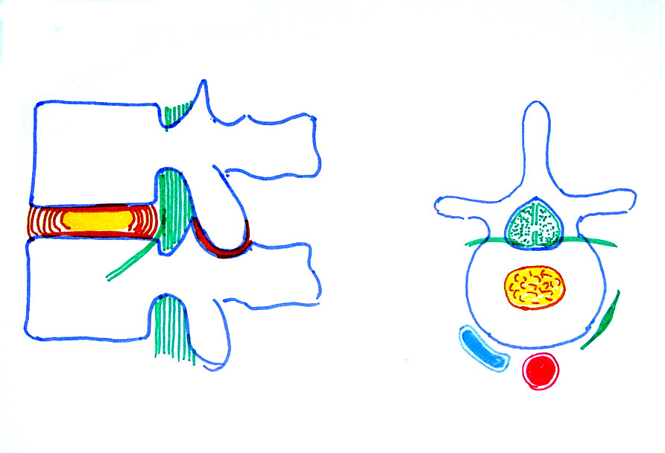
Fig 1
The specific etiology of most back pains is not clear. Postural and traumatic back pains are among the common. Back pain could be a feature of an extra-spinal disease like a genito-urinary or gynaecological disease. The following findings in the clinical examination are helpful in reaching a diagnosis.
Age: Some diseases are more common at a particular age. Back pain is uncommon in children, but if present it is often due to some organic disease. This is different from adults, in whom psychological factors play an important role in producing back pain. In adolescents, postural and traumatic back pain are commoner. In adults, ankylosing spondylitis and disc prolapse are common. In elderly persons, degenerative arthritis, osteo-porosis and metastatic bone disease are usually the cause.
Sex: Back pain is more common in women who have had several pregnancies. Lack of exercise—leading to poor muscle tone, and nutritional osteomalacia are contributory factors in these patients. Some women put on a lot of weight during pregnancy, and later develop mechanical back pain.
Occupation: A history regarding the patient's occupation may provide valuable clues to risk factors responsible for back pain.
Physical examination:
Position-, Look for scoliosis, lordosis pelvic tilt and forward flexion of the torso on the lower limbs.
• Spasm: Muscle spasm may be present in acute back pain and can be discerned by the prominence of the para-vertebral muscles at rest, which stand out on the slightest movement.
• Tenderness: Localised tenderness may indicate a ligament or muscle tear. There may be trigger points or tender nodules in cases of flbrositis. Pain originating from the sacro-iliac joint may have tenderness localised to the posterior superior iliac spine.
• Swelling: A cold abscess may be present, indicating tuberculosis as the cause.
• Range of movement There is limitation of movement in organic diseases of the spine. One must carefully differentiate spinal movements from the patient's ability to bend at the hips
Lying down position: In the supine position the following observations are made:
• Straight leg raising test (SLRT): This is a test to detect nerve root compression • Bending at the spine
Neurological examination: Sensation, motor power and reflexes of the lower limb are examined. This helps in localizing the site of spine pathology.
• Peripheral pulses: The peripheral pulses should be palpated to detect a vascular cause of low back pain due to vascular claudication. The skin temperature in the affected leg may be lower.
• Adjacent joints: Often, the pain originates from the hip joints or sacro-iliac joint, hence these should be examined routinely.
• An abdominal, rectal or per vaginal examination may be made wherever necessary. Chest expansion should be measured in young adults with back pain.
The diagnosis of back pain is essentially clinical. There is no use of getting the X-rays done in acute back pain less than 3 weeks duration, as it does not affect the treatment. On the contrary X-ray examination is a must for back pain lasting more than 3 weeks; it is almost an extension of the clinical examination. There are a number of other investigations like C.T. scan, M.R.I. scan, bone scan, blood investigations etc. One has to be very thoughtful in ordering these investigations—order only when you think it is going to change your line of action, or if the clinical diagnosis is doubtful.
Radiological examination: Routine X-rays of the lumbo-sacral spine (AP and lateral) and pelvis (AP) should be done in all cases. These are useful in diagnosing metabolic, inflammatory and neoplastic conditions. Though, X-rays are usually normal in non-specific back pain, these provide a base line. X-rays should be done after preparation of the bowel with laxatives and charcoal tablets.
The C.T. scan has replaced more invasive techniques like myelography etc. It shows most bony and soft-tissue problems around the spine and spinal canal. M.R.I, scan is an expensive investigation, now available in big cities. It delineates soft-tissues extremely well, and may be needed in some cases.
Blood investigations: These should be carried out if one suspects malignancy, metabolic disorders, or chronic infection (please refer to their respective Chapters for details).
Electromyography: If nerve root compression is a possibility, electromyography (EMG) may be appropriate.
Bone scan: It may be helpful if a benign or malignant bone tumour is suspected on clinical examination but is not seen on plain X-rays.
TREATMENT
Principles of treatment: For specific pathologies, treatment is discussed proper. Most back pains falling in the 'non-specific' category have a set programme of treatment, mostly conservative. It consists of rest, drugs, hot packs, spinal exercises, traction, corset and education regarding the prevention of back pain.
• Rest: In the acute phase, absolute bed rest on a hard bed (a mattress is allowed) is advised. Bed rest for more than 2-3 weeks is of no use;
rather, a gradual mobilisation using aids like brace is preferred.
• Drugs: Mainly analgesic—anti-inflammatory drugs are required. In cases with a stiff spine, muscle relaxants are advised.
• Physiotherapy: This consists of heat therapy (hot packs, short-wave diathermy, ultrasonic wave etc.). Gradually, a spinal exercises programme is started.
• Traction: It is given to a patient with back pain with lot of muscle spasm. It also sometimes help in 'forcing' the patient to rest in the bed.
• Use of corset: This is used as a temporary measure in treating acute back pain, in back pain due to lumbar spondylosis etc.
• Education: Patients must be taught what they can do to alleviate the pain and to avoid injury or re-injury to the back. This includes education to avoid straining the back in activities of daily living such as sitting, standing, lifting weight etc. 'Back Schools' are formalised approach to this education.
MAJOR CAUSES OF LOW BACK PAIN
CONGENITAL DISORDERS
Spina bifida: This and other minor congenital anomalies of the spine are present in about half the population, but are not necessarily the cause of back pain. Therefore, other pathologic conditions should be ruled out before diagnosing this as the cause of symptoms. Treatment is as for non-specific back pain.
Transitional vertebrae: A transitional vertebra is the one at the junction of two segments of the spine, so that the characteristics of both segments is present in one vertebra. It is common in the lumbo-sacral region, either as lumbalisation (S1 becoming L5) or sacralisation (L5 fused with the sacrum, either completely or partially).
TRAUMATIC DISORDERS
Back strain (acute or chronic): The terms back strain and back sprain are often used interchangeably. Most often this arises from a 'trauma' sustained in daily routine activities rather than from a definite injury. People prone to back strain are athletes, tall and thin people, those in a job requiring standing for long hours and those working in bad postures. Sedentary workers and women after pregnancy are also frequent candidates for back strain. Acute ligament sprain may occur while lilting a heavy weight, sudden straightening from bent position, pushing etc. Treatment is 'non-specific' as discussed earlier.
Compression fractures: These fractures occur commonly in the thoraco-lumbar region. Treatment depends upon the severity of compression. It is important to be suspicious of any underlying pathology. Diseases such as an early secondary deposit in an elderly, may produce a fracture spontaneously, in one or multiple vertebrae.
INFLAMMATORY DISORDERS
Tuberculosis: Spinal tuberculosis is a common cause of persistent back pain, especially in undernourished people living in unhygienic conditions. Early diagnosis and treatment is critical for complete recovery.
Ankylosing spondylitis: This should be suspected in a young male presenting with back pain and stiffness. The symptoms are worst in the morning and are relieved on walking about. Spinal movements may be markedly limited along with limitation of chest expansion.
Spinal stenosis: A narrowing of the spinal canal may occur in the whole of the lumbar spinal (e.g., in achondroplasia), or more often in a segment of the spine (commonly in the lumbo-sacral region). The stenosis may be in all parts of the canal or only in the lateral part; the latter is called as root canal stenosis. It may give rise to pressure or tension on the nerves of the cauda equina or lumbar nerve roots. Typically, the patient complains of pain radiating down the lower limbs on walking for some distance, and is relieved on taking rest for a few minutes (neurological claudication). The diagnosis is confirmed by a C.T. scan or myelogram. Treatment is by decompression of the spinal canal or root canal, as the case may be.
TUMOURS
Both benign and malignant tumours occur in the spine and the spinal canal. Tumours of the spinal canal, usually benign, are classified as extradural or intradural; the latter can be either intra-medullary or extra-medullary. These tumours are usually diagnosed on myelogram or C.T. scan. Tumours of the spine are mostly malignant, usually secondaries from some other primary tumours. Some commoner tumours of the spine are as discussed below.
Benign tumours: These are uncommon. Osteoid osteoma is the commonest benign tumour of the spine. It causes severe back pain, especially at night. Typically the pain is relieved by aspirin. The tumour, usually the size of a pea, is found in the pedicle or lamina. Haemangioma also occurs in the vertebral body. Meningioma is a common intradural, extra-medullary tumour which presents with back pain or radiating pain.
Malignant tumours: Multiple myeloma is the commonest primary malignancy of the spine. Metastatic deposits are extremely common in the spine because of its rich venous connections, especially with the vertebral venous plexus. Pain often precedes X-ray evidence of a metastatic deposit. By the time a deposit is visible on an X-ray, the tumour has replaced about 30 percent of the bony content of the vertebra. A bone scan can detect the lesion earlier.
OTHER CAUSES
Facet arthropathy and subtle arthritis of the facet joints can result from a degenerative disease and mal-development of the facets (facet tropism).
Approach to a patient with back pain: The source of back pain is difficult to find because of variable factors. The aim is to identify the pathology that needs immediate treatment, such as an infection, neoplasm, disc prolapse etc. All other back pain are treated as non-specific back pain with more or less common treatment programme. While the patient is on this treatment programme, he is reviewed at regular intervals for any additional signs suggesting an organic illness. First establish whether the problem is acute (3 to 6 months) or chronic (longer than 6 months). If it is an acute pain, whether it is related to a definite episode of trauma or is spontaneous in onset. The causes are accordingly worked out In cases with chronic back pain, it is helpful to judge whether it is mechanical or inflammatory by asking the patient whether the rest brings relief or makes the pain worse. Accordingly, further signs and symptoms help in diagnosis.
SCIATICA
Sciatica is a symptom and not a diagnosis. It means a pain radiating down the back of the thigh and calf. Degenerative arthritis and disc prolapse are the common causes. Broadly, sciatica can either be because of inflammation of the sciatic nerve or because of compression of one of the roots constituting the sciatic nerve.
Disc protrusion
The intervertebral disc consists of three distinct components — the cartilage end-plates, nucleus pulposus and annulus fibrosus. The cartilage plates are thin layers of hyaline cartilage between adjacent vertebral bodies and the disc proper. The disc receives its nutrition from the vertebral bodies via these end-plates, by diffusion.
The nucleus pulposus is a gelatinous material which lies a little posterior to the central axis of the vertebrae. It is enclosed in annulus fibrosus, a structure composed of concentric rings of fibro-cartilaginous tissue. The nucleus pulposus is normally under considerable pressure, and is restrained by the crucible-like annulus. The posterior longitudinal ligament is a strap-like ligament at the back of the vertebral bodies and discs.
The term 'prolapsed disc' means the protrusionor extrusion of the nucleus pulposus through a rent in the annulus fibrosus. It is not a one time phenomenon: rather it is a sequence of changes in the disc, which ultimately lead to its prolapse. These changes consist of the following:
a) Nucleus degeneration: Degenerative changes occur in the disc before displacement of the nuclear material. These changes are: (1) softening of the nucleus, and its fragmentation; and (2) weakening and disintegration of the posterior part of the annulus
b) Nucleus displacement: The nucleus is under positive pressure at all times. When the annulus becomes weak, either because a small area of its entire thickness has disintegrated spontaneously or because of injury, the nucleus tends to bulge through the defect . This is called disc protrusion. This tendency is greatly increased if the nucleus is degenerated and fragmented
Finally, the nucleus comes out of the annulus, and lies under the posterior longitudinal ligament; though it has not lost contact with the parent disc. This is called disc extrusion Once extruded, he disc does not go back. The posterior longitudinal ligament is not strong enough to prevent the nucleus protruding further. The extruded disc may loose its contact with the parent disc, when it is called sequestrated disc . The sequestrated disc may come to lie behind the posterior longitudinal ligament or may become free fragment in the canal.
c) Stage of fibrosis: This is the stage of repair. This begins alongside of degeneration. The residual nucleus pulposus becomes fibrosed. The extruded nucleus pulposus becomes flattened, fibrosed, and finally undergoes calcification. At the same time, new bone formation occurs at the points where the posterior longitudinal ligament has been stripped from the vertebral body and spur formation occurs.
The site of exit of the nucleus is usually postero-lateral on one or the other side. Occasionally, it can be central (posterior-midline) disc prolapse. The type of nuclear protrusion may be: a protrusion, an extrusion or a sequestration. A dissecting extrusion, (an extrusion with disc material between the body of the vertebra and posterior longitudinal ligament, stripping the latter off the body), may occur.
Secondary changes associated with disc prolapse: As a consequence of disc prolapse, changes occur in the structures occupying the spinal canal, and in the intervertebral joints. These are as follows:
a) Changes in structures occupying spinal canal:
• Commonly, the unilateral protrusion is in contact with the spinal theca and compresses one or more roots in their extra-thecal course. Usually, a single root is affected. Sometimes, two roots on the same or opposite sides are affected. The nerve root affected is usually the one which leaves the spinal canal below the next vertebra. This is because the root at the level of the prolapsed disc leaves the canal in the upper-half of the foramen . Thus, the nerve root affected in a disc prolapse between L4-L5 vertebrae is L4, although it is the L4 root which exits the canal at this level.
• Pressure effects on the intra-thecal roots of the cauda equina may occur by a sudden large disc protrusion in the spinal canal, and may present as cauda equina syndrome. This is uncommon.
b) Changes in the intervertebral joints: With the loss of a part of the nucleus pulposus and its subsequent fibrosis, the height of the disc is reduced. This affects the articulation of the posterior facet joints. The incongruity of the facet articulation leads to degenerative arthritis.
DIAGNOSIS
The diagnosis is mainly clinical. Investigations like C.T. scan and M.R.I, scan may be done to confirm the diagnosis, especially if surgery is being considered.

Clinic and diagnosis of DDD . The formation of clinical manifestations of DDD depends on the localization of the process, the form of the disease (stable or unstable ) and the stage of the process, as well as the state of the nervous, immune, endocrine, cardiovascular and muscular systems.
Clinical manifestations of DDD varied from severe back pain in acute hernia dystrophy and including but modified drive in to the discomfort. Provoking factors of back pain are often muscle strain, lifting weights and clumsy movement, prolonged awkward posture, hypothermia, tension, and others
Clinical features: The patient is usually an adult between 20-40 years of age, with a sedentary life-style. The commonest presenting symptom is low back pain with or without the pain radiating down the back of the leg (sciatica). A preceding history of trauma is present in some cases. In a few cases, there is a history of exertion such as having lifted something heavy or pushed something immediately preceding a sudden-onset backache. The following symptoms are common:
• Low backache: The onset of backache may be acute or chronic. An acute backache is severe with the spine held rigid by muscle spasm, and any movement at the spine painful. The patient may be able to get about with difficulty; in extreme cases, he is completely incapacitated — any attempted movement producing severe pain and spasm. In chronic backache, the pain is dull and diffuse, usually made worse by exertion, forward bending, sitting or standing in one position for a long time. It is relieved by rest.
• Sciatic pain: This is usually associated with low back pain, but may be the sole presenting symptom. The pain radiates to the gluteal region, the back of the thigh and leg. The pattern of radiation depends upon the root compressed. In S1 root compression, the pain radiates to the postero-lateral calf and heel. In L5 root compression the pain radiates to the antero-lateral aspect of the leg and ankle. In a disc prolapse at a higher level (L1-L2 etc.), the pain may radiate to the front of the thigh. Often the radiation may begin on walking, and is relieved on rest (neurological claudication).fig2
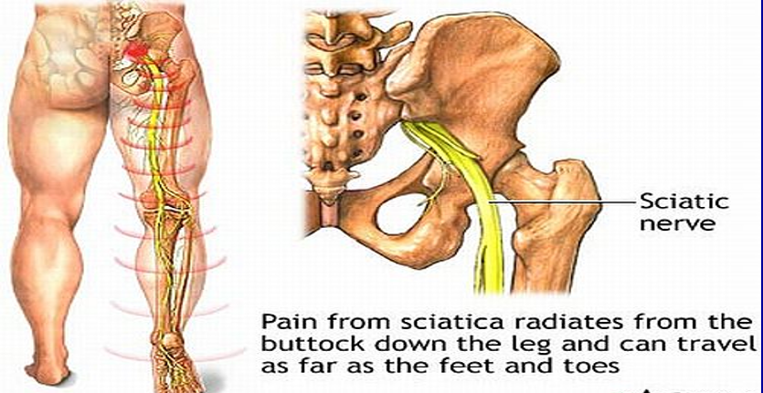
• Neurological symptoms: Sometimes, the patient complains of paraesthesias, most often described as 'pins and needles' corresponding to the dermatome of the affected nerve root. There may be numbness in the leg or foot and weakness of the muscles. In cases with large disc material compressing the theca and roots, a cauda equina syndrome results, where the patient has irregular LMN type paralysis in the lower limbs, bilateral absent ankle jerks, with hypoaesthesia in the region of L3 to S1 derma-tomes, and urinary and bowel incontinence.
Examination: The back and limbs are examined with the patient undressed. The following observations are made:
• Posture: The patient stands with a rigid, flattened lumbar spine. The whole trunk is shifted forwards on the hips). The trunk is tilted to one side (sciatic tilt or scoliosis). The sideways tilt tends to exaggerate on attempted bending forwards.
• Movements: The patient is unable to bend forwards; any such attempt initiates severe muscle spasm in the paraspinal muscles.
• Tenderness: There is diffuse tenderness in the lumbo-sacral region. A localised tenderness in the midline or lateral to the spinous process is found in some cases.
• Straight leg raising test (SLRT): This test indicates nerve root compression. A positive SLRT at 40 degrees or less is suggestive of root compression. More important is a positive contra-lateral SLRT.Fig3
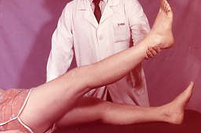
Fig3 Symptom of "tension"
• Lasegue test: This is a modification of SLRT where first the hip is lifted to 90 degrees with the knee bent. The knee is then gradually extended by the examiner. If nerve stretch is present, it will not be possible to do so and the patient will experience pain in the back of the thigh or leg.
• Neurological examination: A careful neurological examination would reveal a motor weakness, sensory loss or loss of reflex corresponding to the affected nerve root of special importance is the examination of the muscles of the foot supplied by L4, L5 and S1 roots, as these are the roots affected more commonly. The extensor hallucis longus muscle is exclusively supplied by L5 root and its weakness is easily detected by asking the patient to dorsiflex the big toe against resistance. Sensory loss may be merely the blunting of sensation or hypoaesthesia in the dermatome of the affected root.
INVESTIGATIONS
Plain X-ray: Plain X-ray does not show any positive signs in a case of acute disc prolapse. X-rays are done basically to rule out bony pathology such as infection etc. In cases of chronic disc prolapse, the affected disc space may be narrowed, and there may be lipping of the vertebral margins posteriorly.
Myelography: With the availability of non-invasive imaging techniques like the C.T. scan, the usefulness of myelography has become limited. It is performed in cases where precise localisation of the neurological signs is not possible. It is also used in cases if facilities for a C.T. scan are not available. The following myelographic features suggest disc prolapse:
• Complete or incomplete block to the flow of dye at the level of a disc.
• An indentation of the dye-column.
• Root cut-off sign: Normally, the dye fills up the nerve root sheath. In cases where a lateral disc prolapse is pressing on the nerve root, the sheath may not be filled. It appears on the X-ray as an abrupt blunting of the dye-column filling the root sheath.
C.T. scan: Normally, in an axial cut section, the posterior border of a disc appears concave. In a case where there is disc prolapse, it will appear flat or convex. There will be loss of pre-thecal fat shadow normally seen between the posterior margin of the disc and theca. The herniated disc material can be seen within the spinal canal, pressing on the nerve-roots or theca
M.R.I. Scan This is the investigation of choice, shows the prolapsed disc, theca, nerve roots very clearly (Fig4)
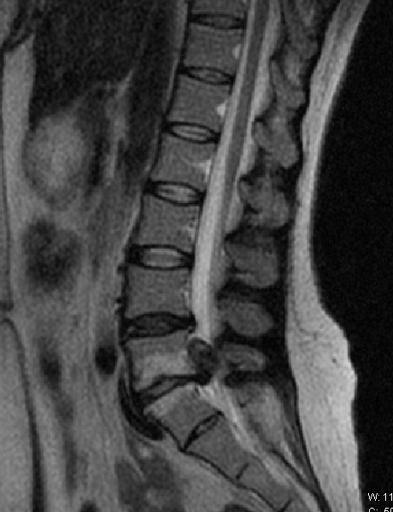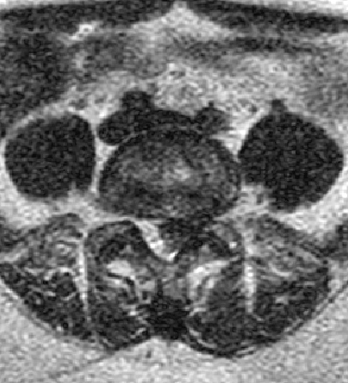

Electromyography (EMG): Findings c denervation, localised to the distribution of particular nerve root, helps in localising the offending disc in cases with multiple dis prolapses. This test is rarely required.
DIFFERENTIAL DIAGNOSIS
A prolapsed disc is a common cause of low backache, especially the backache associated wit sciatic pain. One must be extremely cautious an avoid misdiagnosing other diseases that ma mimic a disc prolapse.
TREATMENT
Principles of treatment: The aim of treatment is to achieve remission of the symptoms, mostly possible by conservative means. Cases who do not respond to conservative treatment for 3-6 weeks, and those presenting with cauda equina syndrome may require operative intervention.
Conservative treatment: This consists of the following:
• Rest: It is most important in the treatment of a prolapsed disc. Rest on a hard bed is necessary for 2-3 weeks.
• Drugs: These consist of mainly analgesics(non-steriods) and muscle-relaxants.
• Physiotherapy: This consists of hot fomentation, gentle arching exercises, etc.
• Others: These consist of lumbar traction, transcutaneous electrical nerve stimulation (TENS) etc.
Operative treatment: Indications for operative treatment are: (1) failure of conservative treatment;
(2) cauda equina syndrome; and (3) severe sciatic tilt. The disc is removed by the following techniques
• Fenestration: The ligamentum flavum bridging the two adjacent laminae is excised and the spinal canal at the affected level exposed.
• Laminotomy: In addition to fenestration, a hole is made in the lamina for wider exposure.
• Hemilaminectomy: The whole of the lamina on one side is removed.
• Laminectomy: The laminae on both sides, with the spinous process, are removed. Such a wide exposure is required for a big, central disc producing cauda-equina syndrome.
Chemonucleosis: In this technique, an enzyme (chymopapain) with the property of dissolving fibrous and cartilaginous tissue, is injected into the disc, under X-ray control. This leads to the dissolution and flbrosis of the disc and thus relief of symptoms. It can be done through a few puncture wounds.
Percutaneous discectomy: This is a more recent technique where the disc is removed by using an endoscope and fine endoscopic instruments or laser probes inserted percutaneously through small stab wounds. Though a minimally invasive technique, its indications are limited, and one requires adequate instrumentation and training.
CERVICAL DISC PROLAPSE
Prolapse of the intervertebral disc in the cervical spine is much less common than it is in the lumbar spine. The disc between C5-C6 is the one affected most frequently. Postero-lateral protrusion is the commonest. A typical patient presents with a vague history of injury to the neck — often a jerk or a twisting strain. Symptoms may begin hours after the episode of injury. The neck becomes stiff and the pain radiates down the shoulder to the outer aspect of the limb. up to the thumb. Paraesthesias may be felt in the hand. On examination, it may be possible to localise the neurological deficit to a particular nerve root, usually C5. In some cases, there may be signs of cord compression from the front (UMN signs). X-rays do not show any abnormality. M.R.1. scan is the imaging modality of choice but should be done if operative intervention is contemplated.
Treatment: There is a strong tendency to spontaneous recovery. Cases may present with signs of cord compression or root compression in the upper limb. Such cases may require surgery. The disc is exposed from the front and the material removed.

DEFORMING SPONDYLOSIS AND SPONDYLOARHTROSIS
Spondylosis is characterized by the primary affection of the vertebral bodies with the following affection of the posterior supporting complex (facet joints and ligaments) with the occurrence and slow progression of degenerative changes in the IVD.
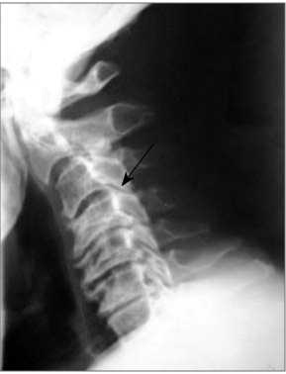
Fig. 5. X-ray of the cervical part of the spine (lateral projection). Cervical spondylosis in C₄-C₅, C₅-C₆segments. Ventral and dorsal osteophytes with the spinal canal stenosis
This pathology is more often observed in the elderly age. Among the spondylosis causes the following are defined: spinal injury of different genesis, continuous sitting work (continuous static load), posture impairment, osteochondrosis. Overcooling or excessive physical activity are often provocative factors. Process can be isolated or can have diffuse character.
Pathogenesis. The main sign of spondylosis - massive osteophytes formation in the area of vertebral bodies apophyses. Due to the degenerative-dystrophic changes, hyaline cartilage loses its fibrous structure and is replaced with the connective tissue, which decreases its ability to resist loads and traumas. Fibrous ring is also involved in the pathologic process, that is accompanied by tear of its fibers in the place of adjunction to the bone margins (apophysis)of the adjacent vertebrae (in front, aside, and back). Tissue, which loses strength and traumatizes the anterior or posterior longitudinal ligaments, of the peripheral disk part dislocate at the place of fibrous ring tear. Anterior longitudinal ligament delaminates from the adjunction place at the vertebral body limb, and then from the vertebral body. Anterior longitudinal ligament is a periosteum for the vertebral body. It reacts to constant trauma and irritation with the formation of the marginal osseous outgrowth at the anterior or lateral surfaces of one or two adjacent vertebrae. Typical feature of these ossification is their symmetry - direction towards each other. they often merge together forming a block of 2 or several adjacent vertebrae at the anterior or lateral surface. Depending on the main osteophytes localization, spondylosis is divided into ventral and dorsal (last can cause the spinal canal stenosis). Cervical (most common), thoracic and lumbar spondylosis are defined. Morphologic changes in the spine are confirmed by additional methods of investigation (Fig. 5).

Clinical picture of spondylosis
Cervical spondylosis manifests with cervical pain and pain in the shoulder girdle, circulation disorders in the vertebrobasilar system (dizziness, noise in the ears, visual disorders, blood pressure changes). When the process is localized in the thoracic or lumbar part of the spine, patient complains of pain, that spread to the chest, buttocks and hips and is accompanied by movements limitation, stiffness, discomfort. Tender areas are determined at palpation along the spine with irradiation to the chest, abdominal wall, pelvic wings, buttocks and hips. Dorsal osteophytes can cause the spinal canal stenosis and radicular canals of the spinal cord with their irritation, rarer - roots compression, compression-ischemic myelopathy in process localization at the cervical and thoracic parts of the spine. In patients with lumbar spondylosis, neurologic disorders can manifest with syndromes of radicular or caudal intermittent claudication (false intermittent claudication symptom).
CERVICAL SPONDYLOSIS
This is a degenerative condition of the cervical spine found almost universally in persons over 50 years of age. It occurs early in persons pursuing 'white collar jobs' or those susceptible to neck strain because of keeping the neck constantly in one position while reading, writing etc.
PATHOLOGY
The pathology begins in the intervertebral discs. Degeneration of disc results in reduction of disc space and peripheral osteophyte formation. The posterior intervertebral joints get secondarily involved and generate pain in the neck. The osteophytes impinging on the nerve roots give rise to radicular pain in the upper limb. Exceptionally, the osteophytes may press on the spinal cord, giving rise to signs of cord compression. Cervical spondylosis occurs most commonly in the lowest three cervical intervertebral joints (the commonest is at C5-C6).
DIAGNOSIS
Clinical features: Complaints are often vague. The following are the common presentations:
• Pain and stiffness: This is the commonest presenting symptom, initially intermittent but later persistent. Occipital headache may occur if the upper half of the cervical spine is affected.
• Radiating pain: The patient may present with pain radiating to the shoulder or downwards on the outer aspect of the forearm and hand. There may be paraesthesia in the region of a nerve root, commonly over the base of the thumb (along the Cg nerve root). Muscle weakness is uncommon.
• Giddiness: The patient may present with an episode of giddiness because of vertebro-basilar syndrome.
Vertebral artery syndrome manifest with pain, paresthesia in the cervico-occipital area with irradiation to the anterior part of the head, crown, temple, dizziness, that are accompanied by nausea, vomiting, stuffiness or noise in the ears, photopsy.(Fig6.)
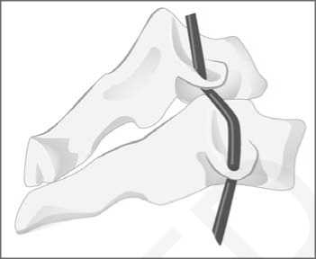
Fig. 6. Instability of the vertebral motor segment in the cervical part of the spine with the vertebral artery deformation
On examination, there is loss of normal cervical lordosis and a limitation in neck movements. There may be tenderness over the lower cervical spine or in the muscles of the paravertebral region (myalgia). The upper limb may have signs suggestive of nerve root compression — usually that of C6, root affection. Motor weakness is uncommon. The lower limbs must be examined for signs of early cord compression (e.g. a positive Babinski reflex etc.).
Radiological examination: X-rays of the cervical spine (AP and lateral) are sufficient in most cases. The following radiological features may be present
• Narrowing of intervertebral disc spaces (most commonly between C5-C6).
• Osteophytes at the vertebral margins, anteriorly and posteriorly.
• Narrowing of the intervertebral foramen in cases presenting with radicular symptoms, may be best seen on oblique views.
DIFFERENTIAL DIAGNOSIS
The diseases to be considered in differential diagnosis of cervical spondylosis are: other causes of neck pain such as infection, tumours and cervical disc prolapse; and other causes of upper limb pain like Pancoast tumour, cervical rib, spinal cord tumours, carpal tunnel syndrome etc.
TREATMENT
Principles of treatment: The symptoms of cervical spondylosis undergo spontaneous remissions and exacerbations. The treatment is aimed at assisting the natural resolution of the temporarily inflamed soft-tissues. During the period of remission, the prevention of any further attacks is of utmost importance, and is done by advising the patient regarding the following:
a) Proper neck posture: The patient must avoid situations where he has to keep his neck in one position for a long time. Only a thin pillow should be used at night.
b) Neck muscle exercises: These help in improving the neck posture.
During an episode of acute exacerbation, the following treatment is required:
• Analgesics • Hot fomentation
• Rest to the neck in a cervical collar
• Traction to the neck if there is stiffness
• Anti-emetics, if there is giddiness
In an exceptional case, where the spinal cord is compressed by osteophytes, surgical decompression may be necessary.
LUMBAR SPONDYLOSIS
This is a degenerative disorder of the lumbar spine characterized clinically by an insidious onset of pain and stiffness and radiologically by osteophyte formation.
CAUSE
Bad posture and chronic back strain is the commonest cause; other causes being previous injury to the spine, previous disease of the spine, birth defects and old intervertebral disc prolapse.
PATHOLOGY
Primarily, degeneration begins in the intervertebral joints. This is followed by a reduction in the disc space and marginal osteophyte formation. Degenerative changes develop in the posterior facet joints. The osteophytes around the intervertebral foramen may encroach upon the nerve root canal, and thus interfere with the functioning of the issuing nerve.
DIAGNOSIS Clinical features: The symptoms begin as low
backache, initially worst during activity, but later present almost all the time. There may be a feeling of 'a catch' while getting up from a sitting position, which improves as one walks a few steps. The pain may radiate down the limb up to the calf (sciatica) because of irritation of one of the nerve root. There may be complaint of transient numbness and paraesthesia in the dermatome of a nerve root, commonly on the lateral side of leg or foot (L5 S1 roots) respectively.
On examination: The spinal limited terminally, but there spasm. The straight leg raising be positive if the nerve root present.
Good AP and lateral views of the lumbo-sacral spine should be done after preparing the bowel with a mild laxative and gas adsorbent like charcoal tablets. It is particularly difficult in obese patients, the ones usually suffering from this disease. The following signs may be present:
• Reduction of disc space • Osteophyte formation
• Narrowing of joint space of the facet joints
• Subluxation of one vertebra over another
Principles of treatment: Like cervical spondylosis, lumbar spondylosis also undergoes spontaneous remissions and exacerbations. Treatment is essentially similar to cervical spondylosis. In the acute stage, bed rest, hot fomentation and analgesics are advised. As the symptoms subside, spinal exercises are advised. In some resistant cases, a lumbar corset may have to be used at all times. Spinal fusion may occasionally be necessary.(Fig7)
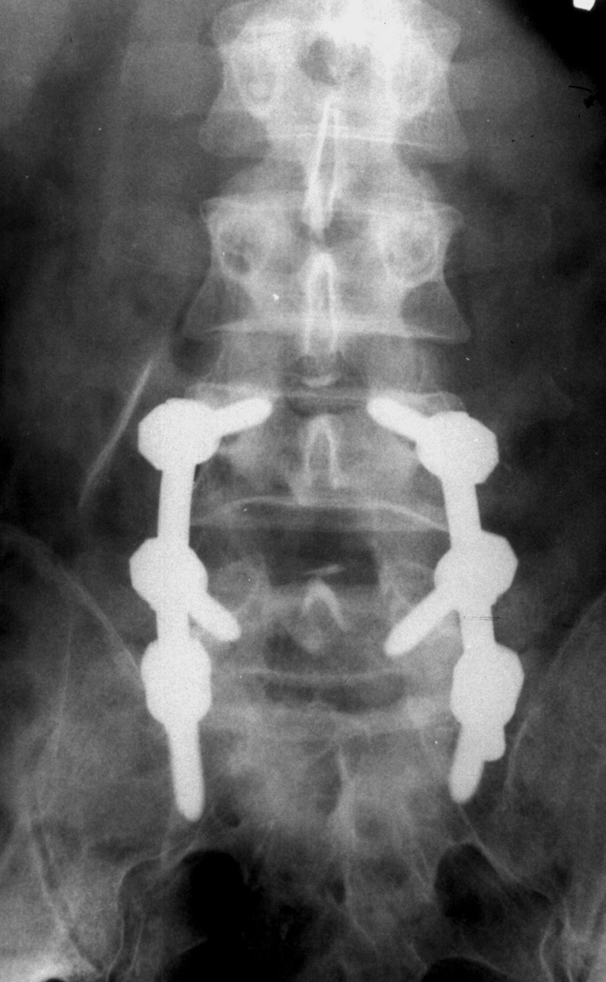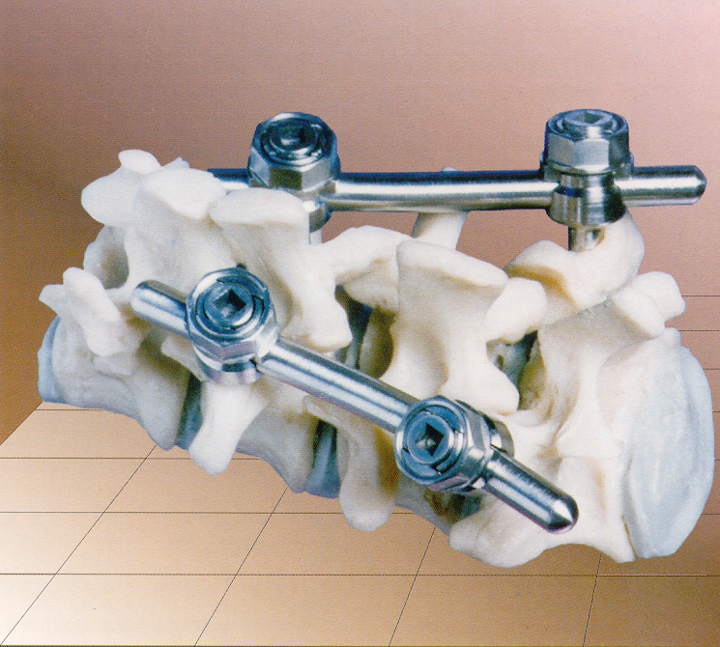

Spondylarthrosis
Spondylarthrosis (facet joints athrosis, facet syndrome) - degenerative affection of the true synovial joints of the spine. Costovertebral (rib head and costotransversal) joints are also included in this group. Spondylarthrosis is often combined with spondylosis and osteochondrosis of the spine. Osteochondrosis development is accompanied by the hyaline covering cartilage destruction, subchondral sclerosis. marginal osteophytes formation, articular processes hyperplasia, dystrophic changes of the articular capsule with its weakening.
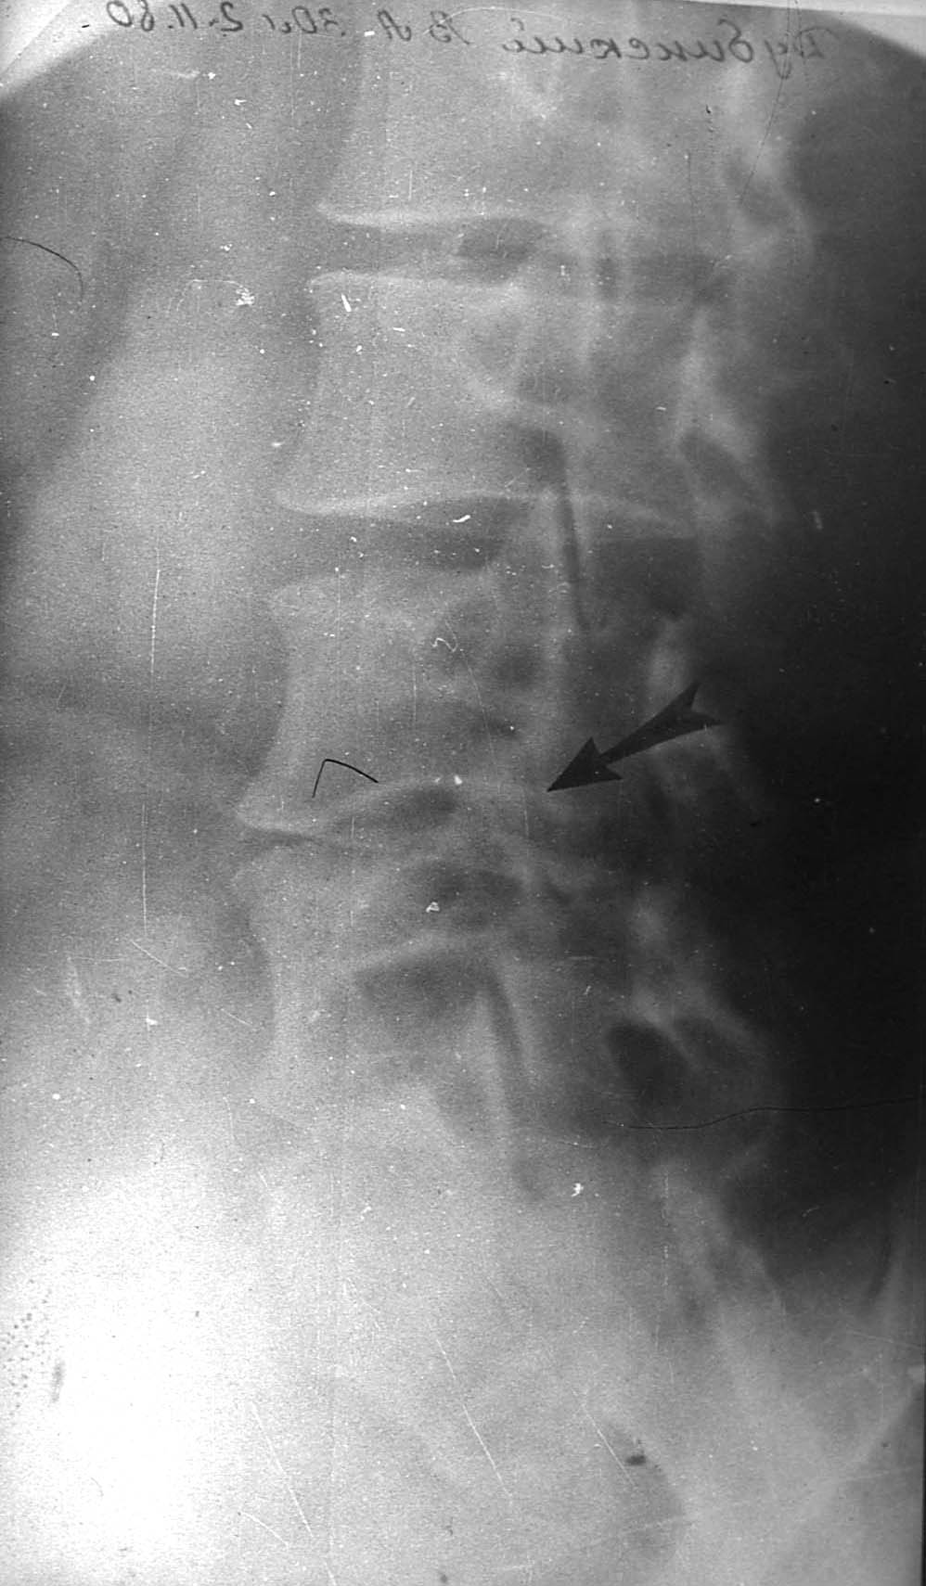 Fig8. Spondylosis and spondylarthrosis
Treatment of spondylosis and spondylarthrosis
Spondylosis and spondylarthrosis treatment should be complex and pathogenetic. In expressed pain syndrome treatment should be directed at the pain and inflammation elimination. These can be reached by the following medicamentous agents: anti-inflammatory drugs, in expressed muscular spasm - muscular relaxants of the central action, local use of the anti-inflammatory ointments, plasters. Blockades of the facet joints are effective in persistent pains under the X-ray or CT-fluoroscopy control - blockade of the joint or nerve, that innervates (supply with nerve endings) the corresponding joint is performed. Local anesthetics, for example lidocaine, and suspension of glucocorticoids, that has good anti-inflammatory features, are used for the blockade. Blockade is not only medical, but also diagnostic procedure: if the positive effect was obtained the doctor can state, that changes in the blocked joints were responsiblef or the pain syndrome development in this patient. Epidural injection of local anesthetics and glucocorticoids are used in the spinal canal stenosis, that have goof analgesic and anti-inflammatory effect. Massage, physiotherapeutical procedures (electrophoresis with novocaine at the affected area, biodynamic currents, ultrasound at the spine area), exercise therapy for the muscular corset strengthening of the spine, pelvic position correction, lumbar lordosis decrease are included in the treatment complex. If the conservative treatment is not effective, operative treatment is indicated. They are divided into decompression (neurovascular formations of the spinal canal decompression), stabilizing (anterior and posterior spondylodesis) and decompression-stabilizing.
After the in-patient treatment patients require rehabilitation measures, that include sanatorium-and-spa treatment, exercise therapy, massage, rational organization of the working regime.
Spondylolisthesis.
Spondylolisthesis is forward displacement of a vertebra over the one below it Normally, forward displacement of a vertebral body is prevented, primarily by the engagement of its articular processes with that of the vertebra below it. (Fig9)
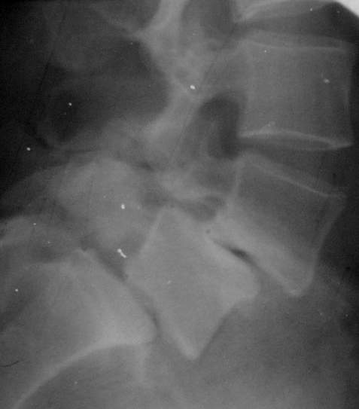 fig9 Spondylolisthesis L5 and L4.
The attachments of the intervertebral disc and ligaments between vertebrae also check this displacement, but to a small extent. Thus, any defect in this 'check' mechanism leads to Spondylolisthesis. Accordingly, Spondylolisthesis has been divided into the following types:
a) Isthmic: This is the overall commonest type. The lesion is in the pars interarticularis. Three sub-types are recognized:
• Lytic: Fatigue fracture of the pars interarticularts
• Intact but elongated pars interarticularis
• Acute fracture of the pars interarticularis. The defect allows the separation of the two halves of the vertebra. The anterior half (i.e., the body with the pedicles and superior articular facet) along with the whole of the spinal column above it, slips forwards over the vertebra below. The posterior half of the
affected vertebra (i.e., laminae and inferior articular facets), remain with the lower vertebrae .
b) Dysplastic: In this, the least common type, there is a congenital abnormality in the development of the vertebrae so that one vertebra slips over the other.
c) Degenerative: This is seen fairly commonly in elderly people. The posterior facet joints becomes unstable because of osteoarthritis, and subluxate. The vertebral displacement is occasionally backwards rather than forwards (retrolisthesis). The displacement is usually not severe, and neurological disturbance is unusual.
d) Pathological: This type results from a generalised or localised bone disease weakening the articulation between the vertebrae.
e) Traumatic: This is a very rare type, where one vertebra slips over other following on injury.
DIAGNOSIS
Clinical features: The isthmic type of spondylolisthesis presents in adolescents and young adults. The degenerative type occurs in old age. The presenting symptom is usually backache, with or without sciatica. The symptoms become worse on standing or walking. Sometimes, there may be neurological symptoms in the lower limbs. In a large number of cases, the abnormality is symptomless, and is detected on a routine X-ray taken during screening for a health check-up.
X-ray examination: The anterior displacement of one vertebra over other can be seen on a lateral view of the spine. The displacement can be graded into four categories depending upon severity of slip. Grade I spondylolisthesis me vertebral displacement up to 25 per cent of antero-posterior width of the lower vertebral whereas grade IV means the complete displacement of the affected vertebra. An view of the spine may show defect in the interarticularis. In this view, in a normal vert the pars interarticularis looks like a scotty dog. If the appearance is that ofascott;'wearing a collar', the defect is in the isthmus interarticularis), and the patient has a defect without slipping of the vertebra If the head of the 'scotty dog' is separated the neck, the patient has spondylolisthei defect with slip of the vertebra. (fig10)
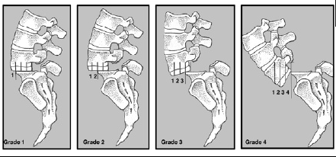
TREATMENT
Principles of treatment: For a mild symptom spondylolisthesis, no treatment is required symptoms are mild, they are adequately by conservative methods such as a bra spinal exercises. When symptoms are severe or more, especially if these help the activity of the patient, an operation required.
Methods of treatment: These conservative and operative methods. Cons methods consist of rest and external fix affected segment followed by flexion. The patient is advised to change his physically less demanding one.
Operative methods consist of decompression; compressed nerves if any, followed by f the affected segments of the spine. commonly achieved by fusion between transverse processes of adjacent vertebra transverse fusion). Use of internal fixation helped in early mobilization of the patients.

TASKS AND TESTS
- In which variant all stages of dorsopathy are mentioned?
- Round and flat back, kyphotic, scoliotic and lordotic postures.
- Osteochondrosis, spondylosis, spondyloarthrosis.
- Spondylolysis, spondylolisthesis, pseudospondylolisthesis.
- Rachitic kyphosis, congenital kyphosis.
- Intradiskal nucleus dislocation, protrusion, disk hernia.
- Degenerative-dystrophic disease of the spine with primary affection of the intervertebral disk is:
- Osteochondrosis.
- Spondylolisthesis.
- Spondyloarthritis.
- Spondylolysis.
- Spondylosis.
- Degenerative-dystrophic disease of the intervertebral joints is:
- Osteochondrosis.
- Spondylolisthesis.
- Spondyloarthritis.
- Spondylolysis
- Spondylosis.
- Degenerative-dystrophic disease of the spine, that is characterized by osseous outgrowth at the are of the ligamentous apparatus detachment from the vertebral body is:
- Osteochondrosis.
- Spondylolisthesis.
- Spondyloarthritis.
- Spondylolysis.
- Spondylosis

TASK №1
Patient complain of the pain in the thoracic part if the spine, that increase in movements, weakness, weight loss. Is ill for 3 months. Pain has aching character. The following is determined during examination: tenderness at the level of Th₉-Th₁₀ vertebrae, slight leukocytosis in blood. At the radiograph: small destruction focus in the Th10 body, that is adjacent to the intervertebral disk. What is the diagnosis?
- Tumor.
- Schomrl's hernia.
- Spondylitis.
- Spondylosis deformans.
- Disk hernia.

TASK №2
Patient B, 43 years, complain of the low back pain, that occur after physical loads. Pain irradiation into the right leg down to the I toe occurs during last months. Physical examination: lumbar lordosis is decreased, moderate atrophy of the right leg muscles, hypesthesia at the area of I toe, positive tension symptoms. At X-ray of the lumbar part of the spine - space between vertebral bodies is narrowed at the level of L₄-L₅. Make the preliminary diagnosis.
- Spinal tumor. D. Lumbago.
- Spinal stenosis. E. Pathologic fracture of lumbar vertebrae.
- Intervertebral disk hernia of L4-L5.
TASK №3
A 39 years old patient grumble about low back pain. On examination: lumbar hyperlordosis, weakness and paresthesia lower extremities. On the roentgenogram of lumbar spine –the 1/3 of vertebrae LIV body dislocation (spondilolistesis). Choose a method of medical treatment.
- Steroid antiinflammetory medical treatment.
- Physio-functional medical treatment.
- Fixing by corset.
- Traction.
- Surgery.

Reference

- Church E, Odle T. Diagnosis and treatment of back pain. Radiologic Technology [serial online]. November 2007;79(2):126-204. Available from: CINAHL Plus with Full Text, Ipswich, MA. Accessed December 12, 2017.
- Deyo RA, Weinstein JN (February 2001). "Low back pain". The New England Journal of Medicine. 344 (5): 363–70. doi:10.1056/NEJM200102013440508. PMID 11172169.
- Cohen SP (February 2015). "Epidemiology, diagnosis, and treatment of neck pain". Mayo Clinic Proceedings. 90 (2): 284–99. doi:10.1016/j.mayocp.2014.09.008. PMID 25659245.
- A.T. Patel, A.A. Ogle. "Diagnosis and Management of Acute Low Back Pain". American Academy of Family Physicians. Retrieved March 12, 2007.
- Hockberger, Robert S.,, Gausche-Hill, Marianne (Ninth ed.). Philadelphia, PA. ISBN 9780323354790. OCLC 989157341.
- Van den Bosch MA, Hollingworth W, Kinmonth AL, Dixon AK (January 2004). "Evidence against the use of lumbar spine radiography for low back pain". Clinical Radiology. 59 (1): 69–76. doi:10.1016/j.crad.2003.08.012. PMID 14697378.
- Woolf CJ (March 2011). "Central sensitization: implications for the diagnosis and treatment of pain". Pain. 152 (3 Suppl): S2-15. doi:10.1016/j.pain.2010.09.030. PMC 3268359. PMID 20961685.
- Raastad J, Reiman M, Coeytaux R, Ledbetter L, Goode AP (April 2015). "The association between lumbar spine radiographic features and low back pain: a systematic review and meta-analysis". Seminars in Arthritis and Rheumatism. 44 (5): 571–585. doi:10.1016/j.semarthrit.2014.10.006. PMID 25684125.
- Lavelle, W. F., Kitab, S. A., Ramakrishnan, R., & Benzel, E. C. (2017). Anatomy of Nerve Root Compression, Nerve Root Tethering, and Spinal Instability. In Benzel's Spine Surgery (4th ed., pp. 200-205). Philadelphia, PA: Elsevier. ISBN 978-0-323-40030-5
- Jarvik JG, Deyo RA (October 2002). "Diagnostic evaluation of low back pain with emphasis on imaging". Annals of Internal Medicine. 137 (7): 586–97. doi:10.7326/0003-4819-137-7-200210010-00010. PMID 12353946. S2CID 860164.
- Burton AK, Tillotson KM, Main CJ, Hollis S (March 1995). "Psychosocial predictors of outcome in acute and subchronic low back trouble". Spine. 20(6): 722–8. doi:10.1097/00007632-199503150-00014. PMID 7604349. S2CID 21171676.
- Carragee EJ, Alamin TF, Miller JL, Carragee JM (2005). "Discographic, MRI and psychosocial determinants of low back pain disability and remission: a prospective study in subjects with benign persistent back pain". The Spine Journal. 5 (1): 24–35. doi:10.1016/j.spinee.2004.05.250. PMID 15653082.

