THE INFLUENCE OF CONTRACEPTION ON VAGINAL MICROBIOCENOSIS CONDITION

Kovalenko T.I., Tishchenko M.O., Vovk O.O., Mishyna M.M.
Kharkiv National Medical University, Kharkiv, Ukraine

It was recently found out that well-structured polymicrobial film is formed with bacterial vaginosis (BV), which covers vaginal epithelium and consists of anaerobic bacteria including Gardnerella vaginalis [6,7]. This in its turn can explain frequent relapses of vaginal microflora disorder which is connected with antibioticoresistance growth of anaerobic microorganisms [1,13]. Despite progressive achievements in diagnostics and treatment etiology of microflora disorders so far remains insufficiently studied.
Vaginal secretion (fluorvaginalis) is a transudate with the admixture of vaginal epithelium cells as well as microflora, transient, transient opportunistic, aerobic and anaerobic ones [8,9]. On the border of two environments (liquid and solid, liquid and air) films with microorganisms are formed. Microbial film is a structural consortium of bacterial or fungal cells, surrounded by matrix of its own production [3].
The biofilms formation is one of the main strategies of bacteria survival in the external environment. At the same time the formation of biofilms like other microbial processes such as bioluminescence, virulence determinants synthesis in pathogenic bacteria, competence state, conjugative plasmids transference, antibiotics biosynthesis, DNA exchange and replication are realized only in condition of curtain density level achievement by population. [2]. Process of biofilms (BF) formation on the contraceptive: Insertion. Accretion and formation of dense resistant matrix (fibrin, thrombocytes, immunoglobulins), which does not respond to traditional antimicrobial treatment, that is why determination of biofilms is a very important aspect of the development of new medications for certain pathogens of separate types of pathogenic BF destruction. Fragmentation.
Many works are dedicated to the use of intrauterine means with the aim of contraception [10]. Little systematized data exist concerning vaginal microflora and endometrium study with the long usage of intrauterine contraceptives (IUC) during certain period of time and after it. In this connection the problems of long-term use of contraceptives influence on the female reproductive system are of great importance [4,11], particularly on vaginal biocenosis and the development of chronic inflammation in women [5,12]. But some clinical and morphological aspects of intrauterine contraception are contradictory and demand further study. Thus vaginal biocenosis study in women with IUC is of current interest.
Aim: in complex to evaluate different types of female vaginal biocenosis on the background of contraceptives usage in order to detect implant-associated infection.
The aim is achieved by general clinico-laboratory characteristics of the state of women who use IUC and microbiological examination of vaginal secretion in women on the background of IUC with the determination of microorganisms ability to form biofilms.
Material and methods:
The studies were of randomized character in presence of informed consent on study participation. 64 women in all were examined at the age between 23 and 36 years old. The first group (control) included 30 practically healthy women. The second group (main) included 34 patients having inert IUC of the second generation for a period from 5 months to 6 years.
Clinical anamnestic data analysis demonstrated that there were no complaints in the first group, women underwent medical routine examination or preconception preparation.
In other clinical group women complained about periodic vaginal profuse discharge (58,8 %), periodic pain in pelvic area and lumbar region (15,6 %), itching and burning of external genitalia (21,4 %), menstrual irregularities (40,0 %).
All women of the control group had 1 pregnancy in anamnesis which resulted in normal physiological childbirth without complications.
Patients of the main group had 1, 2 and more pregnancies. The results of previous pregnancies: 46,6 % of women had normal childbirth, 20,6 % had pathological childbirth (primary uterine inertia, manual uterine cavity revision, fetal distress), 12,5 % - spontaneous abortion, 43,7 % - medical abortion , 32,9 % - artificial abortion.
Clinical examination of women included obstetric-gynecological history, general examination, gynecological examination, pelvic organs USE and laboratory examination in Kharkov multidisciplinary clinico-diagnostic laboratory. The examination data were registered in outpatient medical records.
Vaginal biocenosis stat was assessed according to “Femoflor-Screen” data, polymerase chain reaction (PCR) in real time, this reaction gave a possibility to receive qualitative and quantitative characteristic of vaginal biotopes in general as well as some of its components. Total concentration of bacterial DNA was determined with the help of the test – total bacterial mass (TBM) and concentration (absolute and relative).
The formation of biofilms was explored with the study of the ability of pure culture to adhesion on the surface of polystyrene plates for immune-enzyme analysis. Pure cultures strains from vaginal secretion were allocated with the help of bacterial method during cultivation on elective media at microbiology, virology and immunology department of Kharkov National Medical University. Number of inoculated plankton cells was calculated with photometer «Multiskan EX-355» (Finland) at wavelength 540 nm and expressed in conventional units, optic density (from 4 cells) must not differ for more than 10% from necessary concentration of microorganisms. Straining intensity of crystal violet cells content corresponds to the level of film formation.
For pH determination of vaginal environment diagnostic test-strips CITOLAB were used. Vaginal pH test is dedicated for measurement of vaginal environment acidity. The use of vagina l рН test CITOLAB gives a possibility to monitor vaginal biocenosis quickly and simply by vaginal discharges analysis.
Results.
Vaginal ecosystem disorder in women of reproductive age is of current interest in obstetric and gynecological practice. Vaginal epithelium is coved by microbial biofilms being structured concorcium of bacterial and fungal cells.
Biofilms are differentiated:
Normal, in which lactobacteria prevail from total amount of bacteria producing hydrogen peroxide, lactal acid, thus forming vaginal normoflora (fig. 1).
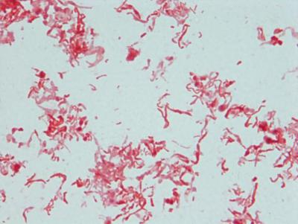

Fig. 1 The total amount of vaginal flora consists of Lactobacillus spp.

Pathological, which are formed on the background of bacterial vaginosis (replacement of lactobacteria by aerobic microorganisms Gardnerella vaginalis, Atopobium vaginaе, which are most pathogenic) (fig. 2).

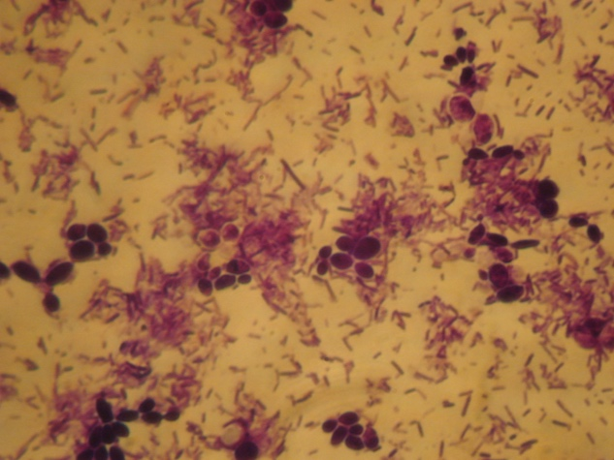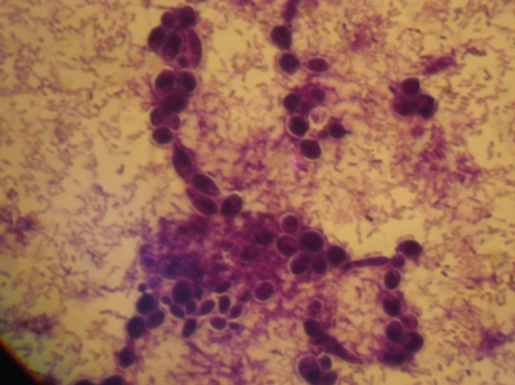
6 hours after incubation 12 hours after incubation

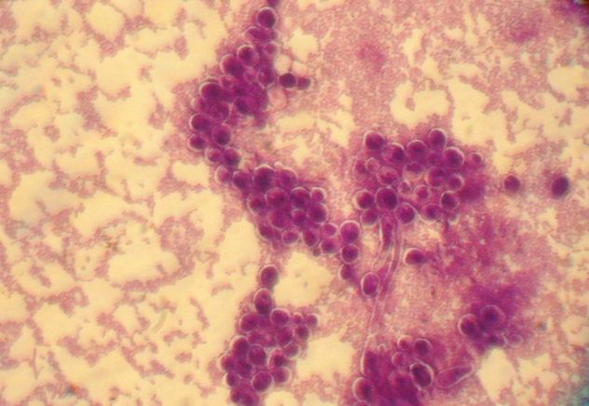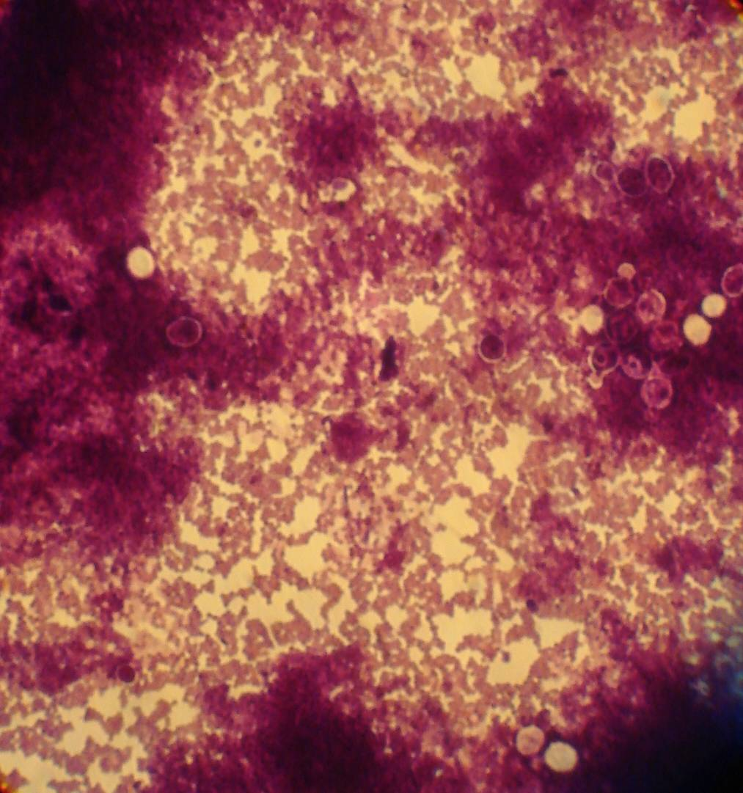
24 hours after incubation 48 hours after incubation

Fig. 2 Formation of pathological biofilm by anaerobic microorganisms under a microscope (Gardnerella vaginalis).

Research of biofilms formation with IUC of the 2 generation use were carried out in this work because bacteria have the ability to adhesion on solid surfaces.
After urogenital tract biocenosis study with the help of PCR using “Femoflor screen” we received the following results.
Total bacterial mass (TBM) according to PCR data fluctuated from 10⁶⁻10⁸ in control group, Lactobacillus spp. (67 %), Bifidobacterium ssp. (54,8 %), Propionibacterium ssp. ( 34,6 %), Enterobacter (24,8%) microorganisms prevailed, in some samples appearance of а Candida spp. (4,6 %) was marked, the number of lactobacteria comprised 10⁶⁻⁸ .
In the main group TBM prevailed 10^{5,5} to 10⁸ - fungus association of Candida genus with Staphylococcus was found in 21,4 % of cases, Streptococcus - in 38,6 % of cases, Proteus and Staphylococcus - in 12,8 %, Candida spp. – in 45,7 %, E. coli – in 43,8 %. The number of lactobacteria sharply lowered to 10^{2,2} or were absent, but Gardnerella vaginalis in concentration >10^{5,3} or Atopobium vaginaе - <10⁵ , Enterobacteriaceae 10³ appeared. Analyzing the received data it can be proved that most prevailing microorganisms received from vaginal discharge were: Peptostreptococcus spp. – 74,2 %, Enterococcus – 57,1 %, S. aureus – 60,0 % , E. coli – 68,6 %, Fusobacterium spp. – 57,1 %, Candida spp. – 42,8 %.
Determination of vaginal acidity by рН-indicator was done with the help of graduated test-strips. рН level was conditioned by lactobacteria and the number of vaginal epithelial glycogen. Thus the method to a certain extent allows assessment of vaginal biotop. So in the control group pH biotope fluctuated from 4,0 to 4,4 (66,6 %), index of рН 4,5 was marked in 33,3 % of cases.
In the main group pH-metry corresponded 4,5 in 29,4 % of cases, the overwhelming majority of bioptates fluctuated from рН >4,7 to рН 5,0 (58,8 %), women who had complaints about odorous discharges, burning, itching, pain deserve special attention, рН corresponded the level >5,0 (14,7 %).
Vaginal alkaline environment according to рН-metry was found in 24 women of the main group. Presence of vaginal disbiosis was confirmed but only 5 patients had clinical manifestations, they had explicit complaints, in 19 patient disbiosis had no symptoms..
After the carried out research the following types of vaginal biocenosis were determined (table. I):
Table 1
Comparative characteristics of groups according to PCR ("Femoflor-screen").
Quantitative metric

Group | Indicators | I type normocenosis  n=10 | II type intermediate  n=10 | III type bacterial vaginosis n=19 | IV type  vaginitis  n=5
Diagnosis of normocenosis | TBM | 10 ^{6.5-}10 ⁸ | 10 ⁸ | 10 ^{6.6-7} | 10 ⁷⁻10 ⁹
 | Lactobacillus spp. | 10 ⁶⁻10 ⁸ | 10 ^{7,3} | 10 ^{2,6-0} | Not found
Aerobic microorganisms | Enterobacteriaceae | 10 ³ | 10 ³ | 10 ^{3,1} | 10 ^{3,2}
 | Streptococcus spp. | 10 ^{3,3} | Not found | 10 ⁵ | 10 ^{3,1}
 | Staphylococcus spp. | Not found | Not found | Not found | 10 ^{3,1}
Anaerobic microorganisms | Gardnerella vaginalis | Not found | 10 ³ | 10 ⁶⁻10 ⁷ | 10 ^{7,8}
 | Eubacterium spp. | 10 ² | Not found | 10 ⁴ | 10 ^{4,2}
 | Fusobacterium spp. | Not found | Not found | Not found | 10 ⁴
 | Megasphaera spp. | Not found | Not found | 10 ⁴ | Not found
 | Clostridium spp. | Not found | Not found | 10 ^{3,2} | Not found
 | Corynebacterium spp. | 10 ^{3,6} | 10 ^{3,7} | 10 ² | 10 ²
 | Peptostreptococcus spp. | Not found | Not found | 10 ^{4,4} | 10 ^{4,5}
 | Atopobium vaginae | Not found | Not found | 10 ²⁻10 ⁵ | 10 ⁶⁻10 ⁷
Mycoplasma | Mycoplasma genitalis | Not found | Not found | Not found | 10 ⁵
 | Ureaplasma | Not found | 10 ^{4,7} | 10 ⁵ | 10 ⁴
Fungal | Candida spp. | Not found | 10 ³ | 10 ⁵ | 10 ⁶

• I type – normocenosis: рН 4,0-4,4; presence of lactobacteria > 78 %; TBM – 10⁸ , number of lactobacteria – 10⁶⁻⁸. Conditionally pathogenic flora, aerobic – up to 30 %, from TBM – 10³⁻⁴, anaerobes – to 10². Women had no complaints, no pathologic discharges were found during vaginal examination, no signs of inflammation.
• II type – intermediate type:(1 and 2 type – IUC was present for a period from some months to 2 years), рН to 4,5; TBM – 10^{6,5}; lactobacteria comprise the total number from 53 % to 77 %; leukocytes 4-10 in sight. Flora is conditionally pathogenic, aerobic – up to 30 % – 10³; anaerobes - to 10³. No clinical manifestations. But in smears of the intermediate type there was a certain amount of leukocytes.
• III type – bacterial vaginosis: (increasing of рН 4,5 into acidic environment proved about the development of BV and the ability to form pathogenic biofilms), disbiosis рН>4,7 - 5,0; TBM –10 ^{5,8}; lactobacteria in biotope are decreased – from 36 % to 0 %. leukocytes – 0–7 in sight. Anaerobic flora prevailed: Gardnerella vaginalis in concentration >10^{5.3}, Atopobium vagта - <10³, which resulted in bacteria accumulation and pathogenic biofilms formation because in this group of women IUC was used more than 2 years.
At рН 5,0 concentration of Gardnerella vaginalis >10⁵, Atopobium vagта- <10⁵, Сandida – was to 10³. Flora is anaerobically pathogenic, conditionally pathogenic to 20 % from total biotope, concentration to 10³; anaerobes to 10³, conditionally pathogenic flora of E. coli.
At рН 4,7 only 8,3 % of women complained about vaginal pathologic discharges without certain characteristics. At рН 5,0 (74 % of women) complained about discharges of grey-white color, abundant, with bad smell.
• IV type – biocenosis corresponds to non-specific and hybrid vaginitis - рН>5,0; TBM - 10⁸. Lactobacteria number is sharply decreased or absent. Biotope is presented by various flora: coccus, sticks in concentration more than 10⁵; aerobes – more than 10³. IUC was used during 5-8 years, which resulted in biofilm formation by anaerobic bacteria as a response factor on long-term presence of implant-associated aggressor in vaginal cavity. Patients complained about expressed discomfort, odorous discharges, burning, itching, pain. Number of leukocytes – more than 50 (table. II).
Table. 2. Types of vaginal biocenosis in the studied women

Type of smear | Control group  n-30 | Main group  n-34
I Normocenosis | 10 (33,3 %) | -
II Intermediate type | 20 (66,6 %) | 10 (29,4 %)
III Bacterial vaginosis | - | 19 (55,8 %)
IV Vaginitis | - | 5 (14,7 %)

Increase of optical density of inoculated isolates in immune enzyme analysis proves about microorganisms reproduction. High level of optical density in a number of microbial bodies allows following the kinetics of microorganisms reproduction, receiving and assessment of bacteria growth and ability to form biofilms.
Discussion:
As a result of the study it was determined that in patients of control group vaginal microbiocenosis data were combined with pH secretion which corresponded to microcenosis of the I and II type (normocenosis, intermediate type).
While investigating the main group of vaginal microbiocenosis contaminations of opportunistic and pathogenic flora were found which gave rise to combination of some bacterial associations and biofilms development.
Attention should be paid on the fact that smears with normocenosis were not found, conformity to smear of the II type was found in 29,4 %, duration of IUC - up to 12 months.
III type was observed in 55,8 %, clinical manifestations were not registered in these women but the smear type depended on the duration of IUC presence in uterus cavity. Thus in 85.6 % of women duration of IUC was from 2 to 5 years.
Women of the IV type smear group demonstrated the conformity to non-specific and hybrid vaginitis with expressed complaints which required immediate treatment and extraction of IUC (IUC duration more than 5 years).

Conclusions.
Considering biotopes change under the influence of commensal bacteria development or separate associators it can be assumed that for diagnostic criteria of bacterial vaginosis attention should be paid not only on clinical manifestations of the given disease but also on urogenital tract biocenosis study, especially at IUC use because it is the factor for implant-associated infection development.
1. Change in total bacterial mass (TBM), determination of opportunistic or pathogenic flora especially at mixed bacterial associations in women with IUC give rise to vaginal biofilm formation.
2. Index of vaginal pH secretion can be used as an indicator of vaginal biocenosis state which responds to quantification of microbiota and presence of lactobacteria in it.
3. Vaginal рН secretion can serve as screening-control of vaginal biotope state with IUC stay for the control of its durability in the uterus.
Conflict of Interest Statement. The authors declare that the research was conducted in the absence of any commercial or financial relationships that could be construed as a potential conflict of interest.

References

1. Anahtar M. N., Byrne E. H., Doherty K. E. [et al.]. Cervicovaginal bacteria are a major modulator of hostin flammatory response sinthefemale genital tract . Immunity. Vol. 42. N 5. 2015: 965−976. DOI: 10.1016/j.immuni.2015.04.019.
2. Franasiak J. M., Jr. Scott R. T. Introduction: Microbiomein human reproduction . Fertil. Steril. Vol. 104, N 6. 2015: 1341−1343. − DOI: 10.1016/j.fertnstert.2015.10.021.
3. Hoiby N. A Personalhi story of research on microbial biofilms and biofilm infections. Pathog Dis. 2014; 70:205-211. DOI: 10.1111/2049-632X.1216.
4. Mastromarino R., Hemalatha R., Barbonetti A [et al.]. Biological control of vaginosis to improvere productive health . Indian. J. Med. Res. Vol. 140. 2014: 91−97.
5. Ross J., Judlin P., J. Jensen J. 2012 Europe an guide line for them an agemen to fpelvic inflammatory disease. International Union against sexually transmitted . Infections. Int. J. STD AIDS. Vol. 25, N 1. 2014: 1−7. DOI: 10.1177/0956462413498714.
6. Авраменко Н. В. Воспалительные заболевания органов малого таза у женщин как ведущий фактор формирования трубно-перитонеального бесплодия // Запорожский медицинский журнал. 2014. № 4. С. 63−68.
7. Бойко В. І., Єжова А. В. Генітальний ендометріоз у жінок із безпліддям: прогнозування і рання діагностика // Здоровье женщины. 2014. № 9. С. 166−167.
8. Гаспаров А. С., Дубинская Е. Д., Титов Д. С. Биохимические маркеры оценки овариального резерва (обзор литературы) // Гинекология. 2014. Т. 16,№ 3. С. 60−63.
9. Назарова В. В., Шалепо К. В., Менухова Ю. Н., Савичева А. М. Микрофлора влагалища женщин репродуктивного возраста при бактериальном вагинозе – соответствие критериям Amsel // Журнал акушерства и женских болезней. 2016. № 1. С. 48-53.
10. Петров Ю. А. Воздействие продолжительной внутриматочной контрацепции на эндометрий // Современные проблемы науки и образования. 2016. № 5. URL: http://www.science-education.ru/ru/article/view?id=25101.
11. Подольський В. В., Лісяна Т.О., Пономарьова І. Г. Стан мікробіоценозу урогенітальних органів у жінок з порушенням репродуктивного здоров'я та змінами вегетативного гомеостазу // Здоровье женщины. 2015. № 2. С. 142−150.
12. Старкова И. В. Реабилитация функции органов репродуктивной системы у девушек-подростков, перенесших двусторонний сальпингоофорит // Експериментальна і клінічна медицина. 2015. № 3. С. 98−100.
13. Тертишник А. О. Стан мікробіоценозу піхви у пацієнток з неспецифічним хронічним сальпінгоофоритом // Неонатологія, хірургія та перинатальна медицина. 2016. Т. VI, №1(19). С. 49–54.

SUMMARY
THE INFLUENCE OF CONTRACEPTION ON VAGINAL MICROBIOCENOSIS CONDITION
Kovalenko T.I., Tishchenko M.O., Vovk O.O., Mishyna M.M.
Kharkiv National Medical University, Kharkiv, Ukraine

Aim: in complex to evaluate different types of female vaginal biocenosis on the background of contraceptives usage in order to detect implant-associated infection. Material and methods: clinical status, features of vaginal microflora and formation of biofilms were assessed in 64 women of reproductive age, who had inert intrauterine device (IUD) of the second generation for a period of from 5 months to 8 years. pH of vaginal secretion was measured by the test strips CITOLAB. The condition of vaginal biocenosis was assessed according to «Femoflor-Screen», polymerase chain reaction in real time. The formation of biofilms was explored with the study of the ability of pure culture Gardnerellaе to adhesion on the surface of microplates and the addition of crystal violet indicator. Optical density was measured with the photometer «Multiskan EX-355». Results: These vaginal micribiota of the patients in control group were inconsistent with microbiocenosis of I and II type (normocenosis, intermediate type). II type of the vagina normocenosis was found in 29,4 % patients with long usage of contraception up to 12 month. III type of vaginal microbiocenosis was observed in 55, 8 % of examined patients within the duration of IUD use from 2 till 5 years. Microbiocenosis of women with IV type of smear was inconsistent with non-specific or hybrid vaginitis (IUD duration more than 5 years). Conclusions: Changes of total bacterial exudates, detection of opportunistic or pathogenic flora, especially for mixed bacterial associations for women with intra-uterine devices gives rise to vaginal biofilm formation. The type of vaginal biocenosis depends on the duration of IUC use. рН level of vaginal secretion, which conforms to the quantitative evaluation of microbiocenosis and the availability of lactobacteria in it can be used as an indicator for condition of vaginal biocenosis. pН level of vaginal secretion can be a screen control of vaginal biocenosis condition during intrauterine devices stay for the control of its durability in the uterus.
Key words: contraception, biofilm, normocenosis, vaginal biocenosis.

РЕЗЮМЕ
ВЛИЯНИЕ КОНТРАЦЕПЦИИ НА СОСТОЯНИЕ ВАГИНАЛЬНОГО МИКРОБИОЦЕНОЗА
Коваленко Т.И., Тищенко М.О., Вовк А.О., Мишина М.М.
¹Харьковский национальный медицинский университет, Украина
Цель: комплексно оценить различные типы вагинального биоценоза у женщин на фоне использования внутриматочных контрацептивов для выявления имплант-ассоциированной инфекции. Материал и методы: оценивали клиническое состояние, особенности микрофлоры влагалища и формирования биопленок у 64 женщин репродуктивного возраста с инертными внутриматочными контрацептивами второго поколения на протяжении от 5 месяцев до 8 лет. РН вагинального секрета измеряли с помощью тест-полосок CITOLAB (Фармаско, Украина). Состояние биоценоза влагалища оценивали по данным «Фемофлор-скрин», полимеразной цепной реакции в реальном масштабе времени. Образование биопленок изучали с помощью способности чистой культуры Gardnerella к адгезии на поверхности полистироловых планшетов и добавления индикатора кристалл-Виолетта. Оптическая плотность биопленки измерялась на фотометре «Multiskan EX-355» (Labsystems, Китай). Результаты: у пациенток контрольной группы данные микробиоты влагалища отвечали микроценозу I и II типа (нормоценоз, промежуточный тип). II тип нормоценоз влагалища был выявлен у 29,4% пациенток при продолжительности внутриматочных контрацептивов до 12 месяцев. III тип микробиоценоза влагалища наблюдался у 55,8% исследуемых при продолжительности использования ВМК от 2 до 5 лет. У женщин с IV типом мазка микробиоценоз отвечал неспецифическому или смешанному вагиниту (продолжительность ВМК более 5 лет). Выводы: изменение общей бактериальной массы, выявление условно-патогенной или патогенной флоры, особенно при смешанных бактериальных ассоциациях у женщин с внутриматочными контрацептивными средствами, дает основания для образования вагинальной биологической пленки. Тип биоценоза влагалища зависит от продолжительности использования ВМК. В качестве индикатора состояния биоценоза влагалища может быть использован показатель рН секрета влагалища, который соответствует количественной оценке микробиоты и наличия в ней лактобактерий. Показатель рН секрета влагалища может быть скрининг-контролем состояния биотопа влагалища во время нахождения внутриматочного контрацептива для контроля продолжительности нахождения его в матке.
Ключевые слова: контрацепция, биопленка, норморфлора, вагинальный биоценоз.

Контактное лицо – Вовк Александра Олеговна тел.+380504750215, vovkalexandra80@ukr.net

