KHARKIV NATIONAL MEDICAL UNIVERSITY



SOCIAL MEDICINE, PUBLIC HEALTH (BIOSTATISTICS)

Methodical developments

for teachers to conduct a practical lesson

on the topic ***“Graphical methods of the statistical analysis”***

for the preparation of students in the specialty:

– 222 “Medicine”

– 228 “Pediatrics”,

– 221 “Dentistry”.

Kharkiv

2019

MINISTRY OF PUBLIC HEALTH OF UKRAINE

KHARKIV NATIONAL MEDICAL UNIVERSITY

DEPARTMENT OF PUBLIC HEALTH AND HEALTHCARE MANAGEMENT

SOCIAL MEDICINE, PUBLIC HEALTH (BIOSTATISTICS)

Methodical developments

for teachers to conduct a practical lesson

on the topic ***“Graphical methods of the statistical analysis”***

for the preparation of students in the specialty:

– 222 “Medicine”

– 228 “Pediatrics”,

– 221 “Dentistry”.

*Затверджено вченою радою Харківського національного медичного університету.*

*Протокол № 6 від 15.06.2017*

Kharkiv

KhNMU

2019

УДК 614.1:519.25

Social medicine, public health (biostatistics): methodical instructions for students to the practical lesson on the topic “Graphical methods of the statistical analysis” for the preparation of students in the specialty 222 “Medicine”, 228 “Pediatrics, 221 “Dentistry” / V.A. Ognev, А.А. Podrpyadovа, I.A. Chukhno. – Kharkiv : KhNMU, 2018. – 20 p.

|  |  |
| --- | --- |
| Drafters: | Ognev V.A. |
|  | Podrpyadovа A.A. |
|  | Chukhno I.A. |

**GUIDELINES FOR TOPIC TRAINING**

The aim of the class: to acquaint students with various types of graphic images, to teach them the methodology of plotting and ability to apply them in medical and social studies.

**Need to know:**

* ***program questions:***
* concepts and types of structures of medical and biological data, structural changes, features of their analysis;
* graphical methods for analyzing of statistical data;
* types of diagrams, rules for their plotting.

**Need to be able to:**

* define methods of graphic representation of results of the statistical analysis;
* master the skills of constructing various types of graphs.

**The form of the classes**: a practical lesson.

**The place of classes:** training room of department.

**Methodical support of the lesson:**

* methodical guidelines to classes;
* guidance literature: student’s workbook (basic training);
* presentation materials;
* summary of lectures;
* test tasks.

**The algorithm of the class:** After verifying presence of students teacher announces topic and goal of class, explains relevance of it’s study and ability to use in practice.

Using educational materials provided by teacher students learn material on their own topics and perform specified tasks. At the end of class teacher will ask student what issues have arisen in preparation of topic and helps to ensure a sufficient understanding of them. Then teacher moves to control students' knowledge on basic theory material.

*Applicable forms of control:* oral questioning of students, theoretical or problematic discussion, prompt controls on options-time to complete 5–7 minutes, daily control of theoretical knowledge – individual tasks or task for several options, including 3–4 theoretical questions (time to complete not more than 20 min.), execution of tests followed by analysis of answers.

After control of theoretical knowledge teacher makes general conclusion on studied subject, sums up control of theoretical knowledge of students, as well as announcing to students their received assessment and homework.

**Plan of the lesson timing duration of occupation percentage:**

|  |  |  |
| --- | --- | --- |
| 1 | Introduction into class | up to 5% |
| 2 | Studying of key themes and issues control of theoretical knowledge | 90% |
| 3 | Summarizing and announcement homework theoretical knowledge | up to 5% |
|  | **Total** | 100% |

**Recommended literature**

**Basis literature**

1. Біостатистика / за заг. ред. чл.-кор. АМН України, проф. В.Ф. Москаленка. – К. : Книга плюс, 2009. − С. 12-31.

2. Социальная медицина и организация здравоохранения / под общ. ред. Ю.В. Вороненка, В.Ф. Москаленко. – Тернополь : Укрмедкнига. 2000. –   
С. 23-32.

3. Социальная гигиена и организация здравоохранения / под ред. Н.Ф. Серенко, В.В. Ермакова. – М. : Медицина, 1984. – С. 102-104.

4. Тестовые задачи по социальной медицине, организации здравоохранения и биостатистике : учеб.пособ. для студентов мед. ф-тов / под ред. В.А. Огнева. – Харьков : Майдан, 2005. – С. 9-14.

5.Лекционный курс кафедры.

**Additional literature**

1. Альбом А. Введение в современную эпидемиологию / А. Альбом, С. Норелл. – Таллинн, 1996. – 122 с.

2. Власов В.В. Введение в доказательную медицину / В.В. Власов. – М. : Медиа Сфера, 2001. – 392 с.

3. Герасимов А. Н. Медицинская статистика / А.Н. Герасимов. – М. : ООО «Мед.информ. агентство», 2007. – 480 с.

4. Зайцев В.М. Прикладная медицинская статистика / В.М. Зайцев, В.Г. Лифляндский, В.И. Маринкин. – СПб. : ООО «Изд-во ФОЛИАНТ», 2003. – 432 с.

5. Общая теория статистики: учебник / под ред. чл.-корр. РАН И.И. Елисеевой. − 4-е изд., перераб. и доп. − М. : Финансы и Статистика, 2000. − 480 с.

6. Основы доказательноймедицины / под ред. М. П. Скакун. – Тернополь : Укрмедкнига, 2005. – 244 с.

7. Реброва О.Ю. Статистический анализ медицинских данных. Применение пакета прикладных программ STATISTICA / О.Ю. Реброва.–М. : Медиа Сфера, 2002. – 312с.

8. Сергиенко В.И. Математическая статистика в клинических исследованиях / В.И. Сергиенко, И.Б. Бондарева. – М. : ГЭОТАР-МЕД, 2001. – 256 с.

**Information resources**

1.Население Украины. Демографический ежегодник. – К. : Госкомстат Украины –[www.ukrstat.gov.ua](http://www.ukrstat.gov.ua)

2.U.S. National Library of Medicine –Национальная медицинская библиотека США– <http://www.nlm.nih.gov/>

3.Государственная научно-педагогическая библиотека Украины им. В.О. Сухомлинского–<http://www.dnpb.gov.ua/>

4.Научная библиотека Харьковского національного медицинского университета – <http://libr.knmu.edu.ua/index.php/biblioteki>

5.Научная педагогическая библиотека им. К.Д. Ушинского Российской академии образования – <http://www.gnpbu.ru/>

6.Национальная библиотека Украины им. В.И. Вернадского –<http://www.nbuv.gov.ua/>

7.Национальная научная медицинская библиотека Украины –<http://www.library.gov.ua/>

8.Харковская государственная научная библиотека им. В.Г. Короленка – http://korolenko.kharkov.com

9.Центральная библиотека Пущинского научного центра РАН –<http://cbp.iteb.psn.ru/library/default.html>

10.Центральная научная медицинская библиотека Первого Московского государственного медицинского университетаим. И.М. Сеченова–<http://elibrary.ru/defaultx.asp>

**BASIC THEORETICAL MATERIAL**

**FOR PREPARATION FOR THE LESSON**

**1. Historical development of diagrams**

The history of the development of diagrams began in the 17th century. French scientists Francois Viet and René Descartes laid foundations of the concept of function. Also they developed a single letter mathematical symbolism which received a universal recognition. The geometric works of Rene Descartes and Pierre Fermat showed a distinct representation of the variable value and the cartesian coordinate system. This coordinate system is the auxiliary elements of all modern diagrams. The first statistical diagram was built by the English economist U. Pleifer in his work “Commercial and political atlas” in 1786. This work pushed the development of graphic methods in the social sciences. The graphical method is widely used in any statistical study.

**2. Graphical imaging and its elements**

**Graphical imaging** **(graphic)** is a visual representation of relative values (statistical indicators) using geometric lines and figures (diagrams/charts) or geographical maps (cartograms, index maps).

Each graph must have the following elements to comply with basic terms of use:

− graphic image;

−field;

− spatial and dimensional references;

− scale lines;

− explication.

**The graphic image** is the geometric signs, lines, figures which represent the statistical data. It must meet the objectives and be sufficiently clear.

**A graph field** is the location of the graphic images.

**Spatial** referencesare systems of coordinate networks. Often a system of Cartesian/Rectangular coordinate is used, in addition, there are curvilinear scales. They are useful for creating sector charts.

**Scale marks/dimensional references** are determined by a system of step scales that are uniform/equal and non-inform/unequal. At uniform/equal step scales, the segments are proportional to the numbers. For example, if the number is doubled, the segment between the numbers should also become twice as large.

**The graph scale** is a certain measure of conversion of a quantitative value into a graphic one.

**Explication** is a name with a brief presentation of the content, time and place of the data. The diagram/chart should also contain signatures along the step scales, explanations for certain elements of the graph.

**3. Types of graphical images**

The following types of graphic images are used in statistics:

**1. Diagrams/charts:**

– ***line chart/linear*** (in the system of directional coordinates and radial);

– ***spatial*** (column/histogram and intracolumn/bar chat, pie chart);

– ***dimensional/3-D*** (cube, pyramid);

– ***figured*** (bed, man, tree, etc.).

**2. Cartograms/ Index maps.**

**3.  Thematic map/ Diagrammatic charts.**

**Line charts (linear)** are used to visualize the frequency of a phenomenon that changes with time and its dynamic. Dynamic is represented as a solid line symbolizing the continuity of observation. The line chart (linear diagram) illustrates the values of a number of values, plotted as points on the coordinate system and connected by lines, which can be straight, broken, curved (the patient's temperature sheet, the monthly child`s weight, morbidity depending on age, etc).

Cartesian coordinate system is usually the basis for constructing line charts. On the abscissa X (horizontal line) equal time intervals (for example, the years for which the data is compared) are plotted. On the ordinate Y (vertical line) the relative values (statistical data) are marked. It is important to take into account the proportion in scale between the value of the X-axis and the Y-axis when a line chart is constructed.

Fig.1. Fertility levels in Ukraine during 1992–1998 (for 1000 of people)

In those cases, when several phenomena are depicted in one chart, the lines are painted in different colors or with different hatching.

A particular kind of line chart is the **radial chart (radial diagram)**. It is built in a system of polar coordinates and depicts the graphic dynamics of the phenomenon for a closed cycle of time (day, week, year).

When a radial chart is constructed, the abscissa X is used as a circle, divided into the same number of parts according to the time intervals of a particular cycle. The y-axis Y is the radius of the circle or its continuation. The radius of the circle is usually the average value of the phenomenon of the analyzed cycle of time. The number of radii corresponds to the time intervals of the studied cycle: 12 radii - when studying the phenomenon for a year, 7 radii - when studying the phenomenon for a week. A mark is made on each radius corresponding to the time interval. For example, the average monthly number of ambulance calls will correspond to the radius of the circle. All monthly indicators of the number of ambulance calls exceeding the average figure will be deposited on an appropriate scale on the continuations of the radius outside the circle, and the indicators less than the average monthly will correspond to points on the radii inside the circle. Beginning of the radii marking (January) is usually started from the radius corresponding to 12 hours, and continue clockwise. So Fig. 2 clearly shows that the number of ambulance calls is more often in June and August.

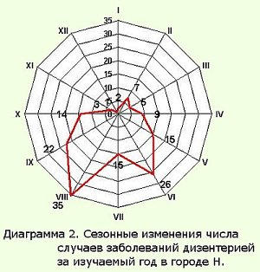

Fig.2. Monthly fluctuations in indicators of the number of emergency calls

Among the spatial charts, the most common are **column/bar (histogram), intra-barchart and pie chart.**

**Bar charts/histograms/column charts** are used to illustrate homogeneous but not connected intensity indicators. They depict the statics of the phenomenon.

A system of cartesian coordinates must be drawn, the size of each column and the intervals between them must be determined to plot a histogram. The base of the same-size columns is placed on the abscissa, and its upper part corresponds to the value of the indicator, which is plotted on the corresponding scale, respectively, to the axis of ordinates. Each individual column corresponds to a separate phenomenon or to one phenomenon over different time periods. The distance between the columns should be the same, although sometimes they are located one near the other.

An example of a bar chart/histogram is shown on Fig. 3.

days

oncologic restore cardiologic therapeutic surgical infectious

treatment

Fig.3*.* Average duration of treatment for adults in different hospital departments, Ukraine, 1997 (hospital days)

Bar chart/histogram are used not only to compare the phenomenon in dynamics, but also to demonstrate the composition of a certain phenomenon (intra-bar chart).

**Intra-bar charts** are used to characterize the structure of a certain phenomenon (mortality, morbidity, etc.), its constituent parts. The component parts of the phenomenon are given in the form of percentages to the total number. In this case, the height of the column is taken as 100% and is divided into parts proportionally to the specific weight of the individual parts in percent. They are located in order of decreasing (increasing) of the percentage.

The structure of the studied phenomenon (morbidity, mortality and others) can also be presented in the form of a pie chart (Fig.4).

To construct a pie chart a radius of arbitrary magnitude makes a circle. There placed the parts of the circle in the degrees, proportional to the percentage distribution of the image data, which is determined by the formula:

Х=360° : 100 a = 3,6° a, where denote:

Х – number of degrees,

а – number of percents.

The location of the segments of the circle is connected by lines with the center, forming sectors. The size of the sector clearly demonstrates the structure of phenomena.

An example of a sector diagram is shown on Fig.4.

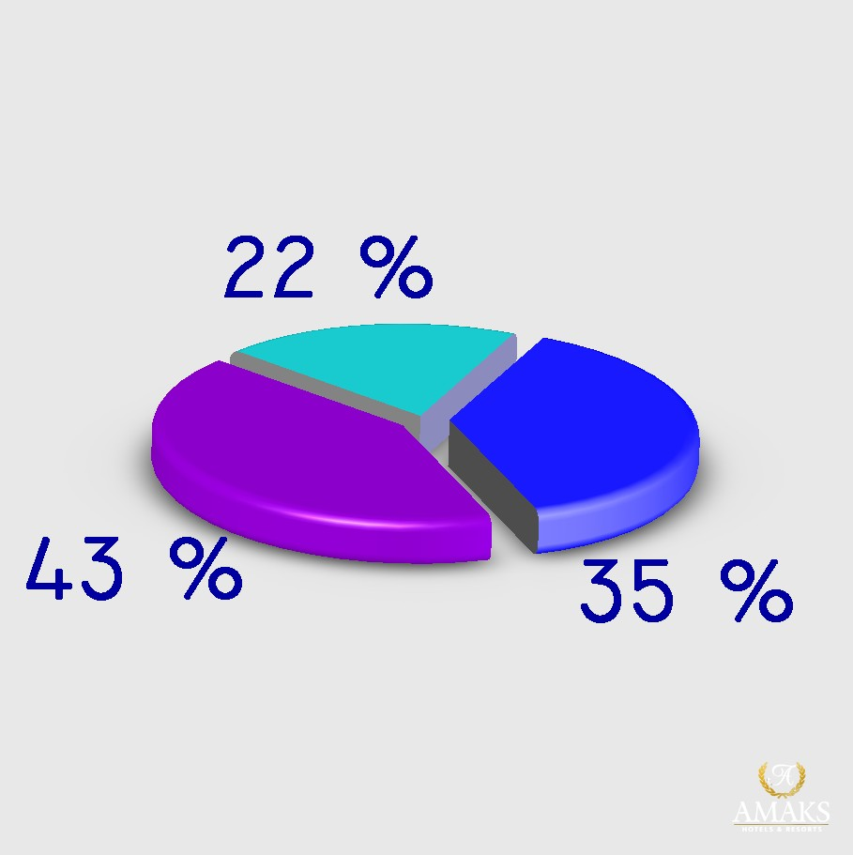

22% – children and teenagers

43%– people of working ability age

35% – people of the older working ability age

Fig.4. Structure of the population of Ukraine by age, 1998 (%)

For greater visibility, **figured diagrams** are used. The data are presented in the form of geometric figures, shapes, symbols. For example, the figure of a person can be used for the rapid determination of the burn area, the picture of the bed to represent the number of patients or beds.

An example of a shape and volumetric diagram is shown in Fig.5 and Fig. 6.

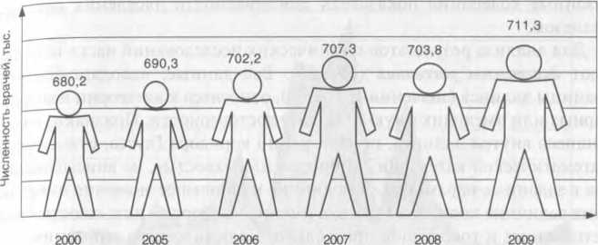

Fig.5. The number of doctors in Ukraine for the period of 2000-2009

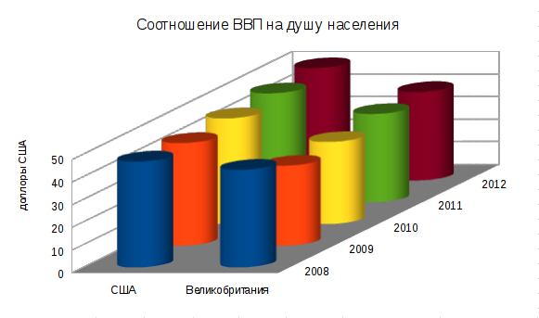

Fig.6. Structure of the population of Ukraine by age, 1998 (%)

**Cartograms/Index maps and Diagrammatic charts/Thematic map** give an idea of the territorial extent of the phenomenon in absolute or relative terms, which are located on geographical maps.

**Cartogram/Index maps** is the way of visualizing practical indicators that characterize certain geographical units (districts, regions, states) for one or another feature.

For this purpose, a different intensity of occurrence is applied to the geographical map by hatching or color of different shades. If we take a certain way of hatching for each group of districts, then it will be clearly seen the different prevalence of diseases in different regions or other phenomena (Fig. 7).

The drawback of such cartograms is that they give only a general idea of the differences in statistical indicators in the regions, but do not reflect their absolute values.

An example of a cartogram is shown in Fig.7.

**Diagrammatic charts/Thematic map** differs from the cartogram. The line chart, histogram can be plotted on a geographical map of a certain territory to display absolute or relative numbers. This allows determine the fluctuations of indicators in the regions. At the same time, other indicators can be represented by the corresponding background color of the territory itself.

An example of a Diagrammatic charts/Thematic map is shown in Fig. 8

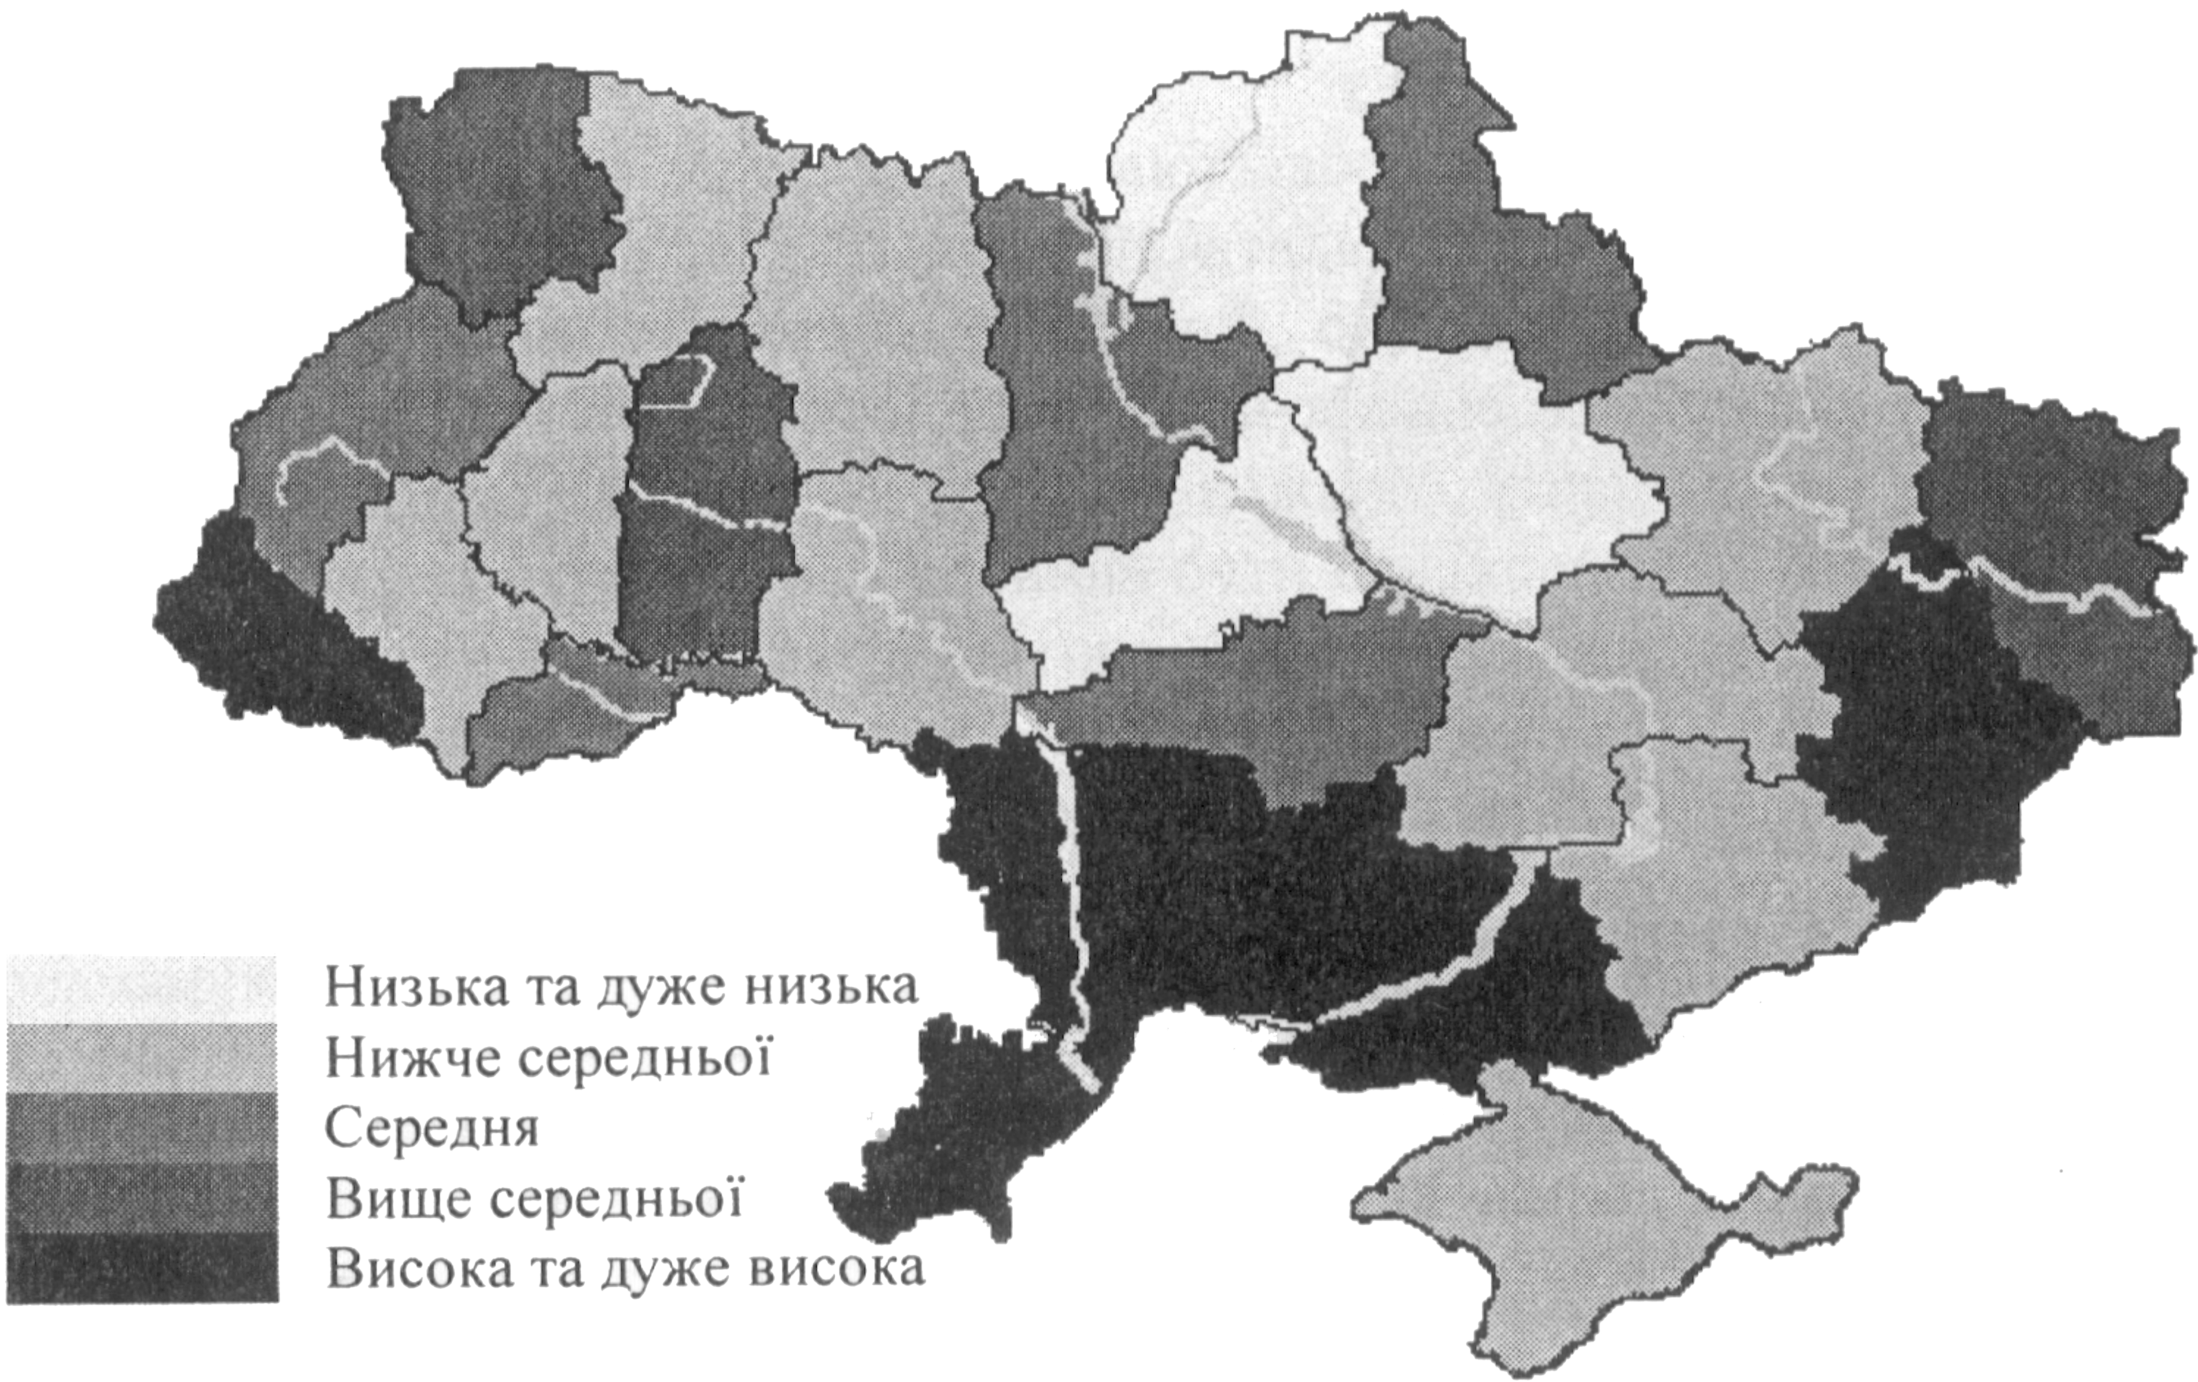

|  |  |
| --- | --- |
| Низька та дуже низька | Low and very low |
| Нижче середньої | Less than average |
| Середня | Average |
| Вище середньої | More than average |
| Висока та дуже висока | High and very high |

Fig.7. Comprehensive assessment of the regions of Ukraine in terms of mortality rates at infectious diseases for 1987-1997

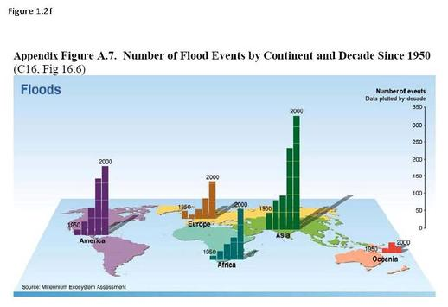

Fig.8. Population dynamics on the world map

**Each graphic must meet certain requirements:**

* have a title reflecting the data presented;
* have the right graphic type;
* have the right scale;
* Include a legend.

**PRACTICAL TASK**

The teacher offers students to perform independently individual assignments on topics that are in the medical literature “Methodological guidelines for independent work of students of medical faculties”. It is necessary to graphically display arbitrary phenomena and processes in the health care system, at the same time, correctly choose the type of graphic imaging:

– dynamics of the phenomenon over a number of years;

– structure of the studied phenomenon;

– provision of the population with doctors for a number of years;

– seasonal changes in morbidity throughout the year.

In the course of independent work of students, the teacher answers the questions that arise and monitors the correctness of the assignment. After finishing the independent work, the teacher checks the task.

**TEST TASKS**

|  |  |  |
| --- | --- | --- |
| 1. | The annual report presents data on the levels of spread of diseases among the population of the area for certain years. What kind of graphical image should be applied in this case? | |
|  | А | Bar chart |
|  | B | Diagrammatic charts/Thematic map |
|  | C | Index maps/Cartogram |
|  | * D | Line chart |
|  | E | Pie chart |
| 2. | Which type of graphical image can be used to show changes in human body temperature throughout the day (closed loop)? | |
|  | А | Bar chart |
|  | B | Cartogram |
|  | C | Line chart |
|  | D | Pie chart |
|  | * E | Radial chart |
| 3. | Data on total morbidity for the last 5 years are presented for analysis. Specify which chart should be used in this case? | |
|  | А | Bar chart |
|  | B | Cartogram |
|  | C | Histogram |
|  | * D | Line chart |
|  | E | Pie chart |
| 4. | Data on the structure of the incidence are presented for analysis. Specify which chart should be used in this case? | |
|  | *А | Index-maps/Cartogram |
|  | B | Intra-bar chart |
|  | C | Histogram |
|  | D | Line chart |
|  | E | Pie chart |
| 5. | Which type of graphical image can be used to show the dynamics of the level of the indicator of total mortality? | |
|  | А | Bar chart |
|  | B | Cartogram |
|  | C | Histogram |
|  | * D | Line chart |
|  | E | Pie chart |
| 6. | The structure of the primary incidence of the population according to ICD-10 was studied. Which diagram should graphically depict the results of this study? | |
|  | А | Bar chart |
|  | B | Cartogram |
|  | C | Histogram |
|  | D | Line chart |
|  | * E | Pie chart |
| *7.\*\** | *General practitioner A studied the causes of mortality in the current year. Among them there were: circulatory system diseases took the first place (63%), neoplasms second (16%), injuries third (10.3%) and others. Which diagram can help the doctor to illustrate the structure of the studied phenomena more clearly?* | |
|  | *А* | *Bar chart* |
|  | *B* | *Cartogram* |
|  | *C* | *Histogram* |
|  | *D* | *Line chart* |
|  | *\* E* | *Pie chart* |
| *8.* | *The absolute incidence of dysentery in the area according to the months of the year is: January – 6; February – 9; March – 11; April – 10; May – 16; June – 23; July – 19; August – 33; September – 58; October – 19; November – 11; December – 5. Total for the year 220 cases. What type of graphical image most clearly shows the monthly deviations of the incidence of dysentery from the average level?* | |
|  | *А* | *Bar chart* |
|  | *B* | *Diagrammatic charts/Thematic map* |
|  | *C* | *Index maps/Cartogram* |
|  | *D* | *Line chart* |
|  | *\* E* | *Radial chart* |
| 9. | According to the population's appealability to the district polyclinic, it was discovered: in January 256 cases of influenza, in February – 223, March – 211, April – 82, May – 25, June – 5, July – 4, August – 8, September – 19, October – 28, November – 48, December – 153. It is necessary to clearly demonstrate the seasonality of fluctuations in the incidence of influenza. What method of graphical representation is most appropriate in this case? | |
|  | А | Bar chart |
|  | B | Diagrammatic charts/Thematic map |
|  | C | Index maps/Cartogram |
|  | D | Line chart |
|  | * E | Radial chart |
| 10. | Select the type of graphical image which should be used to depict the monthly information on the number of registered cases of acute intestinal infections and compare them with the average monthly values that were obtained in the last 5 years: | |
|  | А | Bar chart |
|  | B | Cartogram |
|  | C | Histogram |
|  | * D | Line chart |
|  | E | Pie chart |
| 11. | The infant mortality rate over the past year was – 16.3, this year – 15.7. Name the type of diagram that can be used for the graphical image: | |
|  | А | Index-maps/Cartogram |
|  | B | Intra-bar chart |
|  | * C | Histogram/bar-chart |
|  | D | Line chart |
|  | E | Pie chart |
| 12. | Different diagrams are widely used in the work of the general practitioner. Linear diagram depicts: | |
|  | A | Phenomena that have a cyclical pattern |
|  | * B | The dynamics of the studied phenomenon |
|  | C | The ratio of phenomena |
|  | D | The size of the studied phenomena |
|  | Е | The structure of the phenomenon |
| 13. | In addition to charts, cartograms are used to visualize indicators of public health. So, with the help of cartograms you can visually portray: | |
|  | A | Incidence, which has a cyclical pattern |
|  | B | Monthly variations in incidence. |
|  | C | The dynamics of the incidence of the population of Ukraine |
|  | * D | The incidence rate in different regions of Ukraine |
|  | E | The structure of the incidence of the population of Ukraine |
| 14. | For the graphic representation of the phenomena that are studied, different diagrams are used. In what cases intra-bar charts are used? | |
|  | A | To depict a variety of phenomena |
|  | B | To depict the averages |
|  | C | To depict the dynamics of phenomena |
|  | D | To depict the ratios of phenomena |
|  | * Е | To depict the structure of phenomena |
| 15. | The total mortality rate in Ukraine was: in 2000 – 14.4%, in 2001 – 14.2%, in 2002 – 15.3%, in 2003 – 16.0%. What kind of diagram can be used to display this data? | |
|  | A | Bar chart |
|  | B | Cartogram |
|  | C | Histogram |
|  | * D | Line chart |
|  | Е | Pie chart |
| 16. | The area has a population of 70,000. From them at the age of 0–14 years - 13.0%, 15–49 years – 52.0%, 50 years and older – 35%. With what kind of graphic image is it advisable to display the age structure of the district population? | |
|  | А | Bar chart |
|  | B | Cartogram |
|  | C | Histogram |
|  | D | Line chart |
|  | * Е | Pie chart |
| *17.* | *A photochromometric survey of the admission of patients by general practitioners of Polyclinic No. 1 in the city A. in 2008 showed that 10.6% is spent on preparing and familiarizing with medical documentation, 15.1% is spent on interviewing a patient, and 35 are being examined and examined 9%, for other elements of work – 38.4% of the total time of admission of one patient. What kind of diagram can illustrate the results of the study?* | |
|  | *А* | *Bar chart* |
|  | *B* | *Cartogram* |
|  | *C* | *Histogram* |
|  | *D* | *Line chart* |
|  | *\* E* | *Pie chart* |
| 18. | In January 10 deaths were registered, in February – 9, in March and April – 7, in May – 8, in June – 5, in July – 3, in August – 2, in September – 4, in October – 6, in November – 8 and in December – 11 cases of death of patients in the hospital. What kind of graphic image is it advisable to portray this data. | |
|  | A | Bar chart |
|  | B | Diagrammatic charts/Thematic map |
|  | C | Index maps/Cartogram |
|  | D | Line chart |
|  | * E | Radial chart |
| *19.* | *We studied the incidence of influenza and ARVI in the last 5 years. What kind of graphic image is most appropriate to use for visual display of this data?* | |
|  | *A* | *Index-maps/Cartogram* |
|  | *B* | *Intra-bar chart* |
|  | *\* C* | *Histogram/bar-chart* |
|  | *D* | *Line chart* |
|  | *E* | *Pie chart* |
| 20. | When radical diagram should be used? | |
|  | A | To depict the structure of the phenomenon |
|  | B | To display statistics on a geographic map |
|  | C | To display the phenomenon of statistics |
|  | * D | To image phenomena in a closed loop of time |
|  | E | To image the volume of the phenomenon |
| 21. | When cartogram should be used? | |
|  | A | To depict the structure of the phenomenon |
|  | * B | To display statistics on a geographic map |
|  | C | To display the phenomenon of statistics |
|  | D | To image phenomena in a closed loop of time |
|  | E | To image the volume of the phenomenon |
| *22.* | *The structure of the primary incidence of the population for 17 classes of diseases was studied. What type of the diagram should be used for graphical displaying of the data?* | |
|  | *A* | *Bar chart* |
|  | *B* | *Diagrammatic charts/Thematic map* |
|  | *C* | *Index maps/Cartogram* |
|  | *D* | *Radial chart* |
|  | *\* E* | *Pie chart* |
| 23. | The incidence of influenza among children in general education schools was 40 cases among boys, and among girls – 60 cases per 1000 people. What type of chart should graphically represent the reported incidence rates of schoolchildren flu? | |
|  | A | Index-maps/Cartogram |
|  | B | Intra-bar chart |
|  | * C | Histogram |
|  | D | Line chart |
|  | E | Pie chart |
| 24. | The weather dynamics of the incidence of circulatory system diseases in the past 10 years was obtained. What type of diagram should be used to graphically represent the presented dynamics of morbidity indicators of the population? | |
|  | A | Bar chart |
|  | B | Cartogram |
|  | C | Histogram |
|  | * D | Line chart |
|  | E | Pie chart |
| 25. | What requirements must the graphic image in the statistics meet? | |
|  | A | Full name |
|  | B | Presence of a total row with a unit of measure |
|  | *C | Presence of symbols |
|  | D | Scale compliance |
|  | E | The correct calculation of the indicators that are displayed e |
| 26. | What types of graphic images can be used to represent the dynamics of the level of indicators of total mortality? | |
|  | A | Bar chart |
|  | B | Cartogram |
|  | C | Histogram |
|  | * D | Line chart |
|  | E | Pie chart |
| 27. | What types of graphic images can be used to display the birth rate in different regions? | |
|  | * A | Index-maps/Cartogram |
|  | B | Intra-bar chart |
|  | C | Histogram |
|  | D | Line chart |
|  | E | Pie chart |
| 28. | What graphic image can be used to display data on the division of diseases by disease classes (in%): | |
|  | A | Bar chart |
|  | B | Cartogram |
|  | C | Histogram |
|  | D | Line chart |
|  | * E | Pie chart |

**CONTROL QUESTIONS**

1. What purpose the graphical method in statistics are used for?

2. What are the main elements of a graph?

3. What kinds of charts exist and what determines the choice of one or another kind of chart?

4. How to construct a line chart when comparing several monotonous or related phenomena?

5. Types of dimensional charts and examples of their use?

6. What are the radial, pie and volumetric charts and in which cases are they applied?

7. What is a cartogram and thematic map?

8. What values are used to build graphs?

**CONTENTS**

|  |  |
| --- | --- |
| Guidelines for topic training ……………………………………………………… | 3 |
| Basic theoretical material for preparation for the lesson…………………………. | 6 |
| 1. Historical development of diagrams…………………………………... | 6 |
| 2. Graphical imaging and its elements…………………………………... | 6 |
| 3. Types of graphic images………………………………………………. | 7 |
| Practical task ……………………………………………………………………... | 13 |
| Test tasks.................................................................................................................. | 13 |
| Control questions…………………………………………………....……………. | 19 |

*Educational publication*

**SOCIAL MEDICINE, PUBLIC HEALTH**

**(BIOSTATISTICS)**

Methodical developments for teachers   
to conduct a practical lesson on the topic :

***“Graphical methods of the statistical analysis”***

for the preparation of students in the specialty:

222 “Medicine”, 228 “Pediatrics, 221 “Dentistry”.

|  |  |
| --- | --- |
| Drafters: | ***Ognev Viktor*** |
|  | ***Podrpyadovа Anna*** |
|  | ***Chukhno Inna*** |

*Translated by Chukhno I., Al-Quchim Nasser, Ivahnenko D.*

Responsible to sign-off *Ognev V.*

Формат А5. Ризографія. Ум.друк. арк. 1,25.

Тираж 100 прим. Зам. № 17-33436.

**______________________________________________________________**

Редакційно-видавничий відділ

ХНМУ, пр. Науки , 4, м. Харків, 61022

izdatknmu@mail.ru, izdat@knmu.kharkov.ua

Свідоцтво про внесення суб’єкта видавничої справи до Державного реєстру видавництв,

виготівників і розповсюджувачів видавничої продукції

серії ДК № 3242 від 18.07.2008 р.