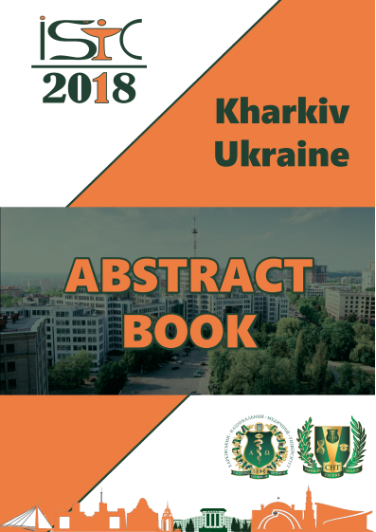
Skorbach T.V., Koshyl’ M.S., Rapota A.I.
The Post-traumatic syndrome
Kharkiv National Medical University (the Department of the Ukrainian language, Basis of Psychology and Pedagogy) Khrakiv, Ukraine
The actuality of our research is stipulated by the fact that the problem of social and psychological rehabilitation of soldiers is very important and not considered enough in the modern science and research literature.
The soldiers, who came back from the battle field, are greeted with flowers and orders, tears of happiness and joy by their relatives. However, absolutely different people come back home even not having died or been wounded. No doubt, any case of facing death leaves traces on man’s soul and fate. Nightmares, depression and alcoholism, suicide attempts are only some symptoms of the disease called “Donbass syndrom”, that is typical post-traumatic stress breakdown.
For example, during the thunderstorm a man has an unintentional defecation, he grabs the gun and tries to hide away. Though the soldier understands that there is no danger, it’s difficult for him to take in this new world with the peaceful sky, where there is no need to worry about your or somebody’s life. The former soldiers get depressed, withdraw into themselves and don’t find the sense of life. Some of them commit suicide.
The psychologists suggest several reasons of this condition. Firstly, it’s hard for former soldiers to adapt in the peaceful life.
They understand that they can’t defend their motherland sitting at home. Secondly, many military men have access to the weapon and it’s easier for them to lay hands on them. Thirdly, they feel injustice and annoyance because of the fact that many men were not at war and did not feel the horror of war.
The specialists distinguish three categories of people: 30 % - those who managed to overcome war stress themselves; 30% - those who need some consulting and taking medicines; the rest – those who need psychological support for the whole life.
It’s known nowadays that about 500 people committed suicide after coming back from war. While facing troubles at the critical moments we feel frightened and nervous. Muscle strength of a person who feels fear can increase, and this person can rush against danger. The same feeling can cause the total loss of strength.
We should remember that former soldiers’ life is very difficult. They live with their pains problems and with war which tries somebody’s strength and firmness. It’s necessary to create the system of psychological support at the front right now. Meanwhile on the peaceful territories it’s important to provide soldiers with jobs and to prepare their relatives for those changes which happen with their husbands and sons. the support of close people is very important in such circumstances. It’s only trouble that unites people. Today the problem is our common one. We are united in our wish to support our brave soldiers. The Ukrainian Forces and the volunteers showed great qualities and became a good example for us.
People, who took part in the war, feel very strong emotions. To motivate themselves in dangerous situations they had high aims: Motherland, nation, freedom and victory. Their relatives don’t understand these words very well because solving everyday problems is more important for them. That’s why soldiers often complain about misunderstanding and conflicts with relatives, friends and colleagues. They can’t adapt to everyday life. They have much worrying, grief and guilt. However, not only former soldiers feel the lack of strong emotions, but also ordinary Ukrainians do. It happens because they did not experience difficult events in full measure. Soldiers should come to the group of support and speak about their emotions because it’s very important to feel sympathy , attention and help from the surrounding people. A kind word plays a magic role. The main defenders’ wish is to find soul peace and harmony.
So, psychological and social rehabilitation is the most important element of renewing the balance and emotional stability.

Contents
The post –traumatic syndrome…………………………………….P. 247-248.

