УДК 615:613.84-099
ELECTRONIC CIGARETTES – IT’S FASHIONABLE BUT VERY DANGEROUS TO HEALTH
E.V. Karnaukh, D.A. Kaljuzhnaja
The Kharkiv National Medical University (61022, Ukraine, Kharkov, 4 Nauky ave.,
The Kharkiv National Medical University), e-mail: ella69k@mail.ru
In this study, we discussed in detail the current trends increasingly growing popularity of electronic cigarettes, especially among adolescents, young adults and even children of school age. The data available to the modern literature on the structure and diversity of the composition of cartridges such modern and trendy innovations, such as electronic cigarettes. The possible side effects and the hidden dangers of uncontrolled use, compared with the already usual and traditional tobacco products as cigarettes and cigars. Analyzed in detail the results of original research in the form of a questionnaire survey among 100 young men from among the students of medical higher educational institutions about the issues and the main purpose of the use of the effects of e-cigarettes, the risk of ignoring the observed complications. Emphasize special harm to health and the beauty of the fair sex, who for the sake of fashion trends, and even during pregnancy are not willing to give up this bad habit. The data clearly refute the myth of the existing safety and security of electronic cigarettes.
Keywords: electronic cigarettes, the composition of cartridges for electronic cigarettes, danger of smoking

ЭЛЕКТРОННЫЕ СИГАРЕТЫ - ЭТО МОДНО, НО ОЧЕНЬ ОПАСНО ДЛЯ ЗДОРОВЬЯ
Э.В. Карнаух, Д.А. Калюжная
Харьковский Национальный медицинский университет (61022, Украина, Харьков, просп. Науки, дом 4. Харьковский Национальный медицинский университет), e-mail: ella69k@mail.ru
В представленной работе подробно рассмотрены современные тенденции все более растущей популярности электронных сигарет, особенно среди подростков, молодых людей и даже детей школьного возраста. Проанализированы данные современной доступной литературы по строению и разнообразию состава картриджей такого современного и модного нововведения, как электронные сигареты. Описаны возможные побочные эффекты и скрытые опасности их бесконтрольного использования по сравнению с уже привычными и традиционными табачными изделиями в виде сигарет и сигар. Подробно проанализированы результаты проведенного оригинального исследования в виде анкетирования среди 100 юношей из числа студентов медицинского высшего учебного заведения касательно вопросов основной цели и последствий употребления ими электронных сигарет, опасность игнорирования наблюдаемых осложнений. Подчеркнут особый вред здоровью и красоте представительниц прекрасного пола, которые в угоду модным тенденциям и даже во время беременности не желают отказываться от подобной вредной привычки. Представленные данные наглядно опровергают существующий миф о безвредности и безопасности электронных сигарет.
Ключевые слова: электронные сигареты, состав картриджей для электронных сигарет, опасность курения

Introduction. As were right fiction — they are in his novels described a future where Smoking cigarettes that didn't have to light it, only to charge special liquid and energy. Today it is an electronic cigarette. Let's slightly delve into the history of origin of electronic cigarettes. So, electronic cigarettes emerged in 2006 in China and to this day continue to slowly but surely capture the market through advertising and marketing, which vehemently claim about the safety of using a "unique product", but rather ESDN (electronic delivery systems nicotine), as they call electronic cigarettes a reputable organization. In the early 60-ies of conventional cigarettes are touted by all who, as they say, not laziness: doctors, dentists, athletes, Santa Claus, children and even presidents. It is therefore not surprising that at that time almost 70% of the US population smoked mindlessly, not even knowing about harm of Smoking [1].
People are led to believe that cigarettes are safe and even benefit! The objective of the e-cigarette manufacturers is to create the illusion of pleasure, but for this purpose, the same chemical compounds that are artificially added to conventional cigarettes. First of all nicotine is a powerful addictive, and everything else, is a strong neurotoxin, i.e. poison. And this is no exaggeration! What's the harm? It gradually destroys the nervous system, and immune, which is the most powerful tool that helps us to fight different kinds of illnesses and infections. Fashionable now the device has become for many the only solution in the light of the law on prohibition of Smoking, consists of: led (imitation of fire on the tip of a cigarette), a battery and microprocessor, sensor, atomizer and content replacement cartridge. What are the base components? Propylene glycol is a viscous, transparent liquid without color, with weak smell, slightly sweet taste and hygroscopic properties. Allowed to use (as food additives) in all countries. Widely used in food and pharmaceutical industries, for cars, the production of cosmetics, etc. Almost non-toxic compared to other glycols. Partly excreted in unchanged form, the remainder turns into lactic acid, metabolizing in the body. Glycerin- viscous liquid without color, hygroscopic. Also widely used in various industries. Acrolein generated in the dehydration of glycerol can be toxic to the respiratory tract.
Charge "e-cigarette" m the network, or directly from the laptop. Its duration is 2-8 hours, depending on intensity of use [2,3].
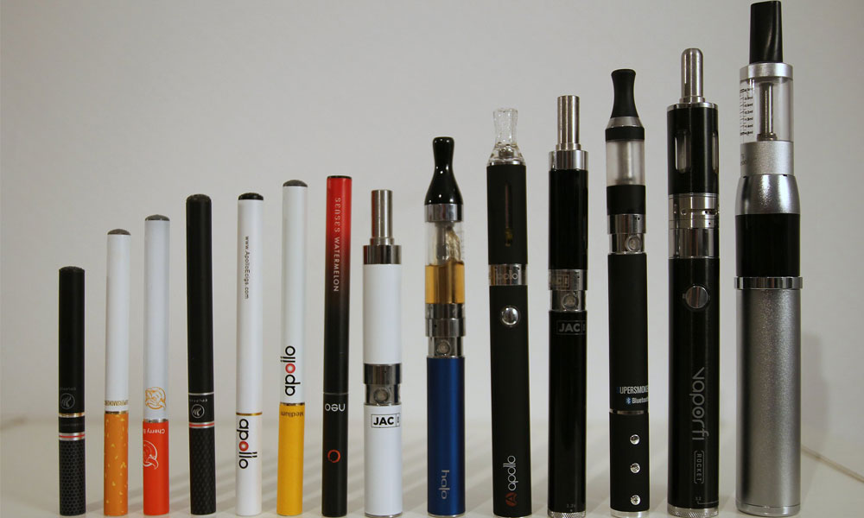

Materials, methods and results of the study. Having conducted the survey among 100 young students, the findings that 76% of smokers use e-cigarettes, alternating with tobacco cigarettes, 6 % - not combine, and 18% occasionally combine the electronic cigarette with the usual. While 58% of smokers do not even think about the double harm to their health (gastrointestinal complications, vasoconstriction and hypertension, stomatitis, herpes, cough, immunosuppression, etc.), and only 23% are informed about it and 15% do not take this fact into account. 83% of respondents do not know of electronic cigarettes can include nicotine in various doses and 78% of them don't even know about the negative effects of nicotine on the body ( neurotoxicity , blurred vision, lesions of the respiratory and digestive system, cardiotoxicity, etc.).
In different countries have been conducted various studies to determine what really is the harm of electronic cigarettes. In Korea was conducted online survey of young people about Smoking , which was attended by more than 70 thousand respondents. 80% of respondents admitted that they smoke at the same time, and electronic and regular cigarettes. Japanese scientists released the results of the verification of electronic cigarettes that vapor emitted by the devices contains two types of aldehydes – chemical compounds that trigger cancer. Smoking electronic cigarettes pregnant women triggers the gestation of a male – these are the results of studies conducted in several Asian countries. Researchers from the University of San Francisco published the results of their research: people who switched from conventional cigarettes to electronic , in the end began to smoke more ,with factors of full refusal of Smoking was relatively small( only a couple of percent). In English the Ministry of health believe e-cigarettes cannot help stop Smoking, but on the contrary, strengthen the psychological dependence of smokers. Such innovation as electronic cigarette, immediately attracted the majority of smokers, so their damage relegated to second plan. This is not surprising – the "e-cigarette " you can smoke at work, in a restaurant, in bed and everywhere else where Smoking classic cigarettes have been banned long ago. The difference, at first glance, only that instead of smoke stands out for couples with a very pleasant smell and no harm to suffering from passive smokers.
Despite the appearance of "harmlessness" electronic cigarettes , nicotine it is still present. On the one hand is a plus. Because the rejection of traditional cigarettes is easier nicotine continues to enter the body, and imitation cigarette "cheating" hand, accustomed to the "Smoking stick." Health e-smokers also improved – after all, harmful contaminants cease to enter the body. Even the oncologists said (though evidence based on deep research, they were not able to lead), that the liquid refills cigarettes cause cancer can not be. But! Nicotine continues to enter the body. That is, to quit Smoking still will not work. Because barely received a single dose of nicotine (whether from regular cigarettes, patches or gum), the body immediately begins to demand a new one. It is a vicious circle. But the dangers of nicotine to tell you makes no sense – everyone knows this. Acknowledge this fact and psychiatrists: the electronic cigarette is a change of the "nipples" on more fragrant. Join them and addiction: the craving for nicotine is not going away, not reduced, and options for the dosing of nicotine are irrelevant [4].
The "safety" of electronic cigarettes plays an important role in the formation of interest in the Smoking of our children. Again not bad — so can you! And more solid somehow, with a cigarette. As for toxicologists – they look at electronic cigarettes with suspicion. Because the absence of harmful substances and smoke in the air – is not proof of harmlessness of electronic cigarettes. A proper test as there was no and no.
The us FDA against e-cigarettes: analysis of the cartridges showed the presence of carcinogenic substances and the discrepancy between the composition of the real cartridges. In particular, nitrosamine found in the composition that can cause cancer. And cartridges without nicotine, again, contrary to the manufacturers, was discovered the nicotine. That is, buying an electronic cigarette, we can't be sure in the absence of injury, and "stuffing" the electronic cigarette is still for us a mystery. Electronic cigarettes – a good business. Are many unscrupulous manufacturers. Smoke inhalation and a couple of different processes. The second option does not bring that saturation that gives a usual cigarette. Therefore, the nicotine monster starts to demand dose more than conventional Smoking. To reclaim the "charm" of old feelings, many begin to smoke more often or increase the strength of the filled liquid. What is it? To overdose of nicotine. This is the temptation to smoke anywhere and at any time, and the illusion of safety. The who has warned that the safety of e-cigarettes has not been proven. And the tests were carried out on these devices, speak about the great difference in the quality of composition, presence of impurities and the amount of nicotine. A large concentration of propylene glycol leads to problems of the respiratory system [5].
Conclusion. Be honest with yourself and ask yourself do you need to be a rocket scientist to understand a simple thing – daily inhalation of the chemical compounds, which you do not even suspect is dangerous and may cause serious harm to your health. Take care of yourself and be free!
References:
- Electronic Cigarettes: harmful fad or a useful device? [Electronic resource]. - Access mode: http://www.colady.ru/elektronnye-sigarety-vrednaya-dan-mode-ili-poleznyj-devajs.html
- Harm electronic cigarette - a scientifically proven fact [Electronic resource]. - Access mode: https://www.allencarrmoscow.ru/vred-elektronnyix-sigaret-nauchno-dokazannyij-fakt/
- The action of electronic cigarettes on the body, harm or benefit? [Electronic resource]. - Access mode: http://ecigi.ru/news/dejstvije-elektronnyh-sigaret-na-organizm
- The harm of electronic cigarettes on the human body [Electronic resource]. - Access mode: http://ozog.ru/vred-elektronnoj-sigarety-na-organizm-cheloveka.html
- Electronic Cigarettes: reviews of doctors. Electronic cigarettes are harmful or not? [Electronic resource]. - Access mode: http://fb.ru/article/158186/elektronnyie-sigaretyi-otzyivyi-vrachey-elektronnyie-sigaretyi-vrednyi-ili-net

