Morphological characteristics of pleural adhesions depending on time of arising
Vitaliy V. Makarov, Anna O. Syrovaya, Vladimir A. Makarov, Evgeniya R. Grabovetskaya
Kharkiv National Medical University, 4 Nauky Avenue, Kharkiv 61022, Ukraine
graboveckaya@inbox.ru
Abstract
Experiments show that the formation of adhesions begins with initial development of exudative purulent inflammation followed by productive inflammation with active proliferation of macrophage cellular elements. Neutrophilic infiltration of granulation tissue is long-termed, with a tendency to secondary suppuration. Transformation of granulation tissue into fibrous tissue occurs from day 14 to 30. On the 60th day, volume adhesions accompanied by hyalinosis, subpleural pleurogenic pneumosclerosis with a tendency to pulmonary sclerosis develop.
Keywords: pleural cavity, adhesions, empyema.
Introduction
Nonspecific pleural empyema is one of the most common pathological processes in thoracic surgery [1, 2]. Development of new surgical technologies and conservative therapy of this disease aims to improve the results of treatment of patients suffering from nonspecific pleural empyema. Modern developments are mainly directed to microflora investigations with the introduction of new schemes of antibacterial therapy and sanitation methods, the introduction of new surgical techniques, and perfection of the complex treatment of patients suffering from this pathology [1, 3, 4]. The number of rigid processes complicating the course of acute pleural empyema and leading to the transformation into the chronic form remains at the same level within the limits 8.3 - 25% [4].
Nowadays morphological alterations of pleural adhesions which depend on time of arising are one of the insufficiently explored problems of nonspecific pleural empyema [1, 5]. We found only few reports devoted to time-dependent morphological alterations of pleural adhesions.
The aim of the study was to investigate the features of morphological alterations of pleural adhesions that depend on time of arising in mature rats.
Materials and methods
Both male and female adult rats of the WAG strain weighing 180-200 g (28 animals) were employed in the present study. The experiment was carried out in accordance with international principles of the European Convention for the Protection of Vertebrate Animals (Strasbourg, 1985). Adhesions in pleural cavity were simulated according to D. Spensor [6].
The experimental animals were divided into four groups of seven animals depending on time of adhesion simulation in the pleural cavity. The 1st group was examined on day14 after initiation of adhesions in the pleural cavity. The 2nd group of animals was examined on day 30 from the start of the experiment, the 3rd group was examined on day 45, and the 4th group – on day 60.
The material obtained in the experiment was used for morphological study. Excised adhesions with fragments of the visceral and parietal pleura along with adjacent parts of subpleural parenchyma were morphologically examined.
The investigated material was fixed in 10% neutral formalin. Then it was subjected to standard histological processing by a series of alcohol solutions of increasing concentration, mixture of Nikiforov (96% alcohol and diethyl ether in the ratio 1:1), chloroform and then infiltrated with paraffin. The blocks formed were cut into serial sections of 4 - 5 μm thick.
Specimens stained with hematoxylin and eosin were used to generally assess the conditions of the tissues. Staining with Weigert's stain for elastic fibers and Van Gieson’s picrofuchsin was used for the detection and differentiation of connective tissue structures. The complex of histochemical techniques was used to assess the functional activity of regenerating tissues. Deoxyribonucleoproteins were revealed by Feulgen-Rossenbeck reaction. Ribonucleoproteins were detected by Brachet’s method. Staining by Mallory’s method was used to assess maturity of connective tissue. Histological and histochemical techniques were performed according to recommendations given in the specific manuals [5, 7].
The complex of histological and cytophotometric researches was carried out using the Olympus BX-41 microscope with Olympus DP-Soft (Version 3: 1) and Microsoft Excel software.
Immunomorphological examination was performed on paraffin sections of 5-6 μm thick by means of indirect Coons method modified by Brosman. Collagens were typed by monoclonal antibodies (mAb) (Serotec) to collagen types I, III, and IV. F (ab) -2 – fragments of rabbit anti-mouse immunoglobulins were used as fluorescent labels. Specimens were examined by means of luminescent microscope using color filters [7].
Results of morphological investigations were processed by mathematical statistics methods using analysis of variance. Methods of variational statistics allowed to find the arithmetical mean, variance, standard deviation, average error, and the probability of difference. The difference between two means in small samples was determined by Student's t Table following the condition of (n₁ + n₂-2). Differences between the data were considered significant at p<0.05 (i.e. P>95%).
Results and discussion
In experimental animals of the 1st group (the 14th day since the simulation of adhesions in the pleural cavity), pleura (both visceral and parietal sheets) was dull, edematous, slightly thickened with filamentous impositions which took the form of soft adhesions in some points. Microscopic examination showed swollen, focally desquamated mesothelium. The pulmonary parenchyma in subpleural parts had signs of edema and focal proliferations of loose connective tissue. Deformation of alveoli and acini, phenomena of purulent exudative pneumonia were observed in these areas.
The adhesions were represented by granulation tissue. It was characterized by focal proliferation and pronounced inflammatory infiltration. The neutrophilic granulocytes were predominant cell population in the infiltrate. The distribution of granulation tissue vessels was uneven, in some areas they were numerous, i.e. hypergranulation developed. Hyperemia of granulation tissue vessels was observed. Endothelium had pronounced signs of proliferation as evidenced by the high histochemical activity of DNA in the nuclei of endothelial cells. Basal membranes of newly formed blood vessels were PAS-positive and thin.
Fibroblasts with signs of active collagen formation were the predominant population among the cells of granulation tissue. This term was characterized by increased number of fibroblasts in the central parts of the granulation tissue. The cytoplasm of fibroblasts was homogeneous, could be stained with basic dyes, demonstrated active synthesis of RNA (Fig. 1) confirmed by Brachet’s reaction. Mean optical density of RNA in the cytoplasm of fibroblasts was (1,637 ± 0,041) conventional units (conv. un.) in the green region of the spectrum. The nuclei of cells were large and bright. They contained delicate mesh of chromatin and large nucleoli. Histochemical DNA activity in the fibroblasts varied from moderate to high in some points, and mean optical density of DNA in the nuclei of cells was (2,147 ± 0,085) conv. un.
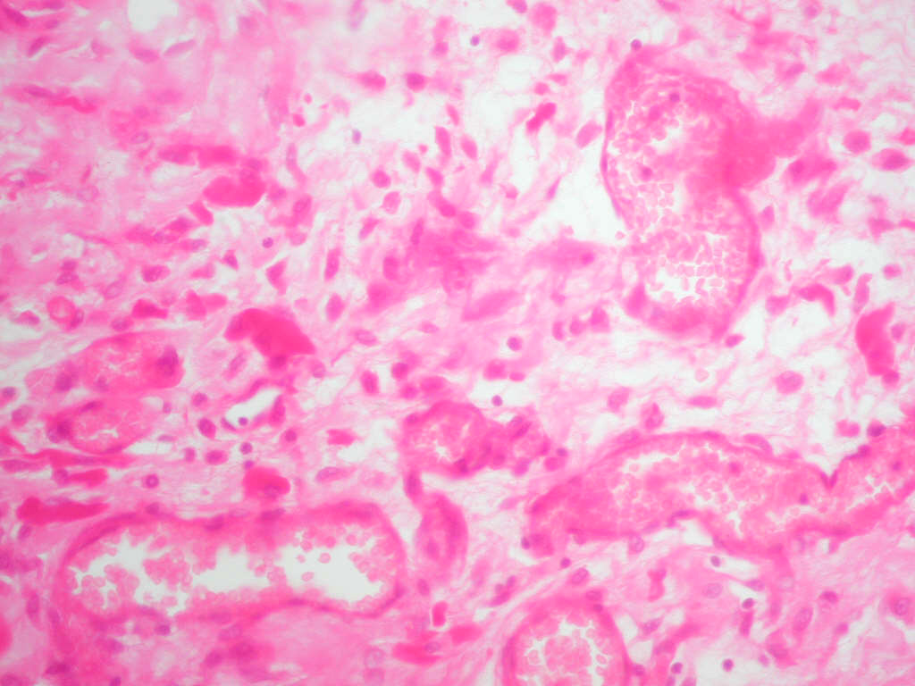
Figure 1. Pronounced synthetic activity of granulation tissue fibroblasts with high RNA content in the cytoplasm. Adhesion from the control group animal eliminated from the experiment on day 14. Staining by Brachet’s method. Magnification 400x.
In this period, granulation tissue was characterized by the beginning of maturation with increasing number of fibrous fuchsinophilic structures represented by individual fine fibers or groups of fibers but clear fiber bundles were not detected. The surface layer of granulation tissue served as an exception because in direct proximity to fibroblasts there was revealed a dense network of newly formed collagen fibers forming small bundles. Both types of interstitial collagens (I and III types), with a predominance of type III were revealed in the composition of connective tissue fibers. By discussed time (the 14th day), the amount of Hale-positive agents of the ground substance of granulation tissue was insignificant which indicated a decrease in the synthesis of acidic GAGs. At the same time there was an accumulation of PAS-positive substances in interstitial substance of granulation tissue. Such accumulation indicates the growing amount of sulfated mucopolysaccharides and hence collagenization processes. The mucopolysaccharides of the ground substance form a matrix for fibers formation. Lymphocytes, plasma cells and small amounts of macrophages were found among the cellular components of the granulation tissue. The cytoplasm of macrophages was vacuolated and PAS-positive. These facts are known to be associated with the glycolytic activity of cells and indicate their intensive functional activity.
On the 30th day, pleura was dull, edematous, thickened, with a large number of filamentous and filmy impositions. Adhesions were shown to be translucent, wet, and shiny (Fig. 2). Subpleural pulmonary parenchyma was heavily edematous, accompanied by necrosis areas and phenomena of exudative purulent pneumonia. Areas of destruction of alveoli and acini were found (Fig. 3). Proliferation of scar tissue with distinct deformation of the lung tissue was detected. Atelectasis areas were found in some points. Histological examination of adhesions showed them wide enough, containing the cellular connective tissue. The inflammatory infiltrate was preserved. It was represented by neutrophilic granulocytes with admixture of macrophages, lymphocytes, and plasma cells.
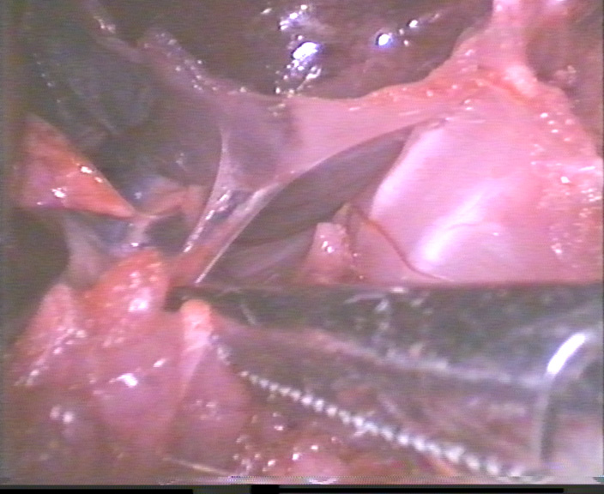
Figure 2. Wet, shiny, translucent adhesions in the control group animal on day 30 of the experiment.
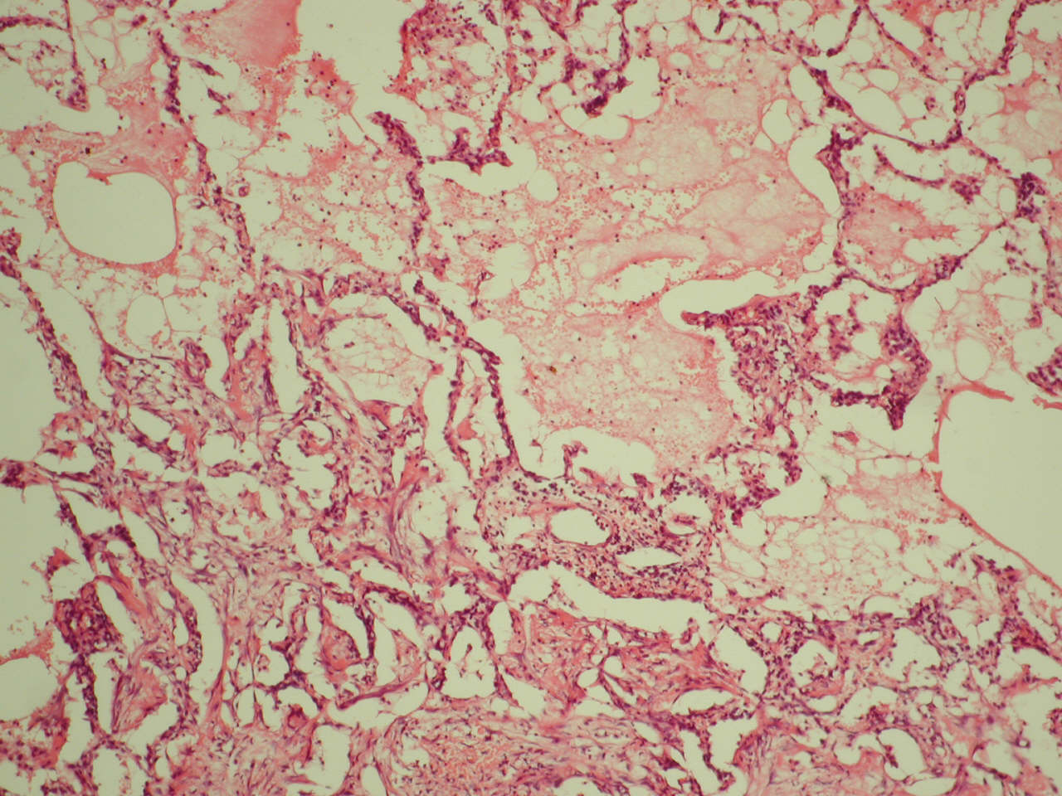

Figure 3. Exudative-purulent pneumonia and edema in subpleural parts of the lung parenchyma in the control group animal on day 30 of the experiment. Hematoxylin and eosin staining. Magnification 200x.
Loose fibrous connective tissue containing bundles of collagen fibers and a small amount of connective tissue cells was formed at this period of observation. Bundles of collagen fibers of the immature connective tissue were wide, fuchsinophilic when stained by Van Gieson and brightly PAS-positive. Type III collagen was determined predominantly in the fibrous structures. It was detected as a linear luminescence of moderate intensity (Fig. 4). Type I collagen was found focally in the form of a bright luminescence.
The DNA content in fibroblasts nuclei was decreased (mean optical density of DNA on sections stained by Feulgen-Rossenbeck method was (1,994 ± 0,06) conv. un.). This fact indicates decreased potency of fibroplastic cells to growth and reproduction. At the same time, their specialized ability to form the ground substance, collagen, and, as a result, the collagen fibers, is maximally manifested.
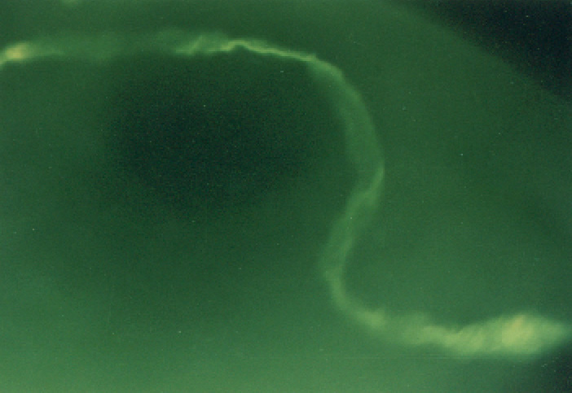
Figure 4. Type III collagen in the form of linear luminescence of moderate intensity in the adhesions from control group animal eliminated from the experiment on day 30. Indirect Coons reaction with antiserum to type III collagen. Magnification 400x.
The synthetic activity of fibroblasts in this period was confirmed by the high level of RNA synthesis – the mean optical density of RNA in the cytoplasm was (1,877 ± 0,066) conv. un. in the green region of the spectrum. Activation of collagen formation may be due to the presence of lymphocytes in granulation tissue. Lymphocytes produce cytokines that stimulate fibroblasts proliferation and collagen synthesis.
The ground substance was PAS-positive and did not contain GAGs. At the same time, most of the blood vessels were empty and degenerated. Endothelial cells forming the vessels walls were lost among fibroblasts.
On the 45th day, the most of the observations showed pronounced pleurogenic pneumosclerosis. Subpleural foci of cicatrizing lung parenchyma containing randomly arranged collagen fibers, as well as portions of the deformed lung parenchyma were found. Deformed lung parenchyma contained small acini with reduced number of alveoli. Carnification foci were found in some portions, i.e. alveolar lumens were filled with inflammatory exudate. The pleura was thickened and intensively fuchsinophilic when stained by Van Gieson. The adhesions were represented by loose connective tissue with a large number of mature PAS-positive and fuchsinophilic collagen fibers arranged in bundles. The fibers had correct longitudinal direction as well as random arrangement. Type III collagen was mainly determined in the fibrous structures as a linear luminescence of moderate intensity. Ground substance was found to be weakly PAS-positive. Connective tissue contained few blood vessels and a small amount of connective tissue cells. Symptoms of inflammatory infiltration were expressed slightly. Small amounts of fibroblasts, lymphocytes, histiocytes, single macrophages and neutrophilic granulocytes were determined in perivascular space. Morpho-functional activity of fibroblasts was decreased as evidenced by the activity of histochemical reactions for DNA and RNA in their cytoplasm and nuclei. Thus, the mean optical density of the DNA content in the fibroblasts nuclei was (1,962 ± 0,621) conv. un., and that of RNA in the cytoplasm was (1,677 ± 0,052) conv. un.
On the 60th day, area of irreversible pleurogenic pneumosclerosis with deformation of the lung parenchyma was formed in the subpleural parts. The sclerosis phenomenon was found in some portions of intrapulmonary parenchyma. The pleura had signs of cicatrical degeneration, i.e. it was tuberous and deformed. The adhesions were dense, massive, opaque, and whitish (Fig. 5).
Symptoms of inflammatory infiltration were weakly manifested. Volume adhesions were represented by fibrous tissue formed by correctly oriented bundles of collagen, reticular, and elastic fibers. At the same time, formation of elastic fibers in the scar tissue was much slower. Elastic fibers were mainly determined in the edges of adhesions as thin fibrils woven in the scar tissue. At this period, the increase in the width and length of the fibers in bundles was detected. The number of cells was small. Many of them disappeared due to atrophy and remaining cells were flattened between the fibers. Fibrocytes were clearly predominant among fibroblast cells. The level of morpho-functional activity of these cells was low. The mean DNA content in their nuclei was determined as (1,752 ± 0,523) conv. un., and that of RNA in the cytoplasm was (1,422 ± 0,037) conv. un.
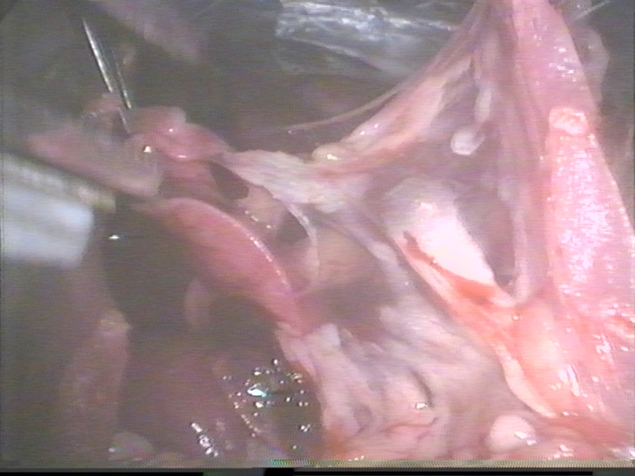
Figure 5. Dense, massive, tuberous, whitish, opaque adhesions in the control group animal on the 60th day of the experiment.
Type III collagen was mainly determined in the fibrous structures as a linear luminescence of moderate intensity. Some observations showed hyalinosis in adhesions. In such cases, the fibers were homogenized, had no fibrillar structure and existed as a homogeneous mass (Fig. 6). The quantity of mucopolysaccharides as PAS-positive structures in the ground substance was decreased.
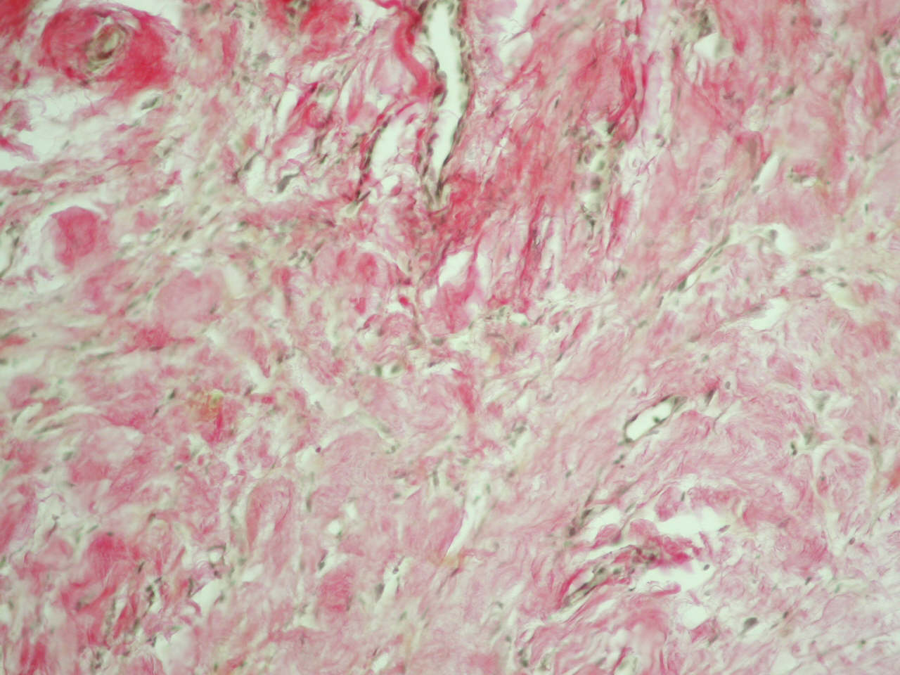
Figure 6. Hyalinosis in adhesion on the 60th day of the experiment. Fibers are homogenized with loss of fibrillation. Some of them are represented by a homogeneous mass. Control group animal. Hematoxylin and eosin staining. Magnification 200x.
Signs of pleura inflammatory infiltration were kept along with the scarring process. Granulation process was prolonged leading to the progression of adhesions.
Conclusion
1. Complex morphological examinations of simulated adhesions in the pleural cavity of animals show that the formation of adhesions begins with initial development of exudative purulent inflammation followed by productive inflammation with active proliferation of macrophage cellular elements. Macrophages stimulate angiogenesis, fibrillogenesis and underlie granulation tissue formation.
2. Neutrophilic infiltration of granulation tissue is long-termed, with a tendency to secondary suppuration. Hypergranulation often develops and transformation of granulation tissue into fibrous tissue occurs from day 14 to 30.
3. Volume adhesions accompanied by hyalinosis, subpleural pleurogenic pneumosclerosis with a tendency to pulmonary sclerosis develop by the 60th day.
References
[1] V.V. Boyko, A.K. Florikyan, Yu. V. Avdosev, G. A. Grigoryan, et al., Purulent diseases of lungs and pleura, Prapor, Kharkov, 2007, 576. [In Russian]
[2] V.N. Naumov, I.V. Ogai, A.E. Sivakov, V.V. Dadabaev, Problemi tuberculioza, 1998, 4, 44 – 49. [In Russian]
[3] D.A. Sergachev, M.V. Golotin, S.N. Grigoriev, S.V. Kostin, Complex treatment of purulent – inflammatory diseases of lungs and pleura, Chelovek i ego zdorovie: (Collection of scientific works.), Kursk, 1998, 153 – 155. [In Russian]
[4] M.E. Cowen, M.R. Johnston, Compr. Ther., 1998, 10, 40 – 45.
[5] V.V. Serov, A.B. Shehter, Connective tissue , Medicina, Moskva, 1981, 312. [In Russian]
[6] J.B. West, Pulmonary pathophysiology, Williams & Wilkins, Baltimore, 1998, 5th Edn, 198.
[7] D.S. Sarkisov, Yu.L. Perov, Microscopic technique: Manual, Medicina, Moskva, 1996, 544. [In Russian]

